**Mui – Material UI notes 2023K**

<https://github.com/mui/material-ui> <https://mui.com/material-ui/getting-started/overview/>

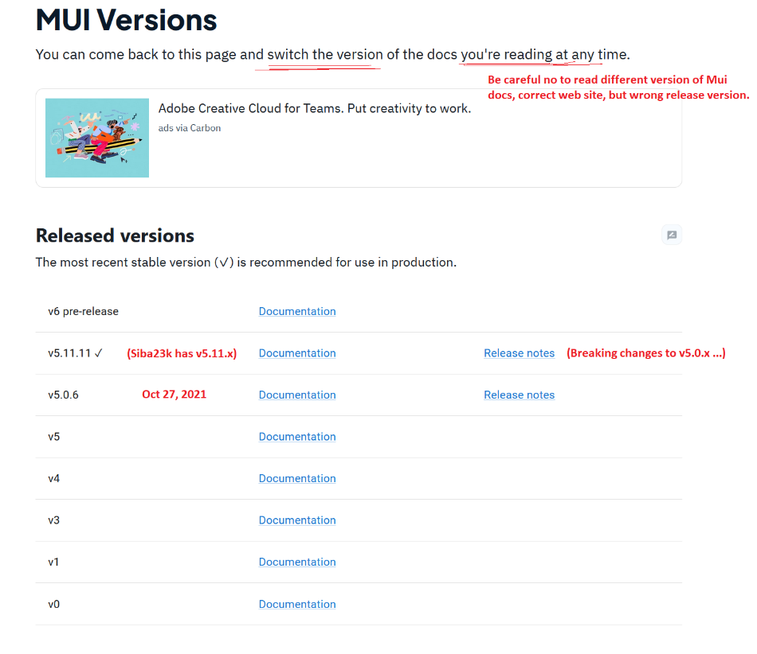

**Viewport breakpoints**  
<https://mui.com/material-ui/customization/breakpoints/#default-breakpoints> Viewport width based breakpoints, e.g. xs, extra-small: **0px** (-599px), sm, small: **600px**, (Or define your own ones: <https://mui.com/material-ui/customization/breakpoints/#custom-breakpoints>)

**Views with Grids and Cards**   
– Find out the generic SRP roles of these: Single-Responsibility Principle roles in any app, not just this case   
Container - <https://mui.com/material-ui/react-container/> <https://mui.com/material-ui/api/container/>  
Grid - <https://mui.com/material-ui/react-grid/> <https://mui.com/material-ui/api/grid/>  
Card - <https://mui.com/material-ui/react-card/> <https://mui.com/material-ui/api/card/>   
 CardContent - <https://mui.com/material-ui/api/card-content/>  
 CardHeader - <https://mui.com/material-ui/api/card-header/>  
 CardActions - <https://mui.com/material-ui/api/card-actions/>  
Typography - <https://mui.com/material-ui/react-typography/> <https://mui.com/material-ui/api/typography/>

**AlertBox**

Alert - <https://mui.com/material-ui/react-alert/> <https://mui.com/material-ui/api/alert/>   
 AlertTitle - <https://mui.com/material-ui/api/alert-title/>

Snackbar - <https://mui.com/material-ui/react-snackbar/> <https://mui.com/material-ui/api/snackbar/>

Button, IconButton - <https://mui.com/material-ui/react-button/> <https://mui.com/material-ui/react-button/#icon-button> <https://mui.com/material-ui/api/icon-button/>

CloseIcon - <https://mui.com/material-ui/material-icons/?query=close&selected=Close> just one of the 2100+ icons <https://mui.com/material-ui/material-icons/> you can use in your Material UI app. You might sometimes have to appropriate an icon whose specified meaning/name is something else, which is fine.

**Dialogs in Material UI**

Dialog - <https://mui.com/material-ui/react-dialog/> <https://mui.com/material-ui/api/dialog/>   
" Component name  
 The name MuiDialog can be used when providing default props or style overrides in the theme."

DialogTitle - <https://mui.com/material-ui/api/dialog-title/>  
(DialogActions) - <https://mui.com/material-ui/api/dialog-actions/>  
(DialogContent) - <https://mui.com/material-ui/api/dialog-content/>  
(DialogContentText) - <https://mui.com/material-ui/api/dialog-content-text/>

Modal - <https://mui.com/material-ui/react-modal/> (Dialog, Drawer, Menu, Popover)  
  
const [**open**, setOpen] = React.**useState**(false); // state or prop 'open' decides whether modal shown

const handleOpen = () => setOpen(true);   
const handleClose = () => setOpen(false);

<Modal open={**open**} onClose={handleClose} … > … </Modal>

**Theming in Material UI –** All style definitions should come from the Theme, changeable in seconds.

<https://mui.com/material-ui/customization/theming/>   
<https://mui.com/material-ui/customization/palette/>  
<https://mui.com/material-ui/customization/color/>  
<https://mui.com/material-ui/customization/typography/>   
<https://mui.com/material-ui/customization/dark-mode/>  
<https://mui.com/material-ui/customization/how-to-customize/>   
<https://mui.com/material-ui/customization/theme-components/>  
<https://mui.com/material-ui/customization/theme-components/#creating-new-component-variants>