South China University of Technology
《Computer Organization and Architecture》Experiment Report
Experiment Title： Serial Adder & Parallel Adder
Name： 谭演锋 Student ID： 202130100456
Class： 计算机全英联合班 Group： None
Collaborator： None
Teacher： 毛爱华
Description
【Objective and Requirement】
Objective：
(1) Understand the structure of serial and parallel adder;
(2) Know the principle and implementation of arithmetic shift register;

Requirement：
Design 4-bit signed serial adder and parallel adder with same inputs, and compare the results of them.

【Environment】
Operating System：Windows XP
Content
【Procedure】
- Step：
Based on previous diagrams and principles, design the whole circuit diagram and verify the correctness.
Start the simulation, Switch SW2 to make 1. Let BUS_[7..4]=0101，BUS_[3..0]=0010(Set the input bits in DSW1)，M=0(switch SW7). Observe the result and compare it between serial and parallel adder, check if it’s overflow. If BUS_[3..0]=0011, what’s the result?
Do the same when
  - BUS_[7..4]=0101，BUS_[3..0]=0011，M=1
  - BUS_[7..4]=0011，BUS_[3..0]=0101，M=1
  - BUS_[7..4]=1101，BUS_[3..0]=0011，M=0
  - BUS_[7..4]=1101，BUS_[3..0]=0011，M=1

2. Data：

3. Major Procedure：
1.Based on previous diagrams and principles, design the whole circuit diagram and verify the correctness.
2.Start the simulation, Switch SW2 to make 0. Let BUS_[7..4]=0101，BUS_[3..0]=0010(Set the input bits in DSW1)，M=0(switch SW7). Observe the result and compare it between serial and parallel adder, check if it’s overflow. If BUS_[3..0]=0011, what’s the result?
Let BUS_[7..4]=0101，BUS_[3..0]=0010, M=0 result is: 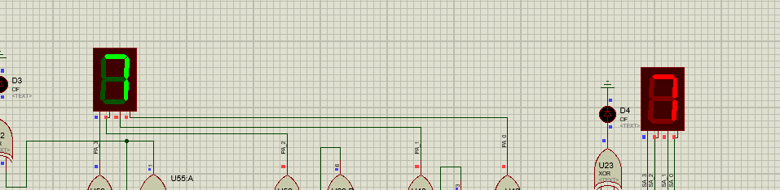
Let BUS_[7..4]=0101，BUS_[3..0]= 0011, M=0 result is:
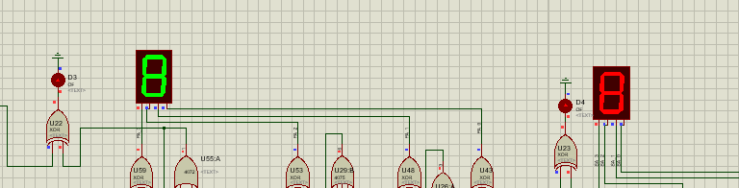

3. Do the same when
(1)BUS_[7..4]=0101，BUS_[3..0]=0011，M=1
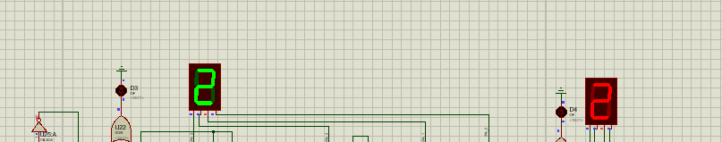
(2)BUS_[7..4]=0011，BUS_[3..0]=0101，M=1
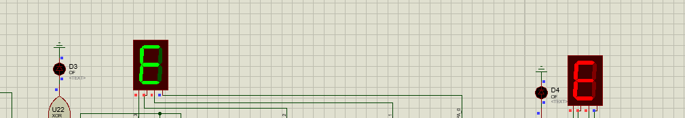
(3)BUS_[7..4]=1101，BUS_[3..0]=0011，M=0
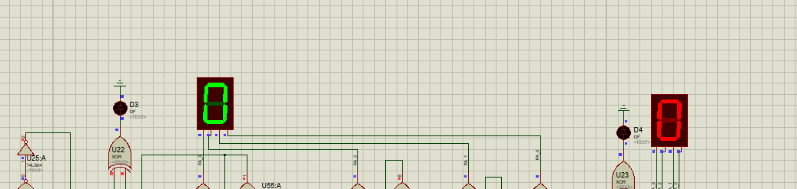
(4)BUS_[7..4]=1101，BUS_[3..0]=0011，M=1
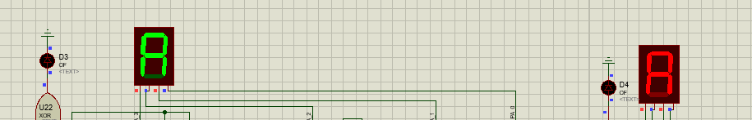
4.Questions:
1. Is this experimental ALU original form or 2’s complement form? Assume we want to modify the circuit into unsigned 4-bit original form ALU, what we need to do?
2’s complement form.

2. In this experiment, what’s the range of the 4-bit 2’s complement code? If we want to modify it into 5-bit 2’s complement ALU(1 bit for sign bit, 4 bits for numbers), how does the range change? How to modify it?
Range[-8,7]. First modify the switcher to 10bits and add a RESPACK-8, 74LS244 LEDS for more bits control. 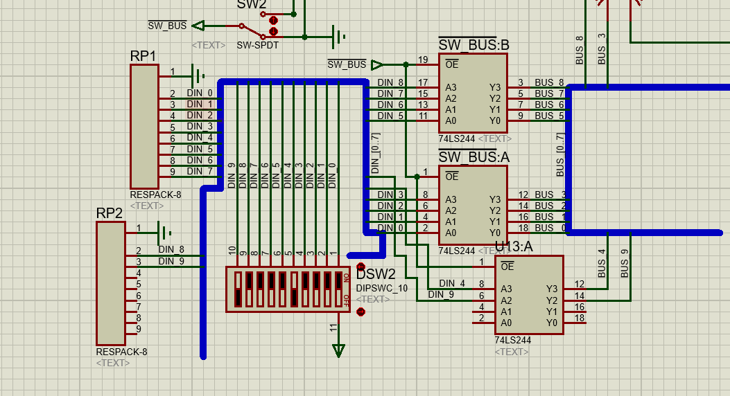 Then modify the circuit, Let BUS_[9..5], BUS_[4..0] to represent two numbers.
For the Serial-Adder: like the picture 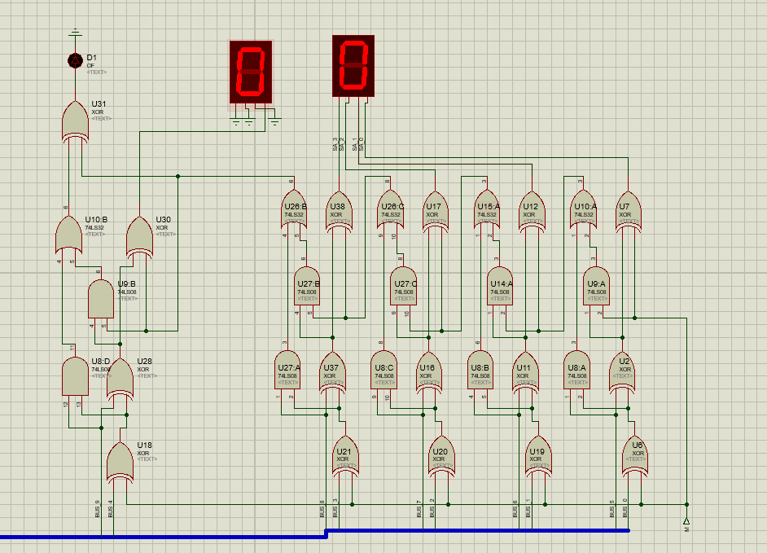
We should add a Full adder to the original circuit to realize the 5 bits adder.
For the Parallel-Adder:
Calculate: C5=Y4+X4C4=Y4+X4Y3 +X4X3Y2+ X4X3X2Y1 +X4X3X2X1Y0 +X4X3X2X1X0C0
Then we can add a C5 circuit with the components of “AND” and ”OR” gates with different pins to construct the circuit to represent the 5th bit of the result.

Conclusion
Teacher’s Comments and Score
Comment：

Score： Signature：
Date：

