South China University of Technology
《Computer Organization and Architecture》Experiment Report
Experiment Title： ALU
Name： 杜喆 Student ID： 202130430379
Class： 21计创 Group：
Collaborator：
Teacher：
Description
【Objective and Requirement】
Objective：
(1) Know the function and component of ALU(74LS181).
(2) Know the implementation of basic arithmetic and logical operation;

Requirement：
Use 74LS181 to excute the signed/unsigned arithmetic and logical operation
【Environment】
Operating System：Windows XP
Content
【Procedure】
1. Step：
a. check status of the following switches: DRA_CLK=DRB_CLK=0,(𝑆𝑊_𝐵𝑈𝑆) ̅=(𝐴𝐿𝑈_𝑂𝐸) ̅=1, (S3,S2,S1,S0,M,CN)=(1,1,1,1,1,1).
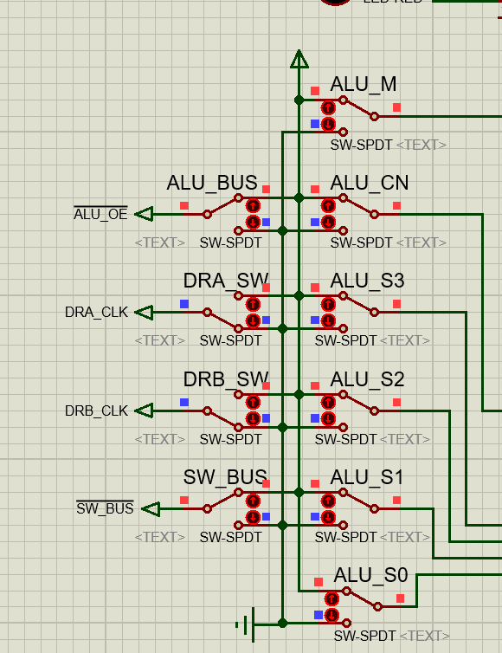
b. When check complete, start simulation and switch DRA_CLK and DRB_CLK to write down 0xAA to data latch register DRA and 0x55 to DRB. Change the control signal set(S3,S2,S1,S0,M,CN), make =0,Observe the output and flags. Record them to the next page’s table to verify the function of 74LS181.
<1>write DRA and DRB

c. Do the same operation to write down 0x7A to DRA and -0x75 to DRB. Observe and record the result.

2. Data：

3. Major Procedure：
a. check status of the following switches: DRA_CLK=DRB_CLK=0,(𝑆𝑊_𝐵𝑈𝑆) ̅=(𝐴𝐿𝑈_𝑂𝐸) ̅=1, (S3,S2,S1,S0,M,CN)=(1,1,1,1,1,1).
b. When check complete, start simulation and switch DRA_CLK and DRB_CLK to write down 0xAA to data latch register DRA and 0x55 to DRB. Change the control signal set(S3,S2,S1,S0,M,CN), make =0,Observe the output and flags. Record them to the next page’s table to verify the function of 74LS181.
<1>write DRA and DRB
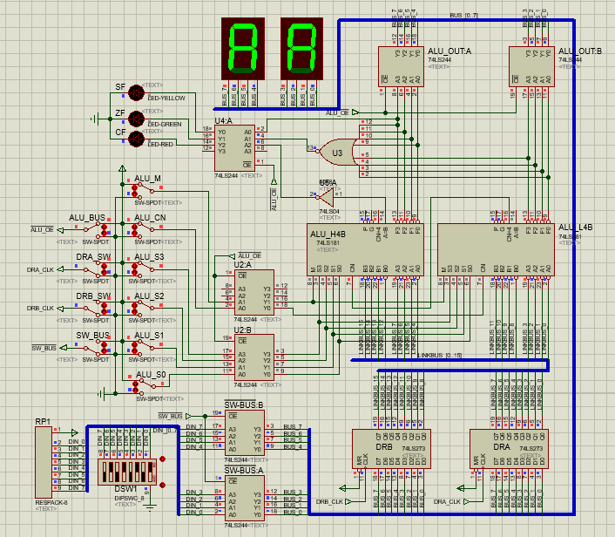
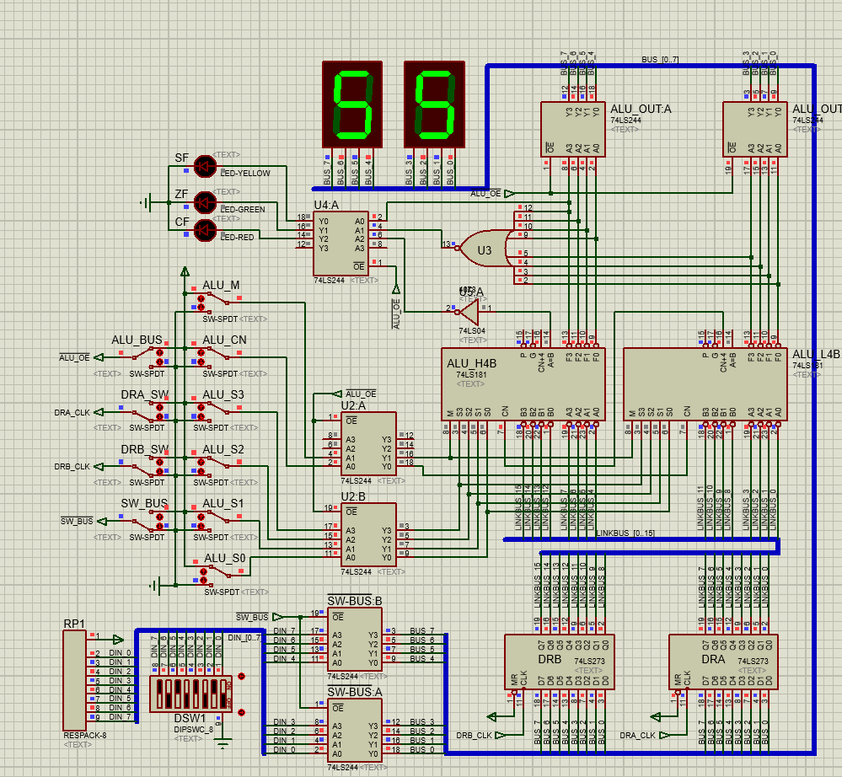
<2>Other result is in the table below.
DRA | DRB | S3 | S2 | S1 | S0 | M=0（算数运算） |  | 标志位  CF/ZF/SF |  | M=1  (逻辑运算)
 |  |  |  |  |  | CN=1无进位 | CN=0 有进位 | CN=1无进位 | CN=0 有进位 | M=1  (逻辑运算)
0xAA | 0x55 | 0 | 0 | 0 | 0 | F=0xAA | F=0xAB | 0/0/1 | 0/0/1 | F=0x55
0xAA | 0x55 | 0 | 0 | 0 | 1 | F=0xFF | F=0x00 | 0/0/1 | 1/1/0 | F=0x00
0xAA | 0x55 | 0 | 0 | 1 | 0 | F=0xAA | F=0xAB | 0/0/1 | 0/0/1 | F=0x55
0xAA | 0x55 | 0 | 0 | 1 | 1 | F=0xFF | F=0x00 | 0/0/1 | 1/1/0 | F=0x00
0xAA | 0x55 | 0 | 1 | 0 | 0 | F=0x54 | F=0x55 | 1/0/0 | 1/0/0 | F=0xFF
0xAA | 0x55 | 0 | 1 | 0 | 1 | F=0xA9 | F=0xAA | 1/0/1 | 1/0/1 | F=0xAA
0xAA | 0x55 | 0 | 1 | 1 | 0 | F=0x54 | F=0x55 | 1/0/0 | 1/0/0 | F=0xFF
0xAA | 0x55 | 0 | 1 | 1 | 1 | F=0xA9 | F=0xAA | 1/0/1 | 1/0/1 | F=0xAA
0xAA | 0x55 | 1 | 0 | 0 | 0 | F=0xAA | F=0xAB | 0/0/1 | 0/0/1 | F=0x55
0xAA | 0x55 | 1 | 0 | 0 | 1 | F=0xFF | F=0x00 | 0/0/1 | 1/1/0 | F=0x00
0xAA | 0x55 | 1 | 0 | 1 | 0 | F=0xAA | F=0xAB | 0/0/1 | 0/0/1 | F=0x55
0xAA | 0x55 | 1 | 0 | 1 | 1 | F=0xFF | F=0x00 | 0/0/1 | 1/1/0 | F=0x00
0xAA | 0x55 | 1 | 1 | 0 | 0 | F=0x54 | F=0x55 | 1/0/0 | 1/0/0 | F=0xFF
0xAA | 0x55 | 1 | 1 | 0 | 1 | F=0xA9 | F=0xAA | 1/0/1 | 1/0/1 | F=0xAA
0xAA | 0x55 | 1 | 1 | 1 | 0 | F=0x54 | F=0x55 | 1/0/0 | 1/0/0 | F=0xFF
0xAA | 0x55 | 1 | 1 | 1 | 1 | F=0xA9 | F=0xAA | 1/0/1 | 1/0/1 | F=0xAA

c. Do the same operation to write down 0x7A to DRA and -0x75 to DRB. Observe and record the result.
DRA | DRB | S3 | S2 | S1 | S0 | M=0（算数运算） |  | 标志位  CF/ZF/SF |  | M=1  (逻辑运算)
 |  |  |  |  |  | CN=1无进位 | CN=0 有进位 | CN=1无进位 | CN=0 有进位 | M=1  (逻辑运算)
0x7A | -0x75 | 0 | 0 | 0 | 0 | F=0x7A | F=0x7B | 0/0/0 | 0/0/0 | F=0x85
0x7A | -0x75 | 0 | 0 | 0 | 1 | F=0xFB | F=0xFC | 0/0/1 | 0/0/1 | F=0x04
0x7A | -0x75 | 0 | 0 | 1 | 0 | F=0x7E | F=0x7F | 0/0/0 | 0/0/0 | F=0x81
0x7A | -0x75 | 0 | 0 | 1 | 1 | F=0x00 | F=0xFF | 0/0/1 | 1/1/0 | F=0x00
0x7A | -0x75 | 0 | 1 | 0 | 0 | F=0xEA | F=0xEB | 0/0/1 | 0/0/1 | F=0xF5
0x7A | -0x75 | 0 | 1 | 0 | 1 | F=0x6B | F=0x6C | 1/0/0 | 1/0/0 | F=0x74
0x7A | -0x75 | 0 | 1 | 1 | 0 | F=0xEE | F=0xEF | 0/0/1 | 0/0/1 | F=0xF1
0x7A | -0x75 | 0 | 1 | 1 | 1 | F=0x6F | F=0x70 | 1/0/0 | 1/0/0 | F=0x70
0x7A | -0x75 | 1 | 0 | 0 | 0 | F=0x84 | F=0x85 | 0/0/1 | 0/0/1 | F=0x8F
0x7A | -0x75 | 1 | 0 | 0 | 1 | F=0x05 | F=0x06 | 1/0/0 | 1/0/0 | F=0x0E
0x7A | -0x75 | 1 | 0 | 1 | 0 | F=0x88 | F=0x89 | 0/0/1 | 0/0/1 | F=0x8B
0x7A | -0x75 | 1 | 0 | 1 | 1 | F=0x09 | F=0x0A | 1/0/0 | 1/0/0 | F=0x0A
0x7A | -0x75 | 1 | 1 | 0 | 0 | F=0xF4 | F=0xF5 | 0/0/1 | 0/0/1 | F=0xFF
0x7A | -0x75 | 1 | 1 | 0 | 1 | F=0xF5 | F=0xF6 | 1/0/0 | 1/0/0 | F=0x7E
0x7A | -0x75 | 1 | 1 | 1 | 0 | F=0xF8 | F=0xF9 | 0/0/1 | 0/0/1 | F=0xFB
0x7A | -0x75 | 1 | 1 | 1 | 1 | F=0x79 | F=0x7A | 1/0/0 | 1/0/0 | F=0x7A

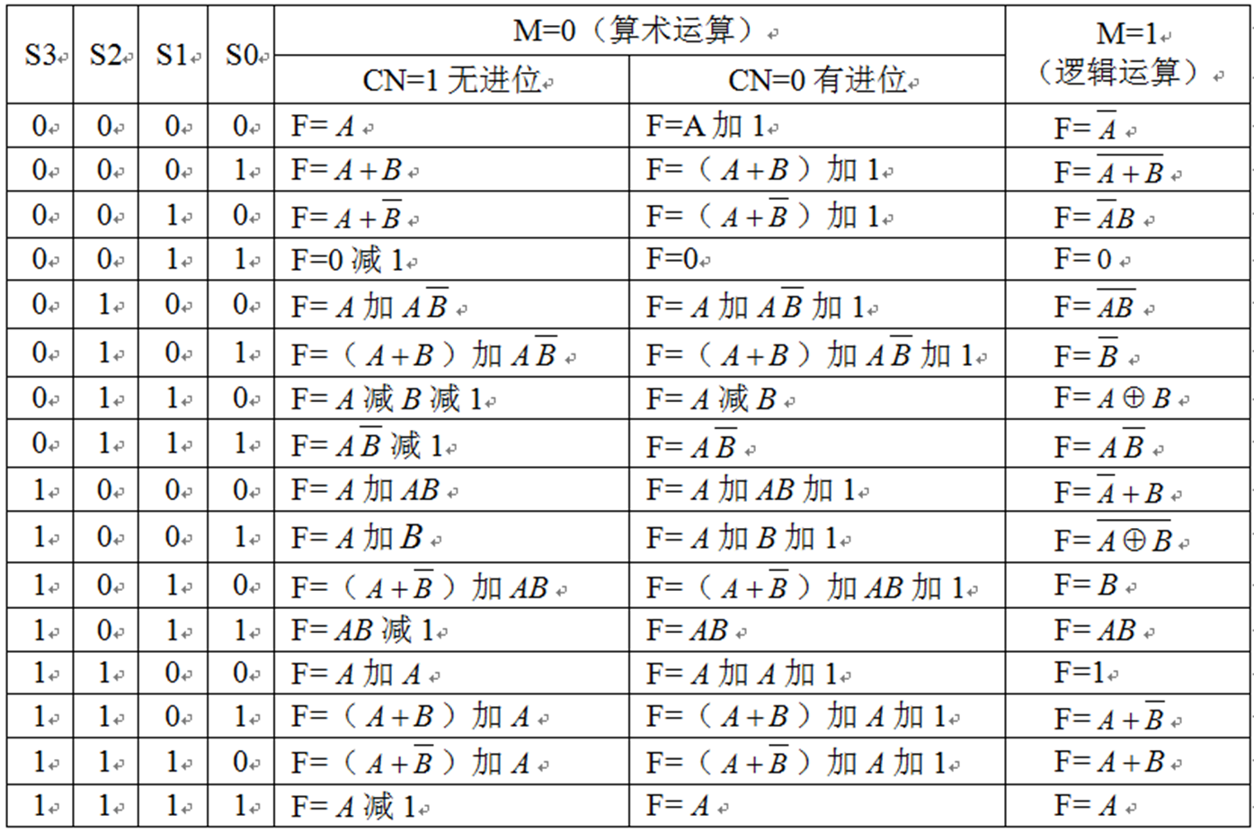
Conclusion
Teacher’s Comments and Score
Comment：

Score： Signature：
Date：

