Task 2 Basic Router Operations

1. Experimental Purposes
（1）Get familiar with Cisco PacketTracer and router
（2）Learn basic router operation command
（3）Static routing

2. Please answer following questions in your lab report

（1） What is router

The router is the piece of network hardware that allows communication between your local home network and other connected devices—and the internet.

A router operates on the Network layer (layer 3) of the OSI model and uses routing tables to understand where traffic is coming from and where it should go.

A router is the first line of security from intrusion into a network.

Routers often act as the DHCP servers in small networks, issuing unique IP addresses.

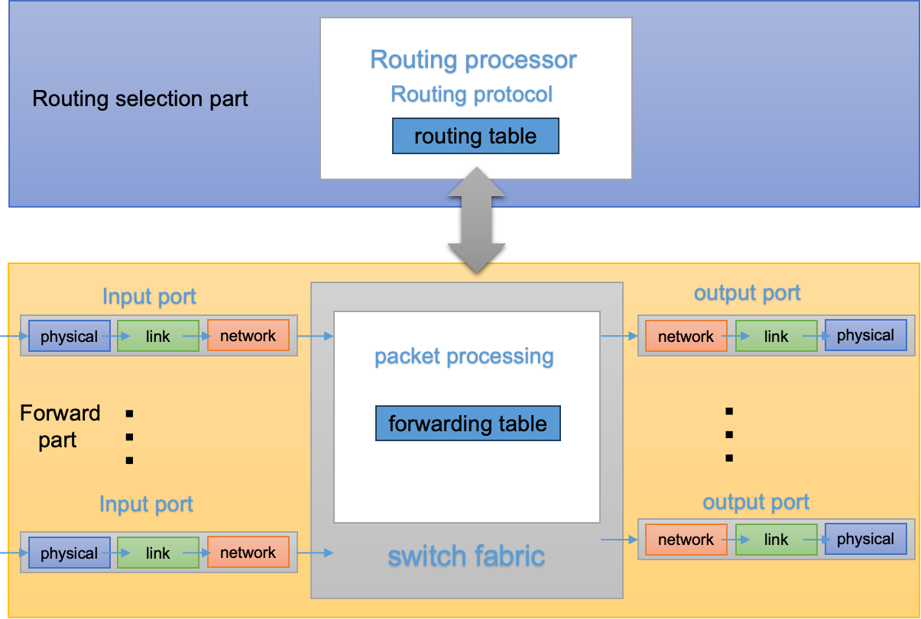
- How can we remotely log onto a router?

Part 1: Turn On remote sharing

First type the router IP or default gateway address in the web browser. Next, enter your username and password. Now, once you are in the router’s web portal, look for the Remote Management option.

Part 2: Setup up Dynamic DNS

A dynamic DNS ensures that your remote access connections can seamlessly integrate with your personal router. There are various dynamic DNS providers in the market today, some of which offer these services for free. For example, there is a free-to-use dynamic DNS and Managed DNS service provider known as NoIP. Once this process is complete, your router should be accessible remotely. All you need to do is to type in your new domain name and then the remote port number.

What tools can be used?
There are many ways to remotely log in to a router, the most common of which is through telnet and SSH modes.In both modes, you need to set a privileged password on the logged in machine, otherwise you cannot enter the privileged mode.
Telnet is a member of the TCP/IP protocol family and is the standard protocol and main mode of remote login service on the Internet. It provides users with the ability to complete remote host work on their local computer. Use the telnet program on the end user's computer and use it to connect to the server. The end user can enter commands in the telnet program, which will run on the server as if they were entered directly on the server's console. You can control the server locally.
SSH is a secure remote login tool based on the TCP protocol, which can encrypt the transmitted data, which is more secure than Telnet. SSH can connect to other computers through the local computer and perform the corresponding operations

- Enter the telnet router IP address/ssh username@router IP address command on the CLI page of the local computer, for example, telnet 192.168.1.1/ssh admin@192.168.1.1.
- Press Enter and try to connect to your router. If the connection is successful, you'll see an output message similar to the following: "Trying 192.168.1.1... Open User Access Verification Password:"/"admin@192.168.1.1's password:".
- Enter the privileged password where you entered it. Note that no characters will be displayed when you enter your password, but the password you enter will be processed correctly.
- If the password is correct, you will successfully log in to the router's privileged mode and will see an output message similar to the following: "Router#".

How could you configure these tools?

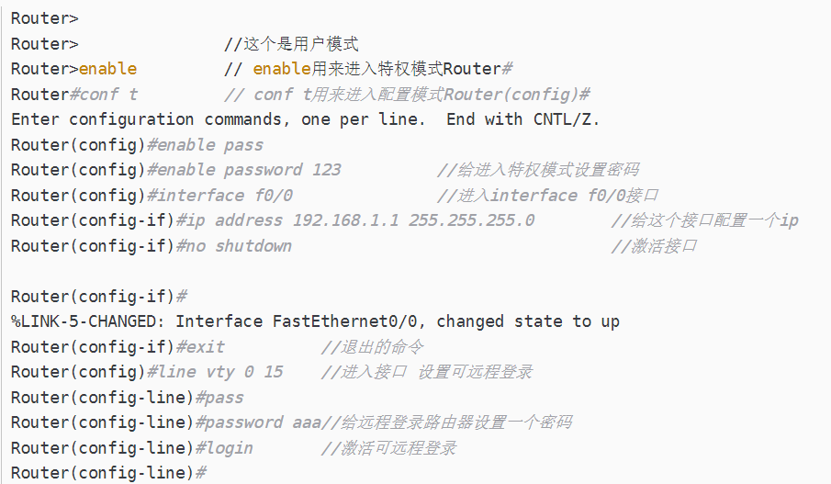

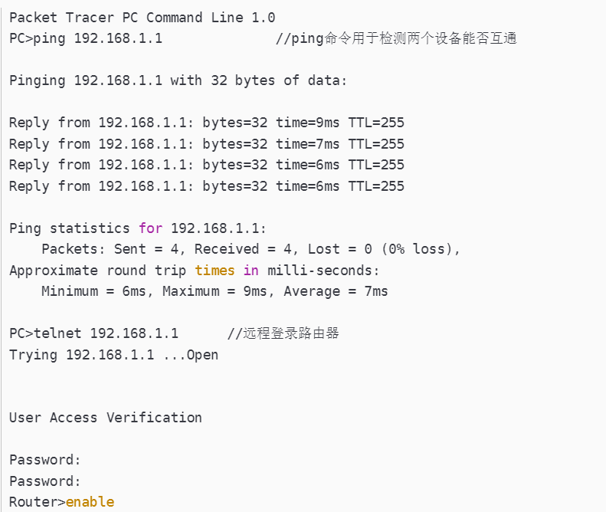
- What are the five working modes of a router?

User execution mode

Prompts

Meaning/function

How can you switch between different modes?
- User EXEC mode (Prompt: Router>):

this mode is limited to some monitoring commands.

The router is in User EXEC mode, where users can view the router's connectivity status, access other networks and hosts, but cannot view or modify the router's configuration settings.

  - Meaning/Function: Provides basic access to the router.
  - Switching: Use exit in other mode or the first time enter the router

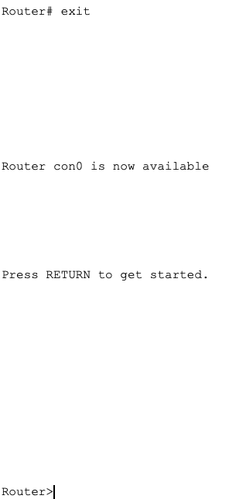
- Privileged EXEC mode (Prompt: Router#):

Privileged mode is the highest level command mode in Cisco routers.

By entering the "enable" command in user EXEC mode, you can access privileged EXEC mode.

In this mode, you can execute privileged operations such as viewing router configurations, running diagnostic commands,
  - Meaning/Function: Allows access to all router commands.
  - Switching: Enter by typing Router> and then enable.

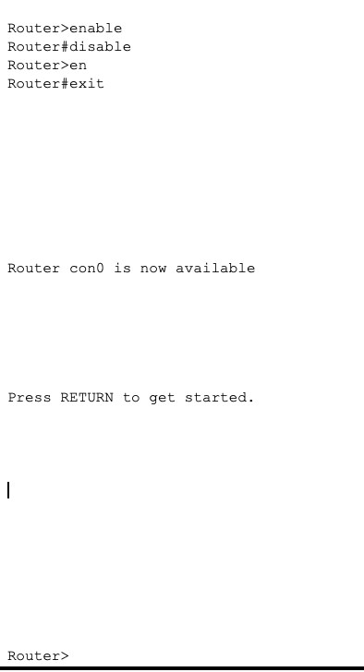
- Global Configuration mode (Prompt: Router(config)#):
  - Meaning/Function: Used for configuring global parameters.
  - Switching: Enter from Privileged EXEC mode by typing Router# configure terminal.

Global Configuration mode is the primary command mode for configuring the router.

To enter global configuration mode, you use the "configure terminal" command in privileged mode.

In this mode, you can configure various aspects of the router, including network interfaces, routing protocols, access control lists (ACLs), security settings, and more. All configuration changes made in this mode affect the entire router.

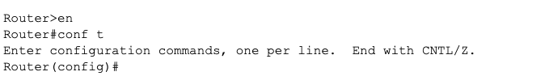
- Interface Configuration mode (Prompt: Router(config-if)#):
  - Meaning/Function: Used for configuring specific interface parameters.
  - Switching: Enter from Global Configuration mode by typing Router(config)# interface <interface_type> <interface_number>.

Interface Configuration mode is used to configure specific network interfaces on the router.

To enter interface configuration mode, you use the "interface <interface name>" command (e.g., "interface e0/0") in global configuration mode.

In this mode, you can configure parameters related to the specified interface, such as IP address, subnet mask, maximum transmission unit (MTU), speed, protocols, and more.

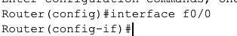

Line Configuration mode is used to configure specific lines (such as console, virtual terminal, auxiliary) on the router.

To enter line configuration mode, you use the "line <line type> <line number>" command (e.g., "line console 0") in global configuration mode.

In this mode, you can configure settings for the specified line, such as setting passwords, controlling access, configuring logging, and more.

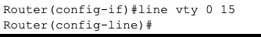
（4） Describe the steps/commands of setting IP address on a router interface
（5）Explain how ‘show’ command can be applied to
obtain router information
interface information/configuration
- Describe how routing entries can be manually configured.

- Experimental Environment

（1）Network topology (for example)
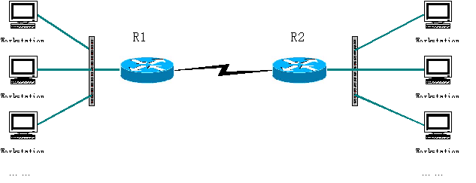
（2）Experiment devices
Two routers, two switches (optional), two PCs and cables.
（3）Experiment requirements
Given 3 C-class Network addresses: 192.168.1.0，192.168.2.0，192.168.3.0. (Just for example. You can design the networks as you like.)
- Using the above topology to design network, explain the address for each node and interface.
Please describe the commands/steps to configure these IP addresses
- Using static routing, to enable the workstations to communicate with each other.
Explain the routing entries on each router
Explain the commands/steps to configure routing entries

