Task 3 Networking

1. Experimental Purposes
（1）RIP configuration
（2）OSPF configuration

2. Experimental Environment
（1）Network topology (for example)
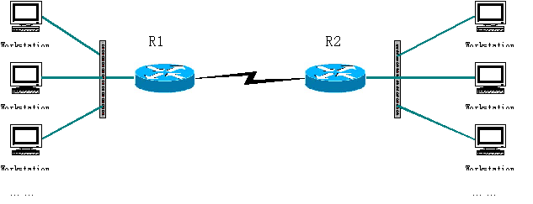
（2）Experiment devices
Two routers, two switches (optional), two PCs and cables.
（3）Experiment requirements
Given 3 C-class Network addresses: 192.168.1.0，192.168.2.0，192.168.3.0. (Just for example. You can design the networks as you like.)
- Using the above topology to design network, explain the address for each node and interface.
- Using RIP, to enable the workstations to communicate with each other.
Explain RIP
Explain the commands/steps to configure dynamic routing
- Using OSPF routing, to enable the workstations to communicate with each other.
Explain OSPF
Explain the commands/steps to configure dynamic routing

（4）Testing and confirmation
How can you test and confirm that the network is working fine?

