South China University of Technology
《Software Engineering》Experiment Report
Experiment Title： Pothole tracking and repair system
Name 资琛义 Student ID： 201936234280
Class： 19计联 Group：
Collaborator： 喻琰
Teacher： 李剑
Description
【Objective and Requirement】
Problem Description:
The department of public works for a large city has decided to develop a on-line pothole tracking and repair system (PHTRS). A description follows:
- Citizens can log onto this system and report the location and severity of potholes. As potholes are reported they are logged within a “public works department repair system” and are assigned an identifying number, stored by street address, size (on a scale of 1 to 10), location (middle, curb, etc.), district (determined from street address), and repair priority (determined from the size of the pothole).
- Work order data are associated with each pothole and includes pothole location and size, repair crew identifying number, number of people on crew, equipment assigned, hours applied to repair, hole status (work in progress, repaired, temporary repair, not repaired), amount of filler material used and cost of repair (computed from hours applied, number of people, material and equipment used). Finally, a damage file is created to hold information about reported damage due to the pothole and includes citizen's name, address, phone number, type of damage, dollar amount of damage. PHTRS is an on-line system; all queries are to be made interactively.
Requirements:
- Development: Implement a prototype of PHTRS system
- Include user interfaces and one function
- Implemented in Ruby (Rails) or other object-oriented programming languages (or Java, C++)
- Object-oriented
- MVC(Model-View-Controller) architecture pattern
- Test:
- Draw a graph to show the structure (execution) of a selected procedure in your program (or your Ruby program).
- Compute the complexity of this procedure according to the structure graph
- Test case design: Design test case for the selected procedure
- Should cover all statements (or methods) of the procedure
- Every branch should be exercised for true and false conditions
- List inputs and corresponding execution paths
【Environment】
Windows 10
Content
【Procedure】
Finish posting and storing reported damage due to the pothole and includes citizen's name, address, phone number, type of damage, dollar amount of damage. PHTRS is an on-line system; all queries are to be made interactively.

MVC
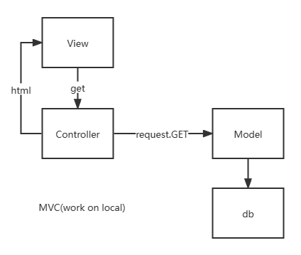
- Major Procedure：
Connect to db:
DATABASES = {
'default':
{
'ENGINE': 'django.db.backends.mysql', # 数据库引擎
'NAME': 'mydb', # 数据库名称
'HOST': '127.0.0.1',
'PORT': 3306, # 端口
'USER': 'user1', # 数据库用户名
'PASSWORD': 'root123', # 数据库密码
}
}
Url:
urlpatterns = [
path('', views.runmain),
path('search/', testdb.testdb),
]
Views
def runmain(request):
views_name = "http://127.0.0.1:8000/runoob"
return render(request,"mainhtml.html", {"web1": views_name})
Html:
<form action="/search" method="get">
<label>name</label>
<input type="text" name="1" >
<br>
<label>address</label>
<input type="text" name="2" >
<br>
<label>phone number</label>
<input type="text" name="3" >
<br>
<label>type of damage</label>
<input type="text" name="4" >
<br>
<label>dollar amount of damage</label>
<input type="text" name="5" >
<br>
<input type="submit" value="submit">
</form>
Function testdb():
def testdb(request):
request.encoding = 'utf-8'
test1 = Test(name=request.GET['1'], address=request.GET['2'], phone=request.GET['3'], type=request.GET['4'], dollar=request.GET['5'])
test1.save()
return HttpResponse("<p>数据添加成功！</p>")
Model test:
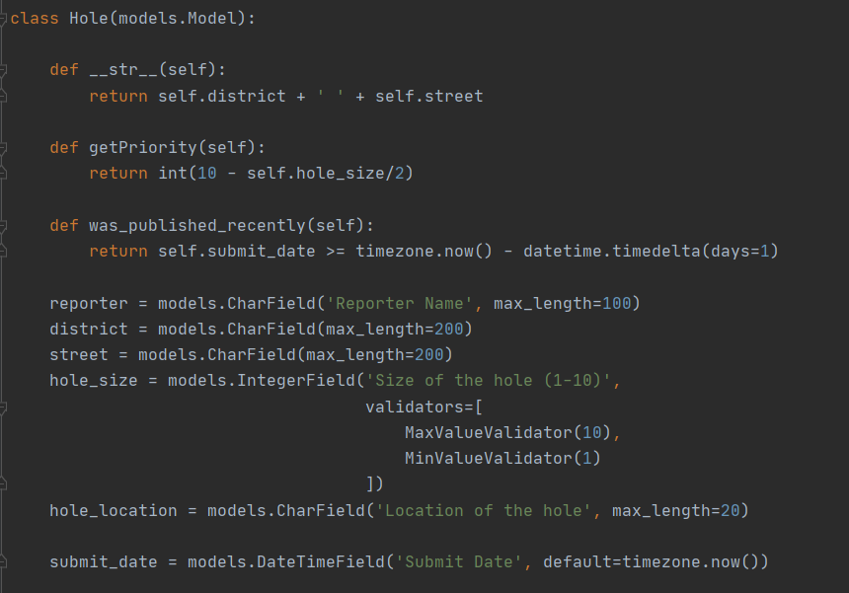
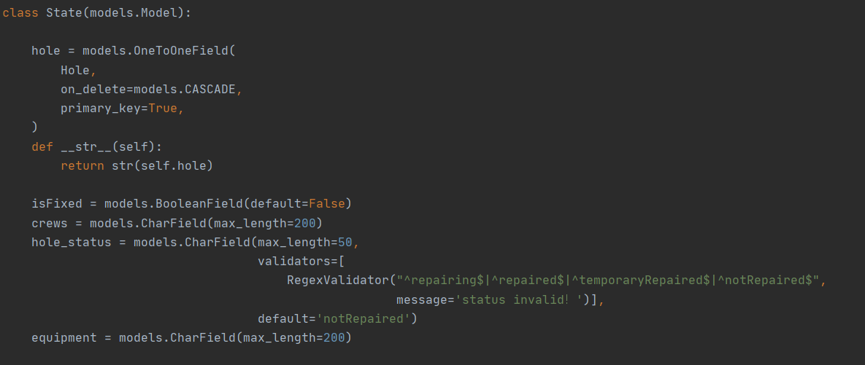

Test:
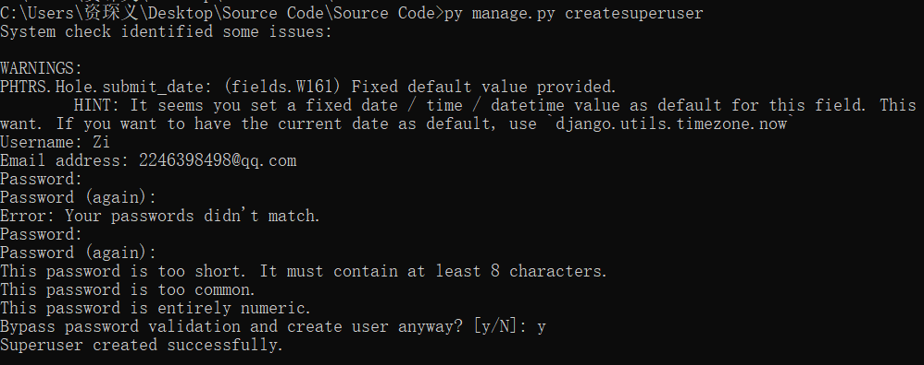
Then put py manage.py runserver in command
Get into
http://localhost:8000/admin/PHTRS/hole/
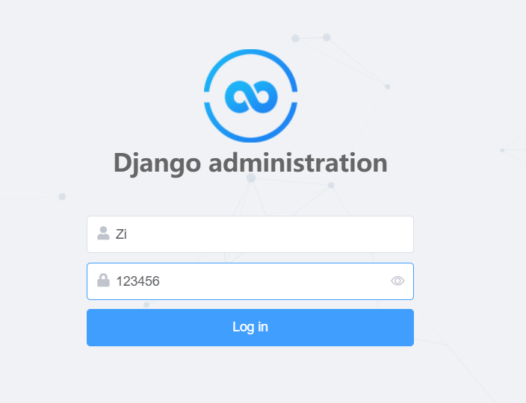
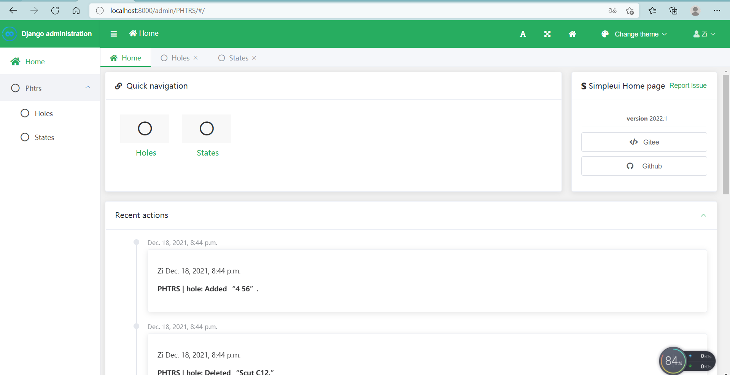

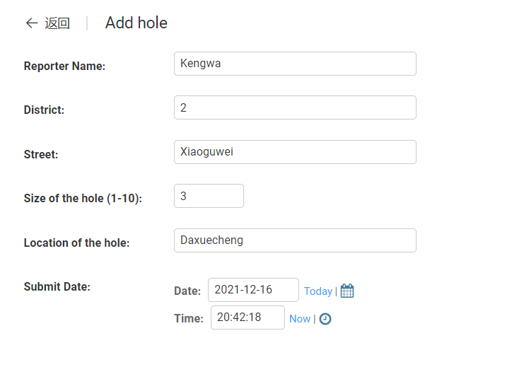
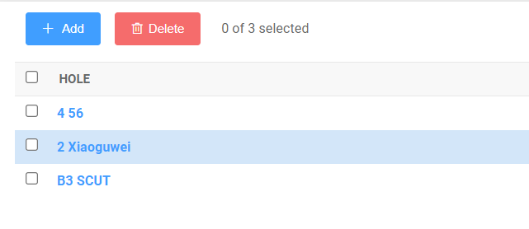
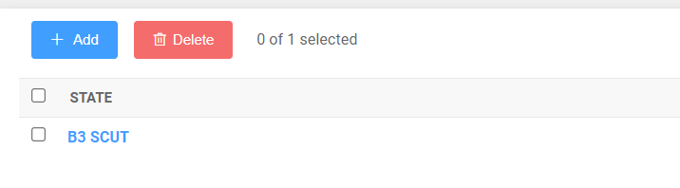

Result is as below
Conclusion
From this lab session we ‘ve learned how to implement a prototype of a system from given description and design test cases based on the functions and structure of the software then apply these test cases on the software testing and show the testing results. This process meaningfully enhances our understanding of the designation of prototype and test case.It is based on django, And I use the simpleui to make the whole web beautyful.
Teacher’s Comments and Score
Comment：

Score： Signature：
Date：

