Experiment Report Template
South China University of Technology
《Course》Experiment Report
Experiment Title：
Name： 罗仲君 Student ID： 200630472165
Class： 06计科(2)班 Group：
Collaborator：
Teacher：
Description
【Objective and Requirement】
Objective：
Description of the Problem:
In the hospital ward, symptom monitors are placed at each bedside to monitor patients. These monitors transmit real-time symptom signals (aggregated) to the central monitoring system for analysis and processing. In the central duty room, the duty nurse uses the central monitoring system to monitor the condition of patients. The monitoring system continuously compares and analyzes the patient's symptom signals with standard diagnostic signals in real-time. When symptoms deviate from the norm, the system automatically raises an alarm, prints a medical condition report, and updates the medical records. The system can print patient medical condition reports at any time upon the doctor's request, and it also automatically updates medical records on a regular basis.
Simple Requirement Analysis Overview:
1. The symptom monitor can collect symptom signals (aggregated), format them, and transmit them in real-time to the central monitoring system.
2. The central monitoring system compares the patient's symptom signals with the normal values of symptoms in the standard symptom signal library. The system automatically raises an alarm when symptoms deviate from the norm.
3. In the event of abnormal symptom signals, the system automatically updates the medical records and prints a medical condition report.
4. Duty nurses have the ability to view and print medical condition reports.
5. Doctors can view medical condition reports, request the printing of reports, and also have the option to view or request the printing of complete medical records.
6. The system performs regular automatic updates to the medical records.
Requirement：
- Draw a use case diagram for the monitoring system.To show the monitoring system’s functions and how it interacts with external entities.Should be drawn in the form of “Use case diagram”in Rational Rose
- Draw a block diagram of a possible architecture for such a system. Should identify the principal sub-systems and the links between them. Should be drawn in the form of Packages in “Class diagram” in Rational Rose (Packages and components)
- Draw a sequence diagram for the Monitoring System.To show the process of Monitoring. Should be drawn in the form of “sequence diagram” （顺序/时序图） in Rational Rose
- Draw a state machine diagrams for the Monitoring System. Show the states and state transitions of monitoring system. Should be drawn in the form of “state machine diagram” in Rational Rose
- Draw a class diagram for the Monitoring System. Identify the main classes in the monitoring system. Identify the relationships between classes. Should be drawn in the form of “class diagram” in Rational Rose

【Environment】
Operating System：Windows XP
Content
【Procedure】
- Step：
After analyzing the requirement, we identified 4 main actors and its responsibilities and requirement supporting.
- Patient: Provide symptom signals(Generate and convey timed symptom signals ).
- Doctor: Take care of paitients and deal with symptoms deviation. Need the monitor system supporting to finish the tasks. Be intersted in the monitor system running results.
- Nurse: Monitor the patients’ symptoms changing. Need to use the monitor system’s main funtcions. Be intersted in the monitor system running results.
- Standard Symptom Signal Library: Provide normal symptom’ signals. Should keep the system work normally. Interate with the systems.

Then we also need some classes and functions to help us develop the system.
- Central Monitor
Decompose the sigals: Decompose the aggregated symptom signals transmitted from the symptom monitor into signals that the system can process.
Compare signals: Compare the patient's symptom signals with standard signals.
Alarm: If the symptom signals deviate from the normal range, specifically exceeding the peak value, an alarm signal is triggered.
Format Symptom Signals: Format the processed data for writing into the medical records database.
- Symptom Monitor
Symptom Signal Acquisition: Collect the symptom signals from the patient.
Analog-to-Digital Conversion: Convert the collected analog signals into digital signals.
Symptom Signal Aggregation: Combine the collected signals data, such as pulse and blood pressure, into a set of signal data
Change Sampling Frequency: Adjust the monitor's sampling frequency based on the patient's condition.
- Medical Record:
Generate Medical Record
Update Medical Record
Display Medical Record
Print Medical Record
- Medical Reprot:
Display Medical Record
Print Medical Record: Print the medical condition report on the printer.

- Major Procedure：
Use Case Diagram
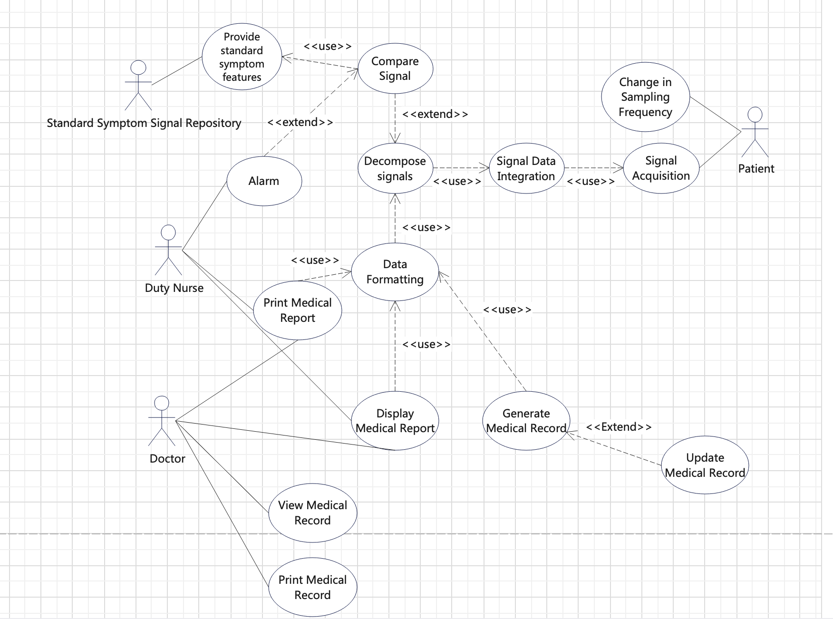

Class Diagram
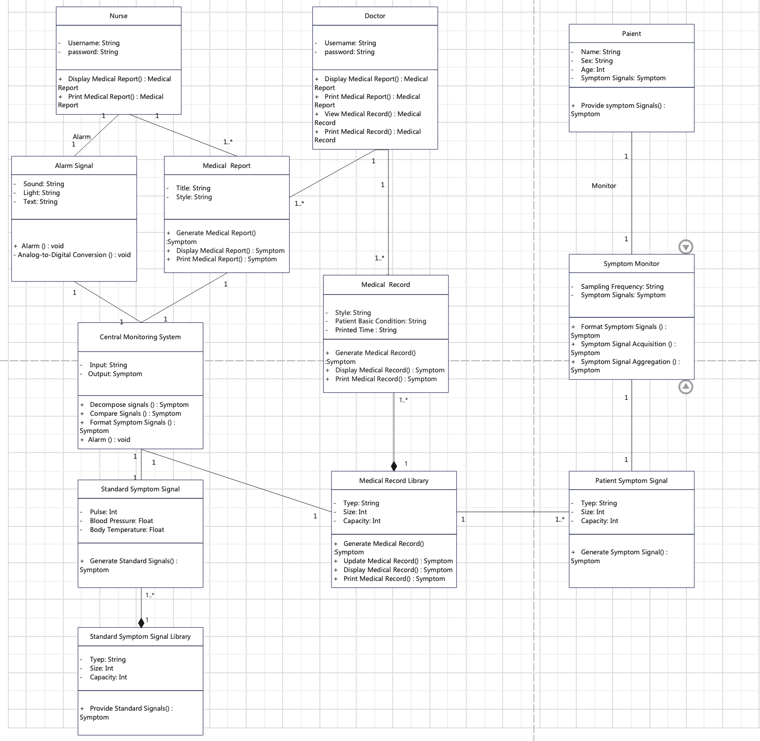

Conclusion
Teacher’s Comments and Score
Comment：

Score： Signature：
Date：

