South China University of Technology
《Software Engineering》Experiment Report
Experiment Title： Pothole tracking and repair system
Name： 杨竣尧/谭演锋 Student ID： 202130442068/202130100456
Class： 21计联 Group： /
Collaborator： /
Teacher： 李剑
Description
【Objective and Requirement】
Objective：
The public works department of a large city is embarking on the development of an online Pothole Tracking and Repair System (PHTRS). The system allows citizens to log in and report potholes, specifying the location and severity. As potholes are reported, they are recorded in a "Public Works Department Repair System" and assigned a unique identifier. The system stores information such as street address, size (rated on a scale of 1 to 10), location (middle, curb, etc.), district (derived from the street address), and repair priority (determined by the size of the pothole).
Each reported pothole is associated with work order data, including details such as pothole location and size, repair crew identification, crew size, assigned equipment, repair hours, hole status (work in progress, repaired, temporarily repaired, not repaired), amount of filler material used, and repair cost (calculated from hours applied, crew size, materials, and equipment used). Additionally, a damage file is created to store information about reported damages caused by the pothole. This file includes the citizen's name, address, phone number, type of damage, and the dollar amount of damage. PHTRS operates as an online system, and all queries are conducted interactively.

Requirement：
- Development: Implement a prototype of PHTRS system
- Include user interfaces and one function
- Implemented in Ruby (Rails) or other object-oriented programming languages (or Java, C++)
- Object-oriented
- MVC(Model-View-Controller) architecture pattern
- Test:
- Draw a graph to show the structure (execution) of a selected procedure in your program (or your Ruby program).
- Compute the complexity of this procedure according to the structure graph
- Test case design: Design test case for the selected procedure
- Should cover all statements (or methods) of the procedure
- Every branch should be exercised for true and false conditions
- List inputs and corresponding execution paths

【Environment】
Operating System：Windows 10
Content
【Procedure】
Finish posting and storing reported damage due to the pothole and includes citizen's name, address, phone number, type of damage, dollar amount of damage. PHTRS is an on-line system; all queries are to be made interactively.

The implementation of MVC:
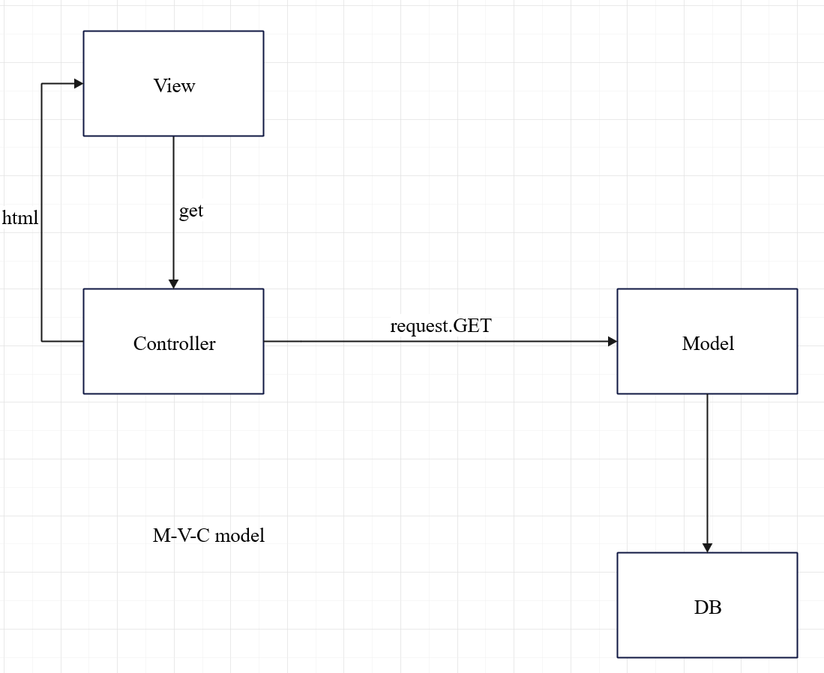

- Model:
  - Manages pothole data, including locations, statuses, and repair priorities.
  - Handles business logic and interacts with the database for data consistency.
- View:
  - Presents the user interface, displaying pothole information and a map of pothole locations.
  - Allows users to report new potholes, update information, and view repair progress.
- Controller:
  - Acts as an intermediary, processing user inputs from the View and updating the Model accordingly.
  - Enforces business logic and ensures consistency between the Model and View.

- Major Procedure：

Connect to db:
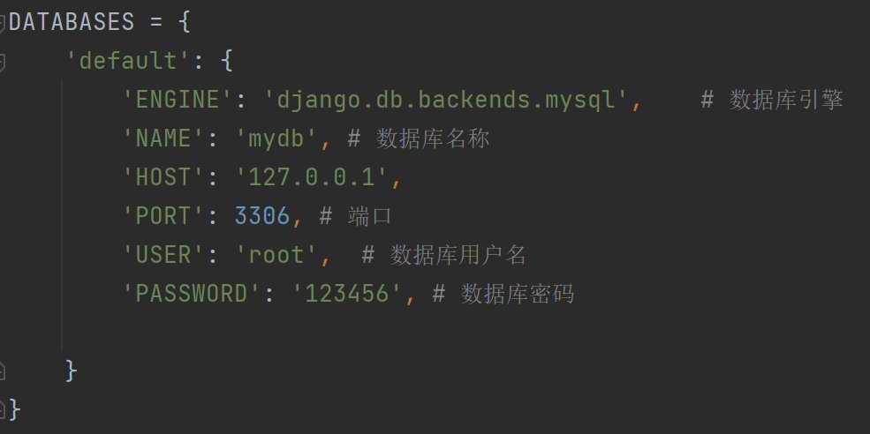
Fig
This configuration is a part of Django's settings and it defines the connection details for project's default database. The explanation of parameters:
- ENGINE: Specifies the database engine. In this case, it's set to 'django.db.backends.mysql', indicating the use of MySQL.
- NAME: Specifies the name of the database. In this case, it's set to 'mydb'.
- HOST: Specifies the database server's address. Here, it's set to '127.0.0.1', which is the loopback address or localhost, meaning the database is on the same machine.
- PORT: Specifies the port on which the database server is running. In this case, it's set to 3306, which is the default port for MySQL.
- USER: Specifies the username to be used when connecting to the database. Here, it's set to 'user1'.
- PASSWORD: Specifies the password associated with the username for database access. In this case, it's set to 'root123'.
This configuration allows your Django application to connect to a MySQL database with the specified credentials. Once these settings are in place, you can run Django management commands like python manage.py migrate to create database tables and python manage.py runserver to start the development server.
Url:
Use the following code to implement URL patterns in file urls.py
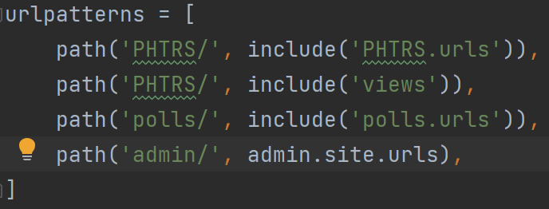

Here's an explanation of each line:
- path('', views.runmain): This maps the root URL ('/') to the runmain function in the views module. When a user accesses the root URL of your Django application, the runmain function in the views module will be invoked.
- path('search/', testdb.testdb): This maps the URL 'search/' to the testdb function in the testdb module. When a user accesses the 'search/' URL of your Django application, the testdb function in the testdb module will be invoked.
In Django, the urlpatterns list is used to define the mapping between URLs and views. Each path() function takes two arguments:
- The first argument is the URL pattern.
- The second argument is the view function or class that should be called when the corresponding URL is accessed.
Make sure that the views.runmain and testdb.testdb functions are defined in their respective modules (views and testdb). Also, ensure that these modules are imported at the beginning of your urls.py file.

Views
There are two basic interfaces of the websites and they are integrated in the file ‘views.py’.
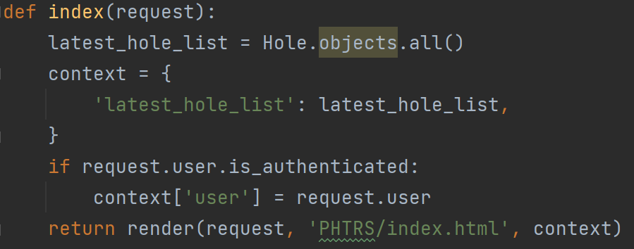

The Index function:
Handle home page requests.
Get all Hole objects and pass them to the template.
If the user is logged in, add the user object to the context.
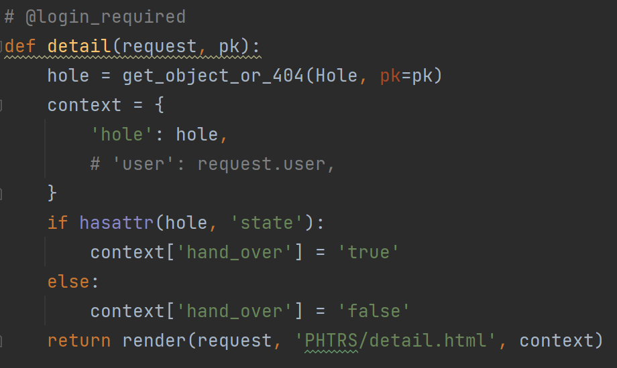

The detail function:
Processing detailed information requests for specific Hole objects.
Obtains the Hole object corresponding to the specific primary key and passes it to the template.
Depending on whether the object has a 'state' attribute, set the 'hand_over' context value to 'true' or 'false'.
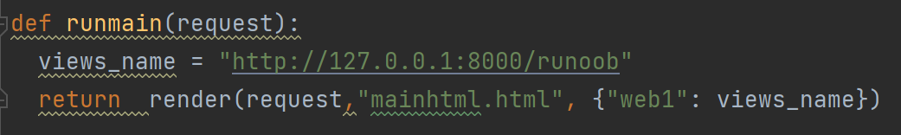

Html: use html to implement the website front page
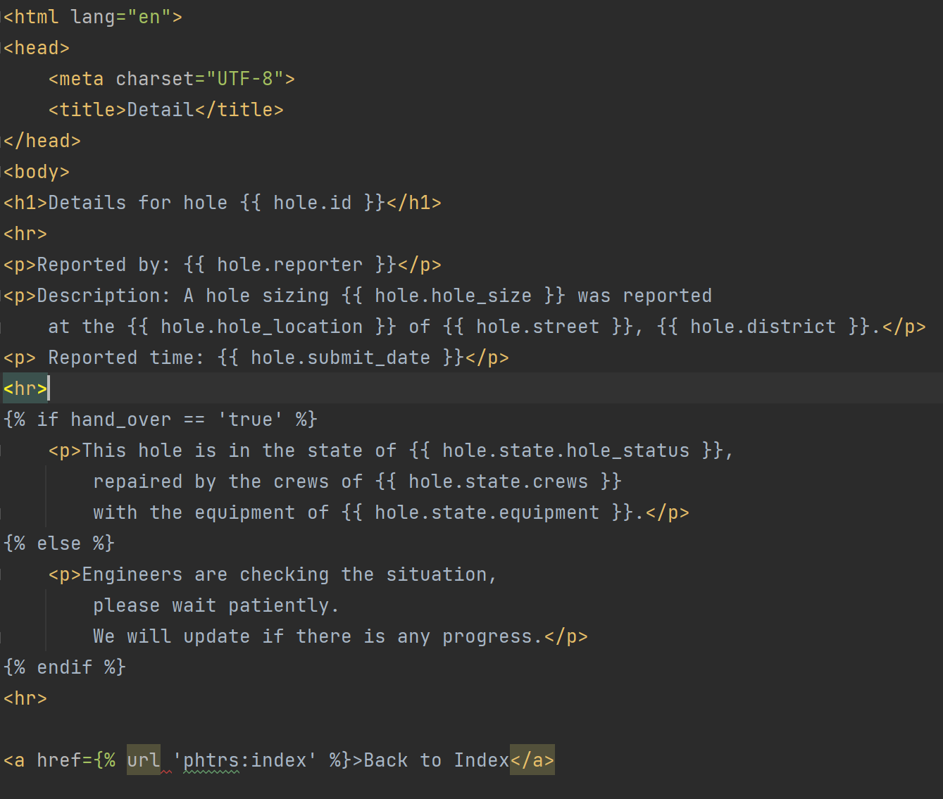

Function testdb():
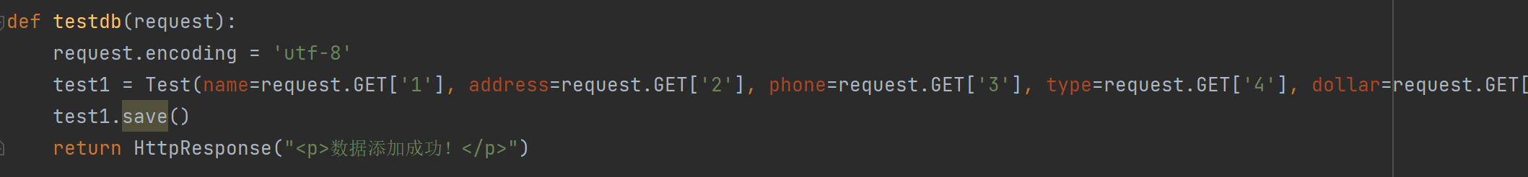

Model test:
- Hole Class:
  - Represents information about a pothole, including reporter name, district, street, hole size, location, and submission date.
  - Defines methods for a custom string representation (__str__), calculating priority based on hole size (getPriority), and checking if the pothole was reported recently (was_published_recently).
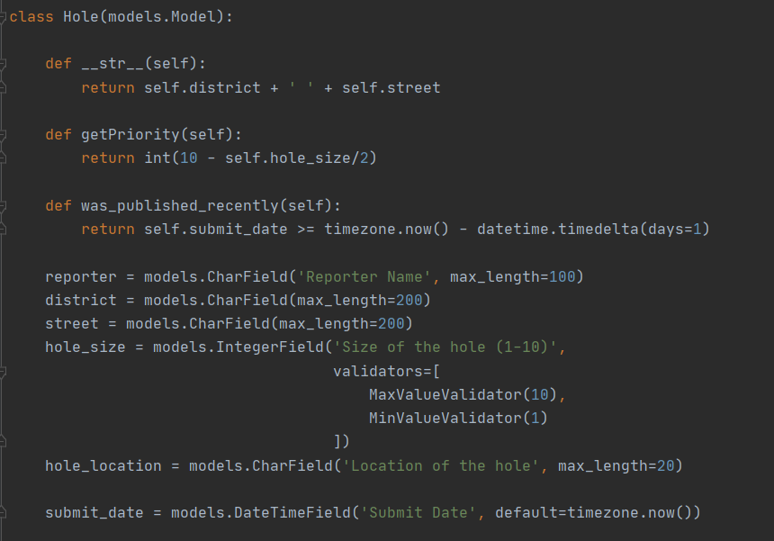

- State Class:
  - Represents the state of a pothole, including whether it's fixed (isFixed), assigned crews, current status, and equipment used for repair.
  - Has a one-to-one relationship with the Hole class, serving as the primary key.
  - Defines a method for a custom string representation (__str__).
These classes are designed for a Pothole Tracking and Repair System (PHTRS) and are implemented using Django's model system for database interaction.
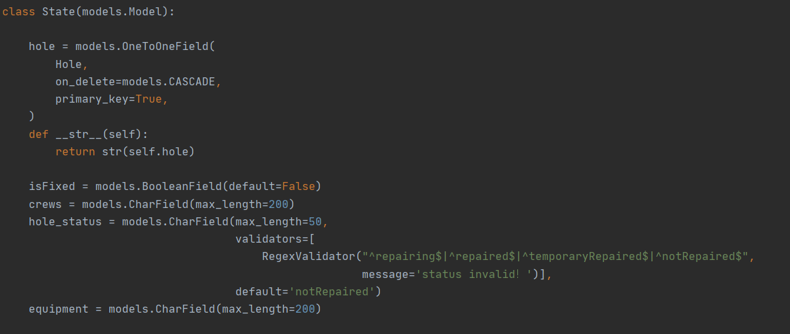

Draw the activity Diagram for PHTRS:
For example, take the most important function of the system: add the hole as an example. The activity diagram is show as follows: First we need to click on the report button on the website. Then click on ‘Add’ hole button. After that the system will judge if there is any damage. Then the user need to fill up the addresses and other information for the hole report.
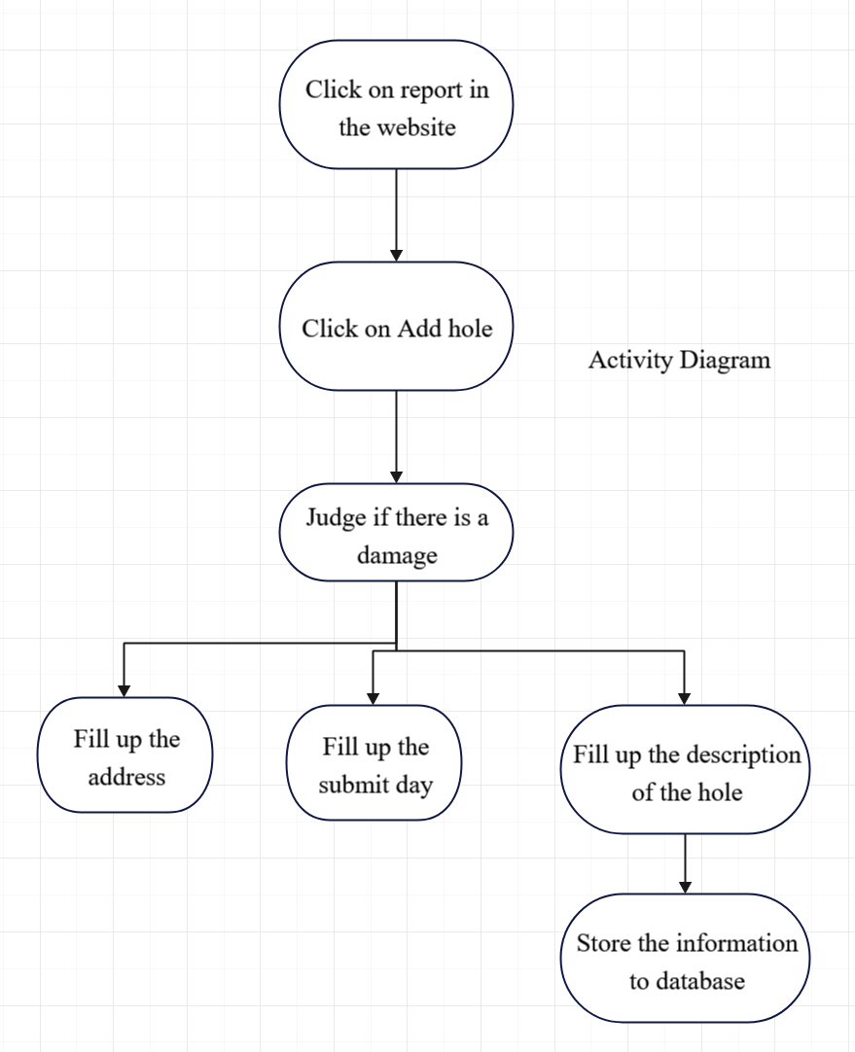

Test of the system:
Certainly, let's consider a specific procedure within the Pothole Tracking and Repair System (PHTRS) for the purpose of designing test cases.
Assume we have a procedure that updates the status of a reported pothole. The procedure takes the pothole ID and the new status as parameters. The goal is to design test cases that cover different scenarios.
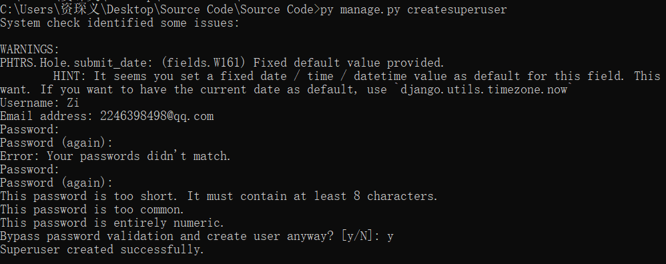

Then in the command prompt type the command “py manage.py runserver”, in order to run the program.
Get into
http://localhost:8000/admin/PHTRS/hole/
Then in the website there is a screen showing the information that you need to login.
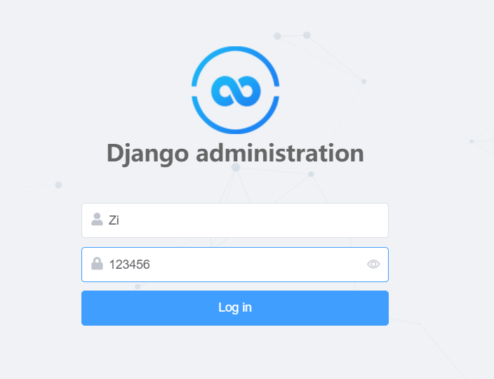
After login, the simpleui in the website allows the administrator to view all for the holes that the users have reported. Namely the administrator can know the addition and deletion of the holes.
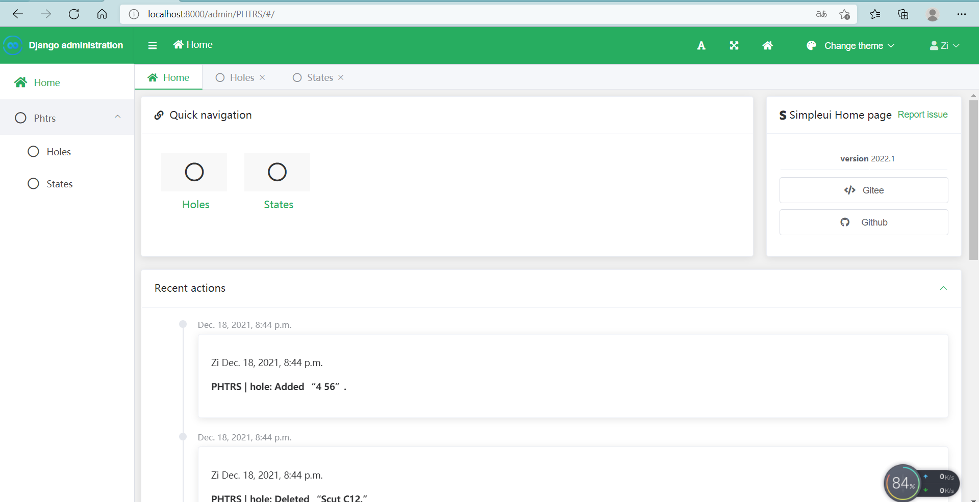

Then in the detail.html, the form on the website allows user to add holes
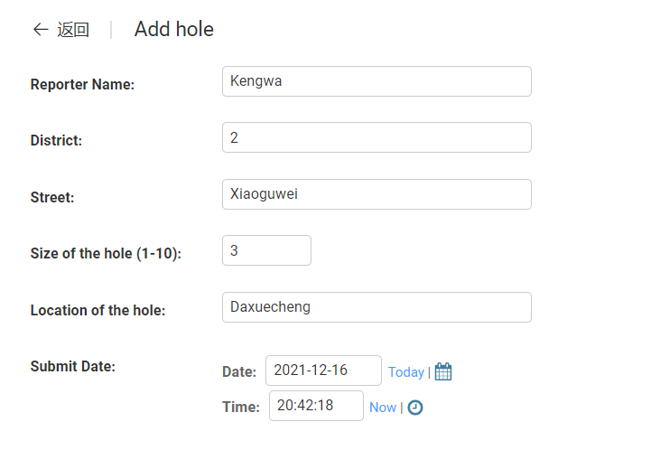
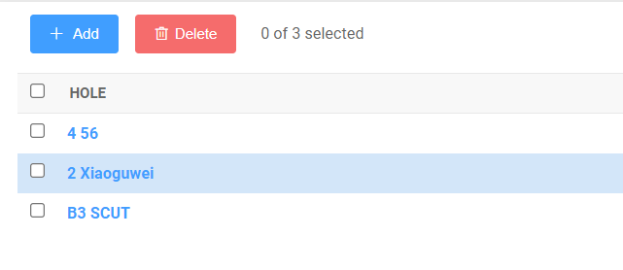
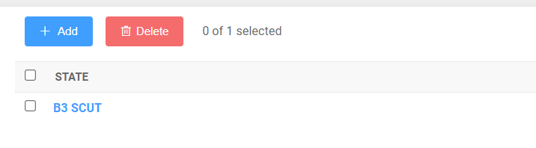

Result is as below
Conclusion
Teacher’s Comments and Score
Comment：

Score： Signature：
Date：

