

Computer Networks

Lab Report

Name ：谭演锋

Student ID ：202130100456

Class ：计算机全英联合班

Collaborator(s) :

# Task 2 Basic Router Operations & static Routing

**1. Experimental Purposes**

（1）Get familiar with Cisco PacketTracer and router

（2）Learn basic router operation command

（3）Static routing

**2. Please answer following questions in your lab report**

**（1） What is router**

The router is the piece of network hardware that allows communication between your local home network and other connected devices—and the internet.A router operates on the Network layer (layer 3) of the OSI model and uses routing tables to understand where traffic is coming from and where it should go.A router is the first line of security from intrusion into a network. Routers often act as the DHCP servers in small networks, issuing unique IP addresses.

Following is the struture of Router. It is consturcted by 2 parts: Routing selection part and Foward part. Routing selection part constructs a routing table based on the selected routing protocol, and regularly or periodically exchange routing information with neighboring routers to continuously update and maintain the routing table. In foward part, forwading table is decued by routing table. Then Router wil select input port with coresponding output port according to forward table.

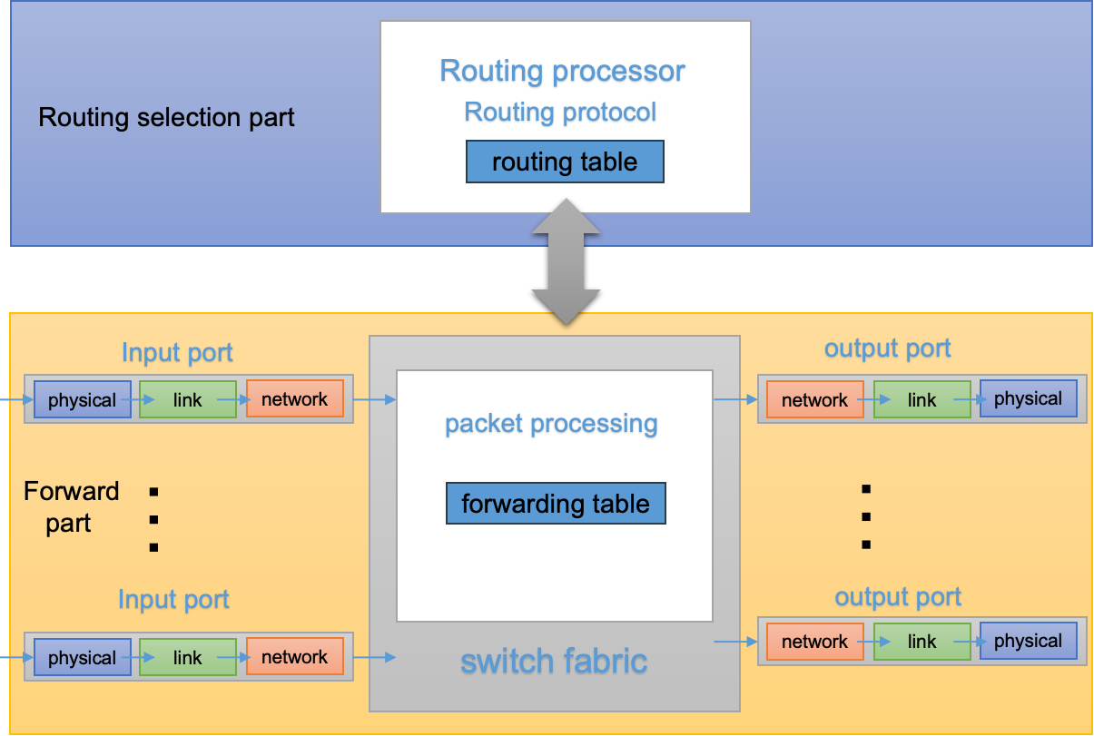

figure1: Struture of Router

1. **How can we remotely log onto a router?**

What tools can be used?

We can use SSH or Telnet to loh onto a router

Telnet is a member of the TCP/IP protocol family and is the standard protocol and main mode of remote login service on the Internet. It provides users with the ability to complete remote host work on their local computer. Use the telnet program on the end user's computer and use it to connect to the server. The end user can enter commands in the telnet program, which will run on the server as if they were entered directly on the server's console. You can control the server locally. For example we can use the command “Telnet IP address” to connect the router.

Following is the examole using telnet log on Router, the Router IP address is 192.168.1.1. “Open” means successfully connection.



figure2: Use telnet connect the of Router

SSH is a secure remote login tool based on the TCP protocol, which can encrypt the transmitted data, which is more secure than Telnet. SSH can connect to other computers through the local computer and perform the corresponding operation.For example we can use the command “SSH -l username IP Address” to connect the router.

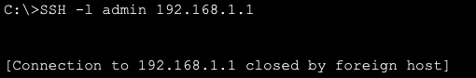

figure3: Use SSHconnect the of Router

1. **What are the five working modes of a router?**
2. User EXEC mode (Prompt: Router>):

This mode is limited to some monitoring commands, where users can view the router's connectivity status, access other networks and hosts, but cannot view or modify the router's configuration settings.

As soon as the interface up message appears and press enter, the router> prompt will pop up.



figure4: User mode

1. Privileged EXEC mode (Prompt: Router#):

Privileged mode is the highest level command mode in Cisco routers. In this mode, you can execute privileged operations such as viewing router configurations, running diagnostic commands.

We can use “enable” or “en ” to enter thep Privileged mode and use “disable” or “exit” to exit the Privileged mode.

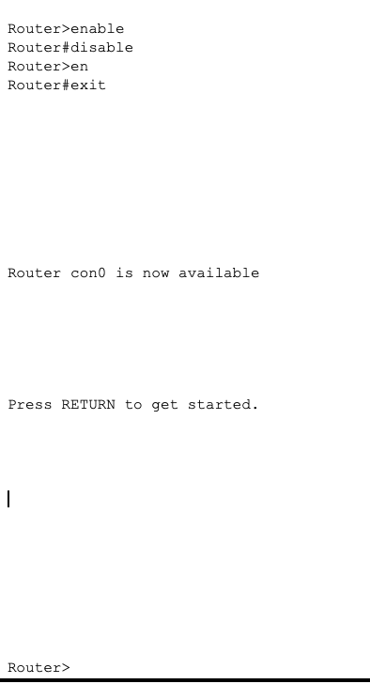

figure5: Privileged mode

1. Global Configuration mode (Prompt: Router(config)#):

Global Configuration mode is the primary command mode for configuring the router.

In this mode, you can configure various aspects of the router, including network interfaces, routing protocols, access control lists, security settings, and more. All configuration changes made in this mode affect the entire router.

We can use the “configure terminal” or “conf t” for short to enter this mode under the Privileged mode



figure6: Global Configuration mode

1. Interface Configuration mode (Prompt: Router(config-if)#):

Interface Configuration mode is used to configure specific network interfaces on the router. In this mode, you can configure parameters related to the specified interface, such as IP address, subnet mask, maximum transmission unit (MTU), speed, protocols, and more.

To enter interface configuration mode, you use the "interface or int <interface type><interface name>" command (e.g., "interface f0/0") in global configuration mode.

Here is the example



figure7: Interface Configuration mode

1. Line Configuration mode (Prompt: Router(config-line)#):

Line Configuration mode is used to configure specific lines (such as console, virtual terminal, auxiliary) on the router. In this mode, you can configure settings for the specified line, such as setting passwords, controlling access, configuring logging, and more.

To enter line configuration mode, you use the "line <line type> <line number>" command (e.g., "line console 0") in global configuration mode.



figure7: Line Configuration mode

1. **Describe the steps/commands of setting IP address on a router interface**

First click the router, then click the CLI for coding. The UI is showed like this

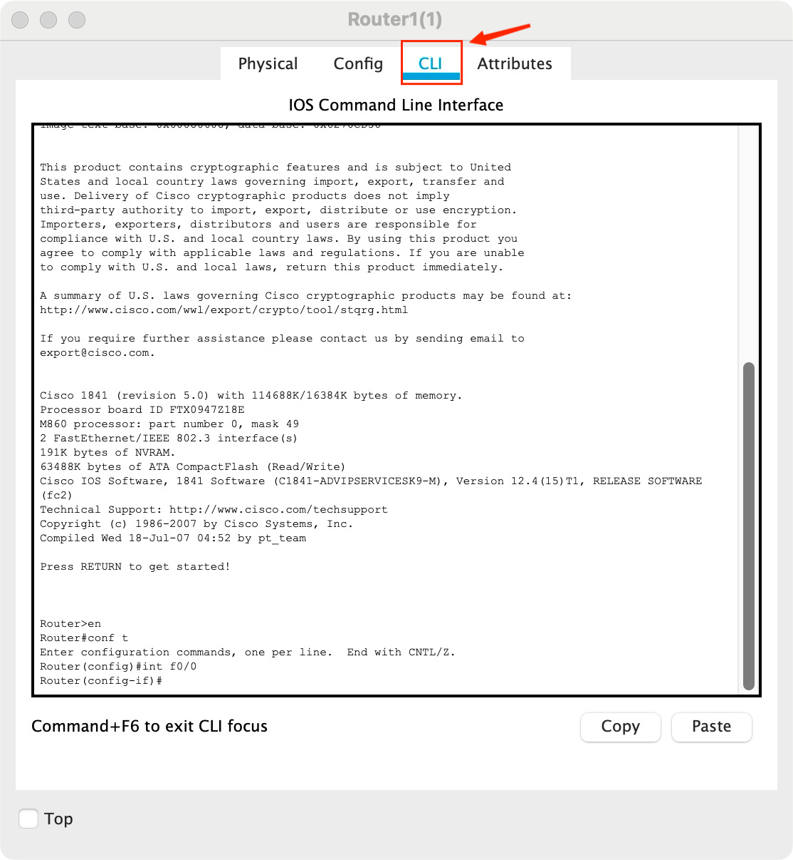

figure8: Enter CLI

Then enter the Interface Configuration mode. First enter “en”(enable) to movr to the Privileged EXEC mode. Then enter “conf t”(config terminal) to movr to the Global Configuration mode. Finally, use the "interface or int <interface type><interface name>" command (e.g., "interface f0/0") into the Interface Configuration mode to configure the IP address on a router interface.

Here is the example for configuring the FastEthernet0/0 interface.

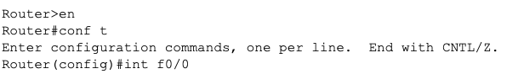

figure9: Codes for entering the Interface Configuration mode

After entering the Interface Configuration mode, use command “ip address <IP Address> <Mask>”press the IP address and the Mask. If you enter a wrong code, the Router will tell you the wrong. Then use the “no shutdown” command to activate the Interface. Finally use “exit” command to exit the Interface Configuration mode.

Following is the example that configure the Router with IP address 172.2.2.1 and Mask 255.255.255.0

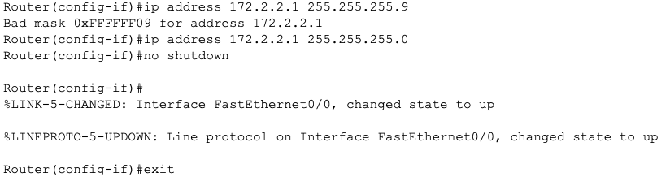

figure10: Codes for configuring the Interface

1. **Explain how ‘show’ command can be applied to**

We need to enter privileged mode to use “show” command. So first press “en” in order to get Router# in promote.

obtain router information

Use “show ip route” command to show route information.Following is an example of router infomation.

To show particular IP Address route information, we can use cammand “show ip route ip adress>”.

C is a direct connected network segment. S is the static route configured for us. Here the route information tell us the network segment 172.1.1.0 and 192.168.1.0 are directly connect by the interface FastEthernet0/1

and FastEthernet0/0 respectively. And if we want to access the 172.2.2.0 network segment, we shoud via 192.168.1.2 which is the subnet of 192.168.1.0 in interface FastEthernet0/0 .

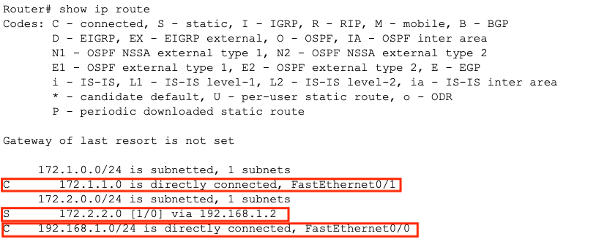

figure11: router information

interface information/configuration

Use “show interface” command to show interface information. To show particular interface, we can use cammand “show interface <interface name>”.

Following figure shows the details information of 3 interfaces(FastEthernet0/0,FastEthernet0/1 and Vlan1). There are many information of the interface, including Interface Status, Interface Hardware Address Information,Maximum Transmission Unit (MTU), Bandwidth, and Delay,Reliability and Load, Interface Encapsulation and Loopback Setting, Keepalive Message, Duplex and Speed,ARP Protocol, Last Input/Output, Last Clearing of Counters, Queueing Strategy and Queues,ata Rate and Packets (5 minutes), Received Packets and Buffer Issues, Broadcast and Multicast, Errors During Reception, Errors During Transmission.

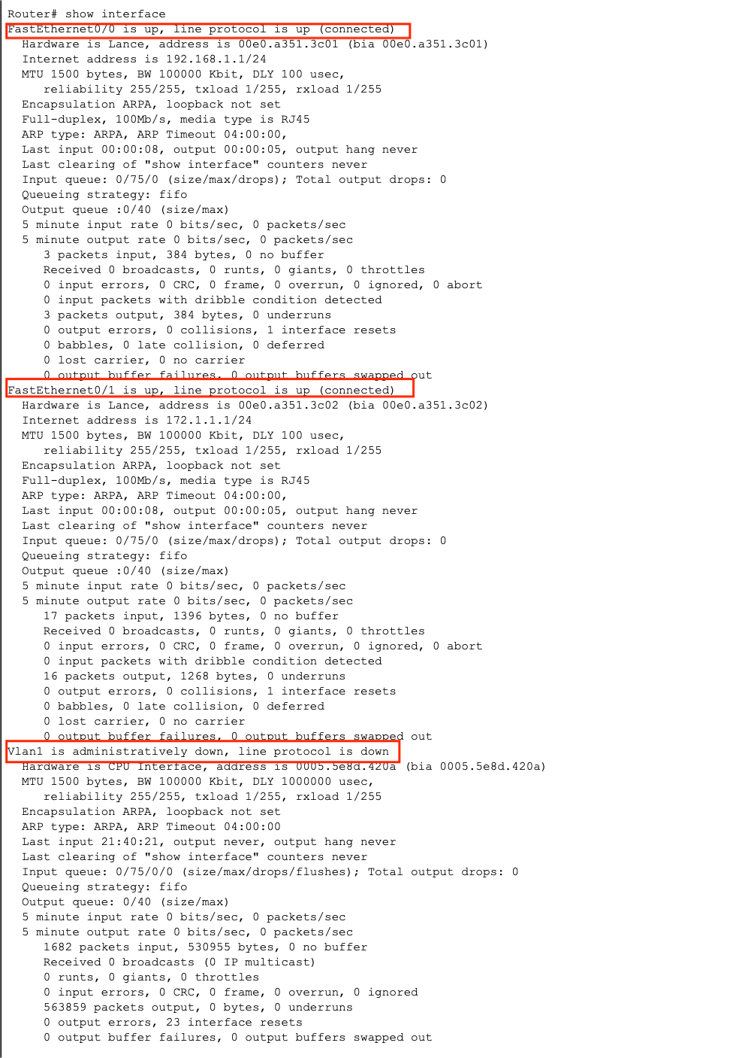

figure12: Interface information of router1

1. **Describe how routing entries can be manually configured.**

Using command: “ip route <Non direct network segment)><Non direct network segment Subnet mask> <Next hop address>” under the Global Configuration mode (Prompt: Router(config)#).

Following shows the configuration of routing entries. The router is configured by if it wants access the network segment 172.2.2.0, it should via 192.168.1.2.

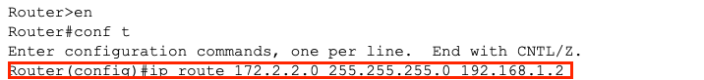

figure13: Manually configured route entries.

routing Then we can find the result by the command “show ip route”

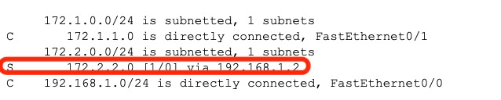

figure14: Routing table

1. **Experimental Environment**
2. Network topology

（2）Experiment devices

Two routers, two switches (optional), two PCs and cables.

（3）Experiment requirements

1. **Using the above topology to design network, explain the address for each node and interface.**

**Please describe the commands/steps to configure these IP addresses**

Topology:

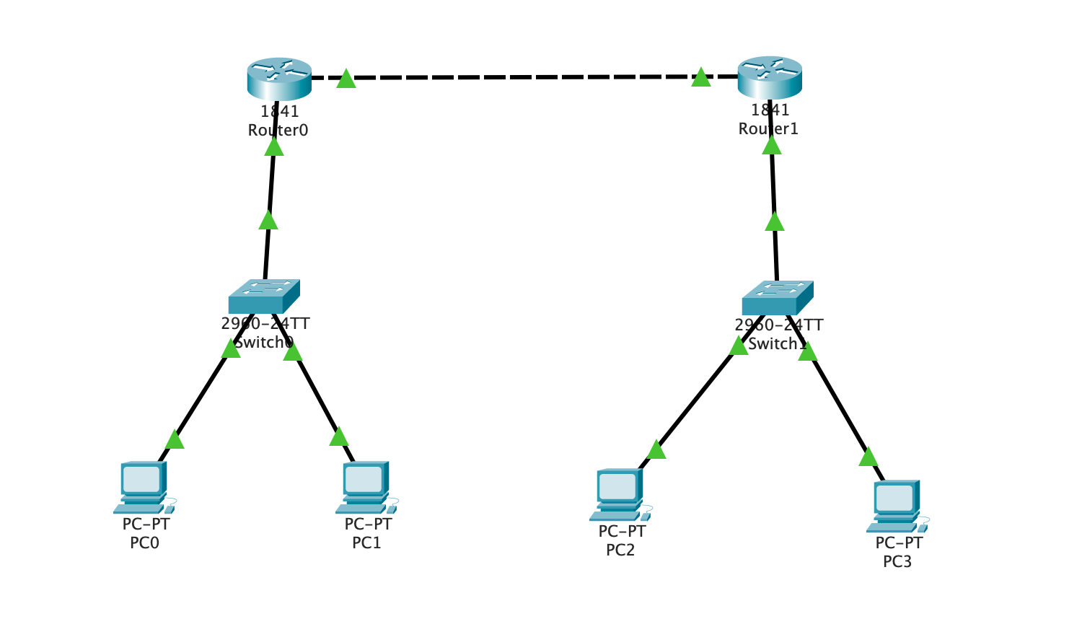

figure14:Network topology

Network configuration:

Use Copper Straight-Through to connect PC and Switch, Router and Switch

Use Copper Corss-Over to connect Router and Router



figure1: Line used to connect

Router0 FastEthernet0/0 (192.168.1.1)=> Router1 FastEthernet0/1(192.168.1.2)

Router0 FastEthernet0/1(172.1.1.1)=> Switch0 FastEthernet0/3

Router1 FastEthernet0/0(172.2.2.1)=> Switch1 FastEthernet0/3

Switch0 FastEthernet0/1 => PC0(172.1.1.2)

Switch0 FastEthernet0/2 => PC1(172.1.1.3)

Switch0 FastEthernet0/1 => PC2(172.2.2.2)

Switch0 FastEthernet0/2 => PC3(172.2.2.3)

PC configuration:

Click the figure of PC, then select the Desktop and IP Configuration to configure the PC

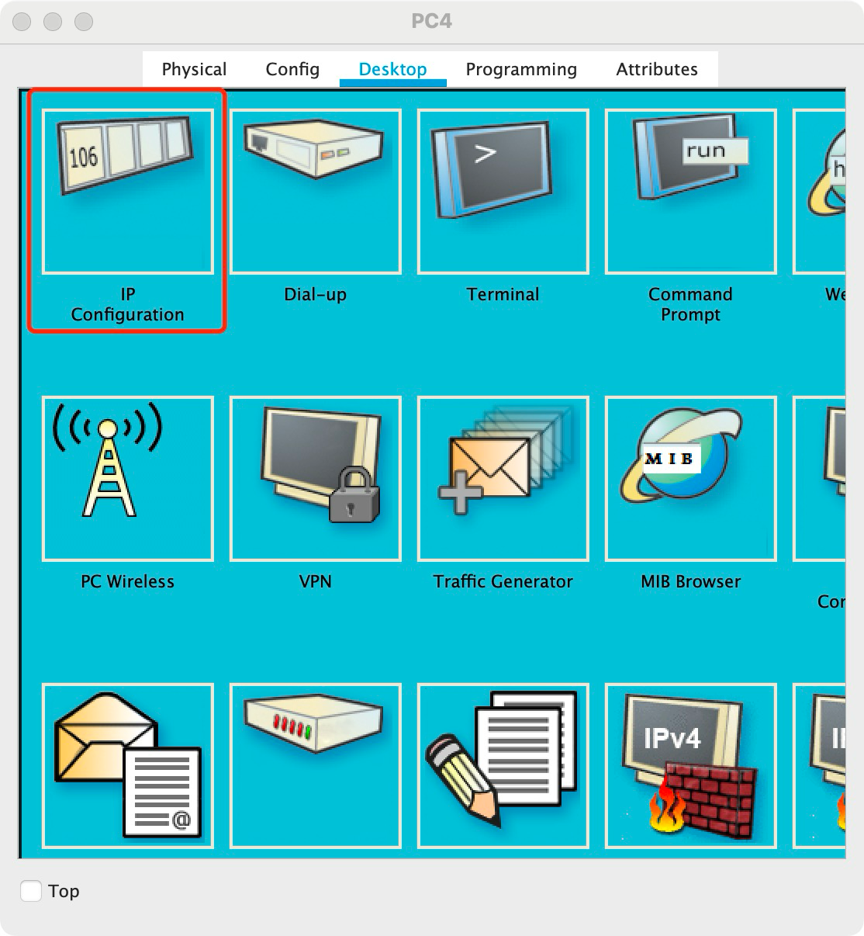

figure15: IP configuration

Following shows the IP address. subnet mark and Default Gateway of the computer

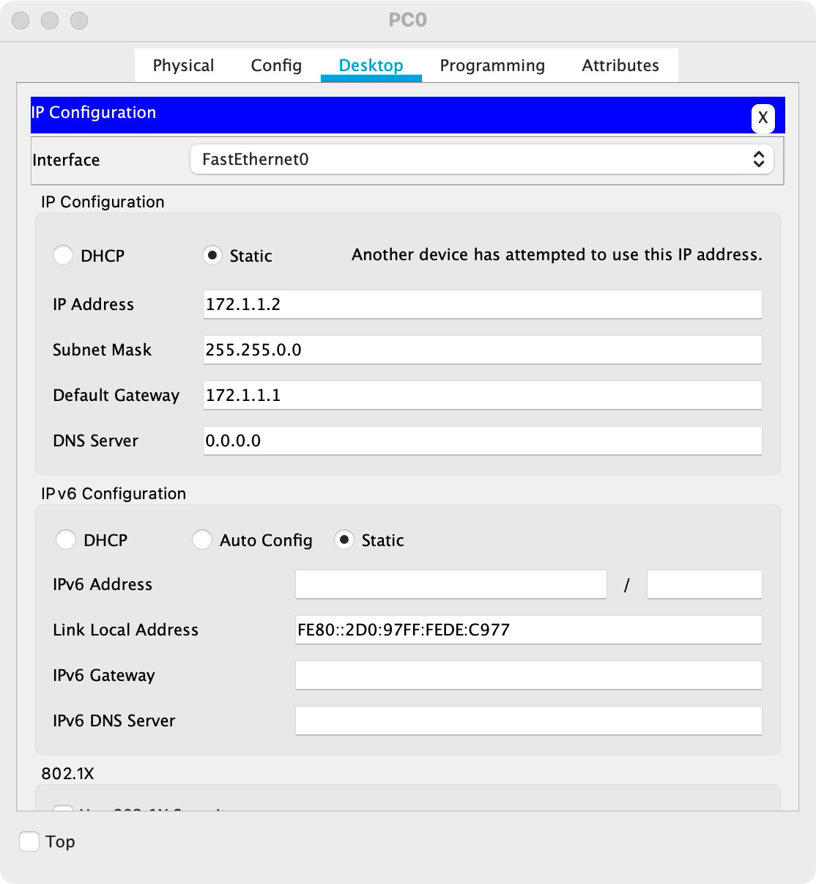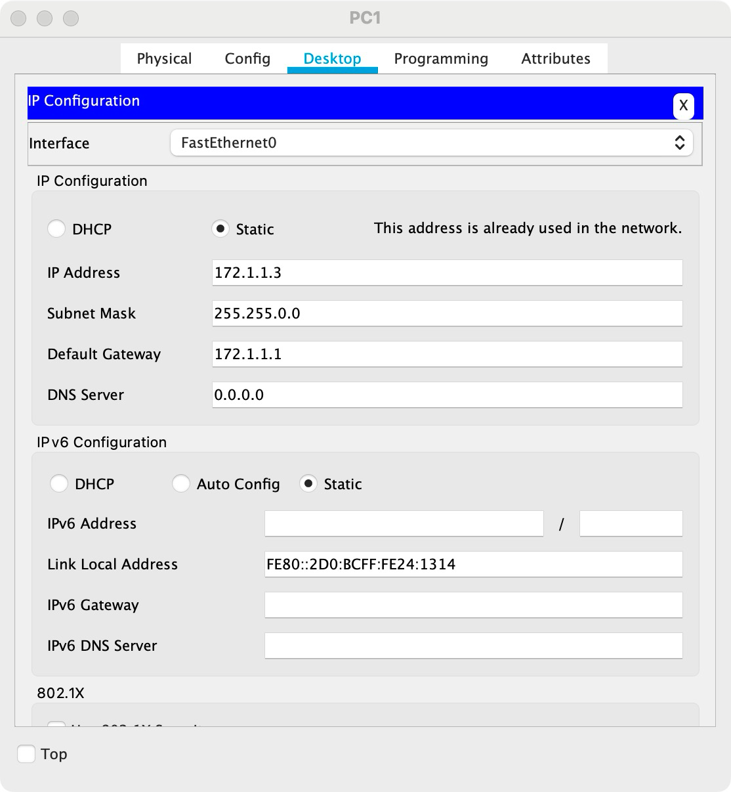

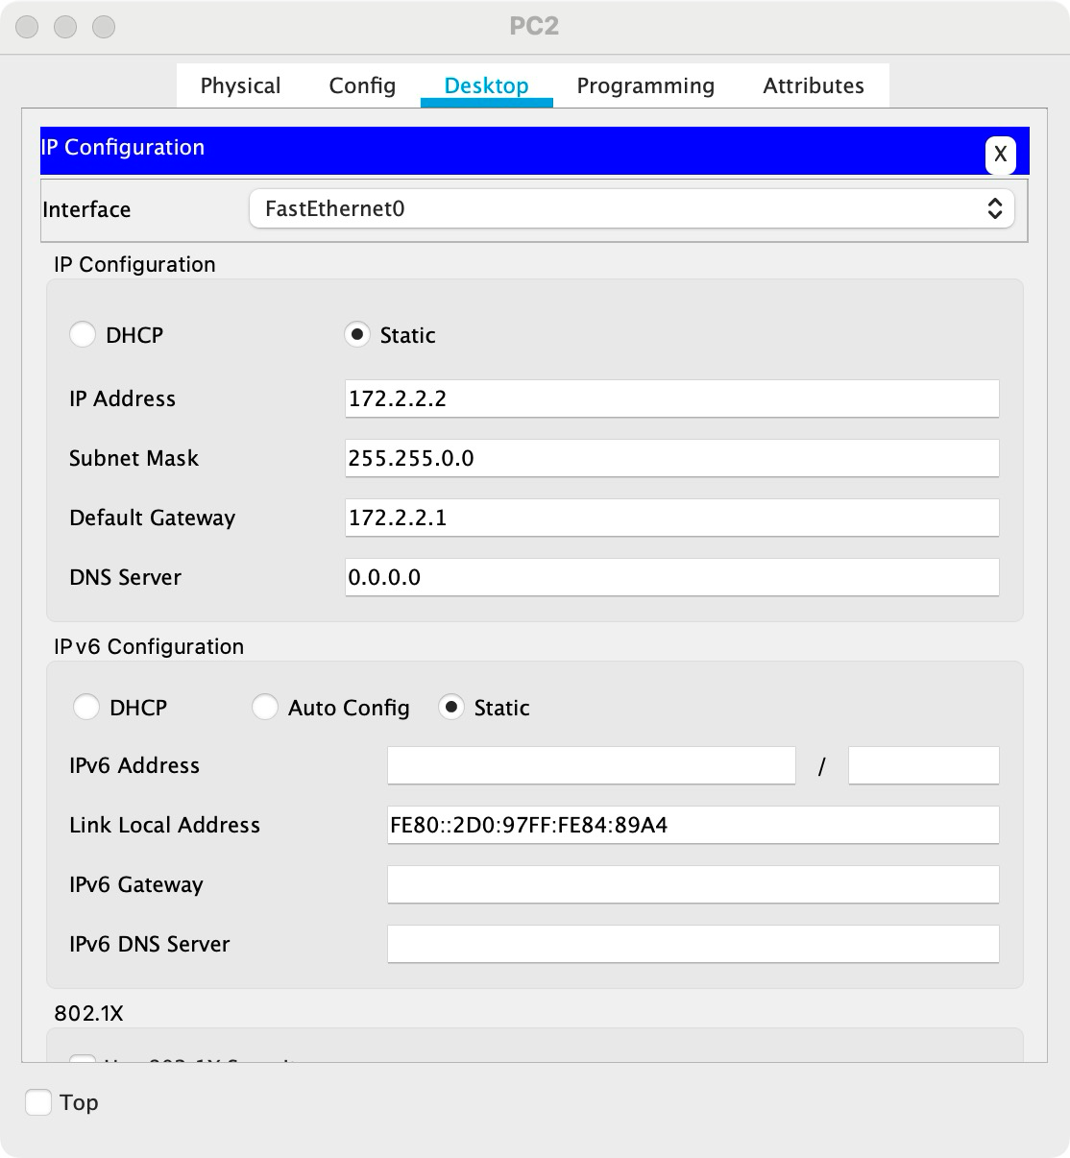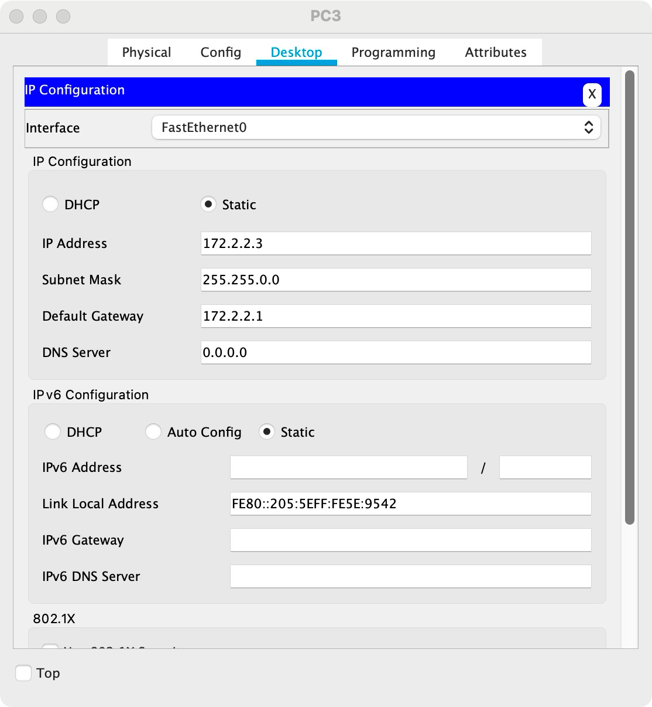

figure16:PC configuration

Router configuration:

Click the Router and then click CIL for configuration

Use command “en” enter Privileged Mode. Then use command “conf t ” enter global configuration mode.Then since we do not set DNS, use no ip domain-look for stopping router seraching DNS. Use command “inf fxx” to enter Interface mode to configure Router Interface. Finally use “no shutdown” to activate the interface. Use the command “exit” to return mode. Following is the configuration fo Router.

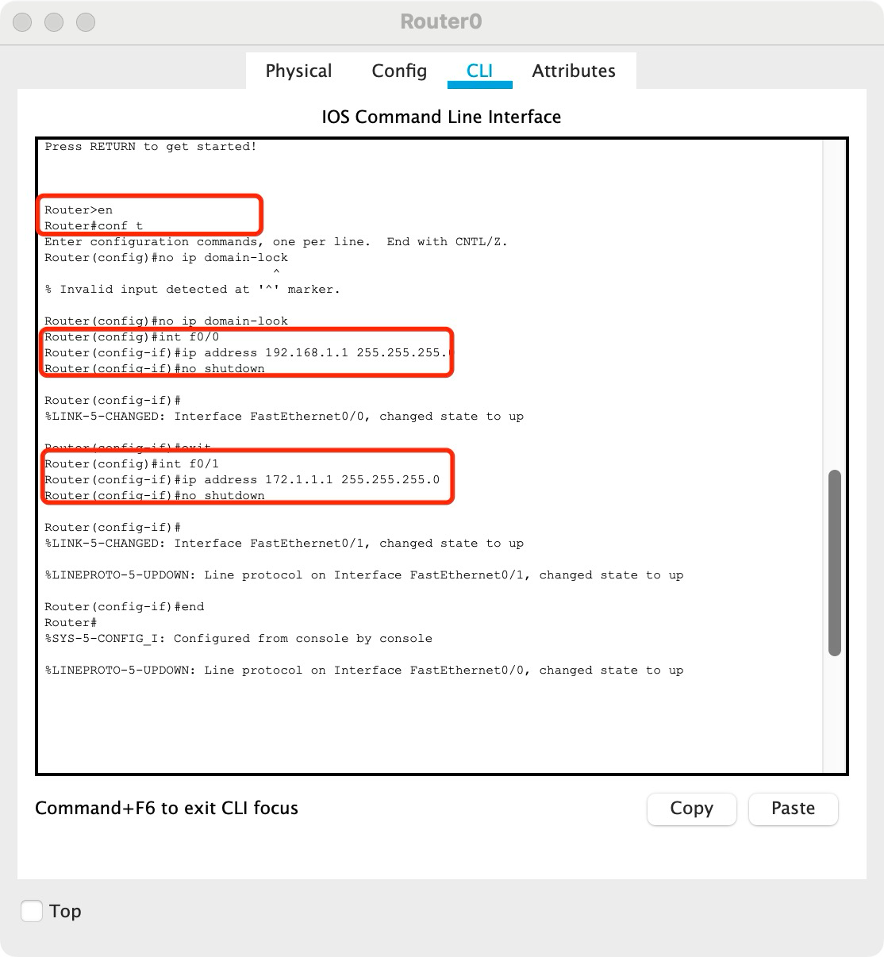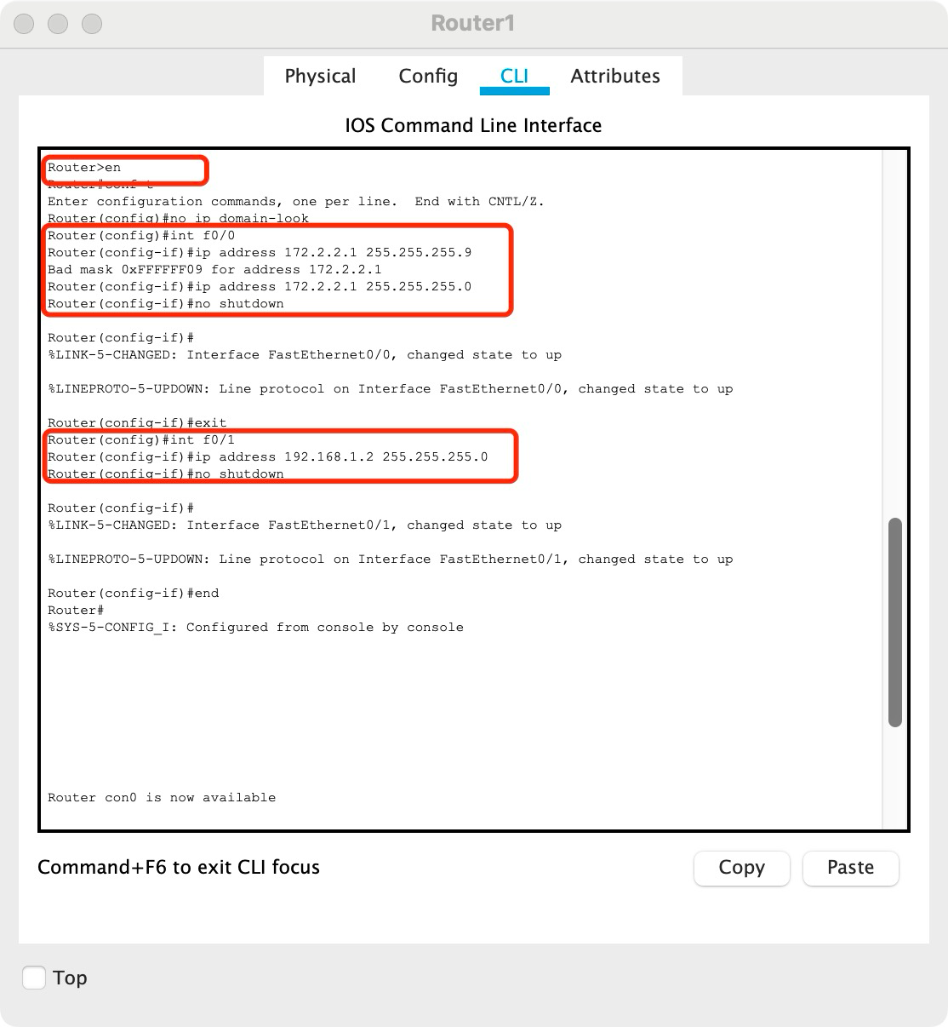

figure17:Router configuration

1. **Using static routing, to enable the workstations to communicate with each other.**

First we configure the routing entris of Router0 and Router1.

For Router0, we configure that FastEthernet0/1(198.162.1.2) in Router1 is the next hop if PC0 or PC1 wants to communicate with PC2 and PC3 (172.2.2.0)

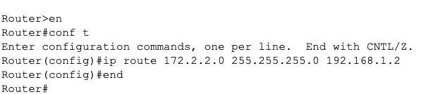

figure18: configure the Route0 entris

For Router1, we configure that FastEthernet0/0(198.162.1.1) in Router 0is the next hop if PC2 or PC3 wants to communicate with PC2 and PC3 (172.1.1.0)

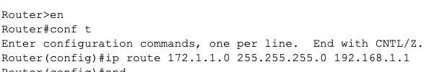

figure18: configure the Route1 entris

Then the PC0 or PC1 can ping PC2 or PC3

The result of PC0 ping PC2

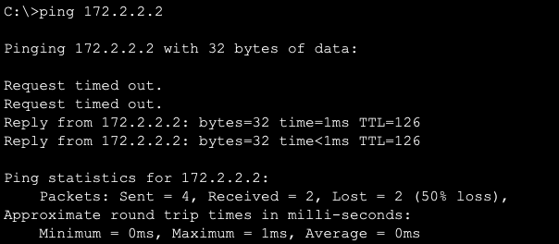

figure19: PC0 ping PC2

The result of PC3 ping PC1

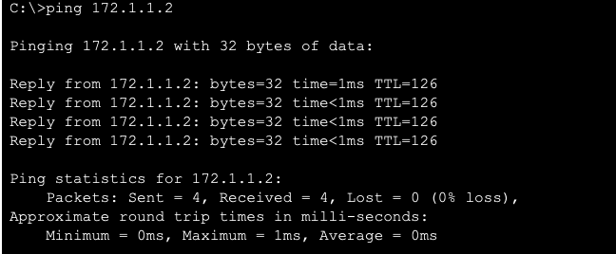

figure20: PC3 ping PC0

**Routing entries on Router0 :**

C is a direct connected network segment. S is the static route configured for us. Here the route information tell us the network segment 172.1.1.0 (PC0 and PC1)and 192.168.1.0 are directly connect by the interface FastEthernet0/1 and FastEthernet0/0 (Router 1’s FastEthernet0/1)respectively. And if we want to access the 172.2.2.0 network segment, we shoud via 192.168.1.2 which is the subnet of 192.168.1.0 in interface FastEthernet0/0 .



figure21: Router0 routing entries

**Routing entries on Router1:**

It is the same as the Router0

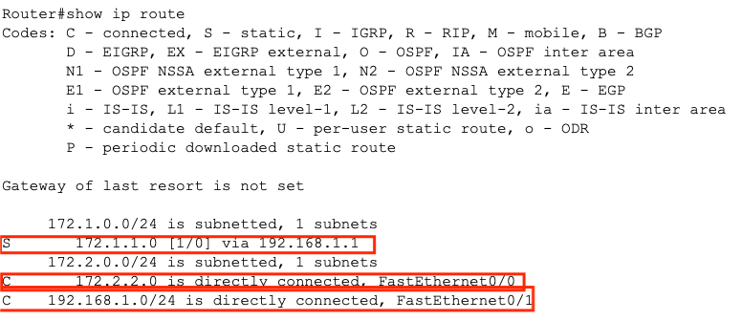

figure22: Router1 routing entries

# Conclusion

**Task2:**

From task 2, I first learn how to use the Cisco for simulating the network. As a result, I have a deeply undertanding of how the router work with the computer. First, I answere some questions about how to monitoring the Router in Cisco. I learn how to log on router by command. I also learn the 5 modes and how it uses of router. Besides, I learn how to set IP address and Mask for computers and routers. Then I learn the way to staically configure the routing tables. Fianlly, I learn how to get the routing table and interface inforamtion by “show” and how to read them. Finally, I make a expriment under the constructing and using the commands that I leaned before, which is how to turlly construct a network with the Cisco simulation. I connect the network with PC, switches and routers. Then I manually set the routing entries to make the PC under different routers connect successfully.