

Computer Networks

Lab Report

Name ：谭演锋

Student ID ：202130100456

Class ：计算机全英联合班

Collaborator(s) :

# Task 3 Networking --- Dynamic routing

**1. Experimental Purposes**

（1）RIP configuration

（2）OSPF configuration

**2. Experimental Environment**

（1）Network topology (for example)

（2）Experiment devices

Two routers, two switches (optional), two PCs and cables.

1. Experiment requirements
2. Using the above topology to design network, explain the address for each node and interface.

Topology:

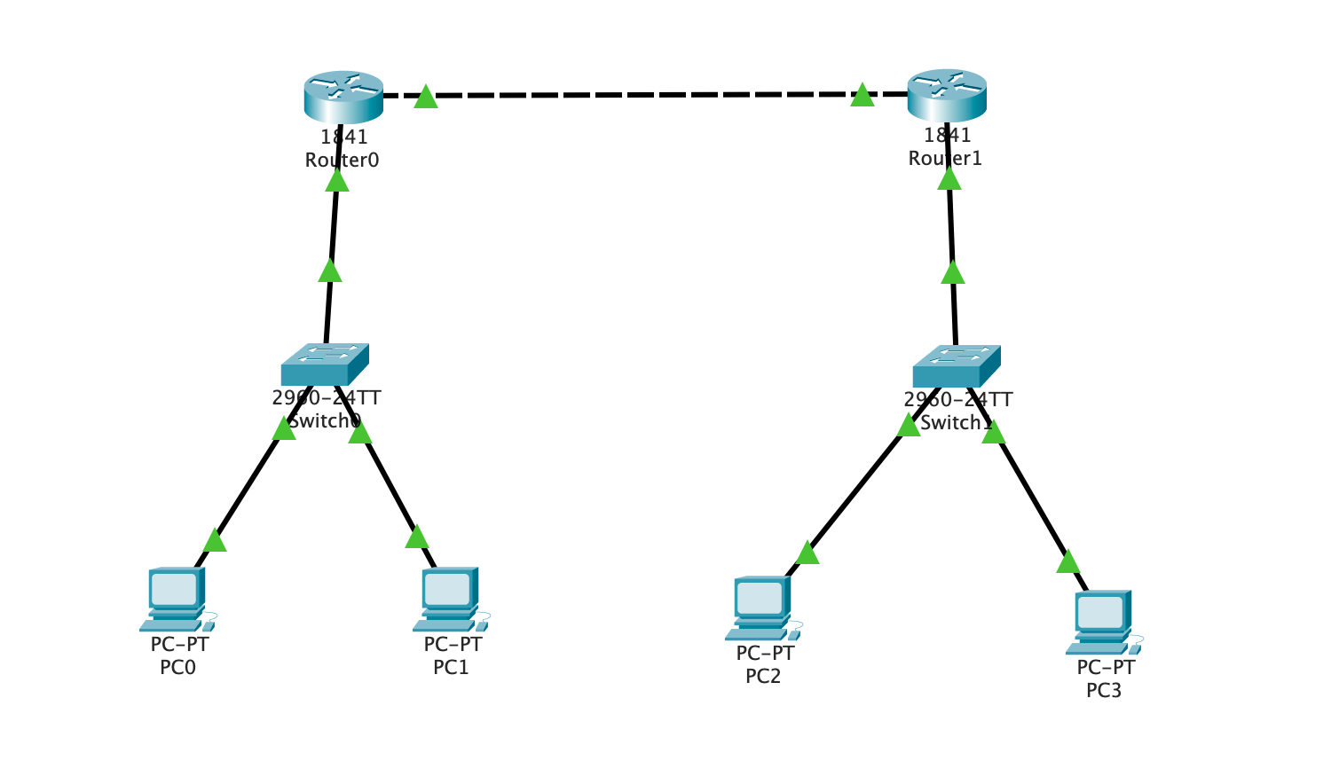

figure1:Network topology

Router0 FastEthernet0/0 (192.168.1.1)=> Router1 FastEthernet0/1(192.168.1.2)

Router0 FastEthernet0/1(172.1.1.1)=> Switch0 FastEthernet0/3

Router1 FastEthernet0/0(172.2.2.1)=> Switch1 FastEthernet0/3

Switch0 FastEthernet0/1 => PC0(172.1.1.2)

Switch0 FastEthernet0/2 => PC1(172.1.1.3)

Switch0 FastEthernet0/1 => PC2(172.2.2.2)

Switch0 FastEthernet0/2 => PC3(172.2.2.3)

1. **Using RIP, to enable the workstations to communicate with each other.**

**Explain RIP**

RIP (Routing Information Protocol) is a distributed distance-vector routing protocol, a standard protocol for the Internet. Its major advantage lies in its simplicity.

The RIP protocol requires each router in the network to maintain a unique best distance record (a set of distances) from itself to every other destination network.

Distance is typically measured in "hops," representing the number of routers passed from the source port to the destination port, with each router passed adding one hop. Specifically, the distance from a router to a directly connected network is 1 hop. RIP allows a route to contain a maximum of 15 routers, so a distance of 16 indicates that the network is unreachable. As a result, RIP is only suitable for small network.

RIP exchanges routing information only with its directly neighboring routers. In the context of RIP, routers share information about their connected networks with routers that are directly connected to them. This information exchange occurs between adjacent or neighboring routers to keep each other updated on the current network topology.

RIP routers send and receive routing updates through periodic broadcast messages. Each router advertises the routes it knows about to its neighbors, and in turn, it learns about routes from its neighbors. This process of exchanging information allows RIP routers to maintain a view of the network and update their routing tables accordingly.

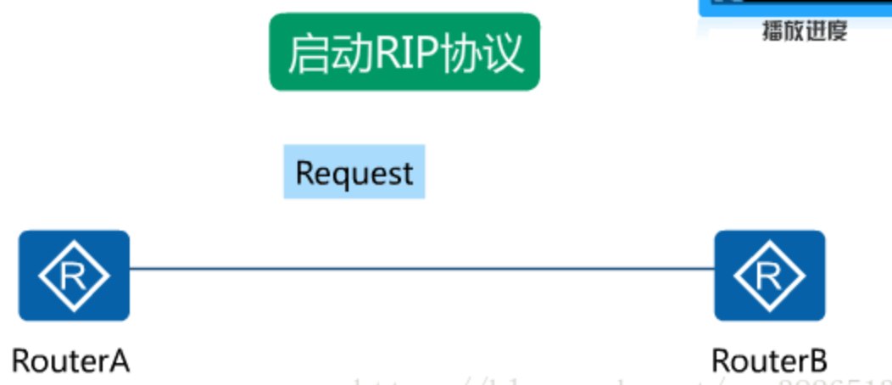

figure2:RIP protocal

**Explain the commands/steps to configure dynamic routing**

Follwing figure shows the steps to configure the dynamic routing after configuring the network.

For Router0:

First enter the Global Configuration mode under the Priviledged mode by “conf t”(configure terminal). Then first enter command “router rip” telling the router use the RIP portocal. Then enter the Router0’s interfaces’ IP Address: FastEthernet0/0 (192.168.1.1) and Router0 FastEthernet0/1(172.1.1.1). We only set it netwrok segment information. Then tell the router with command “version2” that using RIPv2 protocal. Finally using “no auto-summary” for summarizing to classful boundaries, which allows for precise route advertisement without causing excessive summarization. Finally, after we finished the settings, use command “end” to exit the Global Configuration mode mode.

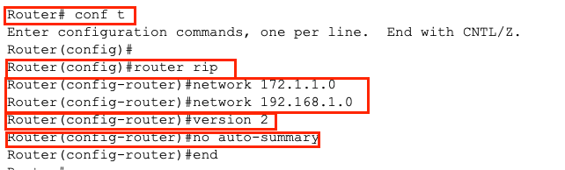

figure3: Router0 configure RIP protocal

For Router1:

It is same as the Router0, except the IP addresses are diffierent.

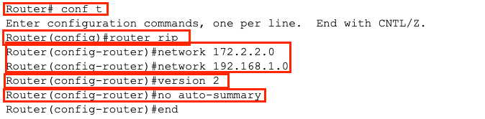

figure4: Router1 configure RIP protocal

After configuration, we can find the RIP result by cliking the router and click Config and RIP for the RIP Information. In the figure, it shows the Network Address information that we set for the router. It will change automatically, since the Mask of PC is 255.255.0.0 and the Mask of routers IP address is 255.255.255.0.

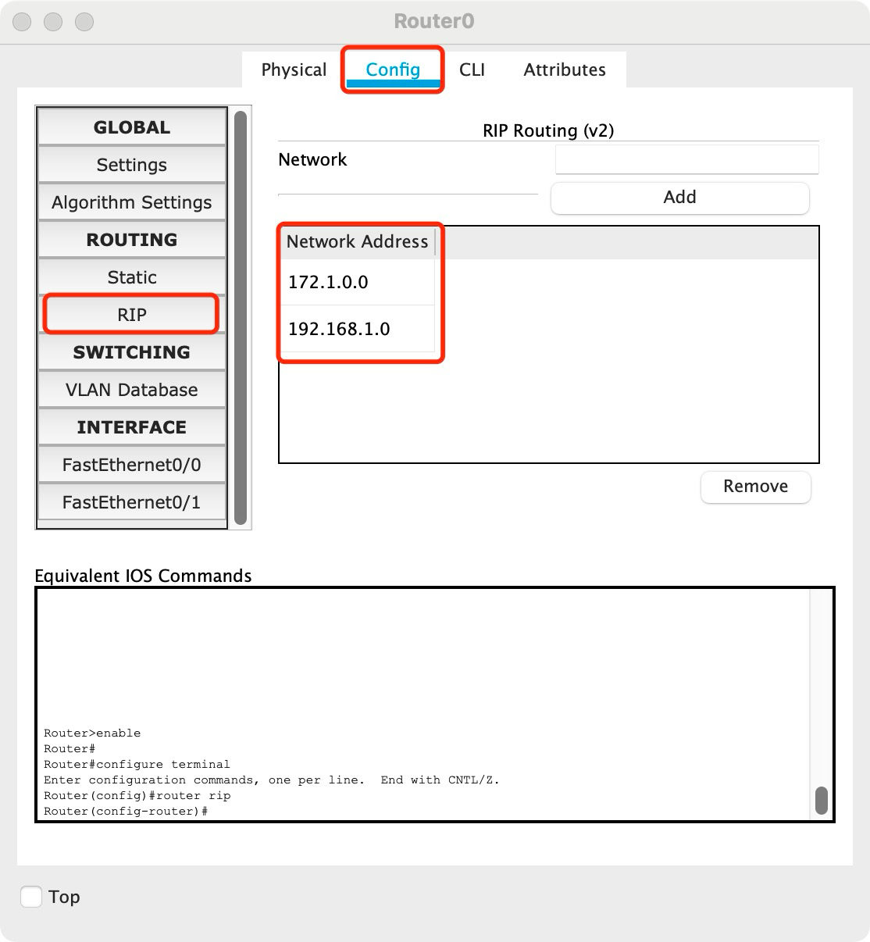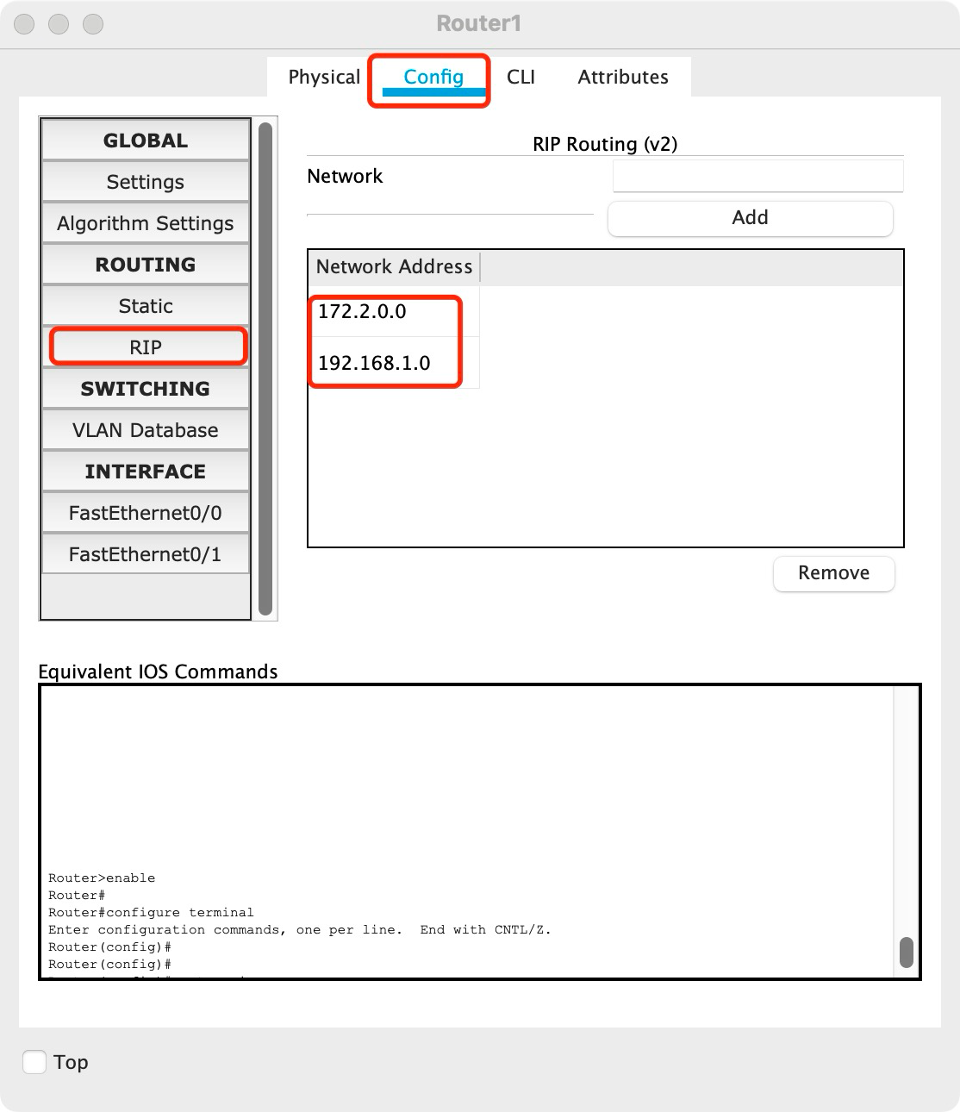

figure4: Router0 and Router1 RIP information

Finally, we can show the router entries of Router0 and Router1 after RIP configruation by command “show ip route” under the priviledged mode. C is a direct connected network segment. R is the RIP route configured for us. We can see from the figure, if PC0 or PC1(172.1.1.0) want to communicate with PC2 or PC3(172.2.2.0), its next hop is 192.168.1.2 via Interface FastEthernet0/0 of Router0 and FastEthernet0/0 of Router1. It is similar if PC2 or PC3 wants to communicate with PC0 or PC1, they should via Interface FastEthernet0/1 of Router1 and Interface FastEthernet0/1 of Router0.

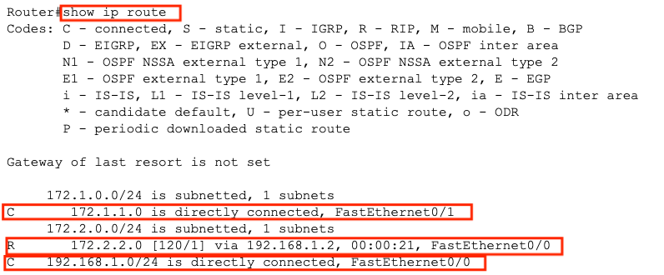

figure5: Router0 router entries

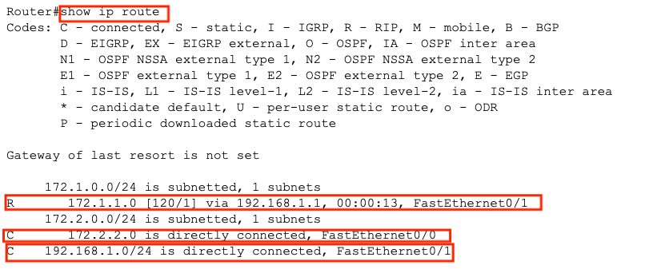

figure6: Router1 router entries

1. **Using OSPF routing, to enable the workstations to communicate with each other.**

**Explain OSPF**

The Open Shortest Path First (OSPF) protocol is an open standard routing protocol. The term "open" indicates that this protocol is not proprietary and is publicly documented, not subject to exclusive control by any specific vendor. Additionally, "Shortest Path First" signifies that the OSPF protocol utilizes Dijkstra's shortest path algorithm (SPF).

Here are the key features of the OSPF protocol:

1. Flooding Method in Autonomous Systems:

- Information is disseminated to all routers within the autonomous system using the flooding method.

- Each router sends the information to all neighboring routers through its output ports, and each neighboring router, in turn, forwards this information to all of its adjacent routers.

- Eventually, every router within the entire region receives a copy of this information.

2. Contents of the Information Sent:

- The transmitted information consists of the link states of all routers adjacent to the sender.

- It includes details about which routers are adjacent to the sender, along with metrics/costs associated with each link (such as fees, distances, delays, bandwidth, etc.).

3. Flooding Triggered by Link State Changes:

- The flooding of this information occurs only when there is a change in the link state.

- Routers will flood the information to all routers within the network only when there is a modification in the state of a link.

As a result, all routers are able to build a link-state database, essentially forming a comprehensive network topology map.

**Explain the commands/steps to configure dynamic routing**

Follwing figure shows the steps to configure the dynamic routing OSPF after configuring the network.

For Router0:

First enter the Global Configuration mode under the Priviledged mode by “conf t”(configure terminal). Command “router ospf 100” starts the OSPF process with a process ID of 100 (the process ID is an integer within the range of 1 to 65535). This process ID is merely a local identifier, holding local significance only. It is unrelated to the OSPF router process IDs within the same area, and having different process IDs does not affect the establishment of adjacency relationships. Command “net 172.1.1.0 0.0.0.255 area 0” declares the network, which involves defining the interfaces Router0 FastEthernet0/1(172.1.1.1) participating in the OSPF process and specifying the area in which it operates (Area 0 is the backbone area). A wildcard mask (0.0.0.255)is used to control the scope of the declaration, where any interface within this address range will run the OSPF protocol, sending and receiving OSPF packets. The '0' indicates an exact match, checking the corresponding bits in the matching address, while '1' represents a wildcard match, not checking the corresponding bits in the matching address. After configuring the OSPF,use command “end” to exit

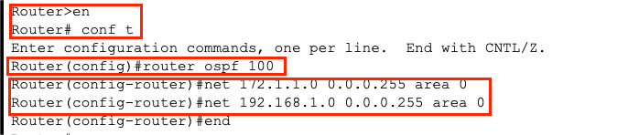

figure7: Router0 configure OSPF protocal

For Router1:

It is same as the Router0, except the IP addresses are diffierent.

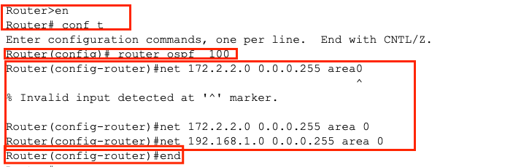

figure8: Router1 configure OSPFprotocal

Finally, we can show the router entries of Router0 and Router1 after OSPF configruation by command “show ip route” under the priviledged mode. C is a direct connected network segment. O is the OSPFroute configured for us. We can see from the figure, if PC0 or PC1(172.1.1.0) want to communicate with PC2 or PC3(172.2.2.0), its next hop is 192.168.1.2 via Interface FastEthernet0/0 of Router0 and FastEthernet0/0 of Router1. It is similar if PC2 or PC3 wants to communicate with PC0 or PC1, they should via Interface FastEthernet0/1 of Router1 and Interface FastEthernet0/1 of Router0.

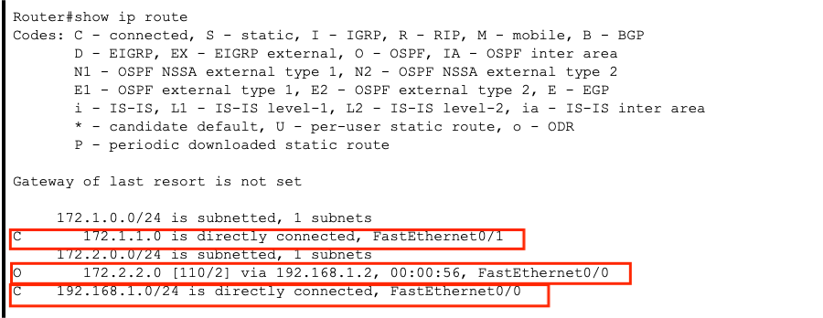

figure8: Router0 router entries

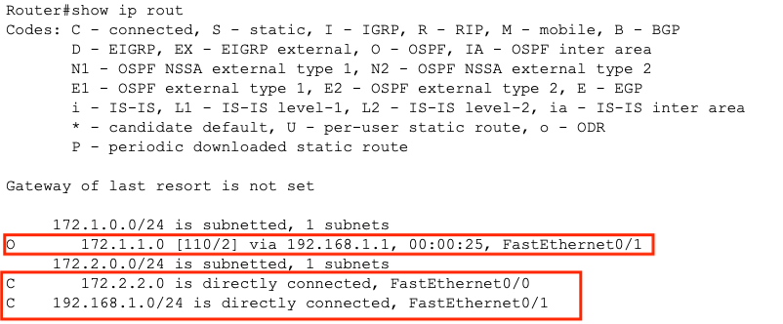

figure9: Router1 router entries

**（4）Testing and confirmation**

**How can you test and confirm that the network is working fine?**

**For RIP:**

We use the PC0 as example. In the PC0 Command Promote, We can ping PC1, PC2, PC3, Router0, Router1 for confirming the network is working fine.

For pinging PC1, Sent 4 ,Received 4 . They are connected.

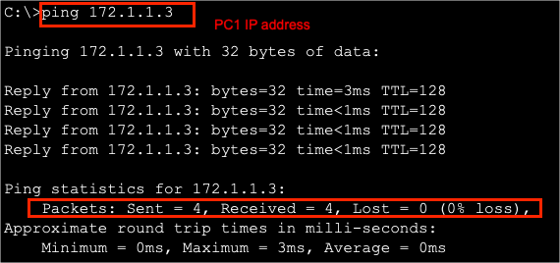

figure9:PC0 ping PC1

For pinging PC2, Sent 4 Received 2 . They are connected. For pinging PC3, Sent 4 Received 3 . They are connected.

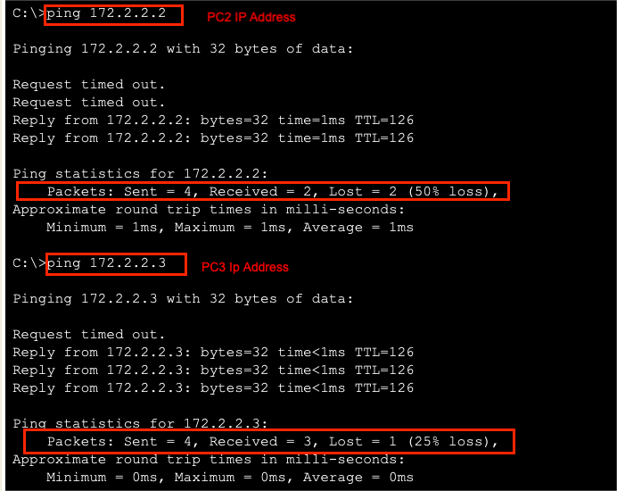

figure10:PC0 ping PC2 and PC3

For pinging Router0, Sent 4 Received 4. They are connected. For pinging Router0, Sent 4 Received 4. They are connected.

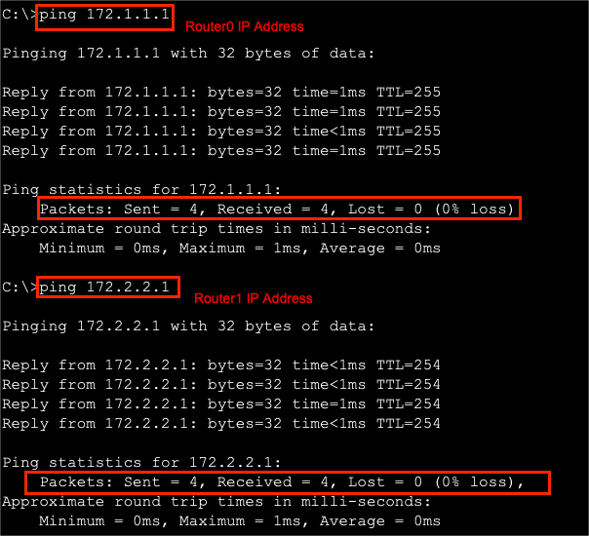

figure11:PC0 ping Router0 and Router1

**For OSPF:**

We use the PC0 as example. In the PC0 Command Promote, We can ping PC1, PC2, PC3, Router0, Router1 for confirming the network is working fine.

For pinging PC1, Sent 4 ,Received 4 . They are connected.

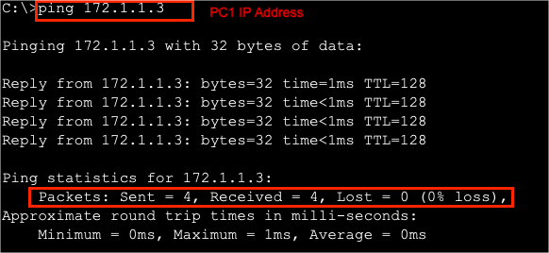

figure12:PC0 ping PC1

For pinging PC2, Sent 4 Received 2 . They are connected. For pinging PC3, Sent 4 Received 3 . They are connected.

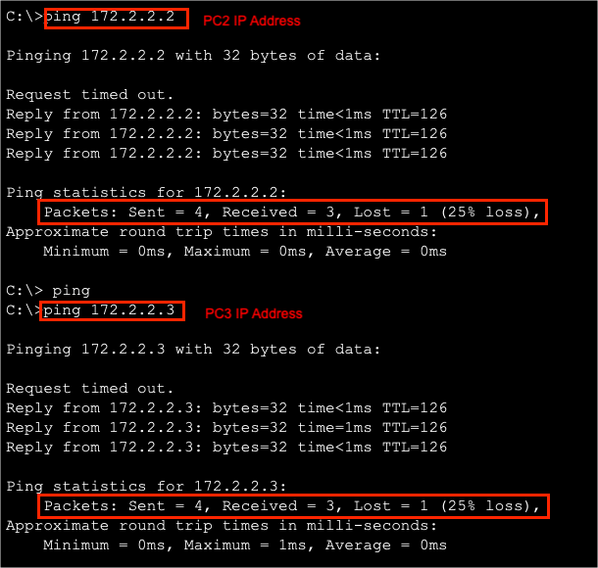

figure3:PC0 ping PC2 and PC3

For pinging Router0, Sent 4 Received 4. They are connected. For pinging Router0, Sent 4 Received 4. They are connected.

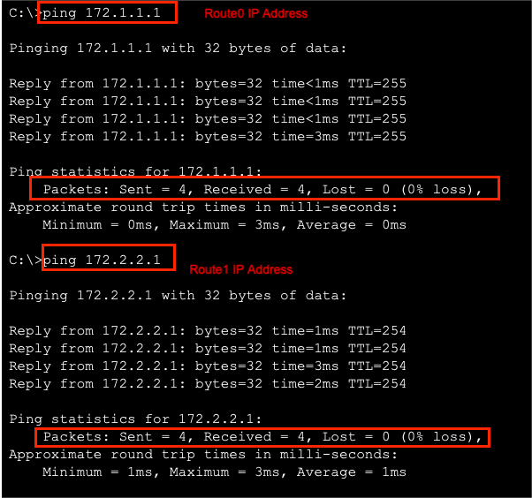

figure14:PC0 ping Router0 and Router1

# Conclusion

**Task3:**

From task 3, I use the network topology used in task2 for the RIP and OSPF experiment. In the experiment of RIP, I first learn what is RIP and hwo RIP work as the role of dynamic routing. Then I learn some command to configure the RIP for network. I also learn how to use the route entries to analyse the network that the RIP routing. In the expriment of OSPF, I also learn how the OSPF work and learn some command to configure the OSPFwhich is more complex than RIP and using “show ip route” for seeing the result fo OSPF. Doing both the experiment of RIP and OSPF, I have a deeply understanding of RIP and OSPF difference. OSPF is more suitbale for lagre network but RIP is more suibtable for small network. Moreover, OSPF is more complex than the RIP. However, they are both useful in the network routing.