1. Introduction and Research Question
The sinking of the RMS Titanic on April 15, 1912 has become a canonical example in both history and data science. Historically, it is remembered as a tragedy shaped by social norms and inequalities; in data science, it serves as a compact, well-structured dataset for studying binary classification and exploratory data analysis. The widely cited idea of “women and children first” suggests that survival was not random: demographic and socio-economic factors likely played a major role in determining who had access to lifeboats and who did not.
The Kaggle Titanic dataset provides individual-level records for passengers, including whether they survived, as well as their sex, age, passenger class, fare, family relations aboard, and embarkation port. This mixture of demographic and ticket-related features allows us to ask questions that are simultaneously statistical and social: we can quantify associations between features and survival, and then interpret those associations in light of historical narratives about class, gender, and privilege.
In this report, I focus on two broad sets of questions.
First, there are descriptive / explanatory questions:
- How are survival outcomes distributed across core variables such as sex, passenger class (Pclass), and age?
- How do derived features like family size (constructed from the numbers of siblings/spouses and parents/children aboard) and a simple indicator for being alone vs. traveling with family relate to survival?
Second, there are predictive questions:
- Using a small set of relatively simple, interpretable features (sex, class, age, family size, embarkation port, etc.), how accurately can we predict whether an individual passenger survived?
- Which features appear to contribute most strongly to model performance, and do these quantitative findings align with intuitive expectations such as “women and children first” and better outcomes for higher classes?
The goal is not to build the most complex black-box model, but to understand what information is present in the data and how it relates to historical accounts of the disaster. For this reason, the analysis begins with exploratory data analysis (EDA): examining distributions, missing values, and survival rates across groups. Only after this descriptive work do we fit some simple models, such as logistic regression and random forests, and use one of the best perform model to formalize some of the patterns observed.
It is important that dataset has limitations: age and cabin information are often missing; names and ticket numbers are noisy; and the outcome is imbalanced, with more deaths than survivors. Finally, the context is highly specific to a single historical event, so any patterns we uncover should be interpreted descriptively rather than generalized to modern settings.
Within these constraints, this report aims to provide a structured exploration of the Titanic dataset, answering the questions above through a combination of EDA and simple predictive modeling, and relating the quantitative findings back to historically plausible explanations.
Within this constrained but rich setting, the goal of this report is to provide a structured exploration of the Titanic data, guided by the research questions above. We will first describe the dataset and basic feature engineering steps, then examine survival outcomes across key variables, and finally build simple predictive models to quantify how much of the survival variability can be captured using readily interpretable features. Throughout, we will try to connect quantitative findings back to intuitive, historically grounded explanations, and remain explicit about the dataset’s limitations and the distinction between correlation and causation.

2. Data Description

2.1 Source and Files
The dataset comes from the Kaggle “Titanic: Machine Learning from Disaster” competition. It consists of two main CSV files:
- train.csv – labeled data with 891 passengers, including the target variable Survived.
- test.csv – similar structure but without Survived, used for competition submissions.
In this report, I primarily analyze train.csv, since it contains both features and survival labels.

2.2 Main Variables
Key columns in train.csv:
- PassengerId: Unique identifier for each passenger (integer).
- Survived: Target variable; 0 = did not survive, 1 = survived.
- Pclass: Passenger class (1 = 1st, 2 = 2nd, 3 = 3rd); proxy for socio-economic status.
- Name: Passenger’s name; contains titles (Mr, Mrs, Miss, etc.).
- Sex: Male or female.
- Age: Age in years (float), with some missing values.
- SibSp: Number of siblings/spouses aboard the Titanic.
- Parch: Number of parents/children aboard the Titanic.
- Ticket: Ticket number (string), heterogeneous formats.
- Fare: Ticket fare.
- Cabin: Cabin number; many entries are missing.
- Embarked: Port of embarkation (C = Cherbourg, Q = Queenstown, S = Southampton).

2.3 Derived Features
For exploration, we often engineer a few additional features:
- FamilySize = SibSp + Parch + 1
(includes the passenger him/herself).
- IsAlone = 1 if FamilySize == 1, else 0.

3. Exploratory Data Analysis (EDA)

3.1 Overall Survival Rate
The overall survival rate in the training set is clearly imbalanced.
As shown in the “Overall Survival Rate” plot, roughly 62% of passengers did not survive (Survived = 0), while only about 38% survived (Survived = 1).
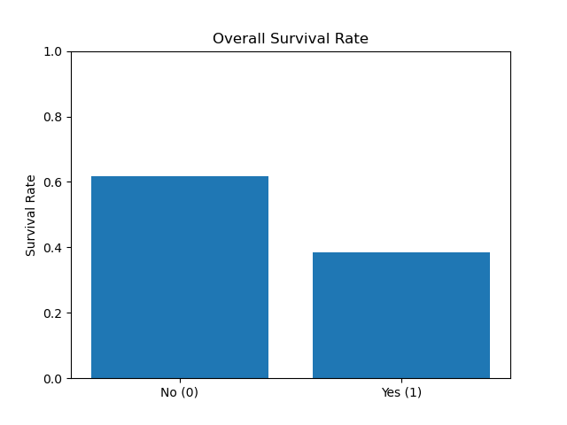
This imbalance means that a naive classifier predicting “non-survivor” for everyone would already achieve around 60% accuracy, so later classification results must be interpreted relative to this baseline.

3.2 Survival by Sex
The “Survival Rate by Sex” plot shows an extremely strong difference between male and female passengers.
The survival rate for female passengers is approximately 0.74, whereas for male passengers it is only around 0.19. In other words, women in this dataset are nearly four times as likely to survive as men as shown in the next plot.
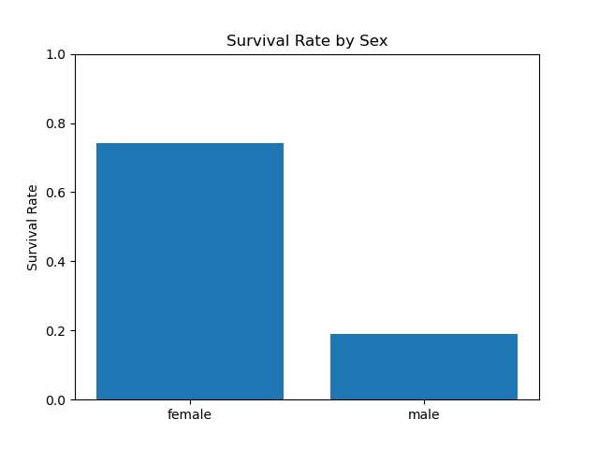
This pattern is consistent with historical accounts of the “women and children first” policy during evacuation and suggests that Sex will be one of the most powerful predictors in any survival model.

3.3 Survival by Passenger Class
Passenger class (Pclass) also exhibits a clear gradient in survival rates.
In the “Survival Rate by Passenger Class” figure, 1st-class passengers have the highest survival rate at roughly 0.63, 2nd-class passengers have a moderate survival rate of about 0.47, and 3rd-class passengers have the lowest survival rate, around 0.24. All of this data are shown in the next plot:
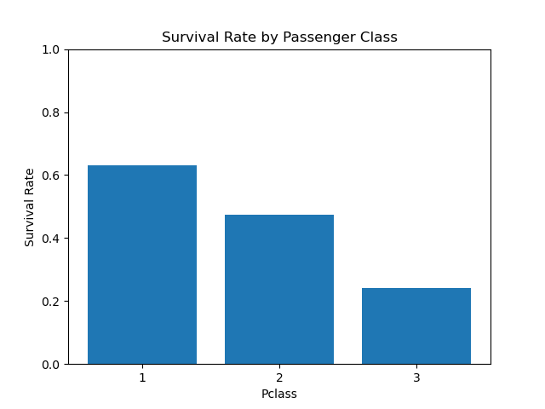

This monotonic decrease from class 1 to 3 reflects the socio-economic structure on board: first-class passengers were likely closer to the boat deck and had better access to lifeboats, while many third-class passengers were located in lower decks and faced more obstacles in evacuating.

3.4 Age Distribution and Survival by Age
The “Age Distribution” histogram indicates that most passengers were between 20 and 40 years old, with a noticeable cluster of young children under 10. The distribution is roughly unimodal with a slight right tail extending into older ages.
When we examine the “Survival Rate by Age Bin” plot, we see more nuanced patterns. Children in the [0, 10) age bin have the highest survival rate, around 0.61, which supports the “women and children first” narrative. For older age groups the pattern is less monotonic: survival is about 0.40 for ages [10, 20), drops to roughly 0.35 in [20, 30), then increases to around 0.44 in [30, 40), and fluctuates near 0.38–0.41 for the [40, 50) and [50, 60) bins.Passengers aged 60 and above have a noticeably lower survival rate, approximately 0.24.All of these are shown in next plot.
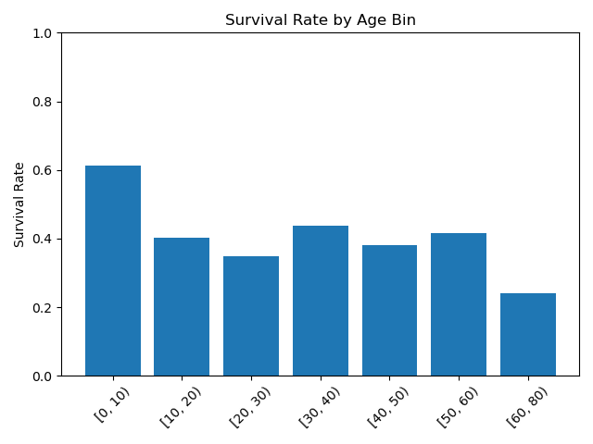
Overall, age is informative but weaker than sex and class, with children benefiting the most.

3.5 Fare Distribution and Survival by Fare
Ticket fares are highly skewed, as shown in the “Fare Distribution” histogram. The majority of passengers paid relatively low fares (below about 50), while a small number of passengers paid very high fares, up to over 500. This long right tail corresponds mainly to wealthy first-class passengers, which you can see it in the next plot.
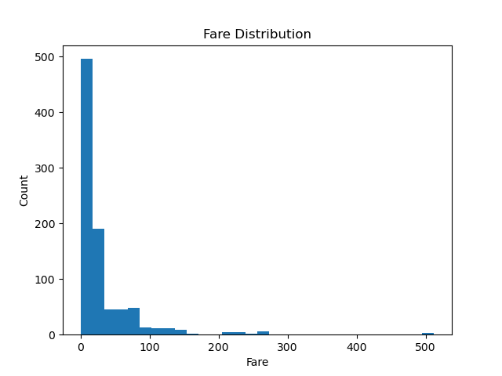
The “Survival Rate by Fare Bin” plot confirms that higher fares are associated with better survival outcomes. In the lowest fare bin [-0.01, 7.91), the survival rate is only about 0.20. It rises to roughly 0.31 in [7.91, 14.45), then to about 0.44 in [14.45, 31.0), and reaches approximately 0.58 in the highest bin [31.0, 513.33).
You can see the distribution in next plot.
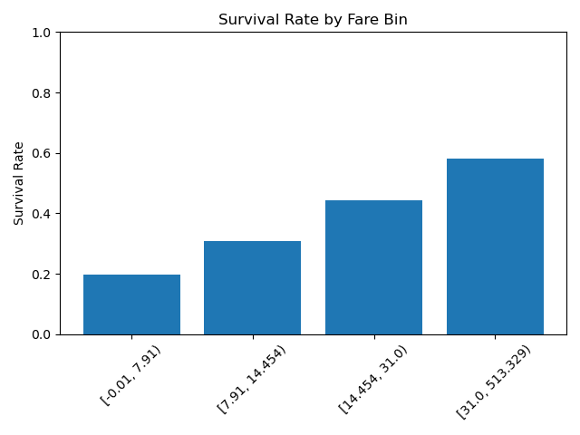
Because fare correlates strongly with passenger class, this gradient largely reflects socio-economic differences, although fare may also capture additional within-class variation in cabin quality and location.

3.6 Family Structure: FamilySize and IsAlone
Family structure on board appears to play a role in survival. Using SibSp and Parch, we define FamilySize = SibSp + Parch + 1. The “Survival Rate by FamilySize” plot shows that survival is relatively low for passengers traveling alone (FamilySize = 1, survival ≈ 0.30) but increases for small families: FamilySize 2–4 have survival rates around 0.55–0.72, with FamilySize = 4 peaking near 0.72. For larger families, the survival rate drops sharply again: FamilySize 5 and 6 show survival around 0.20 and 0.14, respectively, while size 7 partially recovers to around 0.33.
You can see this data distribution in next plot:
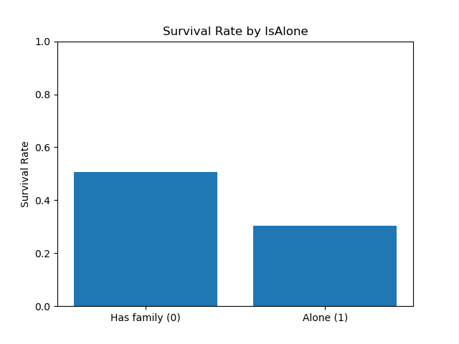
This suggests that being completely alone is disadvantageous, but very large groups may also face coordination difficulties during evacuation.
The derived binary feature IsAlone (1 if FamilySize = 1, 0 otherwise) captures this effect in a simpler form. The “Survival Rate by IsAlone” figure shows that passengers with at least one family member on board (IsAlone = 0) have a survival rate of roughly 0.50, whereas those traveling alone (IsAlone = 1) have a survival rate closer to 0.30. This supports the idea that having companions may have provided both practical and social advantages during the evacuation.

