UNIX REPORT

By Ngo Ha Anh and Tran Thi Hong Hanh

The report covers project 1 part 1 and project 2 part 2 in the project list.

**PROJECT TOPICS**

By Ngo Ha Anh and Tran Thi Hong Hanh

***PROJECT 1:***

Write a program with the following features:

1. Search by keyword:

a. Search for all files that contain a given keyword in the file name.

b. Search for all files that contain a given keyword in the file content.

2. Search by size:

a. Search a file whose size is greater than a given number.

b. Search a file whose size is less than a given number.

3. Search by date:

a. Search a file whose created date/last use date is greater than a given date.

b. Search a file whose created date/last use date is less than a given date.

4. Sort file by file name, file size, created date:

Users can use the combination of all these search criteria.

The Graphical User Interface is written in C/C++.

All commands are written in Shell Script.

***PROJECT2:***

Chat room with multiple users. Chat history is stored in a database.

**CONTENT**

1. **Organization:**
2. **Product Achievement:**
3. Project 1
4. Project 2
5. **Conclusion:**
6. What we have learned after the project
7. The problems we faced during the project
8. Conclusion
9. **Support Tools:**
10. **Organization:**

***PROJECT 1:***

Write a program with the following features:

1. Search by keyword: <Hong Hanh>

a. Search for all files that contain a given keyword in the file name

b. Search for all files that contain a given keyword in the file content

2. Search by size: <Ha Anh>

a. Search a file whose size is greater than a given number.

b. Search a file whose size is less than a given number.

3. Search by date: <Hong Hanh>

a. Search a file whose created date/last use date is greater than a given date.

b. Search a file whose created date/last use date is less than a given date.

4. Sort file by file name, file size, created date: <Ha Anh>

Users can use the combination of all these search criteria. <Ha Anh>

The Graphical User Interface is written in C/C++.

<Ha Anh + Hong Hanh>

All commands are written in Shell Script.

***PROJECT2:***

Chat room with multiple users.

Chat history is stored in a database. <Hong Hanh>

Makefile. <Ha Anh>

1. **Product Achievement:**
2. Project 1:

Project 1 concentrates on doing search and sort algorithm.

We use QRadioButton to choose which type to do: Search or Sort. For example, if you want to sort, a window will pop up and allow you to choose which kind of sort that you want to do: by size, by name or by created date. Enter the directory you want to sort and click sort button, the result will be appeared as below:

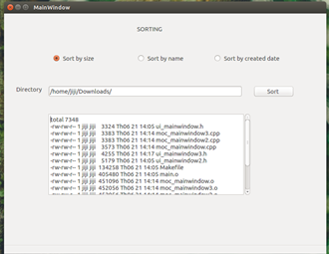

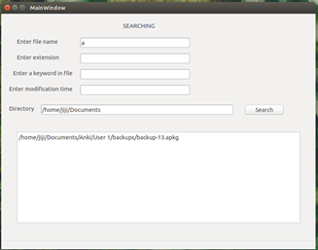

For search, enter the kind of searching you want to so and the directory to search.

1. Project 2:

***Before having makefile***

We create a group chat with a server and multi-clients. To run this program:

**Server:**

***$gcc -o server server.c -L/usr/include/mysql -lmysqlclient I/usr/include/mysql***

***$./server***

**Client:**

***$gcc -o client client.c***

***$./client1 -s localhost:port -p clientport -n name***

The server will receive the connection from the client and allow the message from a client to be transferred to many other clients. Each client who enters the group chat will have a name and that name will be appeared before the message every time the client sends a message to distinguish. All the database of the conversation is saved into MySQL database ***chatHistory***. This database contains one table with two value name and message.

To see the chat history:

***>mysql: SELECT *FROM chat.***

The picture above illustrates an example when we run the program:

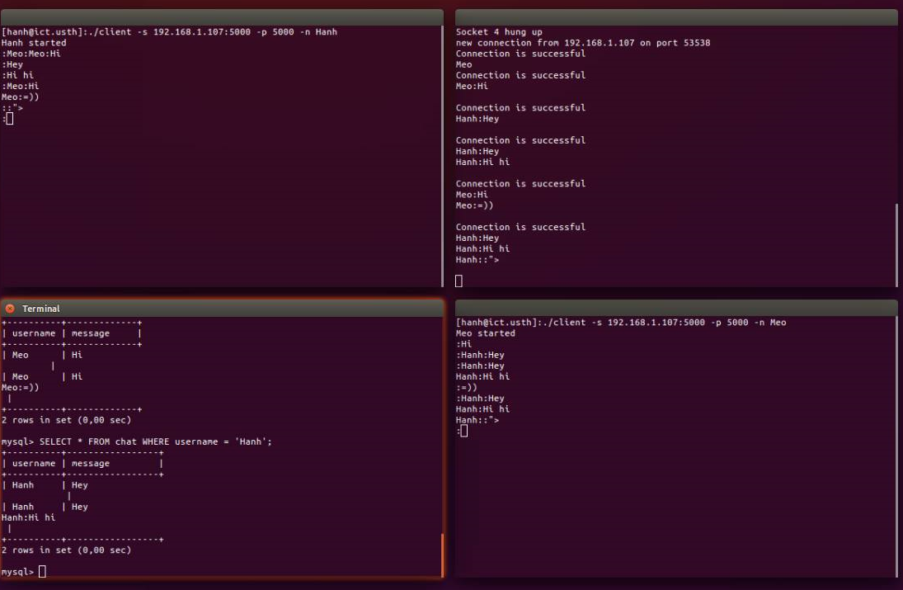

***After having makefile***

With makefile, the program executes more comfortable as there is no need to compile the source file individually.

1. **Conclusion:**
2. What we have learned after the project

* Have a chance to practice what we’ve learned in Unix subject.
* Further understanding about Shell script through Project 1, socket programming through Project2.
* Learn to use new itegrated development environment: Qt
* Learn how to work in a team efficiently and use version control(Github) to control the progress of our Projects.
* See the advantage of using makefile.

1. The problems we faced during the project

The biggest problem that we have to face during the project is to adapt to Qt environment. As Qt is quite new to us, it took time for us to understand and get used to Qt.

1. Conclusion

Unix projects give us a chance to practice what we’ve learned and applied in teamwork way. Despite the fact the our project still lacks a lot, we tried our best to learn and do. By doing teamwork, we can manage project and do the project under the pressure of time.

1. **Support Tools:**
2. Qt Creator:

It is an itegrated development environment with very simple and clean layout compared with other development environment we have used.

We use Qt Creator to build GUI for our project 1.

1. Version Control: Github

Git is a source code version control system, which a series of “commits” or snapshots of code and we make the commit manually.

Github is a website to publish Git repositories for public download and possible collaboration.

As we divide each part of project for each other, we use Git and Github to collaborate our teamwork.

1. Makefile:

With makefile, the program executes more comfortable as there is no need to compile the source file individually.