Output:

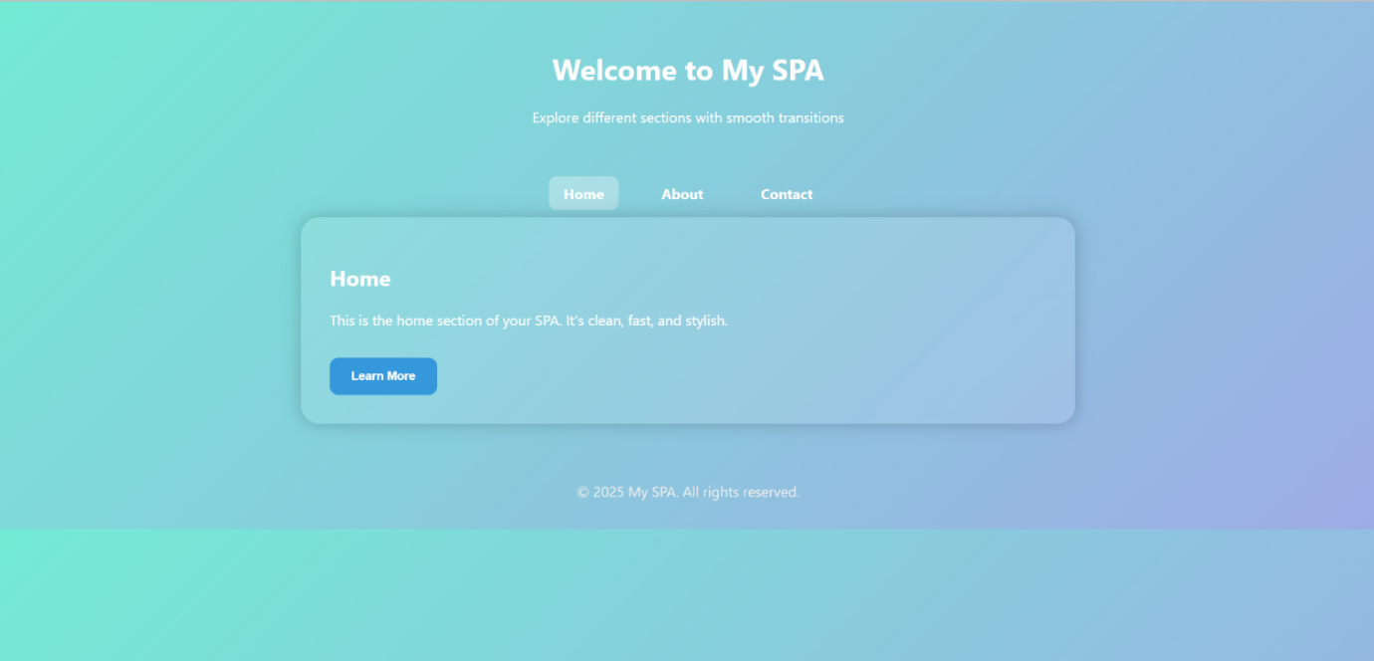

Fig 1: Homepage Interface of the single page application