The Estimator Classes
Gmat’s Estimator classes are shown in Figure 1. The first estimator build of GMAT includes the blocks shaded orange in the diagram: the Estimator base class, the BatchEstimator intermediate class, and the BatchLeastSquares estimator. The second build adds the Filter intermediate class and the SRIF estimator (proposed – final selection for the sequential estimation is yet to be decided) to the system. Potential extensions to this class hierarchy are shown in the figure as well.

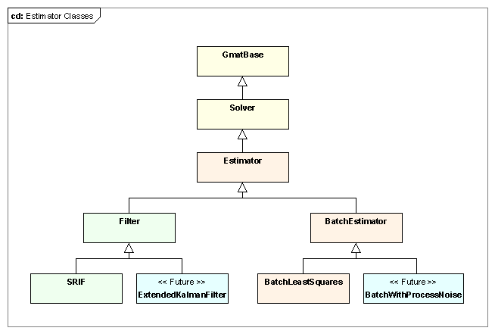
Figure 1: Classes in GMAT's Estimator Hierarchy

GMAT’s Estimator base class defines the core functionality shared by all estimators. It includes the top level Estimator interfaces, initialization code for the shared elements including the EstimationStateManager and MeasurementManager, and the member components implementing these elements. The interfaces in this class are defined so that the estimation commands can treat the estimator process generically, and therefore drive the estimation process without intimate knowledge of the algorithm that is implemented in the estimator.

GMAT’s estimator classes are derived from the Solver base class. The Solver class provides data structures and methods designed so that derived classes can implement a finite state machine that, together with a matching command, organizes the process of working with the elements of the a GMAT mission to drive the algorithm implemented in the solver. The command portion of this partnership manages the interface with the Sandbox and the propagation subsystem, and, when appropriate, with a solver control sequence designed to provide a sequence of commands when that sequence involves more than just direct propagation. The solver side of the partnership manages the state of the solution algorithm. That state is represented by one of several distinct values; hence the state machine is called a finite state machine. The command side retrieves the state if the state machine from the solver, performs any necessary control sequence actions, and then passes control to the solver so that the solver can evaluate and potentially change state based on the results of the command’s actions.

The state machine in GMAT’s solvers provides a mechanism to ensure that the control sequence is executed in a sensible manner for the implemented algorithm. As such, each derived solver class will define its state machine to meet the needs of its algorithm. The state machines for each of the new estimators are described in the corresponding class descriptions below.

The following sections describe each estimation class in the figure, starting with the Estimator base class. The capabilities and member elements are described, along with the processes that each class implements.

The Estimator Base Class
The Estimator class contains two key member objects used by all of GMAT’s estimators: an instance of the EstimationStateManager and an instance of the MeasurementManager. The details of those classes are provided in the corresponding sections of this document. In this section you will see how these objects are set up and used by the Estimator classes.

Figure 2 shows the Estimator class, its ancestors, and its predecessor. The details of the class contents are shown in this figure, along with the helper classes mentioned above. The Estimator class centralizes the interfaces to the measurement data and the estimation state vector, along with the other elements that all estimators need. This class extends the features of the Solver class by adding and initializing these new elements. As a base class, we anticipate that the implementation process for the derived estimators will result in a fair amount of refactoring, particularly as the BatchEstimator and Filter classes are implemented, consolidating additional common estimation features.

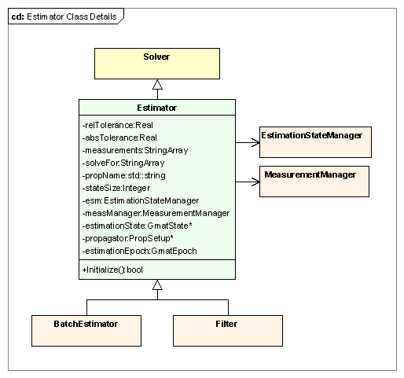
Figure 2: The Estimator Class

Key Processes
The Estimator base class has one key process: the Initialize method, which initializes its management members and prepares its propagation subsystem for initialization.

Estimator Initialization
The Estimator class manages the initialization of the EstimationStateManager and the MeasurementManager, along with preparation of the PropagationStateManager for initialization, as is shown in Figure 3. The Estimator::Initialize() method calls the Solver::Initialize() method first to ensure that the Solver data structures are properly prepared for use. Following this call, the EstimationStateManager::Initialize() method is called, which sets the data structures for the estimation state vector and then builds the vector. Once the estimation state vector has been built, the Estimator walks through the estimation state vector and passes each element that needs propagation into the PropagationStateManager assigned to the Estimator’s propagator. This process prepares the propagation subsystem for initialization, but does not perform the actual initialization. That call is made in the estimation command immediately prior to execution so that all transient forces required for the propagation can be managed. Finally, the MeasurementManager::Initialize() method is called, causing the measurement manager to read all of the data available for processing and to build the structures needed for that processing. This step completes initialization for the Estimator base class.

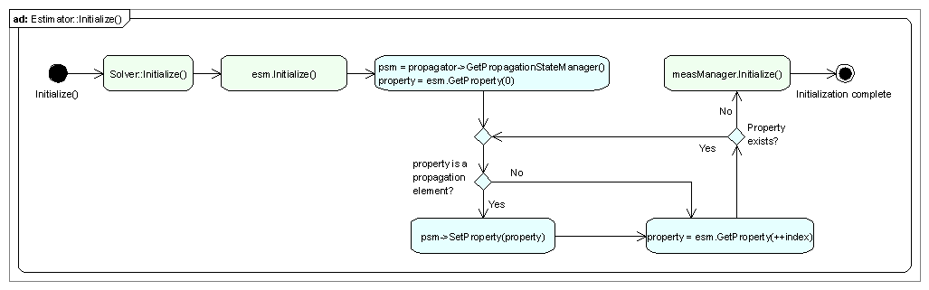
Figure 3: Estimator Class Initialization

Estimator Members
Estimator Attributes
- Real relTolerance: The maximum change from the previous RMS error in the residuals to the current RMS error allowed in order for convergence to be met.
- Real absTolerance: The largest allowed change in the estimation state in order for convergence to be met.
- StringArray measurements: Names of the measurement types used in this estimator. This array of names is passed to the MeasurementManager for processing.
- StringArray solveFor: List of the solve for parameters used in the estimator.
- std::string propName: Name of the configured propagator used to evolve objects during the estimation process.
- Integer stateSize: The size of the estimation state vector.
- EstimationStateManager esm: The EstimationStateManager for the estimator. This member is responsible for the communications between GMAT’s objects and the data structures manipulated by the estimator during the estimation process.
- MeasurementManager measManager: The MeasurementManager for the estimator. This object is responsible for managing all of the measurement objects in the estimation process. It is an intermediary responsible for retrieving observed and calculated data, and supplying those data to the estimator.
- GmatState *estimationState: A pointer to the estimation state managed by the EstimationStateManager. This pointer is set after the EstimationStateManager is initialized. It is provided for convenience, so that repeated calls to esm.GetState() are not needed in the code.
- PropSetup *propagator: The propagator configured for the estimation.
- GmatEpoch estimationEpoch: The estimation epoch. For batch estimators, this epoch is the epoch of the state estimate. For sequential epochs, it tracks the epoch of the current estimate.

Estimator Methods
- bool Initialize(): Prepares the EstimationStateManager and MeasurementManager for use in estimation, and loads the propagator’s PropagationStateManager so it can be initialized by the propagation enabled commands.

The BatchEstimator Class
The BatchEstimator class, shown in Figure 4, implements the infrastructure used by GMAT’s batch estimators. This infrastructure includes the implementation of a state machine intended to support the usual sequence of actions needed for batch estimation. The class defines with the methods called from this state machine, and provides implementations of the methods that are considered to be common to the batch estimation process. All of the common methods implemented for the BatchEstimator class are declared virtual. Derived classes can override the estimation state machine or any of the implemented methods as needed to support algorithm specific needs. The Accumulate(), Estimate(), and CheckCompletion() methods are considered to always be implementation specific, and therefore must be implemented in the classes derived from the BatchEstimator class.

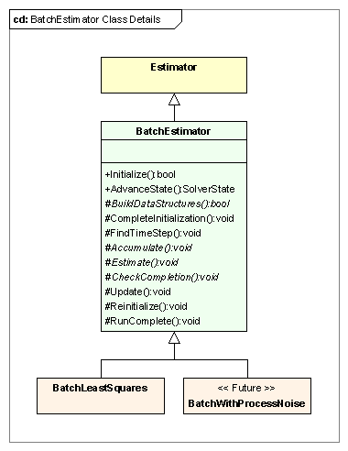
Figure 4: The BatchEstimator Class

Key Processes
The BatchEstimator class implements a basic finite state machine that follows a typical batch estimation process. There are two processes that work together to implement the state machine: initialization of the BatchEstimator and execution of the finite state machine.

Initialization
The initialization process in the Sandbox starts with the object setting phase described in the GMAT run overview. At the end of this phase, all of the references objects have been set on the BatchEstimator object, and it is ready to validate those objects and set the pointers for use in the estimation process. This process is shown in Figure 5.
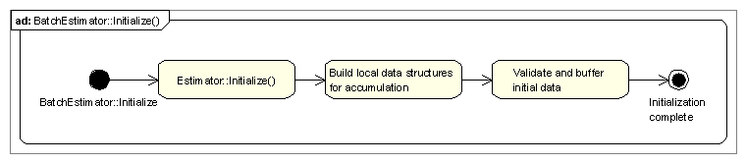
Figure 5: Initialization in the BatchEstimator Class

The initialization process for the BatchEstimator starts by initializing the Estimator base class as described above. Once that process completes successfully, the data structures required for accumulation are prepared. Finally, the initial data are checked to be sure that they contain all of the required data, and that these data are internally consistent, and they are buffered so they can be restored during iteration. This completes the initialization process for the batch estimator.

Estimation State Machine
Figure 6 shows the estimation process implemented in the BatchEstimator class. The batch estimator state machine is shown in the lower partition in the figure, while the actions performed by the command running the state machine are shown in the upper partition. The state machine implementation is key to the estimation process in GMAT, so it will be described in some detail in the following paragraphs.

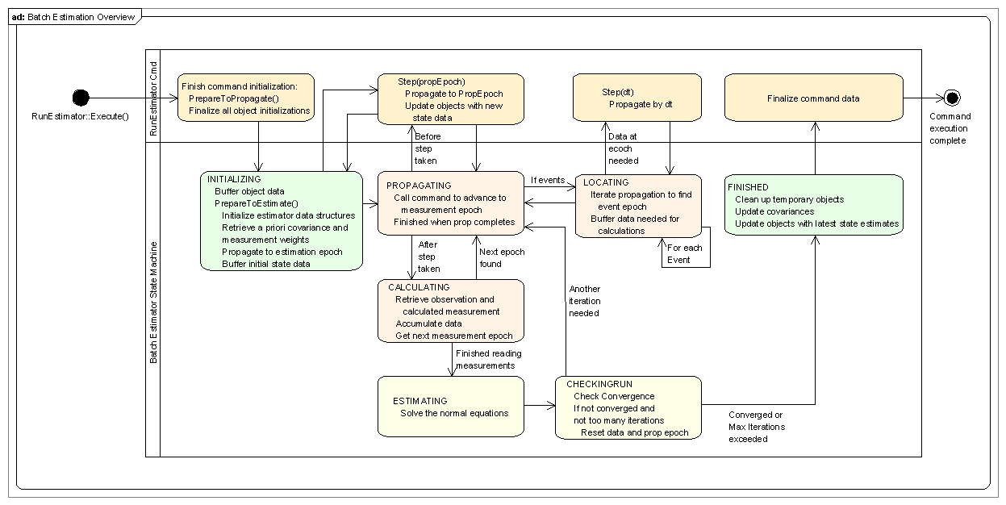
Figure 6: Performing Batch Estimation

GMAT’s Solver State Machines
GMAT’s solver finite state machines are used to move the solution algorithm through the steps required to apply the algorithm to the objects that are used to solve a user specified problem. Each step of the process is represented by a discrete numerical identifier, referred to as the state of the process. That identifier is used to specify a set of actions that, when performed, prepare the finite state machine to advance from its current state to the next state in the solution process. The state identifiers are defined in a C++ enumeration, the SolverState enumeration in the Gmat namespace.

Each state in the solver state machine performs actions designed to move the elements of GMAT from their entry condition to the condition required to advance to the next state. GMAT advances from one state to the next using the AdvanceState() method on the solver. When AdvanceState() is called, the solver executes a method assigned to the state and reports the results to the solver’s text file. The method call is responsible for running the actions assigned to the state, and then determining the next state and changing the state identifier accordingly based on the results of the actions executed.

The BatchEstimator Finite State Machine
The BatchEstimator uses seven states to drive its algorithm. These seven states, shown in the bottom partition of Figure 6, work together to estimation a user defined state vector. The list below describes each state of the machine, including the entry and exit conditions along with the internal actions required to move to the exit condition for the state:

- INITIALIZING:
  - Entry condition: The INITIALIZING state is the state the BatchEstimator takes upon completion of initialization in the Sandbox. Upon completion of an estimation run, the BatchEstimator returns to this state so that a subsequent call can reuse the same estimator.
  - Actions Method Name: CompleteInitialization():
    - Determine if any observations are available; if not, abort estimation
    - If necessary, propagate to estimation epoch
    - Gather the data and fill the batch estimator’s state
    - Initialize the state transition matrix
    - Gather a priori covariances and measurement weights
    - Buffer all estimation objects
  - Exit condition:
    - Change to PROPAGATING state if an observation exists. Change to FINISHED state and post a warning message if none were found.
- PROPAGATING
  - Entry condition: An observation was found
  - Actions Method Name: GetStepEpoch()
    - Determine time step for propagation to the observation epoch
    - Feed time step to command for propagation
    - Determine if measurement for the observation has events that require propagation
  - Exit condition 1:
    - Time step = 0
    - No unprocessed propagation events
    - Change state to CALCULATING
  - Exit condition 2:
    - Time step = 0
    - Events that require propagation not yet processed
    - Change state to LOCATING
- LOCATING
  - Entry conditions:
    - An event that requires propagation has been found
    - Resources are at a known epoch for the event
  - Actions Method Name: ProcessEvent(bufferData)
    - If bufferData is true, buffer state information
    - Calculate time step required for the event
    - Provide time step to command for propagation
    - Evaluate event to determine if propagation results are within tolerance
    - Iterate from time step calculation until event converges
  - Exit condition 1
    - Event has converged
    - No additional events found
    - Reset state information to buffered data
    - Set bufferData flag to true
    - Change state to PROPAGATING
  - Exit condition 2
    - Event has converged
    - Another event found
    - Set bufferData flag to false
    - Change state to LOCATING
- CALCULATING
  - Entry condition: Propagation and any required event location has been performed
  - Actions Method Name: Accumulate()
    - Retrieve observation and calculated data
    - Accumulate the data
    - Retrieve the epoch of the next observation
  - Exit condition 1
    - Another observation was found
    - Change state to PROPAGATING
  - Exit condition 2
    - Final observation was processed
    - Change state to ESTIMATING
- ESTIMATING
  - Entry condition:
    - All measurement data has been processed
  - Actions Method Name: Estimate()
    - Solve the normal equations
  - Exit condition:
    - Estimation update generated
    - Change state to CHECKINGRUN
- CHECKINGRUN
  - Entry condition:
    - An estimation update was generated
  - Actions Method Name: CheckCompletion()
    - Check for convergence
  - Exit condition 1
    - Estimation converged within tolerances
    - Change state to FINISHED
  - Exit condition 2
    - Estimation did not converge
    - Maximum number of iterations exceeded
    - Change state to FINISHED
  - Exit condition 3
    - Estimation did not converge
    - Maximum number of iterations not exceeded
    - Reset data and prop epoch through call to Reinitialize()
    - Update state with new estimate through call to Update()
    - Reset measurement iterator to point to first measurement
    - Change state to PROPAGATING
- FINISHED
  - Entry condition: Estimation work finished
  - Actions Method Name: RunComplete()
    - Update covariances
    - Update objects
    - Clean up data structures
    - Report convergence status
  - Exit condition:
    - Change state to INITIALIZING so estimator is reentrant
TBD: Do this state change here, or at prompting from the command?

BatchEstimator Members
BatchEstimator Attributes
The batch estimator does not have any additional attributes visible to the rest of the system. The structures required for accumulation consist of vectors of the processed data required to solve the normal equations. These data structures are algorithm specific, and are defined in the classes derived from the BatchEstimator class.

BatchEstimator Methods
- virtual bool Initialize(): Prepares the estimator for estimation. The initialize method ensures that all of the top level components needed are present for the estimation process, and performs as much pre-run initialization as possible.
- virtual Gmat::SolverState AdvanceState(): Executions the state machine actions necessary to move into a new state, and then advances the state to the next value in the finite state machine’s process.
- virtual void CompleteInitialization(): Completes the initialization process, performs any necessary final propagation to move to the estimation epoch, and buffers the data that needs to be reset each time the batch process starts a new iteration.
- virtual void FindTimestep(): Compares the current state epoch with the next measurement epoch, and computes the time step – in seconds – that the propagator must apply to move from the current epoch to the measurement epoch.
- virtual void Update(): Applies corrections to the state to incorporate the changes necessary to build a new estimated state.
- virtual void Reinitialize(): Resets all of the buffered data so that a new iteration can be performed.
- virtual void RunComplete(): Finalizes all of the data, cleans up memory, and reports the estimation data.

BatchEstimator Abstract Methods
The classes derived from the BatchEstimator class implement batch estimators that differ in the details of the estimator mathematics. At a minimum, the derived classes must implement three methods: an Accumulate() method designed to collect the information needed from a pass through the measurement data, and Estimate() method that applies the batch algorithm to calculate state vector updates for the estimation state, and a CheckCompletion() method that tests the state updates and other criteria to determine if the estimation process should terminate. These methods are listed here:

- virtual bool BuildDataStructures() = 0: Method called by Initialize() to set up object specific data structures for the classes derived from the BatchEstimator class.
- virtual void Accumulate() = 0: Performs data accumulation for the batch algorithm.
- virtual void Estimate() = 0: Applies the batch algorithm to generate a new set of corrections to the estimation state vector at the estimation epoch.
- virtual void CheckCompletion() = 0: Checks to see if the estimation process should terminate, either because of convergence or for another reason.

The BatchLeastSquares Class

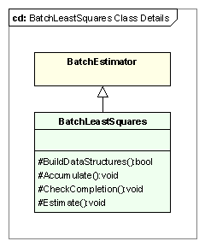
Figure 7: The BatchLeastSquares Class

Key Processes
The key processes performed by the BatchLeastSquares class are described in the parent class’s text. The BatchLeastSquares class does not provide any additional process level elements. It does provide a specific implementation of the batch least squares algorithm, captured in the implementation of the four abstract methods BuildDataStructures(), Accumulate(), Estimate(), and CheckCompletion().

BatchLeastSquares Members
BatchLeastSquares Attributes
The BatchLeastSquares estimator does not require any new data members that need description at this level of the design.

BatchLeastSquares Methods
- virtual bool BuildDataStructures(): Method called by Initialize() to set up the data structures used for accumulation in the BatchLeastSquares estimator.
- virtual void Accumulate(): Collects the observed less calculated data and derivative information needed to build the normal equations.
- virtual void Estimate(): Solves the normal equations, generating the corrections that apply to the estimation state vector to construct a new estimate.
- virtual void CheckCompletion(): Checks the estimate to see if the estimation has converged or if another stopping criterion has been met. If not, the most recent state corrections are applied to the estimation state vector.

The BatchWithProcessNoise Class
This class is not scheduled for implementation in the initial estimation-enabled release of GMAT. The class will be defined when implementation is scheduled.

The Filter Class

Key Processes

Initialization

Filter Members
Filter Attributes

Filter Methods

The SRIF Class
This class is not scheduled for implementation in the initial estimation-enabled release of GMAT. The class will be defined when implementation is scheduled.

Key Processes

Initialization

SRIF Members
SRIF Attributes

SRIF Methods

The ExtendedKalmanFilter Class
While part of the initial estimation release, this class is not scheduled for implementation in the initial estimation-enabled build of GMAT. The class will be defined when implementation is scheduled so that we can capitalize on lessons learned implementing the batch estimator.

Key Processes

Initialization

ExtendedKalmanFilter Members
ExtendedKalmanFilter Attributes

ExtendedKalmanFilter Methods

“State” in the context of a finite state machine corresponds to the status of the machine. This is distinct from the state vector used by an estimator or SpaceObject. When the context does not make the distinction clear, the term “finite state” is used for the state machine states and “state vector” for the data vectors.
The state machine in the figure shows the nominal path through the process. Anomalous paths, like the absence of observation data mentioned here, are not included in the figure.

