Sample script, for reference. Remove from final version.

%----- Create Three Spacecraft and Three Groundstations. For simplicity
%----- we’ll assume the defaults contain the desired settings for these
%----- objects.
Create GroundStation Maui WhiteSands
Create Spacecraft OdSat1 OdSat2 Odsat3OdSat3

% Need to add def’s for antennas here and attach them to the resources

%----- Create a container for two measurement models. The measurements
%----- are Two-Way Range and Doppler between OdSat1’s Antenna1 and Maui’s
%----- Antenna1. (For now we assume the sensors exist).
Create Measurement MyMeas
MyMeas.AddMeasurement = {'TwoWayRange',OdSat1.Antenna1,Maui.Antenna1, …
'Bias',.01, …
'TimeConstant',7200, …
'FileName','..\File1.od'};

MyMeas.AddMeasurement = {'TwoWayDoppler',OdSat1.Antenna1,Maui.Antenna1, …
'Bias',.01, …
'NoiseSigma',.001, …
'TimeConstant',7200, …
'FileName','..\File1.od'};

%----- Create a container for two measurement models. The measurements
%----- are Two Way Range and Doppler between OdSat3 and WhiteSands, and
%----- one way range between ODsat2 and ODsat1. (For now we assume the
%----- sensors exist).
Create Measurement YourMeas
YourMeas.AddMeasurement = {'TwoWayRange',OdSat3,WhiteSands, …
'Bias',.01, …
'TimeConstant',7200, …
'FileName','..\../File1.od'};
YourMeas.AddMeasurement = {'OneWayRange',OdSat2,OdSat1ODSat1, …
'Bias',.01, …
'TimeConstant',7200, …
'FileName','..\../File3.od'};

%----- Create a propagator. Assume the defaults are acceptable.
Create Propagator SimProp;

%----- Create a simulator. Add the measurement objects we would like to
%----- include in the simulation. Specify the measurement time span,
%----- frequency and which propagator to use.
Create Simulator Sim1
Sim1.AddMeasurement = {MyMeas, YourMeas}; % Specify the measurements
% to simulate
Sim1.InitialEpoch = FirstSpacecraftEpoch; % <-- Why not “OdSat1.Epoch”?
Sim1.Duration = 1; % days
Sim1.Frequency = 30; % seconds
Sim1.Propagator = SimProp;

%----- Run the simulator
RunSimulator Sim1;

The Simulator and RunSimulator Classes

The RunSimulator Class
Class diagram
Figure 1: GMAT's RunSimulator Command

The Simulator Class
intro here
Class diagram goes here
Figure 2: The Simulator Class

Key Processes
The Simulator class has two key processes: the Initialize() method, which initializes its management members and prepares its propagation subsystem for initialization, and the AdvanceState() method, which drives the simulation state machine.

Simulator Initialization

The Simulation State Machine

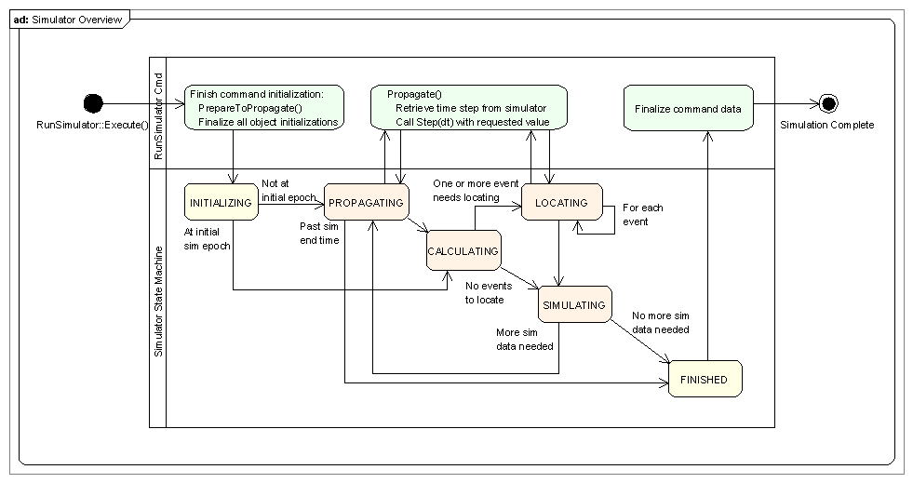
Figure 3: The Simulation Process

Estimator Members
Estimator Attributes
- StringArray measurements: Names of the measurement types used in this simulator. This array of names is passed to the MeasurementManager for processing.
- std::string propName: Name of the configured propagator used to evolve objects during the simulation process.
- MeasurementManager measManager: The MeasurementManager for the simulator
- GmatState *simulationState:
- PropSetup *propagator: The propagator configured for the estimation.
- GmatEpoch simulationEpoch:
- GmatEpoch simulationStart:
- Real simulationDuration:

Simulator Methods
- bool Initialize():
- Gmat::SolverState AdvanceState():

