This is a small file to incorporate in the big one

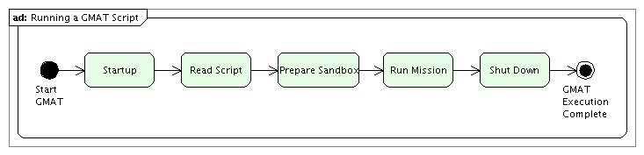
Figure 1: GMAT Run Overview – Running a Script

That’s the top level picture.

Figure 2 shows the first level expansion.

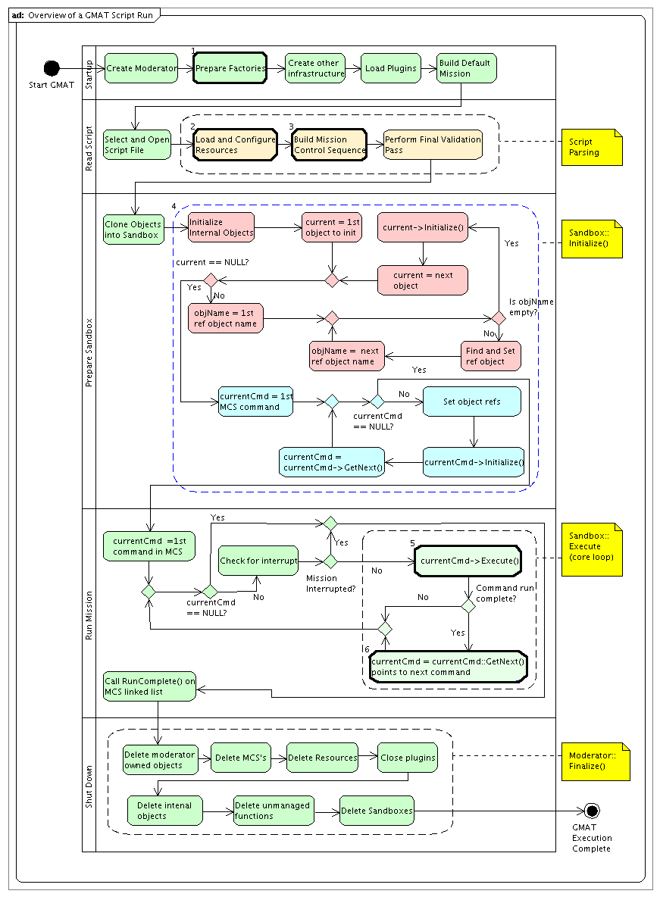
Figure 2: GMAT Run Overview – Top Level Action Details

Applying this overview to the estimation scripting associated with the BLS BatchEstimator, we find that there are specific actions in the activities labeled 2 and 4 in the diagram associated with the object creation and initialization. These actions are shown in Figure 3. The scripting illustrated there are these lines:

%=================================================================
%------ Define the batch least squares solver
%=================================================================
Create BatchEstimator BLS
BLS.MaxIterations = 10;
BLS.RelTolerance = 1e-5;
BLS.AbsTolerance = 1e-5;
BLS.Measurements = {'MauiData'};
BLS.SolveFor = {'ODSat.CartesianState'};
BLS.Propagator = 'ODProp';

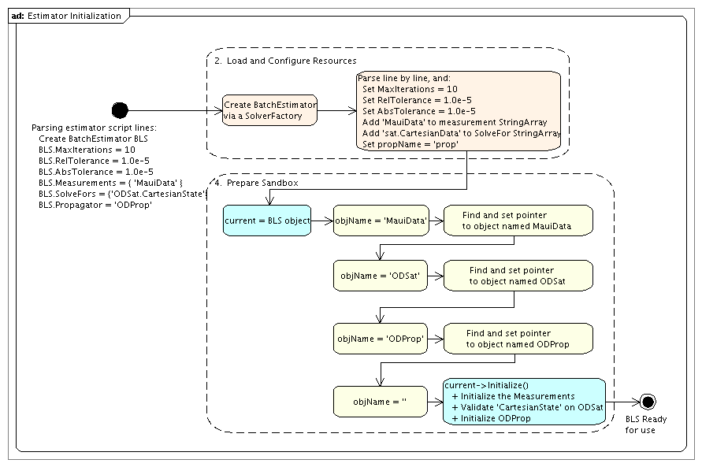
Figure 3: Estimator Initialization for the BLS BatchEstimator

