GMAT-EDD-001

595 / Mission design and navigation branch

General Mission Analysis Tool (GMAT)
Estimation Design Document
GSFC / Mission Design and Navigation Branch
AFRL / Research and Development Site Maui

Version 0.5



CHECK THE GSFC CENTRALIZED CONFIGURATION MANAGEMENT SYSTEM AT:
PRIOR TO USE TO VERIFY THAT THIS IS THE CORRECT VERSION

This page is left intentionally blank.

General Mission Analysis Tool (GMAT)
Navigation Feature Design Document
Version 0.5

Prepared By:
____________________________________________
Darrel J Conway Date
Thinking Systems, Inc.

____________________________________________
Steven P. Hughes Date
NASA Goddard Space Flight Center

____________________________________________
Mathew P. Wilkins Date
The Schafer Corporation

____________________________________________
J. R. Carpenter Date
NASA Goddard Space Flight Center
Approved By:
____________________________________________
Name Date
Title
Organziation

____________________________________________
Name Date
Title
Organziation

This page is left intentionally blank.

Table of Contents
1 Introduction 7
2 Definitions and Terminology 7
3 Requirements 8
4 Use Cases 8
5 User Perspective 10
6 Architectural Overview 12
6.1 Classes and their Responsibilities 12
6.1.1 Resources 13
6.1.2 Commands 15
6.1.3 Helper Classes 15
6.2 Collaboration between Classes 16
7 Walkthrough of Sample Script Execution 18
7.1 The Sample Script 18
7.2 Overview of a GMAT Run 20
7.3 Script Execution Walkthrough 23
7.3.1 Block 1: Prepare Factories 23
7.3.2 Block 2: Load and Configure Resources 24
7.3.3 Block 3: Build Mission Control Sequence 26
7.3.4 Block 4: Prepare Sandbox 27
7.3.5 Block 5: Execute() and Block 6: GetNext() 30
8 OD Component Design 32
8.1 State Manager Classes 32
8.1.1 GmatState Class 33
8.1.2 StateManager Base Class 34
8.1.3 EstimationStateManager Class 36
8.1.4 PropagationStateManager Class 38
8.1.5 The ListItem Structure 39
8.2 Estimator Related Classes 40
8.2.1 Estimator and RunEstimator Interactions 40
8.2.2 Command Usage in GMAT 40
8.2.3 Estimation Command Overview 41
8.2.4 The RunEstimator Command 43
8.2.5 The Estimator Classes 46
8.2.6 The Estimator Base Class 47
8.2.7 The BatchEstimator Class 50
8.2.8 Estimation State Machine 51
8.2.9 BatchEstimator Members 55
8.2.10 The BatchLeastSquares Class 56
8.3 The Simulator and RunSimulator Classes 58
8.3.1 The RunSimulator Command 58
8.3.2 Class Design 60
8.3.3 RunSimulator Members 61
8.3.4 The Simulator Class 62
8.4 Measurement Related Classes 66
8.4.1 Measurement Base Class 67
8.4.2 GroundStationMeasurement 69
8.4.3 GroundStationRange 71
8.4.4 Measurement Manager 72
8.4.5 MeasurementReader Helper Class 73
8.4.6 Simulator Class 75
8.4.7 Run Simulator Commnad 75
8.5 Propagation and Event Location Classes 75
8.5.1 Propagator Class 75
8.5.2 Event Locator Class 75
9 Process for Adding new Features 76
9.1 How to add a new solve-for or consider parameter 76
9.2 How to add a new estimator 76
9.3 How to add a new dynamics model 76
9.4 How to add a new measurement model 76
10 Appendix 1: Simulation Sample Script 76
11 Acronym List 77
12 References 77

This page is left intentionally blank.

Open Issues:
- Fix text to use new measurement terminology.
- Separate factories are provided for these elements. (what does this mean??)
- Fix ObservationReader – File Reader terminology.
- Should measurements have a propagator of their own?
- Simulator requirements/Use case
- Output requirements
- Incorporate new comments for LOJ, JRC, and CS.
- How will we specify to include measurement bias etc as solve fors.
- Does ESM handle consider parameters
- How should we handle sparse matrices in ESM and estimator
- How do you save H’H and H’y, or some other matrices, for later processing.

Introduction

This document describes a design approach for extending GMAT functionality to include estimation capabilities. Implementing estimation functionality in GMAT requires that new objects and commands be implemented and that modifications are made to some existing objects and commands. Additionally, several new helper classes must be developed to act as mediators between OD components and other components such as propagators.
We begin by defining preliminary requirements placed on GMAT to support navigation functionality. Development of navigation features will proceed using an iterative development and the complete set of requirements cannot be fully anticipated. For this reason, extensibility requirements are levied to ensure that design decisions made now anticipate predictable future requirements. After presenting the requirements, we present several use cases that demonstrate how a user will interact with GMAT to solve navigation problems.
The design of the navigation components is presented in sections 5, 6, and 7. Each section addresses more detailed design issues than the previous section. Section 5 discusses the classes that are required for navigation functionality, the primary responsibilities of those classes, and the allowable class interactions. Section 6 presents a walkthrough of the execution process for a simple navigation sample script. An overview of the GMAT execution process is presented and we identify constraints on navigation components that are imposed by GMAT’s architecture. Next, we step through the execution of the use case script and explain how each new navigation component behaves during execution. Chapter 7 presents the component level design including member data and methods along with algorithms and discussion of complex methods when necessary.

Definitions and Terminology

Measurement Model Class: The class that contains the model for a measurement and provides the event function, visibility function, computed value, and measurement partials.

Measurement Value: the numeric value of a measurement. There are two types: Observed measurement value (OMV), and computed measurement value (CMV).

Measurement Object Class: The object created by the user from a script. This object is a container for measurement model objects, which are instantiations of the measurement model class.

Primitive Measurement: A fundamental measurement used to construct compound measurements. Examples include angles, one-way range, one-way range rate among others.

Compound Measurement: A measurement constructed from a sequence of primitive measurement types. Examples include two-way range, (any two-way measurement), TDRSS measurements and many others. There are two types of compound measurements: custom, and user defined. Custom measurements include.

Requirements

These are now tracked in the GMAT Requirements Specification.

Use Cases

The use cases below illustrate possible interactions between a navigation analyst and GMAT. For each use case, we present a summary, a rational, preconditions, and post conditions. Next, we present a sequence of steps the user will follow to perform the analysis. Alternative paths are presented that illustrate variations on the main use case scenario that share most of the steps in the basic sequence of events.

Name: | UC-1 Measurement Simulation
Summary | The user simulates several measurement types between a set of spacecraft and a set of ground stations.
Rational | This is the most basic example of measurement simulation.
Users | Navigation analyst.
Preconditions | - Open version of GMAT.  - Known satellite Ids.  - Known ground station Ids.  - Assume dynamics model is point mass Earth, Sun, Moon.
Basic Course of Events | - The user creates three spacecraft objects, names them OdSat1, OdSat2, and OdSat3. The user sets the spacecraft Id and the state on all spacecraft.  - The user creates two ground station objects and configures them to Maui and WhiteSands.  - The user creates and configures a propagator named SimProp.  - The user creates a measurement object named MyMeas and configures it to contain two-way range and Doppler measurements between OdSat1 and Maui. The user specifies the initial bias, standard deviation, and time constant for the measurement noise. The user sets the file for both measurements to be File1.od.  - The user creates a measurement object named YourMeas and configures it to contain two-way Doppler measurements between OdSat2 and WhiteSands. The user configures the object to contain a one-way range measurement between OdSat2 and OdSat3. The user specifies the initial bias, standard deviation and time constant for the measurement noise. The user sets the file for the Doppler measurement to be File1.od and the file for the inter-spacecraft range to be File2.od.  - The user creates and configures a simulator. The user specifies that measurements defined in MyMeas and YourMeas objects are to be simulated. The user specifies the simulation time span and frequency, and provides a propagator to use for simulation.  - The user runs the simulator.  - The user opens the text file containing the simulated data and inspects the data.
Alternative Paths | - In step 4, the user also adds Ra and Dec to the measurement object.
PostConditions | - Files with requested measurement data exists in requested location and format.

Name: | UC-100 LEO Batch Estimation
Summary | The user applies Batch Least Squares to process range measurements between a single LEO spacecraft and a single ground station, solving for the spacecraft Cartesian state.
Rational | This is perhaps the most basic end-to-end example for practical estimation.
Users | FDF, navigation analyst.
Preconditions | - Open version of GMAT with range measurement file generated using the procedures in UC-1.  - Known satellite Id and initial guess for spacecraft state.  - Known ground station location and sensor Id.  - Known a priori covariances for spacecraft and ground station.  - Known measurement noise covariance.  - Assume dynamics model is point mass Earth, Sun, Moon.
Basic Course of Events | - The user creates a spacecraft and sets its Id using the known value and sets the Cartesian state to the values provided in the initial guess.  - The user creates the ground station and sets its location and Id.  - The user creates and configures a propagator using the assumed dynamics model.  - The user creates a measurement object and provides the location and format the of measurement data file.  - The user specifies that the range and only the range measurement should be processed from the file.  - The user creates a batch estimator and adds the measurement object created in step 5 above and the propagator created in step 4.  - The user configures the solve-for parameters to include the spacecraft Cartesian state only.  - The user creates a report file and includes the spacecraft Cartesian state in the report.  - The user adds a RunEstimator command to the mission sequence.  - The user requests that the system show plots of the residuals updated during the estimation process.  - The user saves the file.  - The user runs the mission.
Alternative Paths | - In step 1, the user specifies the a-priori spacecraft covariance for the spacecraft. In step 6 the user configures the estimator to use a-priori covariance.  - In step 2, the user specifies the a-priori covariance for the ground station location. In step 6 the user configures the estimator to use a-priori covariance.  - In step 5, the user specifies the measurement noise covariance.  - In step 5, the user specifies that range rate, and Ra/Dec measurements should be processed in addition to range.  - In step 6, the user sets the estimation anchor time to be the epoch of the last observation.  - In step 6, the user specifies that solve-fors should include measurement bias and station location in addition to the spacecraft Cartesian state.  - In step 6, the user specifies that the measurements should include corrections for light travel, troposphere, and ionosphere.
PostConditions | TBD

User Perspective

To uniquely define an orbit determination problem, a user must often provide hundreds of pieces of information including clock drift parameters, process noise characteristics, spacecraft physical properties, ground station properties, and atmospheric modelling parameters among others. The objects and supporting data for OD in GMAT are summarized in Fig. 1. The logical organization places key physical and computational elements into one of five categories: (1) Measurement Participants, (2) Sensors, (3) Estimators, (4) Measurements, and (5) Dynamics. In GMAT, the user has access to the objects shown in Fig. 1, and can configure the data identified on each object in a gray bubble. A yellow bubble indicates that the user must attach a previously created and configured object of the identified type. Below we briefly discuss each logical category of object from a user perspective, starting with measurement participants.

Measurement participants are models of physical objects that “participate” in the process of generating a measured quantity that is related to the spacecraft state. Examples of measurement participants include spacecraft, ground stations, and celestial objects. In GMAT, measurement participants are created and configured separately from measurement objects (which are discussed below). For example, if a user requires a Doppler measurement between, for example, Hubble and Canberra, she first configures a spacecraft to model Hubble, and then she configures a ground station to model Canberra.

The sensor models contained in GMAT include, but are not limited to, clocks, receivers, transmitters, transponders, and lasers. A user can create and configure sensors for his application and attach the sensor to the appropriate parent object, such as a spacecraft or ground station.

Measurement objects are complex and a large amount of user-provided data is required to perform the functions described above. In GMAT, a measurement provides the following data: (1) computed measurement values, (2) measurement partial derivatives, and (3) measurement feasibility event data.

GMAT will support several estimators including batch, sequential, and initial orbit determination solvers. These algorithms solve for a state estimate by processing measurements generated by measurement objects configured by the user. Hence, the user provides a list of all measurements to include in a particular estimation run. In addition, the solver object is where the user specifies which parameters are to be treated as solve-for and consider quantities.
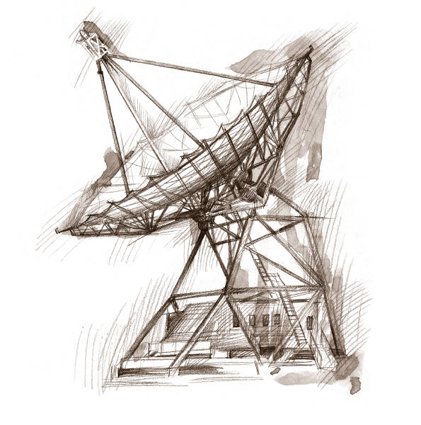
The Real-World View
A ground station signal sends a signal to a spacecraft and the spacecraft sends a return signal. The transfer time is converted to a two-way range measurement
A spacecraft object
A ground station object
A measurement
model object
Script View : Three objects are involved: a spacecraft, a ground station, and a measurement model. The measurement model simulates the process of uplink and downlink and provides a computed measurement value .
GMAT Object View
Three objects are involved: a spacecraft, a ground station, and a measurement model. The measurement model simulates the process of uplink and downlink and provides a computed measurement value .
Create Spacecraft ODSat

Create Measurement MyData
MyData.AddModel = {‘TwoWayRange’,ODSat,Maui}

Create GroundStation Maui

Propagators are used in two areas for estimation problems. Propagators are attached to an estimator to propagate all objects associated with solve-for and consider parameters and computed measurement values. For these cases, a user creates and configures a propagator just like in a mission analysis problem. A separate propagator can be provided so that simulated observations use different dynamics than those used for the computation of expected values.

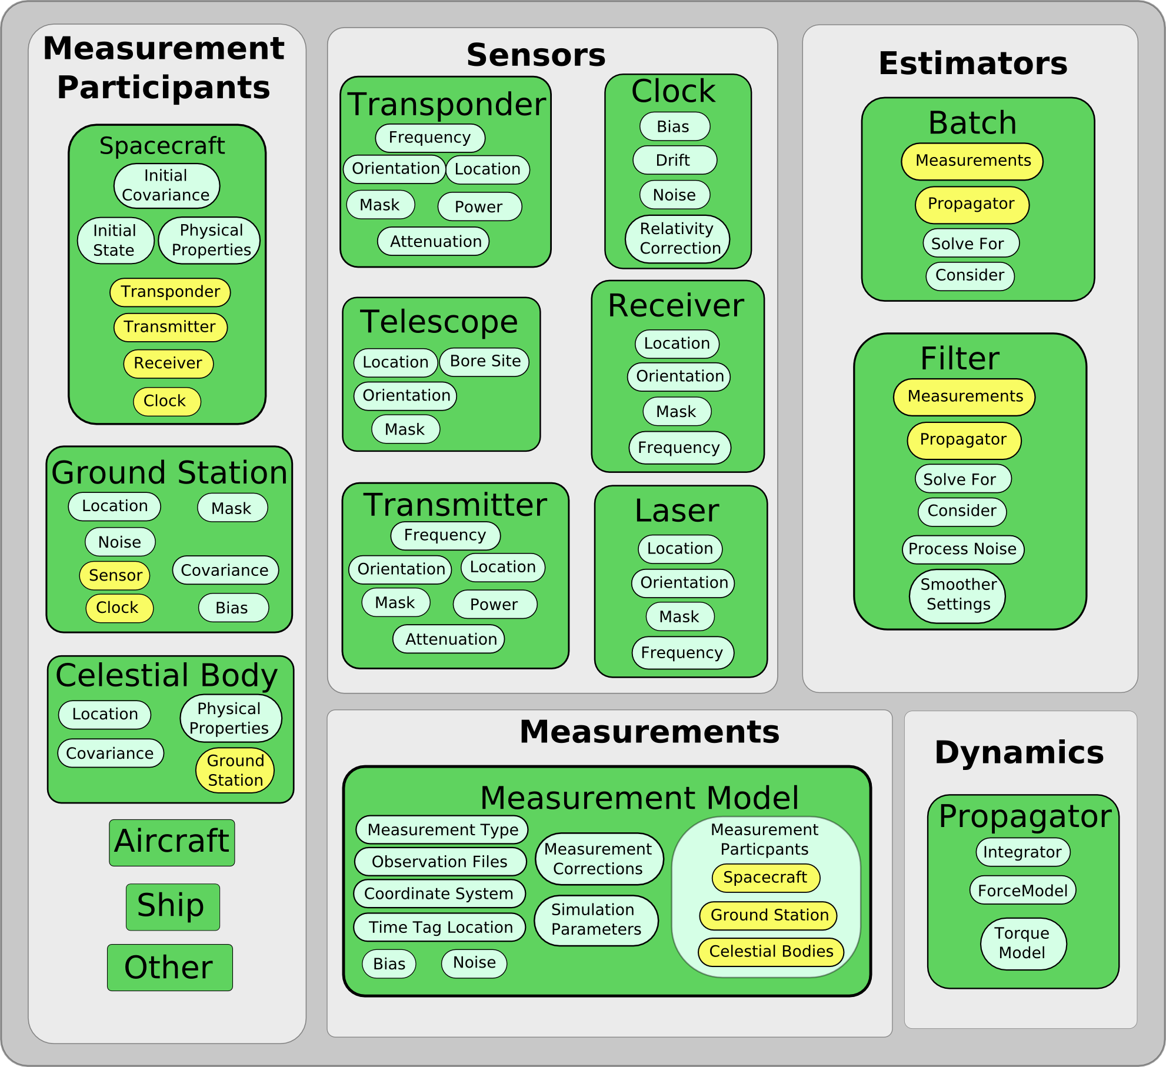
Figure 1: Logical Grouping of OD Objects

Architectural Overview

Below we present the highest level view of the proposed architectural design for estimation functionality in GMAT. We employ the Classes, Responsibilities, and Collaborations (CRC) method discussed by Eckel [1] to describe the architecture. We start by describing the classes and their responsibilities. For each class we present a description and a bulleted list of primary responsibilities. Next, we discuss the allowable interactions and collaborations between the classes. A diagram is presented that illustrates which classes/components can communicate with each other. For each allowable communication between classes, we discuss the motivation for the interaction

Classes and their Responsibilities

There are currently 10 classes required for estimation in addition to core GMAT classes such as the Moderator and Factory subsystems. We only discuss classes relevant to the estimation problem here and these classes are shown in the list below. (* means new class required for estimation)

- Resources
  - Spacecraft and other participants (ground stations, etc.)
  - Estimator*
  - Measurement*
  - Simulator*
  - Propagator
  - Event Locator*
- Commands
  - RunEstimator Command*
  - RunSimulator Command*
- Helper Classes
  - Measurement Manager*
  - State Manager*
    - Propagation State Manager
    - Estimation State Manager*
  - File Reader and database*

Each class in the list has specific responsibilities and, except for special cases, all of the classes above are employed to solve estimation problems in GMAT. Let’s discuss the responsibilities of each class.

Resources

Spacecraft and other Participants: Participants are models of physical objects and processes that partake in the measurement generation process. For a GPS measurement, the participants are the user spacecraft and the GPS constellation. For an altimeter measurement the participants are the spacecraft, and the central body. Participants such as spacecraft and ground stations already exist in GMAT, but will require modification to support estimation. In the long term, participants such as the TDRSS and GPS constellations and other Celestial bodies must be added to the system.

The classes for all measurement participants must contain specific functionality in order to support the modeling of measurements and other estimation related models. All participants must have methods to get and set specific types of data such as state data, state transition matrix data, and covariance data among others. In summary, participants must support the following get/set methods:
- Get State / Set State
- Get STM / Set STM
- Get Covariance / Set Covariance

Estimator Class: The estimator class is the base class for all estimators. Estimators take observed and computed measurement values, and potentially measurement partial derivatives, and generate a sequence of state estimates until convergence or until stopping criteria are met. The estimator class contains the numerical methods such as batch least squares or the extended Kalman filter. In fact, most of the work involved in generating computed measurement values, including evaluating measurement models, determining visibility conditions, and applying measurement corrections, are invisible to the estimator class. Those functions are performed by two helper classes that provide bookkeeping and interfacing between the estimator and the measurement objects and participants. These helper classes are called the Estimator State Manager and the Measurement Manager and are discussed below. The primary responsibilities of the Estimator are:
- Generate state estimates given observed and computed measurements, partial derivatives, weights, and a-priori covariances.

Measurement Class: The measurement class is the base class for all measurements. For each measurement type such as GPS, TDRSS, and ground station, there is a class derived from the measurement base class. Similarly, for each measurement data type such as GPS pseudorange, or ground station right ascension and declination, there is a class derived from the appropriate parent class such as GPSMeasurement or GroundStationMeasurement. The measurement class performs modeling of expected measurements, given the participants in the measurement process. These modeling functions include calculating expected measurement values including corrections, calculating measurement partials, determining if the states of participants meet visibility and other conditions that are required for measurement feasibility, and providing event function data for the iterative determination of light time corrections. In summary, the measurement class has the following primary responsibilities:
- Calculate expected measurement values and measurement partials given the participants involved in the measurement process.
- Determine if criteria are met for measurement feasibility.
- Provide event function for tracking schedule generation and interface with event locator.
- Provide event functions and interface with event locator for iterative determination of light time correction, and propagation through deterministic event times such as averaging intervals.

Simulator Class: The primary responsibility of the Measurement Simulator class is to simulate measurement observations. To perform its responsibilities, a simulator is provided a simulation time span and step size, a set of desired measurements to simulate, and the participants for the measurements, along with a propagator to use for propagation of the system. Similar to the estimator class, most of the work involved in generating simulated measurement values is invisible to the simulator class. For example, determining measurement feasibility, evaluating measurement models, and applying measurement corrections and errors are performed by the measurement objects themselves. The primary responsibilities of the Estimator are:
- Generate simulated measurement values.

Event Locator Class: (Not Implemented in Prototype) The event locater is a helper class for a propagator and controls propagation during the location of discrete events such as eclipse entry or measurement light time correction. The event locator tracks event function root values during propagation and lets the propagator know when a discrete event has been bracketed. To locate an event, iterative root finding methods on the event locator control the propagation. In summary, the responsibilities of the Event Locator are
- Bracket event function roots by identifying two points that surround a root
- Iteratively solve for event function roots by controlling propagation steps.

Commands

RunSimulator Command: Need Text.

RunEstimator Command: The RunEstimator command is used to tell GMAT to solve an estimation problem (when events or maneuvers are not involved). The user specifies an estimator for the problem, and the RunEstimator command and the estimator work together to perform the functions of a finite state machine. Depending upon the state, such as, for example, Initializing or Calculating, either the RunEstimator Command or Estimator will be driving the estimation process. The RunEstimator command also has basic “housekeeping” responsibilities required of all GMAT commands. These include checking for user actions such as hitting the stop button. In summary, the responsibilities of the RunEstimator command are:
- Collaborate with estimator to run the state machine
- Perform initialization and finalization of the estimation processes
- Check for user interrupt.

Helper Classes

Measurement Manager Class: The measurement manager (MM) is a helper class for the estimator class and performs data management and interfacing between the estimator and the measurement objects. A measurement manager has two areas of responsibility: sorting and bookkeeping observed values that may come from numerous files or data streams, and calling the appropriate measurement object to determine computed measurement values and partial derivatives. The estimator does not communicate directly with the measurement objects. This is the job of the measurement manager and it coordinates measurement information among all the measurement objects being used during an OD process. The MM calls the file reader for each data file and then sorts all observations into time-wise order. During the estimation process, the estimator calls the measurement manager and requests observed and computed values at the current epoch, as well as the measurement partials. The measurement manager then calls the appropriate measurement to determine the computed measurement value and the array of partial derivatives. In summary, the measurement manager class has the following responsibilities
- Book keep observed values from observation data files and sort the observation data in time order for use by the estimator.
- Provide the estimator with a time ordered array of measurement epochs.
- Provide the estimator with observed and computed measurement values, and partial derivatives at the current measurement epoch.
- Provide measurement weights to the estimator

Estimator State Manager Class: The estimator state manager (ESM) retrieves state data from objects involved in estimation and provides the data in a form ready for use by the estimator. Hence, much of work performed by the ESM is getting and setting state data, including state transition matrix and covariance information, so that the estimator methods do not have to interact with all of the participant objects. For example, after an iteration (for Batch) or state update (for sequential), the ESM maps the new estimated state vector to the participating objects. Similarly, when an estimator needs the STM, the ESM retrieves the portions of the STM from the objects involved in estimation and assembles the complete STM and provides it to the Estimator. In summary, the responsibilities of the ESM class are:
- Get/Set state portions on objects involved in estimation and assemble the complete state vector.
- Get STM chunks from objects involved in estimation and assemble the total STM for the estimator.
- Get/Set state covariance chunks and assemble the entire covariance matrix.

File Reader/Writer: The DataFile base class defines the methods and procedures to provide data accessibility to other GMAT components. These methods include being able to move from one data record to the next, as well as being able to request individual pieces of data without knowledge of a specific data format. The base class also provides general methods to appropriately handle the basic categories of data formats. The responsibilities of the file reader/writer class are
- Read all or part of a date file.
- Provide data of the requested type to the measurement object.
- Write simulated data to the requested file format.

Propagator State Manager: The propagation state manager (PSM) retrieves state data from objects involved in propagation and provides the data in a form ready for use by the propagator. Hence, much of work performed by the PSM is getting and setting state data. For example, after an integration step the ESM maps the state vector to the participating objects. Similarly, when a propagator needs the initial state vector, the PSM retrieves the portions of the state from the objects involved in propagation and assembles the complete state vector and provides it to the propagator. In summary, the responsibilities of the PSM class are:
- Get/Set state chunks on objects involved in propagation and assemble the complete state vector.

Collaboration between Classes

The design of the estimation system limits interactions between components, in order to promote loose coupling, a design principal used throughout GMAT. Below, we discuss which components can interact, and similarly, which components cannot interact.

There are three logical organizations of classes used in the orbit determination process:
- User configured resources
- Estimation commands
- Helper classes

Examples of resources include measurement participants (with attached sensors), measurements, propagators, and estimators. The helper classes include the EstimationStateManager (ESM), Propagation State Manager (PSM), the Measurement Manager (MM), and the Event Locator (EL). Currently, the only supported estimation commands are RunEstimator and RunSimulator.

Figure 2 contains an illustration all of the components involved in the estimation process, and shows which components can interact via arrows between the components. The interactions are discussed in more detail below.

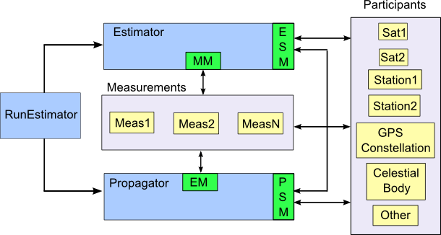
Figure 2: OD Components and Interaction

Estimator -> ESM: The ESM is an “owned-object” of an estimator. The estimator interacts with the ESM to get/set state related data from/on estimation participants. The estimator communicates with the ESM through several interfaces depending upon the type of state data such as STM, covariance, or state vector.

ESM - >Participants: The ESM communicates with participants to set and get state related data.

Measurements->Participants: Measurements communicate directly with measurement participants/sensors. Measurement objects have pointers to all measurement participants in the measurement and therefore have direct access to public state data required to calculate measurement values and partial derivatives.

PSM -> Participants: The PSM communicates with participants to set and get state related data. This interface is similar to the ESM->Participants interface, except the PSM and ESM may not manipulate the same state data.

ESM -> PSM: The PSM and ESM interact during initialization. The ESM provides the PSM with a list of objects and IDs that are involved in the estimation process. The PSM uses this information to determine which states require propagation, and how those states should be propagated (analytically or numerically). In terms of the component level design, the PSM uses the data provided by the ESM to generate the ListItem structure discussed in detail in the Component Design section.

RunEstimator -> Propagator: The RunEstimator command communicates with the propagator to perform initialization and to propagate estimation participants.

RunEstimator -> Estimator: The Estimator and the RunEstimator command function as a finite state machine. This is a complex interaction described in detail in later sections.

MM -> Measurements: The measurement manager interacts with measurements during initialization and execution. During initialization, the measurement manager calls each measurement object’s Initialize() method and calls its GetObsData() method to get the arrays of epochs, observations, and pointers to the measurement data objects. During execution, the measurement manager calls the Evaluate() and GetPartials() methods on the measurement object.
Estimator -> MeasurementManager: The estimator interacts with the measurement manager to get computed measurement values and partial derivatives and other measurement related information.

Walkthrough of Sample Script Execution

In this section, we present a simple estimation example in script form and show at an intermediate level how GMAT would load and execute the script. The first subsection contains the sample script. The next subsection contains a general discussion of the steps GMAT uses to execute any script. We identify 6 key areas in the execution process that must be addressed in the design of new estimation components and conclude the section with a more detailed discussion of what happens for the new estimation components in those 6 key areas.

The Sample Script

The sample script used for the execution walk-through has 5 objects: a spacecraft named ODSat, a ground station called Maui, a batch estimator called BLS, a measurement object named MauiData, a propagator named ODprop, and a RunEstimator command. The system processes range measurements between Maui and ODsat using a batch least squares estimator. The solve-for states are the Cartesian states of the spacecraft.

%==========================================================================
%------ Define the spacecraft properties
%==========================================================================
Create Spacecraft ODSat;
ODSat.Id = 21639;
ODSat.Epoch = 24228.72771990741;
ODSat.X = 9882.164071524565;
ODSat.Y = -23;
ODSat.Z = 1837.579337039707;
ODSat.VX = 0;
ODSat.VY = 6.233189510799131;
ODSat.VZ = 0.8480529946665489;
ODSat.OrbitCovariance = diag([100000^2*ones(3,1);1000^2*ones(3,1)]);

%==========================================================================
%==========================================================================
%------ Define the batch least squares solver
%==========================================================================
%==========================================================================
Create GroundStationMeasurement MauiData;
MauiData.Filename = 'LEOMaui.mat';
MauiData.AddDataType = {'Range','ODSat','Maui'};

%==========================================================================
%------ Define the batch least squares solver
%==========================================================================
Create BatchEstimator BLS
BLS.MaxIterations = 10;
BLS.RelTolerance = 1e-5;
BLS.AbsTolerance = 1e-5;
BLS.Measurements = {'MauiData'};
BLS.SolveFor = {'ODSat.CartesianState'};
BLS.Propagator = 'ODProp';

%==========================================================================
%----- Define the ground station properties
%==========================================================================
Create GroundStation Maui;
Maui.Id = 222;
Maui.X = -4450.8;
Maui.Y = 2676.1;
Maui.Z = -3691.38 ;

%==========================================================================
%----- Define the Propagator
%==========================================================================
Create ForceModel ODProp_ForceModel;
GMAT ODProp_ForceModel.CentralBody = Earth;
GMAT ODProp_ForceModel.PointMasses {Earth};

Create Propagator ODProp;
GMAT ODProp.FM = ODProp_ForceModel;
GMAT ODProp.Type = RungeKutta89;
GMAT ODProp.InitialStepSize = 60;
GMAT ODProp.Accuracy = 9.999999999999999e-12;

%==========================================================================
%----- Solve the estimation problem
%==========================================================================
RunEstimator BLS;

Overview of a GMAT Run

Figure 3 shows a high level view of the path through a run of a GMAT script. When a user wants to run a GMAT script, she starts by opening the program, launching a set of actions that prepare the system for a run. Once this startup process is complete, she loads the script into memory. This script reading process creates the resources described in the script, loading them into GMAT’s configuration (the container GMAT uses for objects created when building the resources in a script or from the GUI), and builds the commands in the Mission Control Sequence. Next the objects are loaded into the Sandbox, and the Sandbox is prepared to perform the run by initializing all of the objects that were loaded. The mission is run, executing the scripted sequence of commands. Finally, the user closes the program, completing the process.

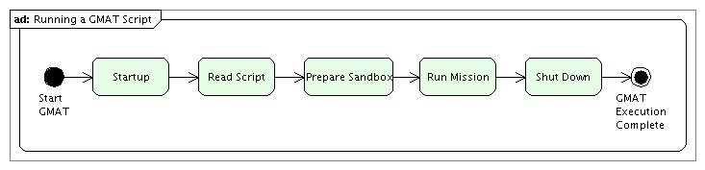
Figure 3: GMAT Run Overview – Running a Script
Figure 4 shows a first level expansion of these steps. The details of the steps shown in that figure can be found in the Architectural Specifications. The blocks that are affected by the new estimation components are numbered in the diagram, and will be discussed in more detail in this document. There are six blocks that will be discussed here:

- Prepare Factories: GMAT uses a set of components, called factories, to create resources, commands for the Mission Control Sequence, and parameters used in calculations during a mission run. New factories will be built to handle the new resources required to run estimation problems in GMAT.
- Create and Configure Resources: When GMAT parses a script, it reads the file one line at a time, building the scripted objects and setting their parameters. Depending on the resource, the parameter setting phase may also include the creation and setting of objects owned by the resource.
- Build Mission Control Sequence: Following the resource definition and configuration steps, the script describes the mission using a sequence of commands tailored to the components supported by GMAT. This sequence of commands is assembled into a linked list of objects called the Mission Control Sequence.
- Prepare Sandbox: GMAT runs missions inside of a component called the Sandbox. When a mission is run, the resources and Mission Control Sequence are loaded into the Sandbox used for the run, interconnections between the components are established, and any pre-run data is set on these components. At the end of this process, the Sandbox is ready to execute the Mission Control Sequence.
- Execute(): Commands in the Mission Control Sequence manipulate the resources in the Sandbox through a call to the Execute() method on each command in the sequence.
- GetNext(): GMAT walks through the Mission Control Sequence by accessing the members of the sequence’s linked list. Movement through the list is performed using the GetNext() method.

These above six portions of a GMAT run are particularly relevant to the new estimation components. The remaining blocks in the diagram may be discussed in passing, but the focus of the descriptions necessary to build the pieces GMAT needs will include discussion of these six elements in more detail.

The sample script presented earlier contains five resources and a command: a Spacecraft named ODSat, a Measurement named MauiData (which contains two owned data members, a MeasurementReader and a GroundstationRange MeasurementData object), a BatchEstimator named BLS, a GroundStation named Maui, a Propagator named ODProp (with an owned ForceModel), and a RunEstimator command. The estimator contains a MeasurementManager and an EstimationStateManager as member objects. Similarly, the propagator contains instances of a PropagationStateManager and an EventLocator. Each of the following sections will conclude with a table reporting the status of GMAT and each of these six objects after the process described in the section has acted on the sample script. Prior to launch of the system, the system description table looks like this:

GMAT Status Before Starting the Program
The program has not yet started.
Object | Status | Notes
ODSat | Not yet created
MauiData | Not yet created
BLS | Not yet created | Once built, includes an EstimationStateManager and a MeasurementManager as members
Maui | Not yet created
ODProp | Not yet created | Once built, includes a PropagationStateManager and an EventLocator as members
RunEstimator | Not yet created

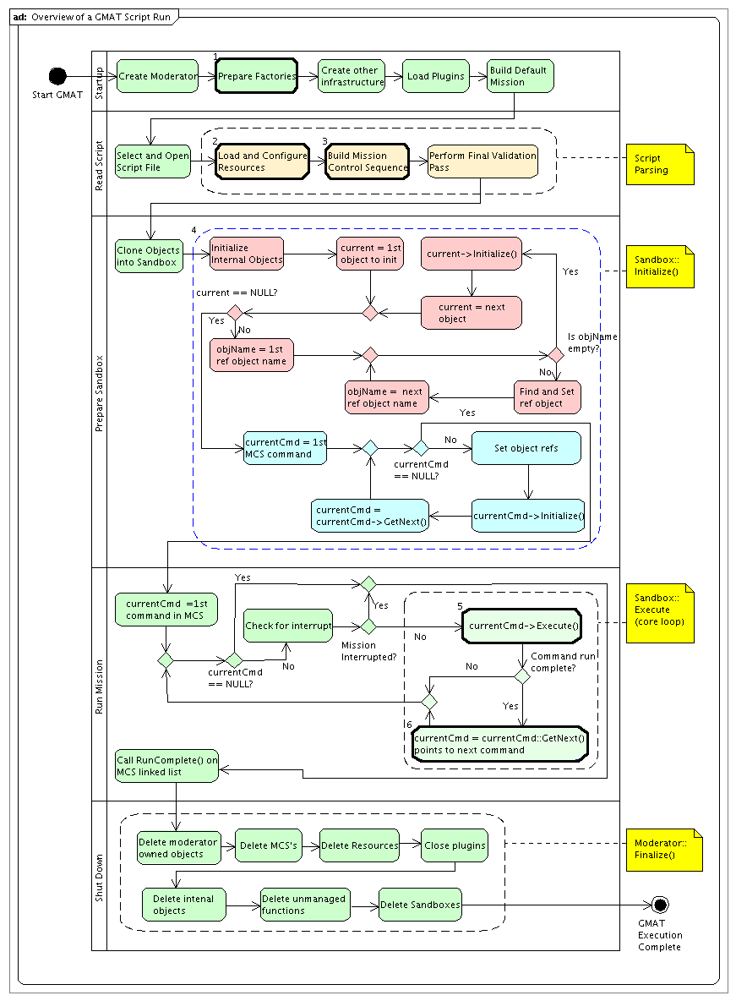
Figure 4: GMAT Run Overview – Top Level Action Details

Script Execution Walkthrough

Block 1: Prepare Factories
GMAT’s Factory subsystem is used to create all scriptable components of the system. The subsystem is an implementation of the Abstract Factory design pattern: it defines the interfaces used for creating user objects and Mission Control Sequence commands, and uses derived Factory classes to provide the implementation for specific class instantiations. The Factory subsystem is managed by a singleton instance of the FactoryManager class. The Moderator calls methods on the FactoryManager to create instances of specific types of objects, identified by the name of the object’s type: Spacecraft, GroundStation, DifferentialCorrector, and so forth. Similarly, the Moderator calls the FactoryManager to create instances of GMAT’s command classes in order to build the Mission Control Sequence.

Each Factory supporting user objects is registered with the FactoryManager when GMAT starts up. The internal factories are registered first, followed by factories contained in plug-in libraries. The addition of estimation capabilities to GMAT necessitates the construction of factories supporting the new types of objects that are used for estimation, along with registration of these new factories with the FactoryManager. The “Prepare Factories” block of the master overview diagram (Figure 4) identifies the location of the factory registration in the life cycle of a GMAT run.

Estimation requires the construction of five (check this) new factories for the internal capabilities being designed here. These new factories are:

- EstimatorFactory: The Factory that creates GMAT’s internal estimators. These components could be added directly to the SolverFactory, since all Estimators are Solvers. The inclusion of a new factory for the Estimator objects keeps the factory subsystem more modular, and will allow for inclusion of the estimation capabilities as a plug-in if desired.
- MeasurementFactory: Measurement objects, a new class of object in GMAT, require a new Factory supporting their instantiation. The Measurement objects include elements that define data types for the measurements and sources for observation data. Separate factories are provided for these elements.
- MeasurementDataFactory: Creates the measurement data objects. The measurement data objects are used to calculate the expected value of a specific type of measurement along with the partial derivatives associated with that value.
- ObservationReaderFactory: Creates the objects used to read and write observation data. The observation data may be fed into GMAT from a data file, a database, or by means of a live data feed. The initial builds of GMAT’s estimation subsystem are designed to work using data from a file.
- EstimationCommandFactory: Creates the commands used in estimation. The inclusion of a new factory for the estimation commands objects keeps the factory subsystem more modular, and will allow for inclusion of the estimation capabilities as a plug-in if desired.

The Moderator creates these factories during system start. Each factory is passed to the FactoryManager once it is created. The FactoryManager obtains the base type of the objects supported by the factory along with a list of the supported types. For example, in the initial estimation release, the MeasurementDataFactory will report that it supports the Gmat::MEASUREMENT_DATA type, and can supply specific objects for “GroundStationRange”, “GroundStationRangeRate”, “GroundStationRADec”, and “GroundStationAzEl” measurement data.

The factories identified above will be described in more detail in the class descriptions. These factories follow the same pattern as is found in the rest of GMAT. There are no special considerations imposed on the system by the inclusion of the estimation related factories.

Several new base object types will be added to GMAT to support estimation. Specifically, new types will be added to support Measurement classes, MeasurementData classes, and ObservationReader classes. (The Estimator classes are already handled through inheritance from the Solver base class.) The Factory base class and Gmat namespace will be extended to include these new types.

The following table shows the configuration of GMAT and the state of each of the objects contained in the sample script after the factory registration phase is complete.

GMAT Status After Preparing Factories
This step prepares the elements of GMAT’s engine that are needed to build the resources and commands in a GMAT script. All of the factories have been created and registered with GMAT’s FactoryManager. GMAT is essentially idle, waiting for a user prompt to begin processing. The GUI versions of GMAT complete the system startup by building the default mission.
Object | Status | Notes
ODSat | Not yet created
MauiData | Not yet created
BLS | Not yet created
Maui | Not yet created
ODProp | Not yet created
RunEstimator | Not yet created

Block 2: Load and Configure Resources

The objects users configure in GMAT fall into two categories: Resources and Commands. The elements that define the time ordered sequence of actions in the Mission Control Sequence fall into the latter category, and are discussed in the Block 3 description below. The elements that identify the physical objects and tools that manipulate those objects are called resources. These components include the Spacecraft; Groundstations; hardware elements (tanks and thrusters); celestial bodies and special locations in the solar system; variables, arrays, and strings; targeters, optimizers, and estimators; and other elements that act as items used when defining the mission timeline. In the GUI versions of GMAT, these pieces are located on the Resources tree, while the commands appear on the Mission tree.

GMAT’s script processing subsystem operates in two distinct modes: object mode and command mode. The resources are created and configured in object mode, prior to the definition of the Mission Control Sequence. As soon as a command for the Mission Control Sequence is encountered, the ScriptInterpreter changes from object mode into command mode. Each subsequent line of the script file is treated as a node in the control sequence, and placed into the linked list defining the Mission Control Sequence.

Block 2 in the master overview diagram represents the actions taken by the ScriptInterpreter in object mode. In this mode, GMAT creates resources, saves them for later use, and sets parameters on created resources. Resources are built from script lines that start with the GMAT keyword “Create”. When the ScriptInterpreter finds a line starting with that keyword, it takes the next word in the line as the text describing the type of object requested, and the remaining words as the names of objects of the specified type that need to be constructed. The ScriptInterpreter passes the request for each new object to the Moderator, which passes the request into GMAT’s FactoryManager. The FactoryManager locates the factory responsible for creating the requested object type, and passes the creation request into that factory. The factory creates the requested object, assigning it the specified name, and returns the new object’s pointer to the Moderator. (If no object was created, the returned pointer is NULL.) The Moderator passes the object into the ConfigurationManager so that the new object can be stored for later use (objects managed this way by the ConfigurationManager are referred to as “configured objects”), and then returns the pointer to the ScriptInterpreter.

Assignment lines – that is, lines of the form “object.parameter = value” – encountered in object mode make calls directly into the configured objects, setting values on those objects. This parameter setting identifies values used by the objects, sets the identities for references the objects use, and in some instances sets up owned objects that the configured objects need. If an object uses a reference to another configured object, the name of the referenced object is stored as a string in the object that uses the reference so that the object pointer can be set during initialization in GMAT’s Sandbox. For example, when the script line “BLS.Propagator = ODProp;” is parsed, the BLS estimator is sent the string ‘ODProp’. The BLS propagator stores that string name for use during the “Prepare Sandbox” phase to identify the propagator object that the estimator needs.

Most of the object parameter setting needed by the estimation resources fall into the category of parameter values and references set by object name. Discussions for this type of parsing will not be presented in detail in this document for all of the estimation components. The components that use owned objects will contain information detailing the creation and configuration of those objects. In particular, the Measurement objects own MeasurementData objects and ObservationReader objects in order to provide calculated and observed data and derivative information to the estimation process. The management of these elements will be discussed in the class descriptions below.

GMAT Status After Creating and Configuring Resources
The resources defined in the script have been created, and all of the object properties defined for these resources have been set. Internal (“owned”) objects defined for the resources have been created and set on the resources. The next script line that is read describes the first command in the Mission Control Sequence. It will toggle the ScriptInterpreter out of object mode and into command mode.
Object | Status | Notes
ODSat | Created, Properties Set, Uninitialized | Scripted data values have been set.
MauiData | Created, Properties Set, Uninitialized | The owned ObservationReader and GroundstationRange objects have also been created and passed to MauiData. The file handle for the ObservationReader has not yet been opened.
BLS | Created, Properties Set, Uninitialized | Scripted data values have been set. The names of reference objects are set. The pointers to the reference objects are all NULL. The BLS MeasurementManager and EstimationStateManager are created as part of the estimator, but not initialized. The EstimationStateManager and MeasurementManager objects have been created as object members. Neither contains any data.
Maui | Created, Properties Set, Uninitialized | Scripted data values have been set.
ODProp | Created, Properties Set, Uninitialized | Scripted data values have been set. The ODProp PropagationStateManager and EventLocator have been created as part of the propagator, but not yet initialized.
RunEstimator | Not yet created

Block 3: Build Mission Control Sequence
Resources in GMAT are built by the ScriptInterpreter running in object mode. As soon as GMAT finds a Mission Control Sequence command in the script file, it toggles into command mode, and remains in that mode until the script has been fully read. Commands in GMAT can be interpreted in one of two different ways. Commands that are scripted using a simple series of strings with no specialized elements follow this format:

commandKeyword [element1 …]

(The formatting here is that optional elements lie in square brackets, and ellipses indicate additional pieces matching the one preceding the ellipses. If a selection is necessary between several options, the choices are separated by a vertical bar.) Commands formatted this way can be handled directly by the ScriptInterpreter. Commands that have more specialized syntax override the GmatCommand::InterpretAction() method and provide customized parsing for the line of text defining the command.

The estimation commands planned for the initial releases of GMAT’s new capabilities, RunEstimator and RunSimulator, fall into the former category. These commands are passed a single command parameter and possibly a mode string defining the mode of operation. Details about the syntax for each of these commands can be found in the descriptions of the command classes, later in this document.

GMAT Status After Building the Mission Control Sequence
This step completes the script reading phase of the Interpreter’s work. All that remains is the final pass through the objects to validate a few settings and to ensure that all of the objects needed to run actually do exist in the ConfigurationManager’s object container.
Object | Status | Notes
ODSat | Created, Properties Set, Uninitialized
MauiData | Created, Properties Set, Uninitialized
BLS | Created, Properties Set, Uninitialized
Maui | Created, Properties Set, Uninitialized
ODProp | Created, Properties Set, Uninitialized
RunEstimator | Created, Properties Set, Uninitialized | The referenced Estimator, ODProp, is identified by name. The pointer is not set.

Block 4: Prepare Sandbox
GMAT runs scripts in an instance of a specialized container class called the Sandbox. The process of running a script is performed in two phases: Sandbox Initialization and Sandbox Execution. The initialization phase consists of four steps, shown in Figure 3.

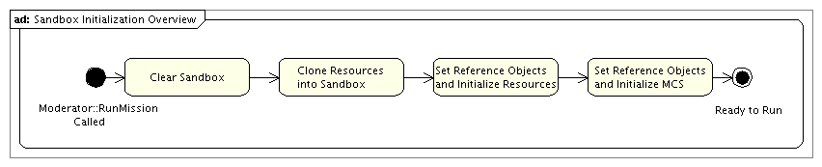
Figure 5: Sandbox Initialization Steps
First, the Sandbox is instructed to clear its data structures in case there are objects in the Sandbox from a previous script execution. Next, all of the resources managed by the ConfigurationManager are copied into the Sandbox. The original configured objects are not moved into the Sandbox; instead, the Sandbox makes a copy of each object for local use in the Sandbox, using each resource’s Clone() method. The Mission Control Sequence is also passed into the Sandbox at this time; the Mission Control Sequence is not cloned.

Once all of the resources have been cloned into the Sandbox, the Sandbox’s Initialize() method is called. This method initializes the resources and commands for use in the mission run. The Sandbox performs this initialization of resources in an ordered fashion, ensuring that more basic resources are initialized before the components that use them are initialized. The resource initialization is performed one object at a time. Resource initialization consists of three steps: (1) the Sandbox retrieves a list of objects referenced by the object that is being initialized, (2) each object in the list of references is located and passed by pointer to the object being initialized, and (3) the object’s Initialize() method is called.

Steps (1) and (2) described here are illustrated in . The Sandbox contains two object containers: the objectMap containing objects specific to the Mission Control Sequence but not automatically visible to functions in the control sequence, and the globalObjectMap containing objects visible to all commands in the Sandbox, including those in function calls. This object scoping complexity is managed as part of the Sandbox initialization process.

Objects in GMAT may contain object references that are accessed in one of two ways. Objects with a single referenced object provide the Sandbox with the name of that object through a call to the GetRefObjectName() method. Objects that reference multiple references provide a StringArray of reference objects names through a call to the GetRefObjectNameArray() method. The calls made in the Sandbox to access these two methods are also shown in .

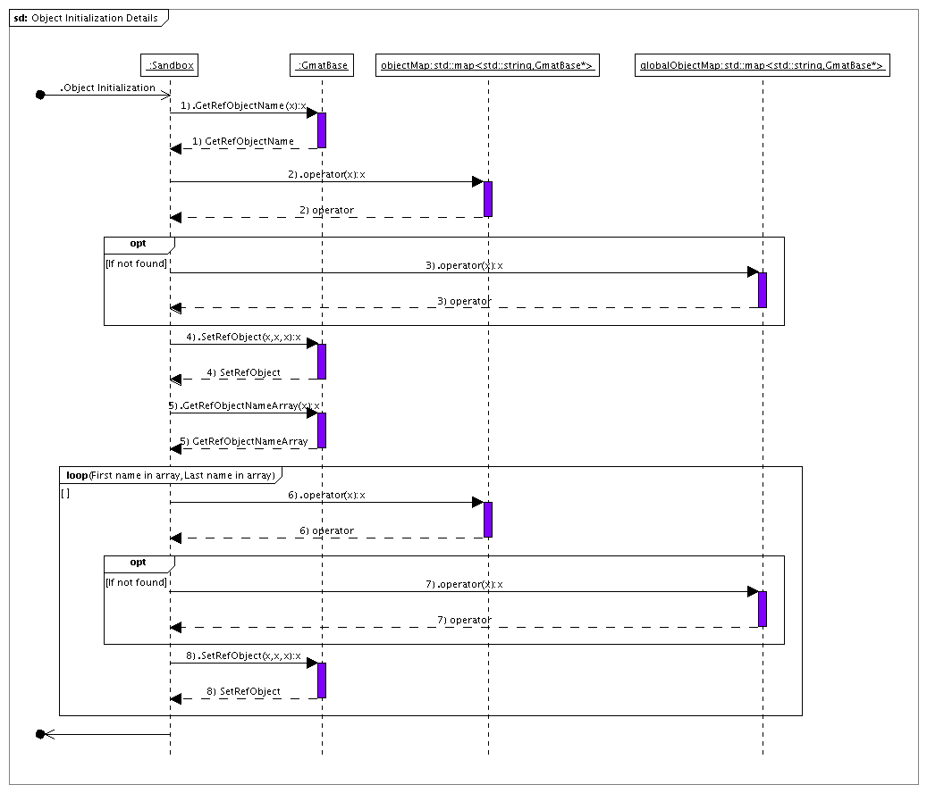

Figure 6: Reference Object Setting during Initialization
After all of the resources have been initialized, the Sandbox initializes the Mission Control Sequence. Control sequence initialization is performed one command at a time, using a pointer to the current command being initialized. This process is performed in three steps. First, the current command is passed a pointer to the solar system used in the Sandbox, the internal object pointers, and the arrays of the resources that were cloned into the Sandbox. Once the command has these pointers set, it initializes itself through a call to its Initialize() method. Finally, the current command pointer is updated to point to the next command that needs initialization through a call to the GetNext() method.

Sandbox initialization is the most complicated phase of a mission run in GMAT. Because of this complexity, the initialization steps required for each of the new estimation objects will be described in the class descriptions below.

GMAT Status After Preparing the Sandbox for the Run
Mission runtime copies of all resources and commands have been passed into the Sandbox. Each resource has had its references to other resources set. The Mission Control Sequence has been passed the local and global object stores (named objectMap and globalObjectMap in the code), and used these structures to locate and set pointers to the objects used by each command in the sequence. GMAT is ready to run the mission.
Object | Status | Notes
ODSat | Created & Initialized | All resources here are clones of the configuration manager’s objects. Pointers to the referenced objects have all been set.
MauiData | Created & Initialized
BLS | Created & Initialized
Maui | Created & Initialized
ODProp | Created & Initialized
RunEstimator | Created & Initialized | The pointer to the estimator has now been set.

Block 5: Execute() and Block 6: GetNext()
Upon completion of the Prepare Sandbox step described above, all of the pointers connecting the objects together for the mission run have been set, and each element of the run has been given the opportunity to perform its initialization. The commands in the Mission Control Sequence have all been passed pointers to the objects used to run the mission, and have been given the opportunity to perform their initialization. The Mission Control Sequence is ready to run the mission.

Figure 7 shows the process GMAT follows when executing the Mission Control Sequence. The Moderator launches the run through a call to the Sandbox’s Execute() method. That method sets a pointer to the first command in the Mission Control Sequence. If that pointer is not NULL, the Sandbox then places a callback to the Moderator to see if a user interrupt (typically a request to stop or pause the control sequence execution) has occurred. If there is no interrupt, the command’s Execute() method is called. The command performs its processing, and returns control to the Sandbox. The Sandbox then calls the command’s GetNext() method, setting the command pointer to the next command that needs to be executed in the Mission Control Sequence. If that pointer is not NULL, the Sandbox makes a callback to the Moderator to see if a user interrupt has occurred, and the process repeats. The run ends when the command pointer is set to NULL. At that point, each command in the Mission Control Sequence is given the opportunity to finalize itself, and then control is returned to the Moderator, completing the run.

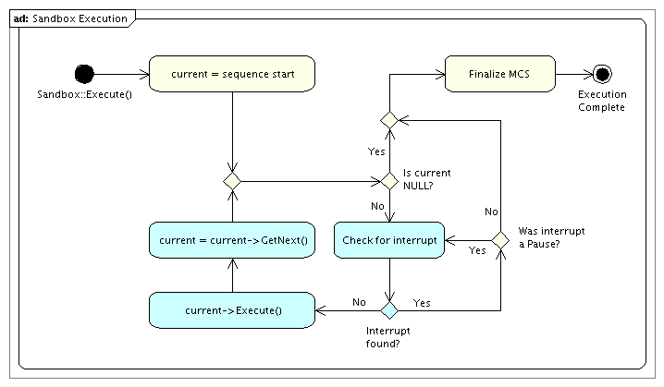
Figure 7: The Sandbox::Execute Method
One subtlety in this process is the interplay between calls to a command’s Execute() and GetNext() methods. Some commands in GMAT – particularly those that perform propagation and those that manage logical branching in the control sequence – consume more computational time than desired before checking for user interrupts. The implementation of the Execute() and GetNext() methods for these commands is designed to allow for interruption and reentry to the command so that interrupt checking can be performed while the command is executing. At select times during execution of these commands, the process is paused and control is returned to the Sandbox. The call to the GetNext() method in these cases returns a pointer to the executing command, rather than the next command in the Mission Control Sequence. After the Sandbox performs the interrupt check, the command is called and execution resumes at the point where it was paused.

The commands that govern estimation – specifically the RunEstimator, RunSimulator, and Estimate commands – described in this document all exhibit this reentrant interrupt behavior. The descriptions of those commands in the following sections include descriptions of this implementation in the descriptions of the execution process for the commands.

GMAT Status After Calls to Execute() and GetNext() are Complete
GMAT has completed the run. Each command in the Mission Control Sequence has been executed, with the possible exception of conditional branches that may have been skipped. Command Summary data is available for each executed command. The objects in the Sandbox have been used as dictated by the contents of the Mission Control Sequence.
Object | Status | Notes
ODSat | Created & Exercised | Sandbox version of the ODSat object contains the results of the estimation process
MauiData | Created & Exercised
BLS | Created & Exercised
Maui | Created & Exercised
ODProp | Created & Exercised
RunEstimator | Executed once | The command has been executed. If the tracking data is suitable, the estimator has run to completion and converged on a solution, which has been fed back into the resources in the Sandbox.

OD Component Design

In this section, detailed design of each component of the estimation subsystem is discussed. This includes the member data and methods of the new system components, and changes to existing components.

State Manager Classes

GMAT’s state management system is shown in Figure 8. This system consists of three management classes: StateManager, the base class for all state management functionality, EstimationStateManager, the state manager that controls the estimation state vector and associated estimation matrices, and PropagationStateManager, used to handle the state vector used by GMAT’s propagation subsystem. The state vector itself is an instance of the GmatState class. This class contains members that represent the epoch of the vector, the data in the vector, and attributes of these data elements. GmatState provides methods that make state vector manipulations simple for the components that need them. Finally, the StateManager classes use a helper structure, ListItem, which makes state manipulations easy to manage. All of these classes are described in more detail in the following paragraphs.

<TBP: A simple figure would help others understand the state managers. Perhaps have a state vector on the left, with different chunks from, say, Cartesian state for 2 spacecraft, and STM for one of the spacecraft. In the middle show something that represents the state manager, and on the right, have the objects themselves. Use arrows to show how the data is mapped from objects to the state vector. A diagram will be added to the earlier materials showing this process.>

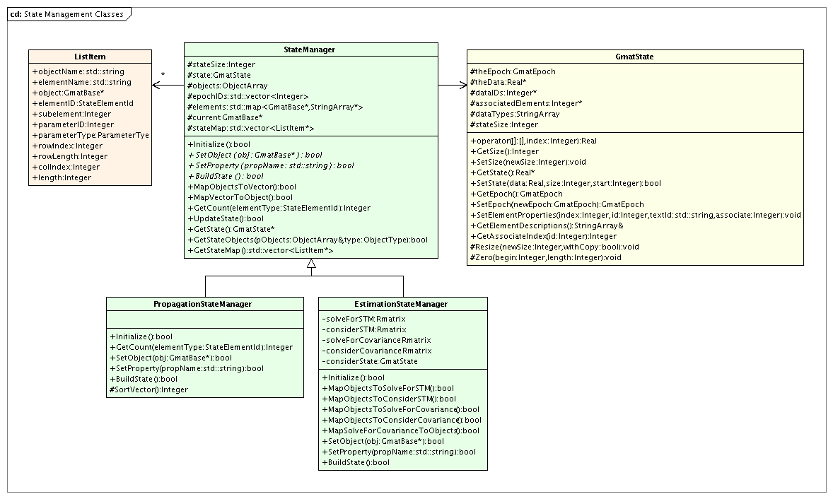
Figure 8: State Management Classes used in Propagation and Estimation

GmatState Class
State data in GMAT is contained in a core class, GmatState, designed to contain an epoch, a vector of corresponding state information at that epoch, and the interfaces necessary to work with the state data. The class provides overridden operators that facilitate element manipulations using C++’s standard array indexing syntax. It also provides the ability to associate elements with one another, simplifying computations that relate one chunk of the vector with state data in a separate chunk.

Attributes of the GmatState Class

- GmatEpoch theEpoch: The epoch associated with the state data.
- Real *theData: The state vector data.
- Integer *dataIDs: Element ID’s associated with the state vector elements.
- Integer *associatedElements: State vector index for the elements associated with the current element. This index is used to associate vector elements that are possibly distant from one another with their core components; for example, the computations of the orbit state transition matrix (STM) use this field to connect the STM to the corresponding Cartesian state elements using this index.
- StringArray dataTypes: Text descriptions of the state elements.
- Integer stateSize: The length of the state vector.

GmatState Methods

- Real& operator[](const Integer index): and
- Real operator[](const Integer index) const: Array element accessor operator overloads that enable access to the state vector element by element using square brackets.
- void SetSize(const Integer size): Resizing method used to change the state vector size.
- Integer GetSize() const: Accessor that returns the current size of the state vector.
- Real* GetState(): Accessor used to directly manipulate the state vector. This method enables direct manipulation of the internal data of the GmatState, and should only be used when performance considerations are paramount.
- bool SetState(const Real *data, const Integer size, const Integer start = 0): Sets all or part of the state data to the input data vector.
- GmatEpoch GetEpoch() const: Retrieves the state vector epoch.
- GmatEpoch SetEpoch(const GmatEpoch ep): Sets the state vector epoch.
- bool SetElementProperties(const Integer index, const Integer id, const std::string &textId, const Integer associate): Sets the properties of a state element for later use.
- const StringArray&GetElementDescriptions(): Retrieves the array that provides an element by element description of the contents of the state vector.
- Integer GetAssociateIndex(const Integer id): Retrieves the index into the state vector for elements associated with a state vector element.

StateManager Base Class
The StateManager base class defines the interfaces used for state management in GMAT. Each StateManager contains a GmatState that is manipulated to perform the associated estimation or propagation. Design of the State Manager class is based on the Mediator design pattern of Gamma et al [add ref in master doc] and promotes loose coupling among system components by using a many to one relationship instead of a many to many relationship. Using the mediator pattern for the State Managers, an Estimator, for example, does not have to communicate directly with all of the objects involved in an estimation problem; the estimator simply communicates with the ESM. The ESM and PSM coordinate state data management between the estimators and propagators. The advantage is that estimators and propagators can remain streamlined and efficient and that new state types can be easily incorporated at a later time without changes to the estimators and propagators. The trade off is that the state manager centralizes complexity and must be carefully designed for ease of maintenance. However, if designed well, the State Manager will make incorporating new objects easier.

<sph: we probably need some transition text that gives an overview of why the data and methods exist on the base SM class.>
<djc: Why? That’s a refactoring issue, and part of OO design. What is confusing here? Base class things exist either to show commonality, or to enforce consistent interfaces. (Not trying to be difficult; I’m just not sure what information is needed.)>

StateManager Attributes

- Integer stateSize: Size of the GmatState vector.
- GmatState state: The GmatState managed by this manager.
- ObjectArray objects: The collection of objects that supply the state vector.
- std::vector <Integer> EpochIDs: Epoch indices for the objects, used to ensure epoch synchronization so that the state data can validate that the data all occurs at the same epoch.
- std::map<GmatBase*, StringArray> elements: Mapping between the objects and the names of the object properties that are used in the managed process.
- GmatBase *current: Pointer to the most recently accessed object, provided for convenience.

StateManager Methods

- virtual bool Initialize(): Initialization code used when the StateManager is prepared for use.
- virtual bool SetObject(GmatBase *obj) = 0: Method used to register an object with the StateManager. Derived classes must provide an implementation for this method.
- virtual bool SetProperty(std::string propName) = 0: Sets a property for the current object as a member of the process that uses this manager. Derived classes must provide an implementation for this method.
- virtual bool BuildState() = 0: Constructs the GmatState vector and any other StateManager data structures (for example, the estimation state transition matrices and covariances) based on the properties that have been set on the manager. This method establishes the state vector, populates the mappings used to fill the vector, and provides the manager with an ordered vector ready for managements. Derived classes must provide an implementation for this method.
- virtual bool MapObjectsToVector(): Retrieves the state data from GMAT’s objects and sets the state vector to contain the values of these data. This method is used to populate the data in the GmatState for use by the process that uses a StateManager.
- virtual bool MapVectorToObjects(): Sets the data on GMAT’s objects to match the data contained in the GmatState vector. This method is used to pass data produced from the estimation or propagation process back into the code objects that need it.
- virtual Integer GetCount(Gmat::StateElementId elementType): Retrieves the number of objects that supply the specified element type to the GmatState.
- virtual bool UpdateState: Updates the state vector to incorporate changes in the data being used in the managed process. The default version of this method simply returns true; StateManager subclasses that need this functionality should override this method.
- virtual GmatState* GetState(): Retrieves the GmatState object for use outside of the Manager.
- virtual bool GetStateObjects(ObjectArray& pObjects, Gmat::ObjectType type = Gmat::UNKNOWN_OBJECT): Walks through the list of objects being managed, filling in the pObjects array with their pointers when they match the requested type. If the requested type is Gmat::UNKNOWN_OBJECT, then all of the managed objects are placed in the list.

EstimationStateManager Class
The estimation state manager is a derived class from the state manager base class and is primarily responsible for getting and setting estimation related state data on measurement participants and assembling STM and covariance matrices from the subelements obtained from individual objects. For example, after an iteration (for Batch) or state update (for sequential), the ESM maps the new estimated state vector to the participating objects. Similarly, when an estimator needs the STM, the ESM retrieves the portions of the STM from the objects involved in estimation and assembles the complete STM, or provides appropriate sub-matrices to the Estimator.

Most of the member data and methods for the ESM are located on the StateManager base class. For example, the estimation state vector (ESV) is the state data member of the StateManager base class and the methods used to manage the ESV are also located on the StateManager base class. However, there are data members and methods that are specific to the ESM. The data members specific to the ESM include the STM of the estimation state vector (ESV), the covariance matrix of the ESV, the vector of consider parameters, the state transition matrix of the consider parameters, and the covariance of the consider states.

In the following sections, we discuss member data and methods specific to the ESM.

Member Data

- Rmatrix solveForSTM: The state transition matrix of the solve-for state vector. If the state vector has n components, then solveForSTM is an nxn array.
- Rmatrix considerSTM: The state transition matrix of the consider state vector. If the consider state vector has m components, then solveForSTM, is an mxm array.
- Rmatrix solveForCovariance: The covariance matrix of the solve-for state vector. If the state vector has n components, then solveForCovariance, is an nxn array.
- Rmatrix considerCovariance: The covariance matrix of the consider state vector. If the consider state vector has n components, then considerCovariance, is an mxm array.
- GmatState considerStateVector: The vector of consider states.

< SPH: We still need to address the issue Matt raised as to how to handle STM chunks and take advantage of sparse matrix manipulations. To do this we will probably need to define new sparse matrix data types. Matt probably has the most insight here regarding what we would need for LaPack. This seems like a future modification though and not a version 1.0 feature.>

Class Methods

- virtual bool Initialize(): During initialization, the ESM gets pointers to all objects that have solve-for states and solve-for states requested by the user, and all consider states.
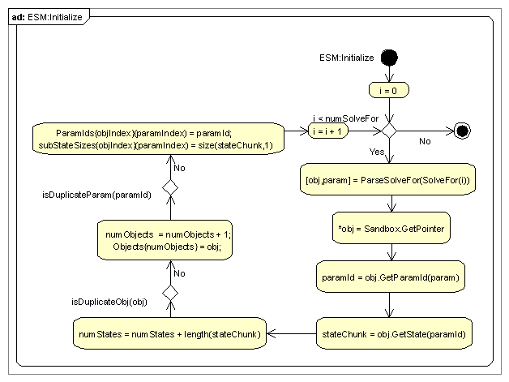
- virtual bool MapObjectsToSolveForSTM(): This method loops over all state chunks contained in the ESV, calls the GetSTM method on the object associated with the current chunk, and places the STM chunk in the correct location in solveForSTM.
- virtual bool MapObjectsToConsiderSTM(): This method loops over all state chunks contained in the consider state vector, calls the GetSTM method on the object associated with the current chunk, and places the STM chunk in the correct location in considerSTM.
- virtual bool MapObjectsToSolveForCovariance(): This method loops over all state chunks contained in the ESV, calls the GetCovariance method on the object associated with the current chunk, and places the covariance chunk in the correct location in solveForCovariance.
- virtual bool MapObjectsToConsiderCovariance(): This method loops over all state chunks contained in the consider state vector, calls the GetCovariance method on the object associated with the current state chunk, and places the covariance chunk in the correct location in considerCovariance.
- virtual bool MapSolveForCovarianceToObjects(): This method loops over all state chunks contained in the ESV and passes the covariance matrix associated with the state chunk to the SetCovariance method on the object associated with the current chunk.

PropagationStateManager Class
<DJC: To be determined: do we need a separate subclass here, or should the propagation pieces all be folded into the base class? The key reason for a subclass is to gather the data necessary to build an ODE model. If these data are the same as data needed to build the estimation state, then the classes can be combined. For now, I’m assuming we’ll refactor to that design if it seems correct once we’re coded and running.>

The PropagationStateManager class manages the state vector that the propagators act on to move GMAT’s objects through time. It is responsible for the following tasks:

- Gathering the data that needs to evolve from the objects that hold them
- Arranging these data into a GmatState vector in an order consistent with the expectations of the Propagators
- Supplying the data necessary for constructing ODEModels for the GmatState for use in numerical integration
- Refreshing the state data with values from the objects
- Updating GMAT’s objects with data produced from propagation

The programmatic flow through the PropagationStateManager for these tasks is described in the (to be updated) propagation chapters of GMAT’s Architectural Specification. The materials presented here are intended to define the class and its interfaces and to

The PropagationStateManager depends exclusively on data members provided by the base class. The managed state vector is the StateManager state data member. The data that identifies the mapping between objects and any ODEModel definition are contained in the stateMap member. The ODEModel contains methods that assemble derivative models based on these data. All that remains for the PropagationStateManager are the methods defined below.

PropagationStateManager Methods

- virtual Integer GetCount(Gmat::StateElementId elementType = Gmat::UNKNOWN_STATE): Retrieves the number of objects that propagate the specified type of element. If the input type is an UNKNOWN_STATE (the default value), the total number of objects propagated is returned.
- virtual bool SetObject(GmatBase* theObject): Identifies an object that requires propagation.
- virtual bool SetProperty(std::string propName): Tells the PropagationStateManager the name of a property that needs to be propagated. This function identifies the propagation elements for the state vector. GMAT adds the identified element to the list of propagation parameters defined for the object. The method uses the most recent object – that is, the object pointed to by the current object pointer – as the object that needs the element propagated.
- virtual bool BuildState(): Uses the objects and properties passed into the PropagationStateManager to assemble the mapping between objects and the propagation state vector. This method sets the size of the propagation state vector and sets the properties of each element of that vector.
- Integer SortVector(): A protected method that uses the configuration information in the PropagationStateManager to determine the size of the propagation state vector, and to build the data needed to populate the vector in the order needed by the propagation subsystem. This method populates the stateMap vector with the data needed to setup each element of the state vector, and it determines the size of that vector. The method is called by the BuildState() method to determine the layout for the state that gets built.

The ListItem Structure
The StateManagers track the elements of the state vector using a vector of structure pointers that contain details about each element. The structure referenced by these pointers is the ListItem structure. A ListItem contains the following data:

- std::string objectName: The name of the object that supplies the data element.
- std::string elementName: The text descriptor used to access the object property that maps into the state element.
- GmatBase *object: A pointer to the object that supplies the data.
- Gmat::stateElementID elementID: The enumerated identifier for the type of data contained in the element. This identifier tells the subsystem the top level type of data; for instance, the elementID is set to CARTESIAN_STATE for each of the six elements of a spacecraft’s Cartesian state in the state vector.
- Integer subelement: The index into the element type for the state vector. This index tells the subsystem how far into the data type the state vector element falls. Continuing with the examples of a CARTESIAN_STATE, the six elements of that state receive the subelement numbers 1, 2, 3, 4, 5, and 6.
- Integer parameterID: The ID used to access the parameter on the object that owns it. This member is the ID used when calling the object’s GetRealParameter() and SetRealParameter() methods.
- Gmat::ParameterType parameterType: Identifier for the type of parameter contained in the element. For the current implementation, the parameter type should always be a Gmat::REAL_TYPE, Gmat::RVECTOR_TYPE, or Gmat::RMATRIX_TYPE. Later build may also use INTEGER_TYPEs.
- Integer rowIndex: This field is only used for Rvector and Rmatrices. It specifies the index into the Rvector, or the row index for the Rmatrix.
- Integer rowLength: For an Rmatrix, this entry specifies the number of columns in the matrix.
- Integer colIndex: For an Rmatrix, this field specifies the column index into the matrix.
- Integer length: The number of elements in the current data set for the current object. For example, if the state vector uses the CARTESIAN_STATE data for two spacecraft and the ORBIT_STM data for the first, the CARTESIAN_STATE elements all have the length parameter set to 6, and the ORBIT_STM elements have it set to 36.

Estimator Related Classes

Estimator and RunEstimator Interactions

GMAT’s Solver subsystem uses a finite state machine model to drive the algorithms implanted in the solvers. Each Solver object implements its own state machine, and pairs that state machine with a command or set of commands that manipulates GMAT’s objects to provide data required for the algorithm. The interaction between the solver and the command subsystem necessitates knowledge on the command side about the state information in the finite state machine. In essence, the Solver finite state machine drives both the solver algorithm and a paired state machine implemented in the corresponding command. The state and state transitions of the solution process is always controlled in the Solver object. Object manipulations are performed in GMAT’s Mission Control Sequence – and in particular, in the Solver Control Sequence that uses the Solver object.

Each type of Solver is matched to command. The targeters, like the differential corrector, are paired with the Target/EndTarget commands, and use the Vary and Achieve commands for additional communications needed by the targeting algorithms. The optimizers are paired with GMAT’s Optimize/EndOptimize commands, and use the Vary, Minimize, and NonlinearConstraint commands for communications.

There are four commands designed to pair with the estimation solvers: RunEstimator, RunSimulator, and in the future, an Estimate/EndEstimate subsequence pair. This document describes the state machine activities for the first two commands. The Estimate/RunEstimate command pair is not part of the first release of GMAT’s estimation capabilities, and will be designed (along with any communications related commands) at a later date.

Command Usage in GMAT
Missions in GMAT are always executed by executing commands in a Mission Control Sequence. The Mission Control Sequence is a linked list of command objects. It is executed inside of one of GMAT’s Sandboxes starting with the first node in the list, and progressing until the end of the list is executed. The Sandbox drives this process when GMAT’s Moderator calls the Sandbox’s Execute() method. The Sandbox tracks the executing command using a current command pointer, initially set to the first command in the list.

When the mission is run, the Sandbox checks for user interrupts, and then calls the Execute() method on the current command pointer, executing that command. Upon return from this call, the Sandbox updates the current command pointer by calling the command’s GetNext() method. The pointer returned from this call is then checked; if it is NULL, the Mission Control Sequence has run to completion. If the returned pointer is not NULL, it points to the next command that needs to be executed, and the process repeats by checking for interrupts and then calling the Execute() method on the command pointed to by the current command pointer. Thus overall control of the process running in GMAT’s Sandbox is managed by the commands in the Mission Control Sequence.

Some of the commands in the Mission Control Sequence manage their pointers to the next command in a reentrant fashion. All of the commands that manage subsequences – GMAT’s “branch commands” – work this way, as do the commands like Propagate that might take a long time to execute. The call to GetNext() for these commands can return a pointer back to the command itself, rather than the next command in the list. This self reference in the list transversal call (i.e. the call to “GetNext()”) lets GMAT perform other processing during execution of time consuming commands.

Estimation Command Overview
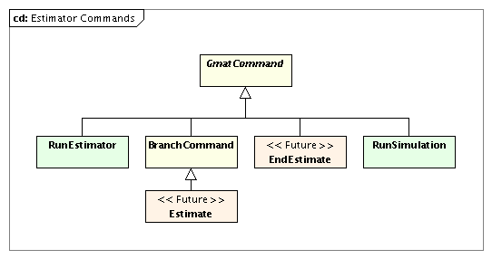
Figure 9: Commands Used in Estimation

The three command sets used for estimation – RunEstimator, RunSimulator, and Estimate/EndEstimate, shown in Figure 9 – all follow a similar methodology at the level of command execution. The commands interact with the estimator and simulator components to run the solver’s finite state machine. Each solver implements a state machine tailored to the needs of the implemented algorithm.

At the highest level, the state machine executes at prompting from the command, which in turn was prompted by a call from the Sandbox containing the Mission Control Sequence, as is shown in Figure 10. The estimation command is part of the Mission Control Sequence assigned to a Sandbox in GMAT. When GMAT runs the Mission Control Sequence, it checks for user interrupts, and then calls the Execute method in the current command in the Mission Control Sequence. The figure shows the high level flow that occurs for this process when the current command pointer is an estimation command, including the interactions between the command and the estimator.

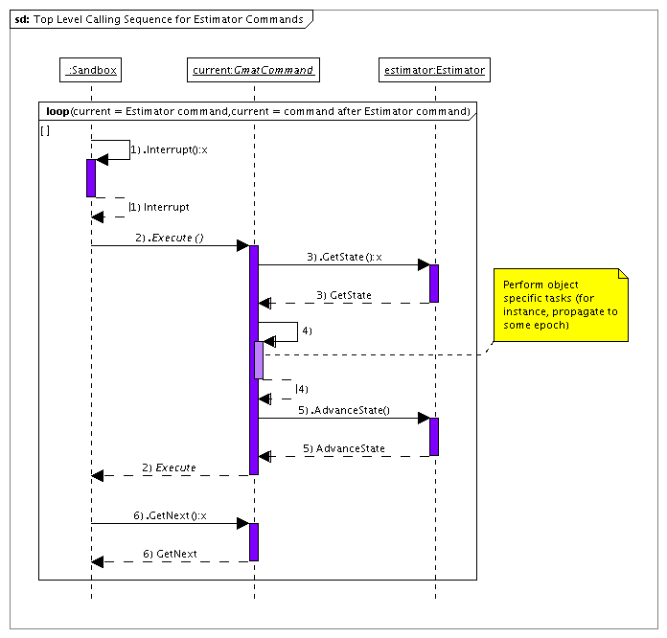
Figure 10: Top level view of State Machine Execution

Each time the estimator command receives a call from the Sandbox to execute (made via the Execute() method), it queries the estimator for the current state, performs any requisite command actions based on that state, and then calls AdvanceState() on the solver so that the solver can perform the next action dictated by the state machine. Upon return from the call to AdvanceState(), the command returns control to the Sandbox, which checks for user interrupts, and then calls the command’s GetNext() method to determine the next command that needs to be executed. The estimation command returns its pointer from this call as long as the solver’s state machine is running. The Execute() method is called on the command, which lets the estimation command process the next state in the state machine. This sequence repeats until the estimation state machine runs the actions required by the FINISHED state, completing the estimation process. Once the process has completed, a subsequent call to the command’s Execute() method returns a reference to the next command in the Sandbox’s Mission Control Sequence.

This general framework for estimation command execution in GMAT follows the basic execution framework for all GMAT commands: the Sandbox checks for interrupts, then executes the command, then retrieves the pointer to the next command to execute, and continues this process until the Mission Control Sequence is finished running.

This overview is intended to provide a framework for understanding the details of how the Estimation commands work in GMAT. The following sections describe the estimation commands using the Batch Least Squares estimator to show the state machine elements of the design. The state machine itself is described in the batch estimator section of this document. The interactions required on the command side for the batch and sequential process are identical; from the point of view of the command, the process is to take an action, call AdvanceState() on the estimator, and repeat until the estimator reports that the process is complete. We’ll begin by examining the RunEstimator command.

The RunEstimator Command
The RunEstimator command drives the estimation process when the evolution of the participants can be modeled through propagation from one epoch to the next. RunEstimator is a propagation-enabled command, meaning that it includes methods and data structures needed to perform propagation. It supplies methods for performing actions in estimator state machines that support the following states:

- INITIALIZING
- PROPAGATING
- LOCATING
- CALCULATING
- ESTIMATING
- CHECKINGRUN
- FINISHED

The RunEstimator command provides methods that are called when the estimator’s state machine is in one of these states and the Execute() command is called. (The command’s initialization is performed prior to the state machine call that detects the INITIALIZING state, so there is no need for a machine command function for that call.) The command methods that perform actions based on the state of the estimator’s state machine are listed here, and described in the command method description below.

- INITIALIZING: Calls the PropagateToStart() method
- PROPAGATING: Calls to the Propagate() method
- LOCATING: Calls the PropToEvent() method
- CALCULATING: Calls the Calculate() method
- ESTIMATING: Calls the Estimate() method
- CHECKINGRUN: Calls the CheckConvergence() method
- FINISHED: Calls the Finalize() method

Different estimators can use different states in their state machines, and are likely to use the states in a different order based on the estimation algorithm. For example, the batch least squares estimator does not use the ESTIMATING state until after all of the tracking data has been processed, while the sequential filters like the extended Kalman filter will estimate – that is, advance through the ESTIMATING state – as the data is processed.

Error: Reference source not found shows the finite state machine for the batch least squares estimator (the lower portion of the sequence partition) and the RunEstimator command. The core interaction supplied by the command during execution of the state machine for this example is the propagation of the participants in the estimation process. The batch estimator performs the other steps of the estimation process without need for direct interaction with the command.

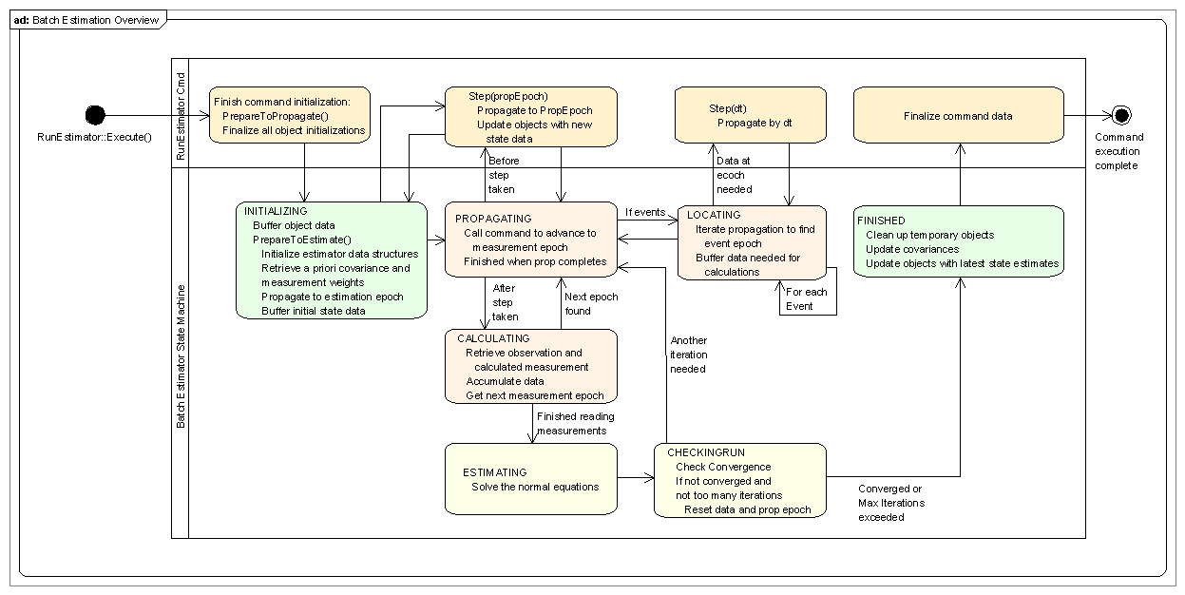
Figure 11: Interactions Between the RunEstimator Command and the Batch Least Squares Estimator

Three of the states specified here require propagation from the command. The INITIALIZING state requires that the command perform propagation from the current state epoch to the estimation epoch specified on the estimator. GMAT’s objects are advanced from their current epoch to the next measurement epoch through calls to the Propagate() method, made when the finite state machine is in the PROPAGATING state. Finally, event location to perform tasks like light-time corrections requires propagation. These tasks are performed while the state machine is in the LOCATING state.

For each of these propagation steps, the RunEstimator command needs to know the size of the time step required to change from the current epoch to the desired epoch. This information is retrieved from the estimator using the FindTimeStep() method. The returned time step is then used to step the participants using a PropSetup reference in the command. That reference, set during command initialization, points to the propagator owned by the estimator. A future enhancement may allow the replacement of the estimator’s propagator with a event-specific propagator tailored to the participants in the event calculation for propagation triggered from the LOCATING state.

The details of the state machine execution are described in the sections describing each specific estimator. The description provided here is intended to specify the command actions required in the estimation process.

The RunEstimator command contains the following data members and methods.

RunEstimator Attributes

- std::string estimatorName: The name of the Estimator that the command uses.
- Estimator *estimator: A pointer to the Estimator.
- PropSetup *propagator: A pointer to the Propagator owned by the Estimator.

RunEstimator Methods
- virtual bool Initialize(): Sets internal references and interconnections, and prepares the estimator for use.
- virtual bool Execute(): Accesses the state from the finite state machine, performs any required command side actions, and then calls AdvanceState() on the estimator to move the finite state machine to its next state.
- virtual void PropagateToStart(): Queries the estimator for the time step required to propagate to the estimation epoch, and then performs that propagation.
- virtual void Propagate(): Queries the estimator for the next required time step, and then performs the required propagation.
- virtual void PropToEvent(bool restoreFromBuffer): Queries the estimator for the time step estimated to find an event, and then performs the required propagation. This method buffers the initial state data if restoreFromBuffer is false, and resets to that buffered data if restoreFromBuffer is true. A call to restore when the buffer has not been set results in an exception.
- virtual void Calculate(): Performs command side actions when the estimator is in the CALCULATING state. This method is used to report intermediate data if the estimator text file is running in verbose mode.
- virtual void Estimate(): Performs command side actions when the estimator is in the ESTIMATING state. This method is used to report intermediate data if the estimator text file is running in verbose mode.
- virtual void CheckConvergence(): Performs command side actions when the estimator is in the CHECKINGRUN state. This method is used to report the status of the estimation process.
- virtual void Finalize(): Finalizes the command so that it can be reexecuted on a subsequent call. This method is also used to report the final estimated state and the status of the convergence criteria.

The Estimator Classes
Gmat’s Estimator classes are shown in Figure 12. The first estimator build of GMAT includes the blocks shaded orange in the diagram: the Estimator base class, the BatchEstimator intermediate class, and the BatchLeastSquares estimator. The second build adds the Filter intermediate class and the SRIF estimator (proposed – final selection for the sequential estimation is yet to be decided) to the system. Potential extensions to this class hierarchy are shown in the figure as well.

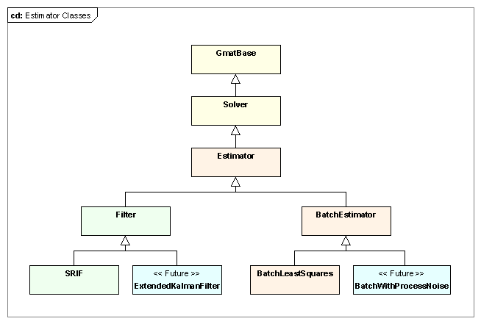
Figure 12: Classes in GMAT's Estimator Hierarchy

GMAT’s Estimator base class defines the core functionality shared by all estimators. It includes the top level Estimator interfaces, initialization code for the shared elements including the EstimationStateManager and MeasurementManager, and the member components implementing these elements. The interfaces in this class are defined so that the estimation commands can treat the estimator process generically, and therefore drive the estimation process without intimate knowledge of the algorithm that is implemented in the estimator.

GMAT’s estimator classes are derived from the Solver base class. The Solver class provides data structures and methods designed so that derived classes can implement a finite state machine that, together with a matching command, organizes the process of working with the elements of the a GMAT mission to drive the algorithm implemented in the solver. The command portion of this partnership manages the interface with the Sandbox and the propagation subsystem, and, when appropriate, with a solver control sequence designed to provide a sequence of commands when that sequence involves more than just direct propagation. The solver side of the partnership manages the state of the solution algorithm. That state is represented by one of several distinct values; hence the state machine is called a finite state machine. The command side retrieves the state if the state machine from the solver, performs any necessary control sequence actions, and then passes control to the solver so that the solver can evaluate and potentially change state based on the results of the command’s actions.

The state machine in GMAT’s solvers provides a mechanism to ensure that the control sequence is executed in a sensible manner for the implemented algorithm. As such, each derived solver class will define its state machine to meet the needs of its algorithm. The state machines for each of the new estimators are described in the corresponding class descriptions below.

The following sections describe each estimation class in the figure, starting with the Estimator base class. The capabilities and member elements are described, along with the processes that each class implements.

The Estimator Base Class
The Estimator class contains two key member objects used by all of GMAT’s estimators: an instance of the EstimationStateManager and an instance of the MeasurementManager. The details of those classes are provided in the corresponding sections of this document. In this section you will see how these objects are set up and used by the Estimator classes.

Figure 13 shows the Estimator class, its ancestors, and its predecessor. The details of the class contents are shown in this figure, along with the helper classes mentioned above. The Estimator class centralizes the interfaces to the measurement data and the estimation state vector, along with the other elements that all estimators need. This class extends the features of the Solver class by adding and initializing these new elements. As a base class, we anticipate that the implementation process for the derived estimators will result in a fair amount of refactoring, particularly as the BatchEstimator and Filter classes are implemented, consolidating additional common estimation features.

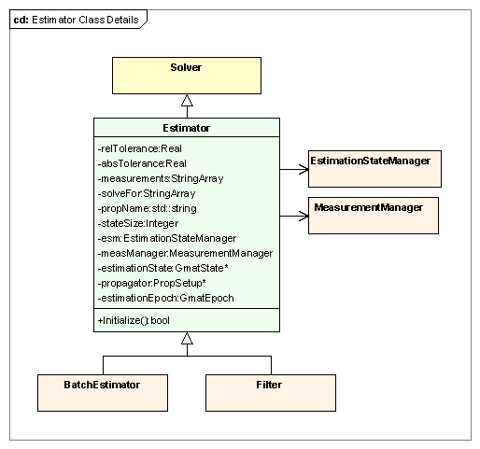
Figure 13: The Estimator Class

Key Processes

The Estimator base class has one key process: the Initialize method, which initializes its management members and prepares its propagation subsystem for initialization.

Estimator Initialization

The Estimator class manages the initialization of the EstimationStateManager and the MeasurementManager, along with preparation of the PropagationStateManager for initialization, as is shown in Figure 14. The Estimator::Initialize() method calls the Solver::Initialize() method first to ensure that the Solver data structures are properly prepared for use. Following this call, the EstimationStateManager::Initialize() method is called, which sets the data structures for the estimation state vector and then builds the vector. Once the estimation state vector has been built, the Estimator walks through the estimation state vector and passes each element that needs propagation into the PropagationStateManager assigned to the Estimator’s propagator. This process prepares the propagation subsystem for initialization, but does not perform the actual initialization. That call is made in the estimation command immediately prior to execution so that all transient forces required for the propagation can be managed. Finally, the MeasurementManager::Initialize() method is called, causing the measurement manager to read all of the data available for processing and to build the structures needed for that processing. This step completes initialization for the Estimator base class.

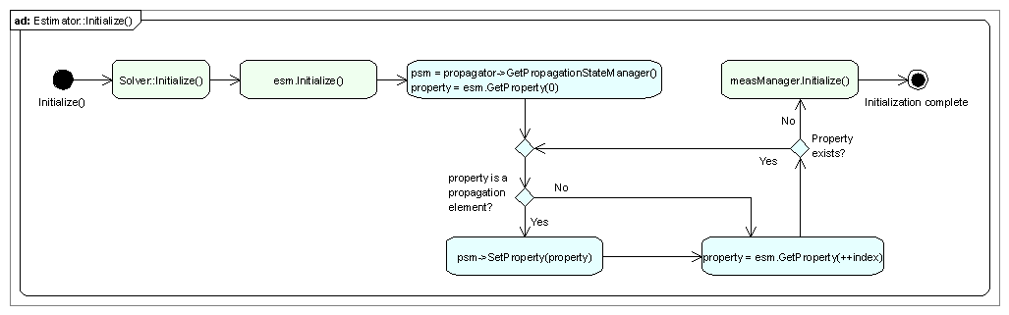
Figure 14: Estimator Class Initialization

Estimator Members

Estimator Attributes
- Real relTolerance: The maximum change from the previous RMS error in the residuals to the current RMS error allowed in order for convergence to be met.
- Real absTolerance: The largest allowed change in the estimation state in order for convergence to be met.
- StringArray measurements: Names of the measurement types used in this estimator. This array of names is passed to the MeasurementManager for processing.
- StringArray solveFor: List of the solve for parameters used in the estimator.
- std::string propName: Name of the configured propagator used to evolve objects during the estimation process.
- Integer stateSize: The size of the estimation state vector.
- EstimationStateManager esm: The EstimationStateManager for the estimator. This member is responsible for the communications between GMAT’s objects and the data structures manipulated by the estimator during the estimation process.
- MeasurementManager measManager: The MeasurementManager for the estimator. This object is responsible for managing all of the measurement objects in the estimation process. It is an intermediary responsible for retrieving observed and calculated data, and supplying those data to the estimator.
- GmatState *estimationState: A pointer to the estimation state managed by the EstimationStateManager. This pointer is set after the EstimationStateManager is initialized. It is provided for convenience, so that repeated calls to esm.GetState() are not needed in the code.
- PropSetup *propagator: The propagator configured for the estimation.
- GmatEpoch estimationEpoch: The estimation epoch. For batch estimators, this epoch is the epoch of the state estimate. For sequential epochs, it tracks the epoch of the current estimate.

Estimator Methods
- bool Initialize(): Prepares the EstimationStateManager and MeasurementManager for use in estimation, and loads the propagator’s PropagationStateManager so it can be initialized by the propagation enabled commands.

The BatchEstimator Class
The BatchEstimator class, shown in Figure 15, implements the infrastructure used by GMAT’s batch estimators. This infrastructure includes the implementation of a state machine intended to support the usual sequence of actions needed for batch estimation. The class defines with the methods called from this state machine, and provides implementations of the methods that are considered to be common to the batch estimation process. All of the common methods implemented for the BatchEstimator class are declared virtual. Derived classes can override the estimation state machine or any of the implemented methods as needed to support algorithm specific needs. The Accumulate(), Estimate(), and CheckCompletion() methods are considered to always be implementation specific, and therefore must be implemented in the classes derived from the BatchEstimator class.

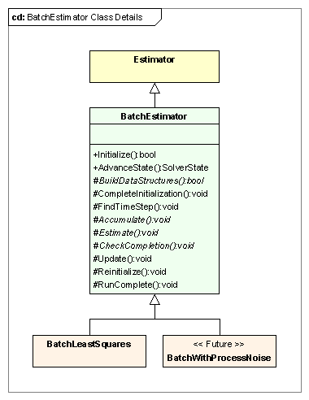
Figure 15: The BatchEstimator Class
Key Processes

The BatchEstimator class implements a basic finite state machine that follows a typical batch estimation process. There are two processes that work together to implement the state machine: initialization of the BatchEstimator and execution of the finite state machine.

Initialization

The initialization process in the Sandbox starts with the object setting phase described in the GMAT run overview. At the end of this phase, all of the references objects have been set on the BatchEstimator object, and it is ready to validate those objects and set the pointers for use in the estimation process. This process is shown in Figure 16.
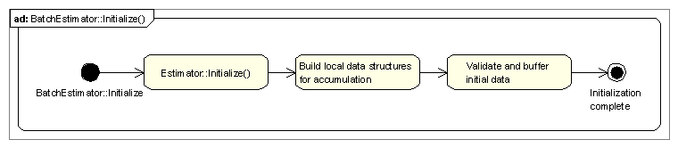
Figure 16: Initialization in the BatchEstimator Class

The initialization process for the BatchEstimator starts by initializing the Estimator base class as described above. Once that process completes successfully, the data structures required for accumulation are prepared. Finally, the initial data are checked to be sure that they contain all of the required data, and that these data are internally consistent, and they are buffered so they can be restored during iteration. This completes the initialization process for the batch estimator.

Estimation State Machine
Figure 17 shows the estimation process implemented in the BatchEstimator class. The batch estimator state machine is shown in the lower partition in the figure, while the actions performed by the command running the state machine are shown in the upper partition. The state machine implementation is key to the estimation process in GMAT, so it will be described in some detail in the following paragraphs.

Figure 17: Performing Batch Estimation

GMAT’s Solver State Machines
GMAT’s solver finite state machines are used to move the solution algorithm through the steps required to apply the algorithm to the objects that are used to solve a user specified problem. Each step of the process is represented by a discrete numerical identifier, referred to as the state of the process. That identifier is used to specify a set of actions that, when performed, prepare the finite state machine to advance from its current state to the next state in the solution process. The state identifiers are defined in a C++ enumeration, the SolverState enumeration in the Gmat namespace.

Each state in the solver state machine performs actions designed to move the elements of GMAT from their entry condition to the condition required to advance to the next state. GMAT advances from one state to the next using the AdvanceState() method on the solver. When AdvanceState() is called, the solver executes a method assigned to the state and reports the results to the solver’s text file. The method call is responsible for running the actions assigned to the state, and then determining the next state and changing the state identifier accordingly based on the results of the actions executed.

The BatchEstimator Finite State Machine
The BatchEstimator uses seven states to drive its algorithm. These seven states, shown in the bottom partition of Figure 17, work together to estimation a user defined state vector. The list below describes each state of the machine, including the entry and exit conditions along with the internal actions required to move to the exit condition for the state:

- INITIALIZING:
  - Entry condition: The INITIALIZING state is the state the BatchEstimator takes upon completion of initialization in the Sandbox. Upon completion of an estimation run, the BatchEstimator returns to this state so that a subsequent call can reuse the same estimator.
  - Actions Method Name: CompleteInitialization():
    - Determine if any observations are available; if not, abort estimation
    - If necessary, propagate to estimation epoch
    - Gather the data and fill the batch estimator’s state
    - Initialize the state transition matrix
    - Gather a priori covariances and measurement weights
    - Buffer all estimation objects
  - Exit condition:
    - Change to PROPAGATING state if an observation exists. Change to FINISHED state and post a warning message if none were found.
- PROPAGATING
  - Entry condition: An observation was found
  - Actions Method Name: GetStepEpoch()
    - Determine time step for propagation to the observation epoch
    - Feed time step to command for propagation
    - Determine if measurement for the observation has events that require propagation
  - Exit condition 1:
    - Time step = 0
    - No unprocessed propagation events
    - Change state to CALCULATING
  - Exit condition 2:
    - Time step = 0
    - Events that require propagation not yet processed
    - Change state to LOCATING
- LOCATING
  - Entry conditions:
    - An event that requires propagation has been found
    - Resources are at a known epoch for the event
  - Actions Method Name: ProcessEvent(bufferData)
    - If bufferData is true, buffer state information
    - Calculate time step required for the event
    - Provide time step to command for propagation
    - Evaluate event to determine if propagation results are within tolerance
    - Iterate from time step calculation until event converges
  - Exit condition 1
    - Event has converged
    - No additional events found
    - Reset state information to buffered data
    - Set bufferData flag to true
    - Change state to PROPAGATING
  - Exit condition 2
    - Event has converged
    - Another event found
    - Set bufferData flag to false
    - Change state to LOCATING
- CALCULATING
  - Entry condition: Propagation and any required event location has been performed
  - Actions Method Name: Accumulate()
    - Retrieve observation and calculated data
    - Accumulate the data
    - Retrieve the epoch of the next observation
  - Exit condition 1
    - Another observation was found
    - Change state to PROPAGATING
  - Exit condition 2
    - Final observation was processed
    - Change state to ESTIMATING
- ESTIMATING
  - Entry condition:
    - All measurement data has been processed
  - Actions Method Name: Estimate()
    - Solve the normal equations
  - Exit condition:
    - Estimation update generated
    - Change state to CHECKINGRUN
- CHECKINGRUN
  - Entry condition:
    - An estimation update was generated
  - Actions Method Name: CheckCompletion()
    - Check for convergence
  - Exit condition 1
    - Estimation converged within tolerances
    - Change state to FINISHED
  - Exit condition 2
    - Estimation did not converge
    - Maximum number of iterations exceeded
    - Change state to FINISHED
  - Exit condition 3
    - Estimation did not converge
    - Maximum number of iterations not exceeded
    - Reset data and prop epoch through call to Reinitialize()
    - Update state with new estimate through call to Update()
    - Reset measurement iterator to point to first measurement
    - Change state to PROPAGATING
- FINISHED
  - Entry condition: Estimation work finished
  - Actions Method Name: RunComplete()
    - Update covariances
    - Update objects
    - Clean up data structures
    - Report convergence status
  - Exit condition:
    - Change state to INITIALIZING so estimator is reentrant
TBD: Do this state change here, or at prompting from the command?

BatchEstimator Members
BatchEstimator Attributes
The batch estimator does not have any additional attributes visible to the rest of the system. The structures required for accumulation consist of vectors of the processed data required to solve the normal equations. These data structures are algorithm specific, and are defined in the classes derived from the BatchEstimator class.

BatchEstimator Methods
- virtual bool Initialize(): Prepares the estimator for estimation. The initialize method ensures that all of the top level components needed are present for the estimation process, and performs as much pre-run initialization as possible.
- virtual Gmat::SolverState AdvanceState(): Executions the state machine actions necessary to move into a new state, and then advances the state to the next value in the finite state machine’s process.
- virtual void CompleteInitialization(): Completes the initialization process, performs any necessary final propagation to move to the estimation epoch, and buffers the data that needs to be reset each time the batch process starts a new iteration.
- virtual void FindTimestep(): Compares the current state epoch with the next measurement epoch, and computes the time step – in seconds – that the propagator must apply to move from the current epoch to the measurement epoch.
- virtual void Update(): Applies corrections to the state to incorporate the changes necessary to build a new estimated state.
- virtual void Reinitialize(): Resets all of the buffered data so that a new iteration can be performed.
- virtual void RunComplete(): Finalizes all of the data, cleans up memory, and reports the estimation data.

BatchEstimator Abstract Methods
The classes derived from the BatchEstimator class implement batch estimators that differ in the details of the estimator mathematics. At a minimum, the derived classes must implement three methods: an Accumulate() method designed to collect the information needed from a pass through the measurement data, and Estimate() method that applies the batch algorithm to calculate state vector updates for the estimation state, and a CheckCompletion() method that tests the state updates and other criteria to determine if the estimation process should terminate. These methods are listed here:

- virtual bool BuildDataStructures() = 0: Method called by Initialize() to set up object specific data structures for the classes derived from the BatchEstimator class.
- virtual void Accumulate() = 0: Performs data accumulation for the batch algorithm.
- virtual void Estimate() = 0: Applies the batch algorithm to generate a new set of corrections to the estimation state vector at the estimation epoch.
- virtual void CheckCompletion() = 0: Checks to see if the estimation process should terminate, either because of convergence or for another reason.

The BatchLeastSquares Class

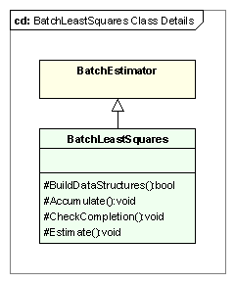
Figure 18: The BatchLeastSquares Class

Key Processes

The key processes performed by the BatchLeastSquares class are described in the parent class’s text. The BatchLeastSquares class does not provide any additional process level elements. It does provide a specific implementation of the batch least squares algorithm, captured in the implementation of the four abstract methods BuildDataStructures(), Accumulate(), Estimate(), and CheckCompletion().

BatchLeastSquares Members

BatchLeastSquares Attributes
The BatchLeastSquares estimator does not require any new data members that need description at this level of the design.

BatchLeastSquares Methods
- virtual bool BuildDataStructures(): Method called by Initialize() to set up the data structures used for accumulation in the BatchLeastSquares estimator.
- virtual void Accumulate(): Collects the observed less calculated data and derivative information needed to build the normal equations.
- virtual void Estimate(): Solves the normal equations, generating the corrections that apply to the estimation state vector to construct a new estimate.
- virtual void CheckCompletion(): Checks the estimate to see if the estimation has converged or if another stopping criterion has been met. If not, the most recent state corrections are applied to the estimation state vector.

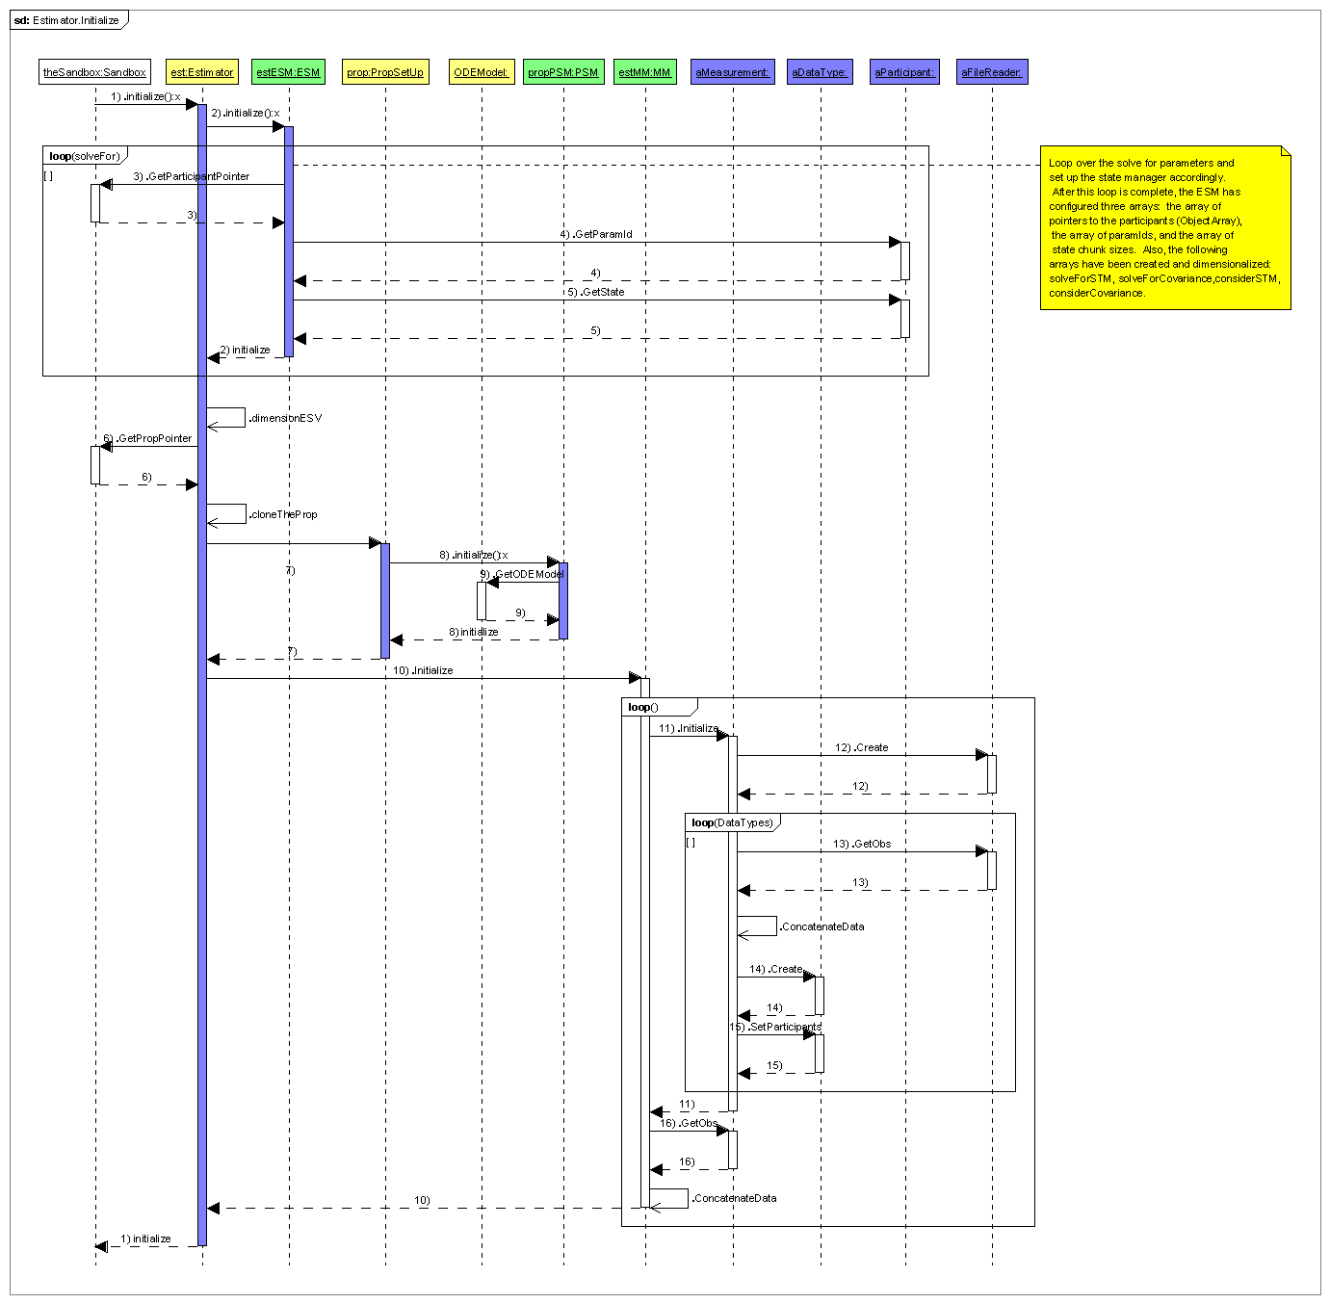

The Simulator and RunSimulator Classes
The Simulator and RunSimulator classes work together to model the measure gathering process for a mission. RunSimulator is a Mission Control Sequence command designed to provide a mechanism to run a finite state machine that generates simulated measurement data over a user specified time span. The Simulator class captures the state transitions in the finite state machine, and uses the processes supported by these transitions to generate simulated measurements using GMAT’s measurement models, captured in the Measurement classes.

The roles and responsibilities for each of these classes are described in the following sections.

The RunSimulator Command
The RunSimulator command is a propagation-enabled command that manages the processes required to run and respond to the finite state machine defined in Simulator objects. It supplies methods for performing actions in these state machines that when the finite state takes one of the following values:

- INITIALIZING
- PROPAGATING
- LOCATING
- CALCULATING
- SIMULATING
- FINISHED

The RunSimulator command provides methods that are called when the simulator’s state machine is in one of these states and the Execute() command is called. The command methods that perform actions based on the state of the estimator’s state machine are listed here, and described in the command method description below.

- INITIALIZING: Calls the PrepareToSimulate() method
- PROPAGATING: Calls to the Propagate() method
- LOCATING: Calls the PropToEvent() method
- CALCULATING: Calls the Calculate() method
- SIMULATING: Calls the Simulate() method
- FINISHED: Calls the Finalize() method

Figure 19 shows the finite state machine for the simulator in the lower portion of the sequence partition, and the non-trivial processes executed in the RunSimulator command. The core interaction supplied by the command during execution of the simulator state machine is the propagation of the participants in the simulation process. The simulator performs the other steps of the process without need for direct interaction with the command.

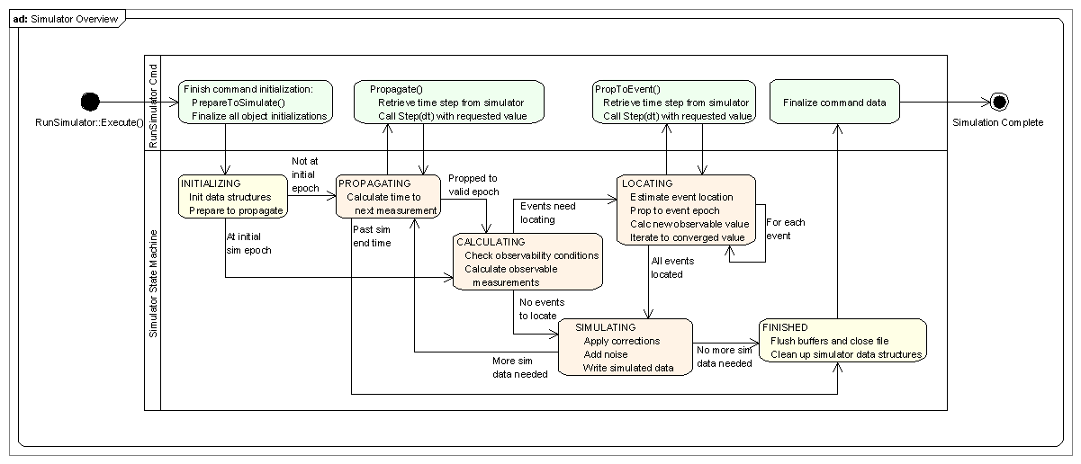
Figure 19: The Simulation Process

The RunSimulator command defines the interface between the Mission Control Sequence running in a Sandbox and a Simulator object. The RunSimulator command manages all of the propagation performed in support of the simulation, simplifying the interrupt processing during the simulation.

In GMAT, the simulator object owns the propagator and the measurement manager. The command retrieves the propagator pointer from the simulator for use during command execution. The simulator also provides the information about the duration of any needed propagation to the command. The RunSimulator command manages a buffer of objects that are propagated in support of the simulation, and uses this buffer to restore object data when performing calculations that would otherwise corrupt the time dependent states of those objects. As an example, this object buffer is used during light time iterations so that the object states at the anchor time for a measurement can be restored after iteration has converged on the light time correction.

Key Processes

The RunSimulator command has two key processes, captured in the Initialize() and Execute() methods.

Initialization

The RunSimulator::Initialize() method performs the usual reference object location and setting tasks performed by all commands. For the RunSimulator command, this process involves finding the associated Simulator and cloning it for local use. The Clone() process for a Simulator object includes a call that creates a clone of the propagator (a PropSetup object) used in the simulator. The RunSimulator command retrieves a pointer to that clone for use when propagating elements of the simulation. The command does not make an additional clone based on the simulator’s propagator; it works directly with the propagator owned by the cloned simulator.

Execution

The RunSimulator::Execute() method determines the current state of the simulator’s finite state machine, performs command side actions in response to that state, and then calls the simulator’s AdvanceState() method so that the simulator can respond to the results of these actions.

Two specific states in the simulator use this interaction to trigger propagation: the PROPAGATING state is used to advance GMAT from one simulation epoch to another, and the LOCATING state is used to perform tuning of a simulated measurement through corrections that require propagation like light time iteration. In both of these cases, the simulator is responsible for determining the size of the propagation steps that are necessary for the underlying process. The RunSimulator command manages the actual evolution of the system based on the time step data retrieved from the simulator.

The propagation required in the LOCATING state requires buffering of information so that the objects in the simulation can be restored to their settings at the anchor epoch for the measurement. The RunSimulator command determines when states should be buffered and reset through calls to the simulator.

Class Design
Figure 20 shows the top level internal structure of the RunSimulator command. RunSimulator is derived directly from the GMatCommand base class. It references a Simulator object and, through that object, a PropSetup which provides the propagator infrastructure used by the command.
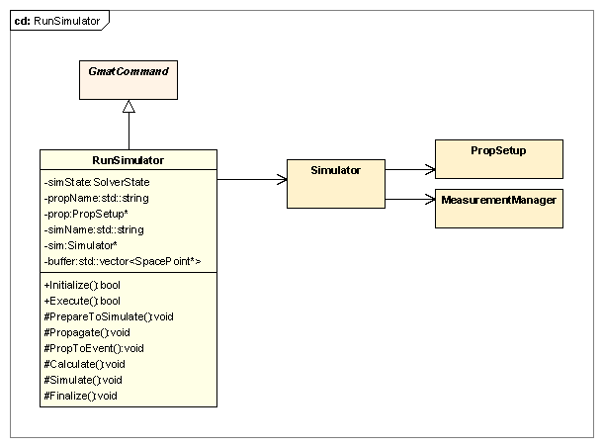
Figure 20: The RunSimulator Class

RunSimulator Members
RunSimulator Attributes
- Gmat::SolverState simState: Tracks the state coming from the simulator’s finite state machine so that appropriate actions can be triggered.
- std::string propName: Name of the PropSetup used to evolve the objects involved in the simulation.
- PropSetup *prop: A pointer to the simulator’s copy of the configured PropSetup.
- std::string simName: The name of the simulator that implements the finite state machine.
- Simulator *sim: A pointer to the simulator clone that is used with this command.
- <<future 0.7>> std::vector<SpacePoint*> buffer: A local data buffer used to store copies of the simulation participants so that they can be restored later.

RunSimulator Methods
- virtual bool Initialize(): The method used to wire together all of components of the simulation that are available prior to execution of the Mission Control Sequence.
- virtual bool Execute(): The Mission Control Sequence entry point to the simulation. This method makes calls to the AdvanceState() method on the simulator to drive the finite state machine.
- void PrepareToSimulate(): Method used to complete command initialization prior to execution of the finite state machine. This method is triggered when the finite state machine is in the INITIALIZING state, prior to actual calls to the state machine. The PropSetup completes initialization of its ODEModel and propagation state data during this call.
- void Propagate(): Propagates the components of the simulation when the finite state machine is in the PROPAGATING state. This method queries the simulator for the desired time step (specified in seconds), and propagates by that duration to the next simulation epoch. If the simulator specifies a zero time step, the command propagates by the natural time step of the propagator in the PropSetup.
- <<future 0.7>> void PropToEvent(): Propagates the components of the simulation when the finite state machine is in the LOCATING state. This method buffers the state data if necessary, queries the simulator for the desired time step (specified in seconds), and propagates by that duration to the next simulation epoch. If the simulator specifies a zero time step, the command throws an exception and stops the simulation.
- void Calculate(): Method called when the finite state machine is in the CALCULATING state. This method is used to report status to the simulator text file.
- void Simulate(): Method called when the finite state machine is in the SIMULATING state. This method is used to report status to the simulator text file.
- void Finalize(): Cleans up the data structures used during the simulation, including the objects in the object buffer. This method is triggered when the simulator is in the FINISHED state.

Add exceptions etc…

The Simulator Class
The Simulator class capitalizes on the state machine infrastructure provided by the Solver base class. Simulators inherit these structures and use them to drive the simulation process. Figure 13 (FIGURE NEEDS UPDATING) shows the structure of the Simulator class, described in this section.

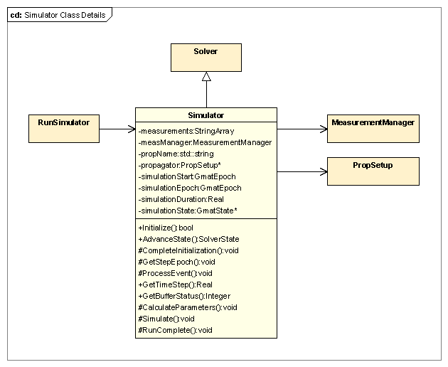
Figure 21: The Simulator Class

Key Processes

The Simulator class has two key processes: the Initialize() method, which initializes its management members and prepares its propagation subsystem for initialization, and the AdvanceState() method, which drives the simulation state machine.

Simulator Initialization

The initialization process manages the initialization of the MeasurementManager, PropSetup, and the referenced objects associated with these members. The MeasurementManager initialization, described in the MeasurementManager class description, prepares the Measurement objects for use in the simulation. The initialization for the PropSetup performs the pre-initialization steps so that the ODEModel and associated state data can be initialized at the start of the RunSimulator::Execute() call during the Mission Control Sequence run.

The Simulation State Machine

The Simulator uses six states to drive its algorithm. These six states, shown in the bottom partition of Figure 22, work together to simulate measurement data for a mission.

Figure 22: The Simulation State Machine

The list below describes each state of the machine, including the entry and exit conditions along with the internal actions required to move to the exit condition for the state:

- INITIALIZING:
  - Entry condition: The INITIALIZING state is the state the Simulator takes upon completion of initialization in the Sandbox. Upon completion of a simulation run, the Simulator returns to this state so that a subsequent call can reuse the same simulator.
  - Actions Method Name: CompleteInitialization():
    - Gather the data and fill the simulator’s state. Get current epoch from spacecraft participants, make sure all participants have the same epoch. If not, throw an exception.
  - Exit condition 1:
    - Change to PROPAGATING state if current epoch is not the simulation start epoch
  - Exit condition 2:
    - Change to CALCULATING state if current epoch is the simulation start epoch
  - TBD: How do we get back to the INITIALIZING state after a simulation? Does measurement manager need a call here. Check to see if simulation end time is after simulation begin time.
- PROPAGATING
  - Entry condition: A new observation needs to be simulated.
  - Actions Method Name: GetStepEpoch()
    - Determine time step for propagation to the observation epoch
    - Provide time step to command for propagation on request
    - Determine if measurement for the observation has events that require propagation
  - Exit condition 1:
    - Propagation to the desired time has occurred
    - No unprocessed propagation events
    - Change state to CALCULATING
  - Exit condition 2:
    - Propagation to the desired time has occurred
    - Current epoch is past simulation end time
    - Change state to FINISHED
- << future 0.7>> LOCATING
  - Entry conditions:
    - An event that requires propagation has been found
    - Resources are at a known epoch for the event, called the anchor epoch.
  - Actions Method Name: ProcessEvent()
    - Manage the flag used to handle buffer state information
    - Calculate time step required for the event
    - Provide time step to command for propagation on request
    - Evaluate event to determine if propagation results are within tolerance
    - Iterate from time step calculation until event converges
  - Exit condition 1
    - Event has converged
    - No additional events found
    - Reset state information to buffered data
    - Change state to SIMULATING
  - Exit condition 2
    - Event has converged
    - Another event found
    - Change state to LOCATING and start a new iteration
- CALCULATING
  - Entry condition: Epoch is at a simulation epoch.
  - Actions Method Name: CalculateParameters()
    - Determine observability for measurements at the current epoch
    - Measurement manager gets and stores measurement values for the current epoch
  - Exit condition 1
    - No measurements are observable
    - Change state to PROPAGATING
  - Exit condition 2
    - At least one measurement primitive was calculated
    - No propagation is required for corrections
    - Change state to SIMULATING
  - <<future 0.7>> Exit condition 3
    - At least one measurement primitive was calculated
    - Corrections that require event finding were detected
    - Change state to LOCATING
- SIMULATING
  - Entry condition:
    - All measurements and events at the current epoch have been pre-processed
  - Actions Method Name: Simulate()
    - <<future 0.2>> Apply corrections to all observable measurements
    - Tell measurement manager to write measurement data to the measurement data stream
    - Calculate the time step to the next measurement that needs to be simulated
  - Exit condition 1:
    - Measurement data was written to the data stream
    - Propagation time step remains within the simulation span
    - Change state to PROPAGATING
  - Exit condition 2:
    - Measurement data was written to the data stream
    - Propagation time step remains outside of the simulation span
    - Change state to FINISHED
- FINISHED
  - Entry condition: Simulation work finished
  - Actions Method Name: RunComplete()
    - Clean up data structures
    - Flush and close the measurement data stream
  - Exit condition:
    - Change state to INITIALIZING so simulator is reentrant
TBD: Does this state change here, or at prompting from the command?

Simulator Members

Simulator Attributes
- StringArray measurements: Names of the measurement models used in this simulator. This array of names is passed to the MeasurementManager for processing.
- MeasurementManager measManager: The MeasurementManager for the simulator
- std::string propName: Name of the configured propagator used to evolve objects during the simulation process.
- PropSetup *propagator: The propagator configured for the simulation.
- GmatEpoch simulationStart: The start epoch for the simulation.
- GmatEpoch simulationEpoch: The current epoch of the simulation.
- Real simulationDuration: The length of the simulation, in seconds.
- GmatState *simulationState: The state vector that is propagated. (TBD: if really needed)

Simulator Methods
- bool Initialize(): Validates reference objects and sets up all available interconnections in the simulator.
- Solver::SolverState AdvanceState(): Evaluates the status of the finite state machine and implements transitions between states.
- virtual void CompleteInitialization(): Performs the final initialization steps needed before executing the simulation. This method is called when the finite state machine is in the INITIALIZING state, and completes the actions required to transition to the next state.
- virtual void GetStepEpoch(): Determines the time step to the next epoch for access by the RunSimulator command. This method is called when the finite state machine is in the PROPAGATING state.
- virtual void ProcessEvent(): Determines the next time step needed to manage event finding. This method is called when the finite state machine is in the LOCATING state. It may be called repeatedly as the event finding algorithm seeks the location of one or more events.
- Real GetTimeStep(): Retrieves the most recently computed time step for use in propagation. This public method is called by the RunSimulator command to determine the desired propagation step size.
- Integer GetBufferingStatus(): Returns -1 if objects need to be restored from the buffered objects in the RunSimulator command, 0 if the buffers are not to be accessed, and +1 if the simulation objects need to be buffered. This public method is called by the RunSimulator command to determine when buffer actions are needed.
- virtual void CalculateParameters(): Calculates measurement data in the measurement primitives. This method is called when the finite state machine is in the CALCULATING state.
- virtual void Simulate(): Calculates the fully corrected measurement values that are reported to the measurement data stream, and writes those data to the stream. The measurement data stream can be either a file, a database, or a live data stream. (The initial estimation builds of GMAT support the file option.)
- virtual void RunComplete(): Cleans up the data structures used during the simulation, flushed the data buffers associated with the measurement data stream, and closes the stream.

Measurement Related Classes
The Measurement classes define the interfaces used to work with measurement data during the estimation process. These classes provide access to the observation data, typically provided by way of a data file, using a helper object derived from the MeasurementReader base class. The Measurement classes provide methods that calculate the expected value of a specific measurement type, along with the derivative data needed for estimation. These data include calculation of expected measurements, measurement partials, determination of measurement feasibility, and interactions with root finders to determine tracking schedules and light time corrections. A measurement object acts as a participant in the measurement, as the measurement object contains estimated states associated with measurement errors.

The measurement hierarchy consists of a base class and a tiered hierarchy of derived classes as shown in Figure 23. The following sections discuss each class in the hierarchy in detail, starting with the Measurement base class.
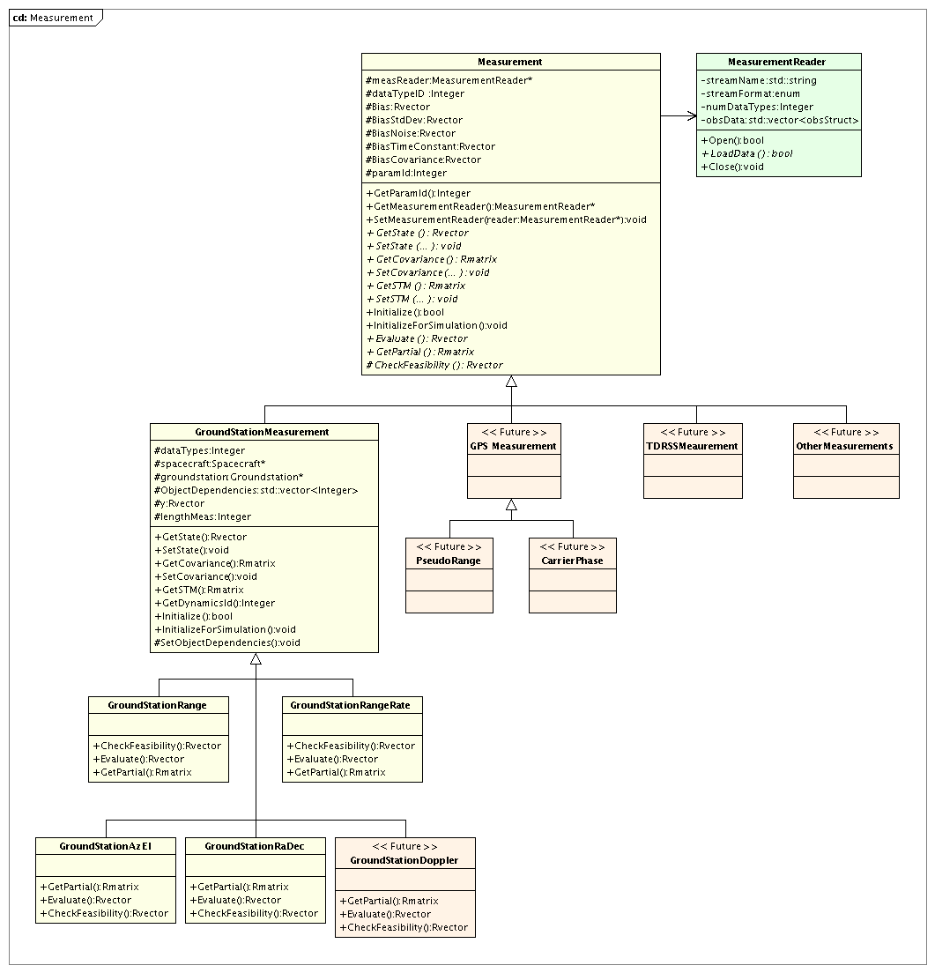
Figure 23: The Measurement Class Hierarchy

Measurement Base Class
The Measurement base class contains member data and functions associated with all measurement objects as well as data associated with parameters that are set by the user when configuring the measurement object. Examples of these data include the measurement file name and format, the data types to be processed from the file, and measurement stochastic properties such as biases and time constants.

The Measurement class defines many of the interfaces implemented in the derived classes so that the estimation process can work with measurement objects using base class references and pointers. These interfaces are defined as either overridable or abstract (that is, pure virtual) methods on the Measurement base class. The derived classes implement custom versions of these methods that are specific to the measurement type being implemented. The data members of the Measurement base class are described below, followed by descriptions of the methods provided in the Measurement base class. Finally, we will describe the MeasurementReader helper class before moving to the definitions of the derived classes.

Member Data

The list below describes the data elements provided in the Measurement base class to support the derived classes. These elements are designed to facilitate access to measurement information through calls to a Measurement instance pointer. Some Measurement objects provide multiple data elements. For that reason, some of the data members listed here gain a dimension over what might be expected for single-valued measurements. For example, the ground station RA/Dec measurement type returns two values for each measurement: the right ascension and declination values, so the methods that calculate these values return an Rvector rather than a Real number. Since there are Measurement classes that have this multivalued return requirement, GMAT uses an Rvector for the data, even when the return value is a single number.

The data members of the Measurement are:

- MeasurementReader *measReader: The MeasurementReader that supplies the observation data. This pointer can be NULL when simulating data.
- Integer dataTypeID: An integer containing the Id for the data type. Although the user may specify several data types on a measurement object, GMAT creates an object for each data type during initialization. <DJC: I’m not quite sure what you mean here. Where are these objects?> Each object has an Id associated with its data type which is specified by dataTypeId.
- Rvector Bias: A vector of real numbers containing the measurement biases. These data can be estimation state parameters.
- Rvector BiasStdDev: A vector of real numbers containing the standard deviations of the biases. These data can be estimation state parameters.
- Rvector BiasNoise: A vector of real numbers containing the noise in the measurement biases. These data can be estimation state parameters.
- Rvector BiasTimeConstant: A vector of real numbers containing the time constants for the measurement biases. These data can be estimation state parameters.
- Rvector BiasCovariance: A vector of real numbers containing the bias covariances.
- Integer ParamId: ID for the type of measurement parameter?
- Integer numDataTypes: The number of data types the user specified on the measurement object. During measurement initialization, a new object is created for each data type specified on the measurement object. <DJC: Still confused about what this means>

Class Methods

The Measurement class includes the following methods designed to make access to measurement data as generic as possible by the classes that use Measurement objects. Many of these methods are abstract (pure virtual in C++ terminology): they are defined in this base class, but no implementation is provided in the base class. The abstract classes can be identified by an “= 0” suffix in this list.

- enum MeasurementFormat: An enumeration defining the supported measurement formats. Note: This enumeration is not a class member; it is a member of the Gmat namespace.
- Integer GetParameterId():A method to determine the integer id for solve-for and consider parameters on the measurement object. This is how the system converts from the string definition provide by the user, say MauiGSRange.Bias,to a numeric Id. <DJC: Not sure of this part.>
- MeasurementReader *GetMeasurementReader(): Retrieves a pointer to the MeasurementReader.
- void SetMeasurementReader(MeasurementReader *reader): Sets the pointer to the MeasurementReader.
- virtual Rvector& GetState() = 0: Retrieves the state vector.
- virtual void SetState(Rvector& newState) = 0: Sets the state vector to match the provided data.
- virtual Rmatrix& GetCovariance()= 0: Retrieves the covariance matrix.
- virtual void SetCovariance(Rmatrix& newCovariance) = 0: Sets the covariance matrix data.
- virtual Rmatrix& GetSTM() = 0: Retrieves the state transition matrix.
- virtual void SetSTM(Rmatrix& newSTM) = 0: Sets the STM matrix data.
- virtual bool Initialize(): Prepares the Measurement object for use in a Sandbox.
- virtual void InitializeForSimulation(): Prepares the Measurement object for use during measurement simulation.
- virtual Rvector& Evaluate() = 0: Calculates the expected observation value.
- virtual Rmatrix& GetPartial() = 0: Retrieves the measurement partial derivative matrix.
- virtual Rvector& CheckFeasibility() = 0: Checks to see if a measurement can be made using the current state information.

GroundStationMeasurement

Measurements that are made at a ground station are modeled using the GroundStationMeasurement class. Data and member functions that are common to all Ground Station measurements are located on the GroundStationMeasurement class, including the participants in the measurement process, Get/Set functions, and common modeling algorithms. Below we discuss in detail all member data and functions.

GroundStationMeasurent Member Data:

- Integer dataTypes: ???
- Spacecraft *spacecraft: A pointer to the spacecraft that is participating in the measurement. This pointer is set during measurement initialization.
- Groundstation *groundstation: A pointer to the ground station that is participating in the measurement. This pointer is set during measurement initialization.
- std::vector<Integer> ObjectDependencies: A vector of integers that contains information on how participants on a measurement object map to participants in the overall estimation problem. In general, the participants on a measurement are a subset of the participants for the estimation problem. The ObjectDependencies is used primarily to determine partial derivatives and ensure they are placed in the correct location in the overall partial derivative array. The ESM maintains an array of pointers, called ObjectsVector, to the participant associated with each state chunk in the estimation problem. The ObjectDependencies array is the same length as ObjectsVector. If, for example, element 1 of ObjectDependencies is zero, then the first object in the estimator’s participant list is not a participant in the measurement. If element 1 is nonzero, then the integer is associated with the participant Id used internally by the measurement. The ObjectDependencies array is set during initialization when the Measurement Manager makes a call to initialize the measurement.
- Rvector y: The vector of calculated measurements.
- Integer lengthMeas: ???

GroundStationMeasurement Methods:

<DJC: These need to be filled out with the method signatures>

- SetState: Given a state value and id, this method updates the state on the measurement object.
- GetState: Given a state id, this method gets the state from the measurement object.
- SetCovariance: Given a covariance matrix and the state id, this method updates the state’s covariance on the measurement object.
- GetCovariance: Given a state id, this method gets the state’s covariance from the measurement object.
- GetSTM: Given a state id, this method gets the states’ STM.
- GetDynamicsId: Given a state Id, this method returns the ODE model ID for use in propagation of the state and it’s STM.?? Not implemented yet for measurement.
- Initialize: This method makes a call to the file reader and gets the observations and epochs from the requested data type. If there are multiple data types on the measurement, the measurement object concatenates them into the Obs and Epochs Arrays. These are then extracted by the measurement manager later in the initialization process. For each data type, a new object is created and pointers to the object’s participants are set. (Matlab currently only supports one data type per measurement. Not a difficult mod though)
- InitializeforSimulation: This method prepares a measurement object for simulation. The process is similar to the Initialize method on GroundStationMeasurement, with the exception the reading and managing observations and epochs is not required.
- GetDataTypeId: This method returns the integer Id for the measurement type, given the string name for the measurement.
- SetObjectDependencies: This method takes as input an array of pointers to the participants in the estimation state vector. The method steps through each element in the input array and determines if it points to any of the measurement participants. If not, then the element in ObjectDependencies is set to zero. If so, then the element is set to the Id of the participant used internally by the measurement object.

GroundStationRange

The GroundStationRange class is derived from the GroundStationMeasurement class, and performs modelling range measurements, measurement feasibility, and partial derivatives, and light time iteration.

GroundStationRange Member Data:

None. The data members in the GroundStationMeasurement class are sufficient for this class.

GroundStationRange Member Functions:

<DJC: These need to be filled out with the method signatures>

- CheckFeasibility: This method evaluates the feasibility function for the range measurement. If the value of the feasibility function is positive, then the conditions required to perform a measurement are met. If the feasibility function is negative, conditions are not met. Event locators determine the roots of the feasibility function to determine tracking data scheduling.
- Evaluate: The evaluate function calculate the computed value of the measurement based on the current state of the participants.
- GetPartial: This method returns the requested partial derivative based given a participant Id and the state Id. The participant Ids are contained in the array ObjectDependencies. This method is called by the measurement manager to determine individual partials. The measurement manager assembles the entire partial derivative from the pieces returned by the measurement object.

Unresolved issues. Much of the math required for say measurement calculation, partials evaluation, and feasibility checking is the same. We need to figure out how to consolidate the math while keeping interfaces clean and intuitive. In Matlab, the same math is repeated in several locations.

Measurement Manager

The measurement manager functions as the interface between the Estimator and the measurement objects defined by the user. The primary jobs of the measurement manager are

- To coordinate measurement data and provide observed and computed values to the estimator
- To maintain the sorted list of observed measurement quantities from all measurement sources.
- To assemble the H matrix for each measurement based on state information and the partials map provided by the measurements.

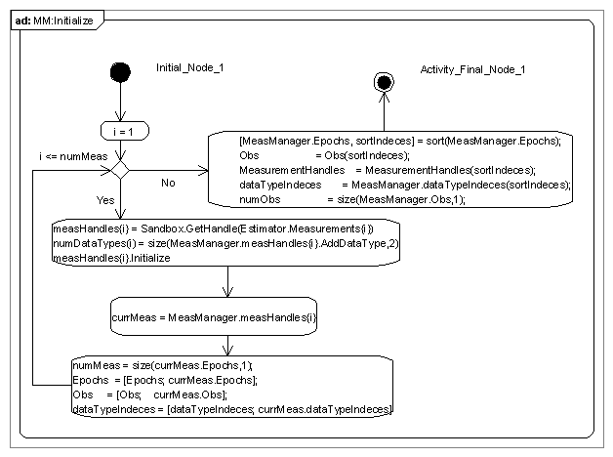

MeasurementReader Helper Class
The arrays of observations and epochs for the measurement objects are located on the base class.

<To be filled in: by Matt? I’m treating this as a place holder for those bits; maybe it goes elsewhere, though.>
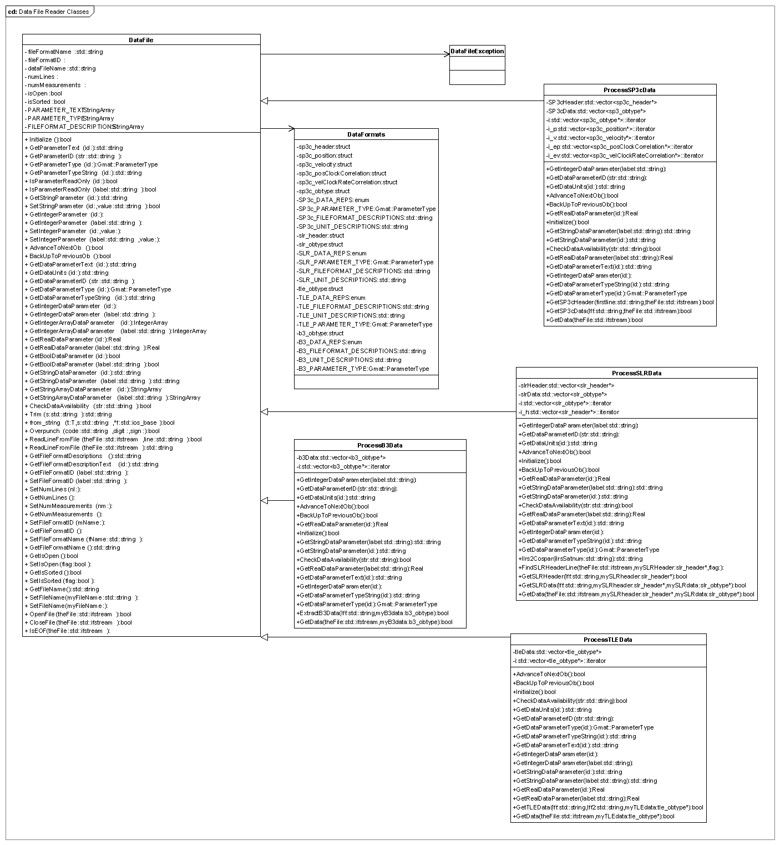
Member Data

- std::string streamName : A string containing the name of the file provided by the user that contains observed measurement values.
- MeasurementFormat streamFormat: A string containing the format of the file contained in filename.

Class Methods

- bool Open(): Opens the stream that provides observation data. Simulator Related Classes

Simulator Class

Run Simulator Commnad

PropSetup is initialized as it would be for any other mission.

Propagation and Event Location Classes

Propagator Class

Event Locator Class

Process for Adding new Features

How to add a new solve-for or consider parameter

How to add a new estimator

How to add a new dynamics model

How to add a new measurement model

Appendix 1: Simulation Sample Script

%----- Create Three Spacecraft and Three Groundstations. For simplicity we’ll assume the defaults contain the desired settings for these objects.
Create GroundStation Maui WhiteSands
Create Spacecraft OdSat1 OdSat2 OdSat3

Need to add def’s for antennas here and attach them to the resources
%----- Create a container for two measurement models. The measurements are Two-Way Range and Doppler between OdSat1’s Antenna1 and Maui’s Antenna1. (For now we assume the sensors exist).
Create Measurement MyMeas
MyMeas.AddMeasurement = {'TwoWayRange',OdSat1.Antenna1,Maui.Antenna1, …
'Bias',.01, …
'TimeConstant',7200, …
'FileName','..\File1.od'};
MyMeas.AddMeasurement = {'TwoWayDoppler',OdSat1.Antenna1,Maui.Antenna1, …
'Bias',.01, …
'NoiseSigma',.001, …
'TimeConstant',7200, …
'FileName','..\File1.od'};
%----- Create a container for two measurement models. The measurements are Two Way Range and Doppler between OdSat3 and WhiteSands, and one way range between ODsat2 and ODsat1. (For now we assume the sensors exist).
Create Measurement YourMeas
YourMeas.AddMeasurement = {'TwoWayRange',OdSat3,WhiteSands, …
'Bias',.01, …
'TimeConstant',7200, …
'FileName','../File1.od'};
YourMeas.AddMeasurement = {'OneWayRange',OdSat2,OdSat1, …
'Bias',.01, …
'TimeConstant',7200, …
'FileName','../File3.od'};
%----- Create a propagator. Assume the defaults are acceptable.
Create Propagator SimProp;
%----- Create a simulator. Add the measurement objects we would like to include in the simulation. Specify the measurement time span, frequency and which propagator to use.
Create Simulator Sim1
Sim1.AddMeasurement = {MyMeas, YourMeas}; % Specify the measurements to simulate
Sim1.InitialEpoch = OdSat1.Epoch
Sim1.Duration = 1; % days
Sim1.Frequency = 30; % seconds
Sim1.Propagator = SimProp;
%----- Run the simulator
RunSimulator Sim1;

Acronym List

ESM Estimator State Manager
PSM Propagate State Manager
MM Measurement Manager
EM Event Manager
GMAT General Mission Analysis Tool

References

[1] Eckel, Bruce. “Thinking in C++”, Prentice-Hall, New Jersey, 2000.
[2] Stellman, A., and Greene, J., “Applied Software Project Management”, O’Reilly, Sebastopol, CA, 2006.

Internal and plug-in factories are constructed and registered in the Moderator’s initialization code, so the statement that the factories are registered during startup is true regardless of which type of implementation the final estimation subsystem uses for deployment.
Resource initialization is actually handled in an instance of the ObjectInitializer class in the Sandbox. The ObjectInitializer manages the ordered initialization process, which is performed as described here.
“State” in the context of a finite state machine corresponds to the status of the machine. This is distinct from the state vector used by an estimator or SpaceObject. When the context does not make the distinction clear, the term “finite state” is used for the state machine states and “state vector” for the data vectors.
The state machine in the figure shows the nominal path through the process. Anomalous paths, like the absence of observation data mentioned here, are not included in the figure.

