Measurement Modeling in GMAT’s First Estimation Build
The initial estimation builds of GMAT use a simplified measurement model architecture in order to support scripting for the measurement models that follows the format shown in Listing 1. In this sample script fragment, two measurement models are created. The first one supports range measurements taken at a ground station between a spacecraft named MySat and a sensor named Sensor1 on that ground station, which is named MyGS. The second supports averaged Doppler measurements measured at the same ground station between the ground station and the spacecraft MySat.

% Script Example 1
%--------------------------------------------------------------------------
%----------- Define the measurements between MySat and Maui Ground Station
%--------------------------------------------------------------------------
Create B3Datafile MauiDataStream
MauiDataStream.Filename = MauiData.B3

Create MeasurementModel MySatMauiRange
MySatMauiRange.Type = Range;
% Here is how sensors enter the measurement models once we have them
MySatMauiRange.Participants = { MyGS.Sensor1, MySat };
MySatMauiRange.Bias = 0.1;
MySatMauiRange.NoiseSigma = 0.01;
MySatMauiRange.TimeConstant = 7200;

Create MeasurementModel MySatMauiDoppler
MySatMauiDoppler.Type = AveragedDoppler;
MySatMauiDoppler.Participants = { MyGS, MySat };
MySatMauiDoppler.Bias = 0.075;
MySatMauiDoppler.NoiseSigma = 0.02;
MySatMauiDoppler.TimeConstant = 7200;

% Stream specifiers can be part of either the models or, when models are
% collected together, the resulting groups. Here is the group version:
Create MeasurementGroup MauiData;
MauiData.ObservationData = MauiDataStream;
MauiData.AddModel = {MySatMauiRange, MySatMauiDoppler};

Listing 1: Measurement Model Scripting

The initial estimation builds will not include sensor objects; the scripting shown here for the first measurement model illustrates scripting for sensors once they are available.

The class structure for the measurement model subsystem is shown in Figure 1. When a user scripts a measurement model using the line “Create MeasurementModel myModel”, an instance of the MeasurementModel class is created for use by the estimation subsystem. The MeasurementModel class is a wrapper for measurement calculation objects. The initial estimation builds support four primitive measurement modes: range, range rate, right ascension-declination angles, and azimuth-elevation angles. These models are the end nodes in the orange portion of the class diagram. Each of these measurement primitives is derived from the GeometricMeasurement class, which defines the interfaces the measurement model uses to access measurement calculations needed for simulation and estimation. Future builds of GMAT will collect these primitive measurement interfaces in a generalized MeasurementPrimitive base class.

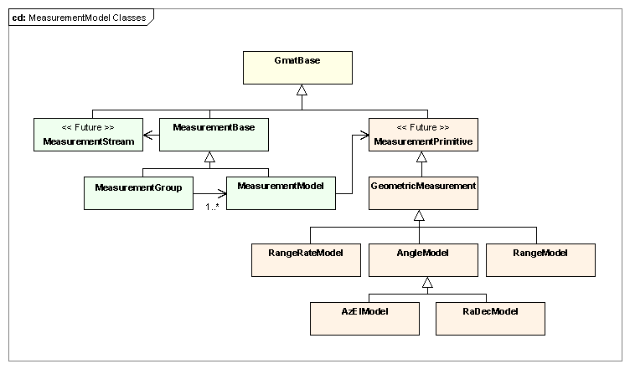
Figure 1: Classes Used in Measurement Modeling

MeasurementGroup objects are instances of a container class that group together measurement models that share a data stream. For the sample script, the data stream is a B3 formatted data file object with the file name MauiData.B3. This data stream is used to handle range and averaged Doppler measurements as defined in the two measurement models, named MySatMauiRange and MySatMauiDoppler.

The MeasurementBase class defines the interfaces that the MeasurementManager uses to work with GMAT’s measurement models. This base class includes the measurement data interfaces along with a pointer and interfaces to the corresponding measurement stream objects. The MeasurementManager works through pointers to MeasurementBase objects so that it can treat MeasurementGroups and MeasurementModel objects identically.

The following paragraphs describe the measurement model classes in the hierarchy, and then the measurement primitives starting with the GeometricMeasurement class. The measurement stream classes – and more specifically, the DataFile classes that define the measurement streams for the first build – are described elsewhere in this document.

The MeasurementBase Class
GMAT’s measurement model interfaces are defined in the MeasurementBase class, along with methods used to manage the measurement data. Figure 2 shows the MeasurementBase base class in its hierarchy.
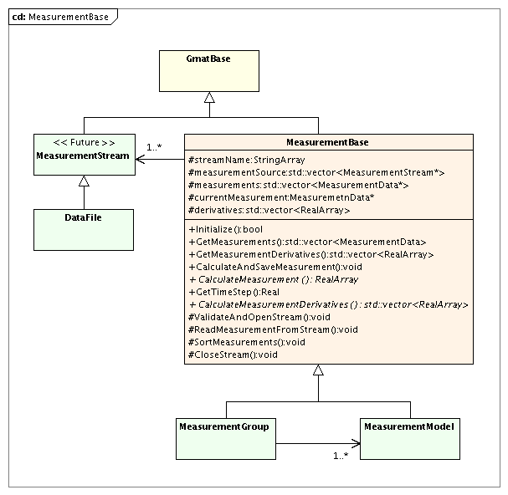
Figure 2: The MeasurementBase Class

Key Processes
MeasurementBase provides the methods used to access measurement data read during the estimation process or written during the simulation process. Gmat supports measurement data accessed from measurement data files in a variety of formats, from databases using Structured Query Language (SQL) (Matt – is this correct? Or does the database contain information about where to find the measurement files?) or through real time interfaces. The initial release includes design features that can be extended for these methods, but focuses on file interfaces. The first builds implement an internal measurement data file. The format for this data file is provided in an appendix to this document. (Okay, that means we need to provide it or make this a TBP.)

The MeasurementBase class also defines the interfaces, implemented in the derived classes, that are used to calculate expected measurement values, the derivative information associated with these values, and the time step information required to iterate state data to perform propagation related measurement corrections. All of these interfaces are described below.

MeasurementBase Attributes
- StringArray streamName: List of all of the data streams used tor measurement data.
- std::vector<MeasurementStream*> measurementSource: The measurement data streams.
- std::vector<MeasurementData> Measurements: The collection of measurement stream objects that supply the data
- StringArray streamName: Names of the measurement stream objects.

MeasurementBase Methods

MeasurementBase Abstract Methods

The MeasurementModel Class

Key Processes

MeasurementModel Attributes

MeasurementModel Methods

The MeasurementGroup Class

Key Processes

MeasurementGroup Attributes

MeasurementGroup Methods

For the initial builds of GMAT’s estimation code, a type definition is defined that equates Measurement-Stream objects with DataFile objects and GeometricMeasurement objects with MeasurementPrimitives.

