Measurement Related Classes

Overview

Measurement modeling in GMAT requires several system components: participants and their attached sensors, a model for how the sensors interact to create a measurement, dynamics models and propagators that model the participants/sensors time evolution over the measurement time span, and an event locator that locates relevant discrete events in the measurement process. As a result, measurement modeling is perhaps the most complex aspect of the estimation process.

The two primary classes that are involved in providing computed measurement values to the estimator are the Measurement Manager class and the measurement class. Because the measurement process is managed by the measurement manager helper class, it’s difficult to discuss the measurement class, without first discussing the Measurement Manager itself. Due to the complexity of both classes, our approach is based on a detailed example that contains two measurements provided by a user, where each measurement has at least two data types. We introduce the measurement object from a user perspective, and then discuss how the measurement manager and measurement class are designed to manage and evaluate measurement data. For each class we present at a low level the class responsibilities, the initialization process, the exectution time activities, the class diagram, and descriptions of the member data and functions.

Detailed Script Examples

The text below contains script snippets that illustrate how a user can specify several measurement types: measurements between a spacecraft sensor and a ground station, measurements between the TDRSS constellation and a user spacecraft, and synthesized measurement types constructed from fundamental measurement types defined on the measurement class. A measurement object is created by using the Create command and providing a name for the measurement object. From the user perspective, the measurement object is a container for different data types located on a measurement file: each measurement object has a single data file (is this a good idea: pros/cons??). User’s select which measurements to process form the file or provide instructions for processing the individual measurements using the AddDataType field. Let’s look at each script snippet in detail.

In the script shown below the user first creates a measurement object called MauiData using the create command and defines the measurement file and format. In the next script line, he adds a Range data type to the measurement object and specifies the ground station sensor and spacecraft that are used to create the range measurement. The data type’s dynamic model compensation is configured by providing the bias, noise standard deviation, and time constant. Similarly, in the last line the user adds an averaged Doppler data type between MyGS.Sensor1 and MySat.

%------------------------------------------------------------------------
%----------- Define the measurements between MySat and Maui Ground Station
%--------------------------------------------------------------------------
Create Measurement MauiData;
MauiData.DataFile = MauiData.B3
MauiData.FileFormat = B3 % Is this needed?
MauiData.AddDataType = {‘Range’,MyGS.Sensor1,MySat,’Bias’,.1,’NoiseSigma’,
.01,’TimeConstant’,7200};
MauiData.AddDataType = {‘AveragedDoppler’,MyGS,MySat,’Bias’,.1};
’NoiseSigma’,.01,’TimeConstant’,7200};

In the script snippet below, the user creates a measurement object that contains measurements between MySat and the TDRSS constellation. The specific data types are specified as TDRSS four way range and TDRSS forward Doppler.

%------------------------------------------------------------------------
%----------- Define the measurements between MySat and Maui TDRSS
%--------------------------------------------------------------------------
Create Measurement TDRSSData
TDRSSData.DataFile = TDRSSData.Rinex;
TDRSSData.FileFormat = Rinex;
TDRSSData.AddDataType = {‘TDRSS4WayRange’,MySat,TDRSS,’NoiseSigma’, .01, ‘Bias’,.01};
TDRSSData.AddDataType = {‘TDRSSForwardDop’,MySat,TDRSS,’NoiseSigma’, .05,.0001};

In the final script snippet below, the user creates a user-defined “synthesized” measurement between the Maui ground station, the user spacecraft, and the Canberra ground station. In this case, GMAT creates the data type by ‘piecing together’ the data type from fundamental data types defined on the measurement class.

%------------------------------------------------------------------------
%----------- Define a new data type not used before.
%--------------------------------------------------------------------------
Create Measurement MyNewMeas
MyNewMeas.DataFile = MyNewMeas.Rinex;
MyNewMeas.FileFormat = Rinex;
MyNewMeas.AddDataType = {‘Range’,Maui,MySat,Canberra,’NoiseSigma’, .01, ‘Bias’,.01};

Measurement Manager

Measurement Class

File Reader/Writer Helper Class

Measurement Manager

Responsibilities

The measurement manager functions as the interface between the estimator and the measurement objects defined by the user. The primary jobs of the measurement manager are

- To coordinate measurement data and provide observed and computed values to the estimator
- To maintain time-sorted lists of
  - measurement epochs
  - observed measurement quantities
  - pointers, with a one-to-one mapping to the observed and epoch lists, to measurement objects that calculate computed values.
- To assemble the H matrix for each measurement based on state information and the partials map provided by the measurements.
- To assemble the measurement weight matrix for measurements taken at the same epoch.

Initialization

Activities during Execution

Basically everything you wrote is right on point except for one "small" thing. I was thinking that the MeasurementManager needs to go through the sensor to get to MeasurementModel. The MeasurementManager will know four basic things: 1) the data format, 2) the sensor tag, 3) the target tag, and 4) the measurement(s) on a given data record. In the case of B3 data, there is a flag that says "this record contains range, az and el" but SLR has no such flag. The MeasurementManager will need a method to figure out what measurement(s) it is currently playing with for each data format. Or more precisely, the MeasurementManager will query the DataFile object to return the individual measurement types provided by a data record which can change on a record by record basis for things like B3. For simulated data, there most likely will be a measurement type flag that bypasses the need to figure all this stuff out.
That being said, the data readers load all data into memory at initialization and we can play with it as we see fit. One option would be to parse through the data and determine all possible measurement models and construct the vector of MeasurementModels that comes from the statement "Each MeasurementManager has a vector of MeasurementModels. There must be at least one MeasurementModel in that vector for estimation to proceed." But I'm not sure that this will buy us anything because we will still need to determine which measurement model to use when handling each data record. It seems to me that we would be doing this work twice. I'm more in favor of the MeasurementModel asking the sensor for a particular measurement as it processes each data point and the sensor responding with a boolean true/false. In my mind, the sensors should keep tabs of their own capabilities and the MeasurementManager should rely on them to get it's job done.

These are the programmatic steps that I envision happening:

1) MeasurementManager obtains pointer to Sensor object (mapping between sensor tag and GMAT sensor objects)
2) MeasurementManager obtains pointer to target object (mapping between target tag and GMAT objects)
3) MeasurementManager asks DataFile object for a StringArray of measurement types for current data record
4) MeasurementManager requests measurement from Sensor object and passes StringArray to Sensor object
5) Sensor object uses appropriate MeasurementModel based upon StringArray
6) Sensor object returns true/false with measurements and/or partials if true

Now I'm not entirely sure what this does to the SyntheticMeasurement model. As you have it in the diagram, SyntheticMeasurements flow down from the generic MeasurementModel. I kinda see synthetic measurements as a helper class to the MeasurementManager more than a true measurement model.

I'll also comment that the geometric angle models compute range and range rate in the process of computing the angles. I'm not sure how that will or should affect the organization of classes. Currently, I have AzEl and RangeAzEl as two separate models even though they both compute Range. It's just that in the first case, the AzEl MeasurementModel will deny being able to compute Range.
Error! Filename not specified.
Here are the salient points of what I'm trying to capture in this picture:
- SpacePoint objects (Spacecraft, Groundstations; probably disabled for the other SpacePoints until we need it there) will have a vector of Sensor object pointers so that each enabled object can have 0 or more Sensors. (The Sensor piece is a post-Sep 13 build item in my "crawl first" implementation scheme; that role will initially be built as part of the SpacePoint infrastructure.)
- Each Sensor object can have 0 or more MeasurementModel objects. (Allow for no measurement models so the sensors can be used in other contexts -- for example, to show the sensor view cone while propagating, or to show station masks).
- Estimators access the MeasurementModels through a MeasurementManager. Each Estimator has exactly one MeasurementManager.
- Each MeasurementManager has a vector of MeasurementModels. There must be at least one MeasurementModel in that vector for estimation to proceed.
- Each MeasurementModel can have 0 or more MeasurementCorrection helper objects. These helpers will be used to do teh correction calculations, and to provide the prop epochs that are needed to do things like light time correction iterations.
- There is a special MeasurementModel, the SyntheticMeasurement, that uses a collection of measurements and consolidates their computations for use in the Estimator. SyntheticMeasurement objects must have at least one MeasurementModel.
(Can Individual sensors own a SyntheticMeasurement object? I'm thinking not, but don't object to having that as a possibility if there is a good case for it. My current thinking is that each SyntheticMeasurement object is owned by a MeasurementManager, meaning that while the other measurement models have their scope set to match the scope of the SpacePoint/SpacePoint Sensor that they are attached to, the SyntheticMeasurement objects have their scope set to match that of a MeasurementManager, and get destroyed as part of the destructor call to that MM.)
Does this all hit -- at least at a coarse level -- with what you are thinking?

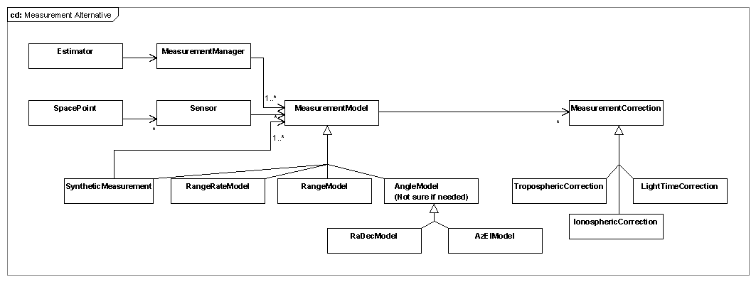

Measurement Class
The Measurement classes define the interfaces used to work with measurement data during the estimation process. These classes provide access to the observation data, typically provided by way of a data file, using a helper object derived from the MeasurementReader base class. The Measurement classes provide methods that calculate the expected value of a specific measurement type, along with the derivative data needed for estimation. These data include calculation of expected measurements, measurement partials, determination of measurement feasibility, and interactions with root finders to determine tracking schedules and light time corrections. A measurement object acts as a participant in the measurement, as the measurement object contains estimated states associated with measurement errors.

The measurement hierarchy consists of a base class and a tiered hierarchy of derived classes as shown in Figure 1. The following sections discuss each class in the hierarchy in detail, starting with the Measurement base class.
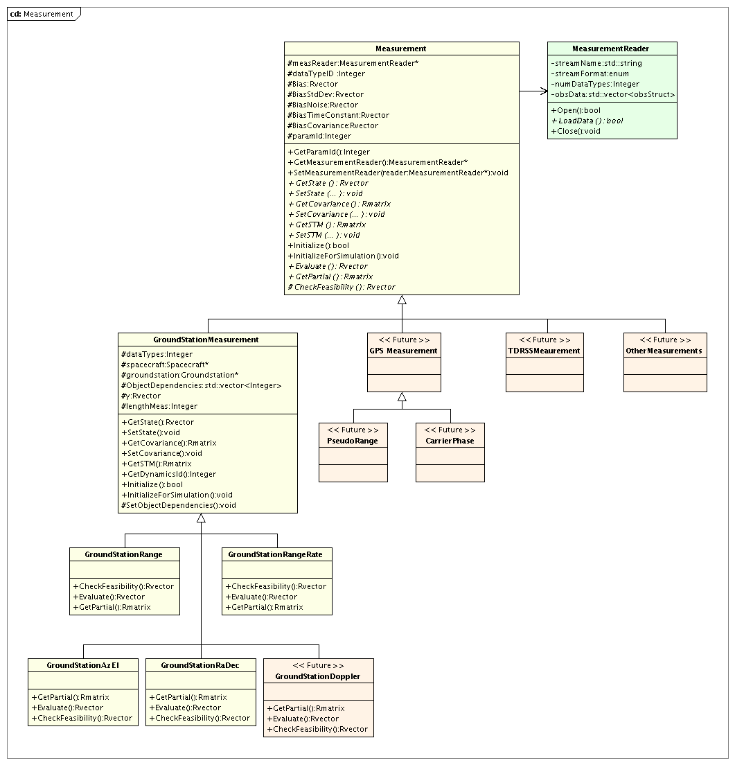
Figure 1: The Measurement Class Hierarchy

Measurement Base Class
The Measurement base class contains member data and functions associated with all measurement objects as well as data associated with parameters that are set by the user when configuring the measurement object. Examples of these data include the measurement file name and format, the data types to be processed from the file, and measurement stochastic properties such as biases and time constants.

The Measurement class defines many of the interfaces implemented in the derived classes so that the estimation process can work with measurement objects using base class references and pointers. These interfaces are defined as either overridable or abstract (that is, pure virtual) methods on the Measurement base class. The derived classes implement custom versions of these methods that are specific to the measurement type being implemented. The data members of the Measurement base class are described below, followed by descriptions of the methods provided in the Measurement base class. Finally, we will describe the MeasurementReader helper class before moving to the definitions of the derived classes.

Member Data

The list below describes the data elements provided in the Measurement base class to support the derived classes. These elements are designed to facilitate access to measurement information through calls to a Measurement instance pointer. Some Measurement objects provide multiple data elements. For that reason, some of the data members listed here gain a dimension over what might be expected for single-valued measurements. For example, the ground station RA/Dec measurement type returns two values for each measurement: the right ascension and declination values, so the methods that calculate these values return an Rvector rather than a Real number. Since there are Measurement classes that have this multivalued return requirement, GMAT uses an Rvector for the data, even when the return value is a single number.

The data members of the Measurement are:

- MeasurementReader *measReader: The MeasurementReader that supplies the observation data. This pointer can be NULL when simulating data.
- Integer dataTypeID: An integer containing the Id for the data type. Although the user may specify several data types on a measurement object, GMAT creates an object for each data type during initialization. <DJC: I’m not quite sure what you mean here. Where are these objects?> Each object has an Id associated with its data type which is specified by dataTypeId.
- Rvector Bias: A vector of real numbers containing the measurement biases. These data can be estimation state parameters.
- Rvector BiasStdDev: A vector of real numbers containing the standard deviations of the biases. These data can be estimation state parameters.
- Rvector BiasNoise: A vector of real numbers containing the noise in the measurement biases. These data can be estimation state parameters.
- Rvector BiasTimeConstant: A vector of real numbers containing the time constants for the measurement biases. These data can be estimation state parameters.
- Rvector BiasCovariance: A vector of real numbers containing the bias covariances.
- Integer ParamId: ID for the type of measurement parameter?
- Integer numDataTypes: The number of data types the user specified on the measurement object. During measurement initialization, a new object is created for each data type specified on the measurement object. <DJC: Still confused about what this means>

Class Methods

The Measurement class includes the following methods designed to make access to measurement data as generic as possible by the classes that use Measurement objects. Many of these methods are abstract (pure virtual in C++ terminology): they are defined in this base class, but no implementation is provided in the base class. The abstract classes can be identified by an “= 0” suffix in this list.

- enum MeasurementFormat: An enumeration defining the supported measurement formats. Note: This enumeration is not a class member; it is a member of the Gmat namespace.
- Integer GetParameterId():A method to determine the integer id for solve-for and consider parameters on the measurement object. This is how the system converts from the string definition provide by the user, say MauiGSRange.Bias,to a numeric Id. <DJC: Not sure of this part.>
- MeasurementReader *GetMeasurementReader(): Retrieves a pointer to the MeasurementReader.
- void SetMeasurementReader(MeasurementReader *reader): Sets the pointer to the MeasurementReader.
- virtual Rvector& GetState() = 0: Retrieves the state vector.
- virtual void SetState(Rvector& newState) = 0: Sets the state vector to match the provided data.
- virtual Rmatrix& GetCovariance()= 0: Retrieves the covariance matrix.
- virtual void SetCovariance(Rmatrix& newCovariance) = 0: Sets the covariance matrix data.
- virtual Rmatrix& GetSTM() = 0: Retrieves the state transition matrix.
- virtual void SetSTM(Rmatrix& newSTM) = 0: Sets the STM matrix data.
- virtual bool Initialize(): Prepares the Measurement object for use in a Sandbox.
- virtual void InitializeForSimulation(): Prepares the Measurement object for use during measurement simulation.
- virtual Rvector& Evaluate() = 0: Calculates the expected observation value.
- virtual Rmatrix& GetPartial() = 0: Retrieves the measurement partial derivative matrix.
- virtual Rvector& CheckFeasibility() = 0: Checks to see if a measurement can be made using the current state information.

<DJC: Open question – Where does the other data come from? For instance, for range, I need the positions of a spacecraft and observer (aka groundstation); are those objects set somewhere on the Measurement? Or is the Spacecraft passed in for GroundStationRange? Or what? I’m not yet sure where this connection happens.>

MeasurementReader Helper Class
The arrays of observations and epochs for the measurement objects are located on the base class.

<To be filled in: by Matt? I’m treating this as a place holder for those bits; maybe it goes elsewhere, though.>

Member Data

- std::string streamName : A string containing the name of the file provided by the user that contains observed measurement values.
- MeasurementFormat streamFormat: A string containing the format of the file contained in filename.

Class Methods

- bool Open(): Opens the stream that provides observation data.

GroundStationMeasurement

Measurements that are made at a ground station are modeled using the GroundStationMeasurement class. Data and member functions that are common to all Ground Station measurements are located on the GroundStationMeasurement class, including the participants in the measurement process, Get/Set functions, and common modeling algorithms. Below we discuss in detail all member data and functions.

GroundStationMeasurent Member Data:

- Integer dataTypes: ???
- Spacecraft *spacecraft: A pointer to the spacecraft that is participating in the measurement. This pointer is set during measurement initialization.
- Groundstation *groundstation: A pointer to the ground station that is participating in the measurement. This pointer is set during measurement initialization.
- std::vector<Integer> ObjectDependencies: A vector of integers that contains information on how participants on a measurement object map to participants in the overall estimation problem. In general, the participants on a measurement are a subset of the participants for the estimation problem. The ObjectDependencies is used primarily to determine partial derivatives and ensure they are placed in the correct location in the overall partial derivative array. The ESM maintains an array of pointers, called ObjectsVector, to the participant associated with each state chunk in the estimation problem. The ObjectDependencies array is the same length as ObjectsVector. If, for example, element 1 of ObjectDependencies is zero, then the first object in the estimator’s participant list is not a participant in the measurement. If element 1 is nonzero, then the integer is associated with the participant Id used internally by the measurement. The ObjectDependencies array is set during initialization when the Measurement Manager makes a call to initialize the measurement.
- Rvector y: The vector of calculated measurements.
- Integer lengthMeas: ???

GroundStationMeasurement Methods:

<DJC: These need to be filled out with the method signatures>

- SetState: Given a state value and id, this method updates the state on the measurement object.
- GetState: Given a state id, this method gets the state from the measurement object.
- SetCovariance: Given a covariance matrix and the state id, this method updates the state’s covariance on the measurement object.
- GetCovariance: Given a state id, this method gets the state’s covariance from the measurement object.
- GetSTM: Given a state id, this method gets the states’ STM.
- GetDynamicsId: Given a state Id, this method returns the ODE model ID for use in propagation of the state and it’s STM.?? Not implemented yet for measurement.
- Initialize: This method makes a call to the file reader and gets the observations and epochs from the requested data type. If there are multiple data types on the measurement, the measurement object concatenates them into the Obs and Epochs Arrays. These are then extracted by the measurement manager later in the initialization process. For each data type, a new object is created and pointers to the object’s participants are set. (Matlab currently only supports one data type per measurement. Not a difficult mod though)
- InitializeforSimulation: This method prepares a measurement object for simulation. The process is similar to the Initialize method on GroundStationMeasurement, with the exception the reading and managing observations and epochs is not required.
- GetDataTypeId: This method returns the integer Id for the measurement type, given the string name for the measurement.
- SetObjectDependencies: This method takes as input an array of pointers to the participants in the estimation state vector. The method steps through each element in the input array and determines if it points to any of the measurement participants. If not, then the element in ObjectDependencies is set to zero. If so, then the element is set to the Id of the participant used internally by the measurement object.

GroundStationRange

The GroundStationRange class is derived from the GroundStationMeasurement class, and performs modelling range measurements, measurement feasibility, and partial derivatives, and light time iteration.

GroundStationRange Member Data:

None. The data members in the GroundStationMeasurement class are sufficient for this class.

GroundStationRange Member Functions:

<DJC: These need to be filled out with the method signatures>

- CheckFeasibility: This method evaluates the feasibility function for the range measurement. If the value of the feasibility function is positive, then the conditions required to perform a measurement are met. If the feasibility function is negative, conditions are not met. Event locators determine the roots of the feasibility function to determine tracking data scheduling.
- Evaluate: The evaluate function calculate the computed value of the measurement based on the current state of the participants.
- GetPartial: This method returns the requested partial derivative based given a participant Id and the state Id. The participant Ids are contained in the array ObjectDependencies. This method is called by the measurement manager to determine individual partials. The measurement manager assembles the entire partial derivative from the pieces returned by the measurement object.

Unresolved issues. Much of the math required for say measurement calculation, partials evaluation, and feasibility checking is the same. We need to figure out how to consolidate the math while keeping interfaces clean and intuitive. In Matlab, the same math is repeated in several locations.

