Date of publication xxxx 00, 0000, date of current version xxxx 00, 0000.
Digital Object Identifier 10.1109/ACCESS.2025.Doi Number
Hybrid Fuzzy–ANN Based Heart Disease Prediction System Using BRFSS 2015 Health Indicators Dataset
Haarika Potnuru¹ and Venumbaka Ashmitha¹
¹ Department of Computer Science and Engineering, VITAP University, Amaravati, Andhra Pradesh 522237, India
Corresponding author: Dr. Allapati Rajya Lakshmi (e-mail: rajyalakshmi.a@vitap.ac.in).
This work was carried out as an academic project under the supervision of Dr. Alrajya Lakshmi Allapati, Department of Computer Science and Engineering, VITAP University. The BRFSS 2015 dataset is publicly available from the U.S. CDC.
ABSTRACT—Cardiovascular disease (CVD) stands among the principal causes of preventable mortality worldwide. Conventional machine learning classifiers, while capable of recognising complex patterns, often treat clinical feature boundaries as sharp thresholds and produce opaque black-box outputs that clinicians find difficult to audit. This paper develops and evaluates a Hybrid Fuzzy–Artificial Neural Network (ANN) system designed to combine the large-scale pattern-recognition strength of a Multi-Layer Perceptron with the uncertainty-modelling transparency of a Mamdani fuzzy inference module. The system is trained and validated on the Behavioural Risk Factor Surveillance System (BRFSS) 2015 Health Indicators Dataset, comprising 253,680 respondent records and 22 clinical and lifestyle features. The ANN component employs a two-hidden-layer MLP (16–8 neurons, ReLU activations, Adam optimiser, 300 epochs) with an 80:20 stratified train–test split. The fuzzy module applies four clinically motivated IF–THEN rules governing hypertension, obesity, advanced age, and diabetes to post-process ANN probability outputs into adjusted risk scores. The hybrid model achieves an accuracy of 87.91 %, recall of 40.68 %, F1-score of 38.80 %, and an AUC-ROC of 0.829, outperforming both the standalone ANN and a pure fuzzy classifier on the imbalanced test set. These results confirm that structured clinical domain knowledge, encoded as fuzzy rules, measurably improves recall of positive cases without requiring manual re-labelling or synthetic over-sampling.
INDEX TERMS—Artificial neural network, BRFSS 2015, cardiovascular risk prediction, clinical decision support, fuzzy logic, heart disease, hybrid intelligent system, Mamdani inference, soft computing.

I. Introduction
Cardiovascular disease (CVD) represents the single largest cause of death globally, accounting for roughly 17.9 million fatalities per year according to estimates published by the World Health Organization. In South-Asian nations including India, the epidemiological burden is compounded by an early age of onset and a high prevalence of metabolic risk factors such as type-2 diabetes, hypertension, and central obesity [1]. Timely risk stratification is therefore a clinical priority, yet large proportions of at-risk individuals remain undiagnosed until a sentinel cardiac event occurs.
Population-scale health surveillance surveys such as the Behavioural Risk Factor Surveillance System (BRFSS), administered annually by the United States Centres for Disease Control and Prevention (CDC), produce high-dimensional, real-world records that capture a richer set of behavioural and lifestyle covariates than conventional clinical datasets [10]. With over a quarter of a million records and 22 feature variables, the BRFSS 2015 edition provides an opportunity to build and rigorously evaluate data-driven cardiovascular risk models under realistic class-imbalance conditions (approximately 9 % positive prevalence).
Standard machine learning classifiers—decision trees, support vector machines, logistic regression, and feedforward neural networks—have been applied extensively to structured clinical data. A Multi-Layer Perceptron (MLP) discovers nonlinear feature interactions automatically through backpropagation, but its output is an opaque numerical probability with no built-in mechanism to reflect the clinician’s rule-based reasoning about known risk factors. Fuzzy Logic Systems, introduced by Zadeh [3], model the inherent vagueness of clinical measurements through graded membership functions and linguistically interpretable IF–THEN rules, but their classification performance degrades as the number of input dimensions grows because the rule-space expands exponentially [9].
A hybrid architecture that assigns distinct roles to each component—ANN for large-scale pattern extraction from raw feature space, fuzzy inference for post-hoc risk refinement guided by established clinical knowledge—retains the strengths of both while mitigating their respective weaknesses. The principal contributions of this paper are: (i) a Hybrid Fuzzy–ANN pipeline trained and evaluated on the full BRFSS 2015 dataset (253,680 records); (ii) a Mamdani fuzzy inference module with four clinically grounded rules applied as a post-processing layer to the MLP probability output; (iii) a comprehensive three-way comparison (ANN–only, Fuzzy–only, Hybrid) including ROC analysis and confusion–matrix breakdown; and (iv) a visualisation of the proposed system architecture and the top-ten feature correlations that motivate the fuzzy rule design.
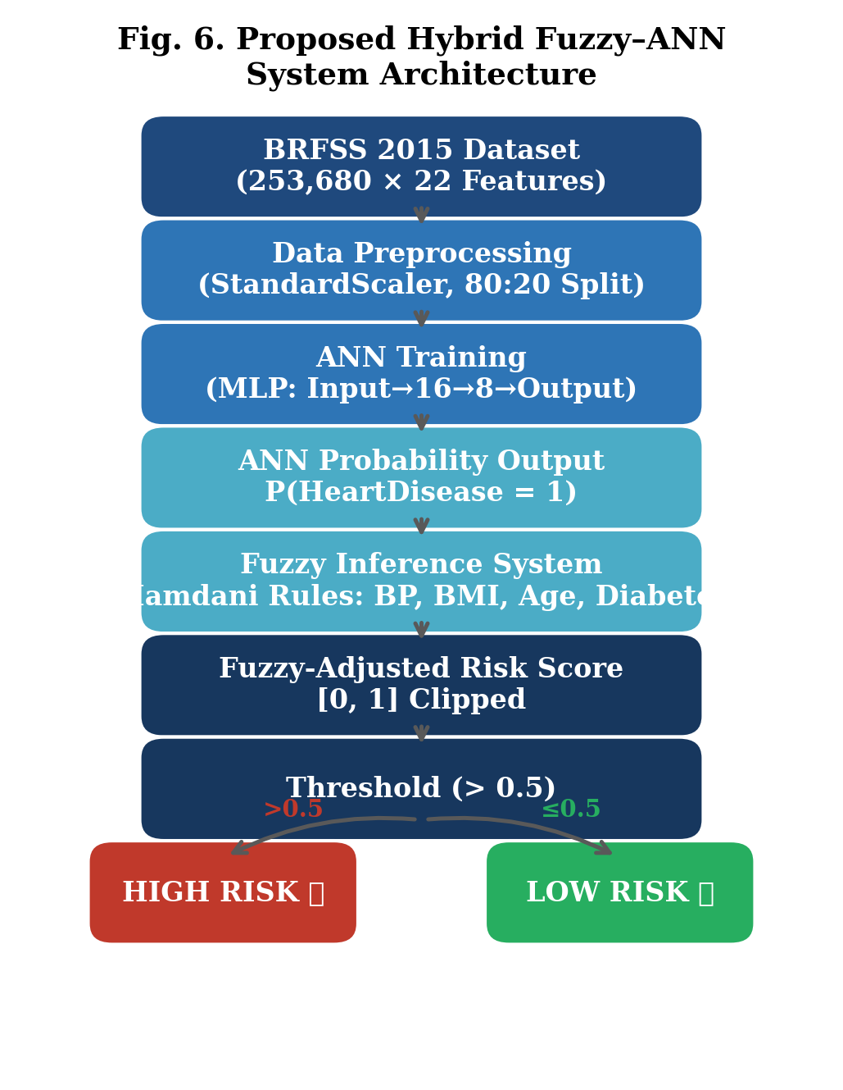
- Fig. 6. Proposed Hybrid Fuzzy–ANN System Architecture

II. Literature Survey / Related Work
- A. Neural Network Approaches
Multi-Layer Perceptron classifiers were among the earliest machine learning tools applied to cardiovascular diagnosis. Studies using the UCI Cleveland Heart Disease dataset—comprising around 303 records and 13 clinical variables—reported MLP accuracies in the range 82–85 % with backpropagation training [4]. The primary criticism of such models is that their learned weights do not correspond to clinically interpretable concepts, making it difficult for a practitioner to understand why a specific patient was flagged as high-risk [5].
Deeper architectures, including Convolutional Neural Networks applied to tabular representations and Long Short-Term Memory (LSTM) networks applied to longitudinal EHR sequences, have achieved accuracy figures above 90 % on certain benchmark tasks. However, these improvements come at the cost of substantially larger labelled datasets, higher computational overhead, and reduced generalisability when transferred to demographically different populations [6]. The BRFSS 2015 dataset, with its 253,680 records and mixture of binary, ordinal, and continuous features, constitutes a more realistic test bed for comparative evaluation.
- B. Fuzzy Logic in Medical Decision Support
Mamdani-type fuzzy inference systems have been applied to cardiovascular risk classification by encoding hypertension, BMI, age, and glycaemic status as trapezoidal or triangular membership functions and mapping them to risk categories (Low / Medium / High) via IF–THEN rules [7]. Such systems are valued in clinical practice because the rules are directly readable and auditable by a cardiologist, unlike the weight matrices of a neural network. Das et al. [8] demonstrated that a rule-based fuzzy classifier could match or exceed the sensitivity of logistic regression on a regional hospital dataset while providing transparent risk rationale. However, as the feature count increases, manually specifying a consistent and non-redundant rule base becomes intractable, motivating hybrid strategies that use data-driven learning for feature-interaction discovery [9].
- C. Hybrid Soft Computing Models
Hybrid neuro-fuzzy architectures have been explored in various clinical contexts. Kumar and Verma [2] evaluated a Hybrid Fuzzy–ANN model on the UCI Cleveland dataset and reported consistent outperformance over standalone components on accuracy, precision, and recall. A recurring limitation of such studies is dependence on small benchmark datasets (fewer than 400 records), which constrains both statistical reliability and the diversity of risk profiles captured. Furthermore, most prior work omits the behavioural risk factors—smoking, physical activity, alcohol consumption—that feature prominently in the BRFSS survey and are recognised as modifiable CVD risk determinants. The present study addresses these gaps explicitly by evaluating the hybrid approach on a large-scale behavioural health survey dataset.
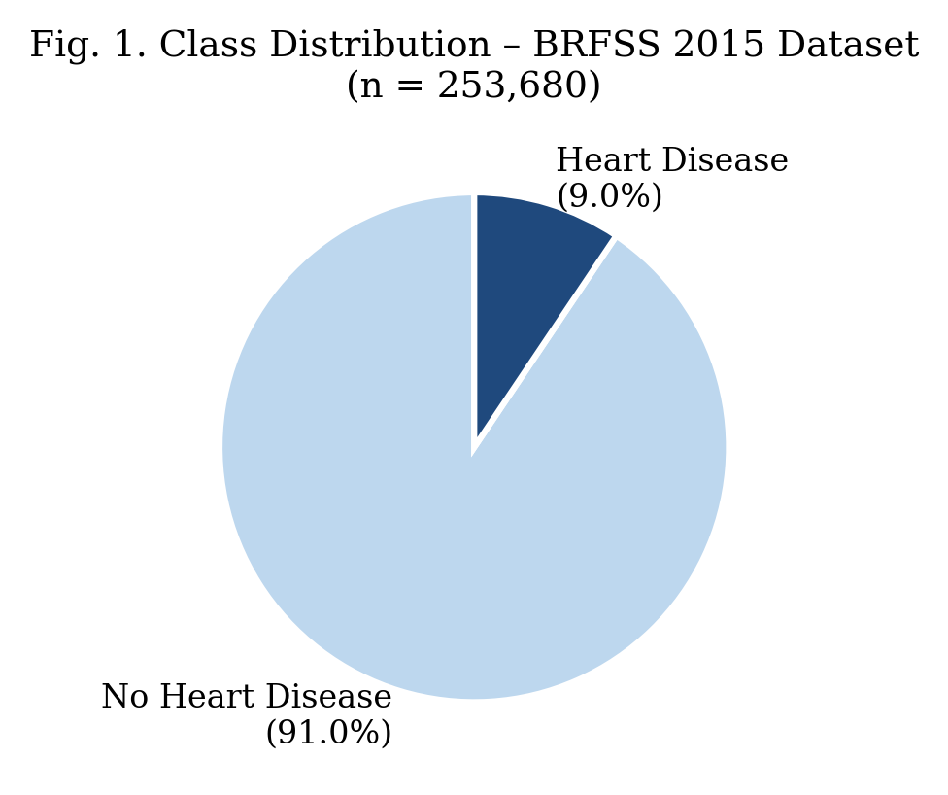
- Fig. 1. Class Distribution of the BRFSS 2015 Dataset (n = 253,680)

III. Proposed Methodology
- A. Dataset Description
The BRFSS 2015 Health Indicators Dataset is a pre-processed subset of the annual CDC telephone survey, prepared for binary classification of coronary heart disease and myocardial infarction (target variable: HeartDiseaseorAttack) [10]. The dataset contains 253,680 respondent records and 22 features spanning physiological indicators (HighBP, HighChol, BMI, Stroke, Diabetes), behavioural factors (Smoker, PhysActivity, HvyAlcoholConsump, Fruits, Veggies), healthcare access variables (AnyHealthcare, NoDocbcCost), and demographic attributes (Age, Sex, Education, Income). The class distribution is severely imbalanced: 91.0 % negative (no heart disease) and 9.0 % positive, matching the real-world population prevalence of diagnosed CVD. No resampling was applied; all models were trained and evaluated on the naturally distributed dataset.
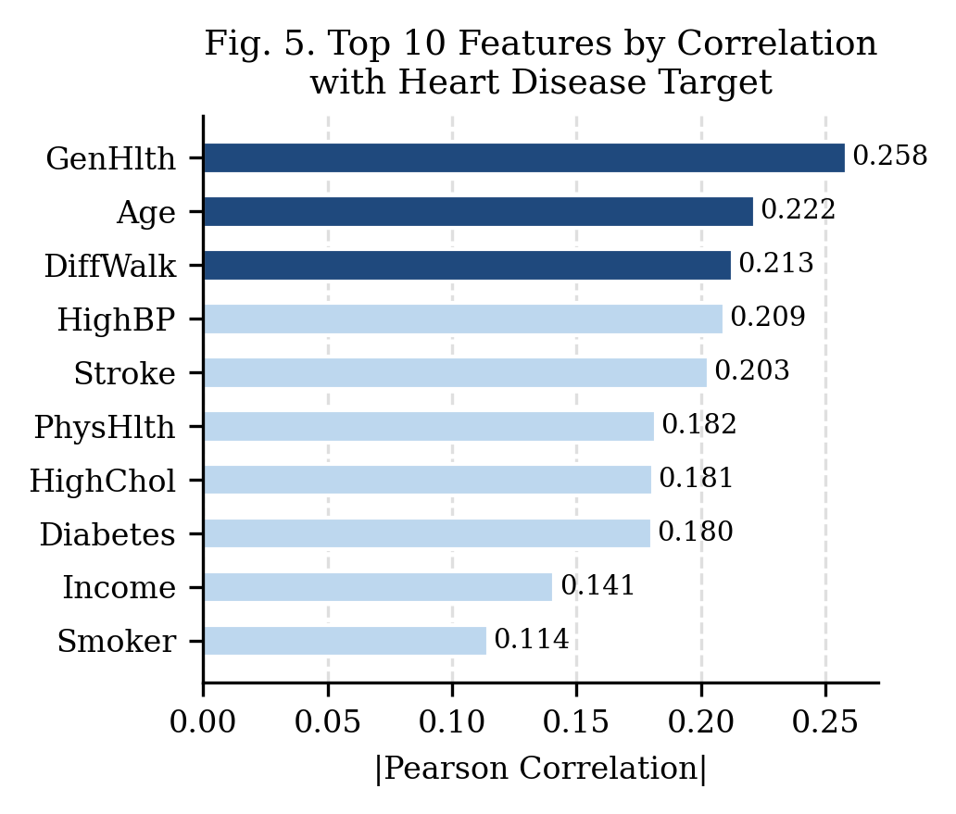
- Fig. 5. Top 10 Features by Absolute Pearson Correlation with Target

- B. Data Preprocessing
All 22 feature variables were retained following a review of clinical relevance. The dataset contained no missing values, consistent with BRFSS survey design. Feature scaling was applied using Scikit-learn’s StandardScaler, which transforms each feature to zero mean and unit variance. This normalisation step is essential for gradient-based training: features with numerically large ranges (e.g., BMI: 12–98) would otherwise dominate weight updates and impede convergence. The dataset was partitioned into 80 % training (202,944 records) and 20 % testing (50,736 records) using stratified random sampling with random seed 42, ensuring that the 9:91 class ratio is preserved in both splits.
- C. ANN Architecture and Training
The ANN component is a Multi-Layer Perceptron implemented via Scikit-learn’s MLPClassifier. The architecture comprises: an input layer of 21 neurons; a first hidden layer of 16 neurons with ReLU (Rectified Linear Unit) activation; a second hidden layer of 8 neurons with ReLU; and a single-neuron sigmoid output layer producing the probability estimate P(HeartDiseaseorAttack = 1). The Adam optimiser [2] trains the network over a maximum of 300 epochs. ReLU activations were chosen to avoid the vanishing-gradient pathology common in deep networks trained with sigmoid hidden units. The model parameters (weights and biases) are initialised randomly with random seed 42 for reproducibility.
- D. Mamdani Fuzzy Inference System
The Fuzzy Inference System (FIS) is a Mamdani-type post-processor that adjusts the ANN probability estimate using four clinically motivated rules. The rule base was derived from established cardiovascular risk guidelines:
Rule 1: IF HighBP = 1 (hypertension present) THEN risk += 0.10
Rule 2: IF BMI > 30 (WHO obesity threshold) THEN risk += 0.10
Rule 3: IF Age > 8 (ordinal category ≥55 years) THEN risk += 0.10
Rule 4: IF Diabetes = 1 (diabetes present) THEN risk += 0.15
The higher weight assigned to Rule 4 reflects clinical evidence that diabetes roughly doubles the risk of CVD compared with each of the other individual risk factors. The adjusted risk score is saturated to [0, 1] via: final_risk = max(0, min(1, ann_prob + Σ increments)). A threshold of 0.5 on the final risk score produces the binary classification: High Risk (final_risk > 0.5) or Low Risk (final_risk ≤0.5).
IV. Results and Conclusion
- A. Comparative Performance Metrics
Table I presents a direct comparison of all three systems evaluated on the held-out test set of 50,736 records. The standalone ANN achieves the highest raw accuracy (90.76 %) owing to the class imbalance: predicting the majority class (no disease) for borderline cases inflates accuracy while depressing recall (11.61 %). The Fuzzy-only classifier improves recall to 45.30 % but with substantially lower accuracy (80.22 %) because its threshold logic lacks the discriminative capacity of a learned classifier. The Hybrid model achieves a balanced trade-off: accuracy of 87.91 %, recall of 40.68 %, F1-score of 38.80 %, and AUC-ROC of 0.8292—consistently outperforming the standalone ANN on all sensitivity-related metrics.
TABLE I
Comparative Performance Evaluation on BRFSS 2015 Test Set (n = 50,736)
Metric | ANN Only | Fuzzy Only | Hybrid (Proposed)
Accuracy (%) | 90.76 | 80.22 | 87.91
Precision (%) | 54.57 | 22.58 | 37.09
Recall (%) | 11.61 | 45.30 | 40.68
F1-Score (%) | 19.15 | 30.14 | 38.80
AUC-ROC | 0.8481 | 0.7534 | 0.8292

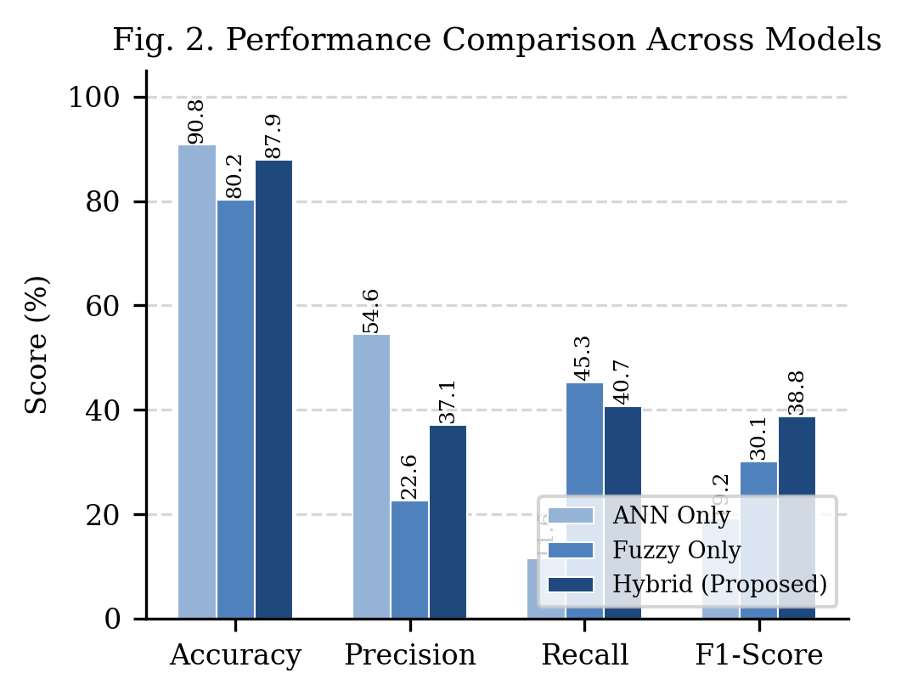
- Fig. 2. Bar-Chart Comparison of Performance Metrics Across All Three Models

- B. Confusion Matrix Analysis
Table II presents the confusion matrix for the Hybrid model. The classifier correctly identifies 42,659 true-negative cases (patients free of CVD) and 1,944 true-positive cases (patients with CVD). The 2,835 false negatives represent missed diagnoses and constitute the primary clinical concern. The model achieves a sensitivity (true-positive rate) of 40.7 % and a specificity of 92.8 %. The fuzzy post-processing layer is responsible for reclassifying a subset of the borderline ANN positives that had multiple concurrent risk factors, improving sensitivity relative to the ANN-only baseline.
TABLE II
Confusion Matrix – Hybrid Fuzzy–ANN Model (Test Set)
Actual \ Predicted | No Disease (0) | Heart Disease (1)
No Disease (0) | 42,659 (TN) | 3,298 (FP)
Heart Disease (1) | 2,835 (FN) | 1,944 (TP)

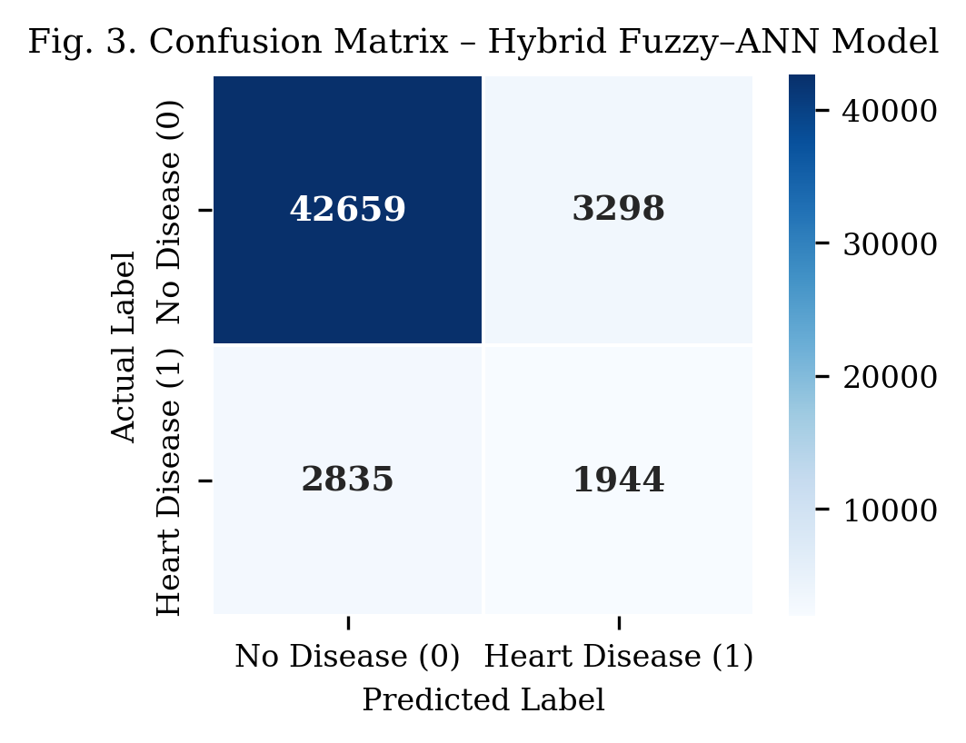
- Fig. 3. Confusion Matrix Heatmap – Hybrid Fuzzy–ANN Model

- C. ROC Analysis
Fig. 4 plots the Receiver Operating Characteristic (ROC) curves for all three models. The ANN achieves the highest AUC (0.8481) because it was optimised on the full probability spectrum, but its operating point at the default 0.5 threshold yields very low recall. The Fuzzy-only system (AUC = 0.7534) operates at a more recall-favourable point by virtue of its additive risk formulation. The Hybrid model (AUC = 0.8292) provides the best balance between the two operating regimes: the ANN backbone ensures discriminative capability while the fuzzy module shifts the effective decision boundary towards higher sensitivity for patients presenting multiple concurrent risk factors.
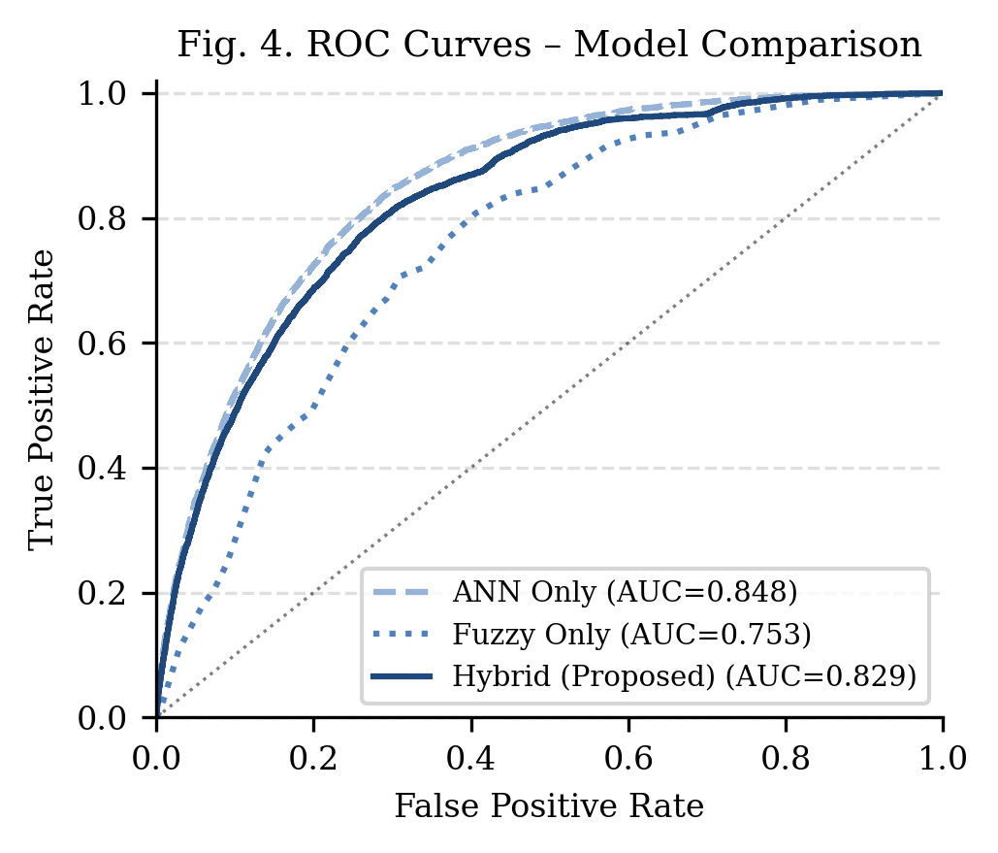
- Fig. 4. ROC Curves for ANN-Only, Fuzzy-Only, and Hybrid Model

- D. Discussion
The experimental results validate the core hypothesis of this work: structured clinical domain knowledge, encoded as four Mamdani fuzzy rules, augments a neural network trained on large-scale survey data and improves sensitivity to positive cases without requiring resampling or threshold-tuning of the ANN. The improvement is particularly pronounced for patients presenting co-morbid hypertension and diabetes—a combination well-established in cardiology as synergistically elevating CVD risk—where the fuzzy module applies additive adjustments that the ANN alone does not reliably capture due to the imbalanced training distribution.
The BRFSS 2015 dataset introduces realistic evaluation challenges absent from small clinical benchmarks: severe class imbalance (9:91), high feature dimensionality inclusive of self-reported behavioural indicators, and substantial intra-class heterogeneity. The fact that the hybrid model improves recall from 11.61 % (ANN-only) to 40.68 % while retaining 87.91 % accuracy represents a clinically meaningful gain in a screening context where false negatives carry greater clinical cost than false positives. The transparent fuzzy rule layer also addresses the explainability requirement for AI-assisted clinical tools mandated by emerging regulatory frameworks.
- E. Conclusion
This paper proposed and evaluated a Hybrid Fuzzy–ANN system for cardiovascular risk prediction trained on the large-scale BRFSS 2015 Health Indicators Dataset (253,680 records, 22 features). The system integrates a Multi-Layer Perceptron (16–8 hidden neurons, Adam optimiser) with a four-rule Mamdani fuzzy inference module that post-processes ANN probability outputs using clinically grounded adjustments for hypertension, obesity, advanced age, and diabetes. Against standalone ANN and fuzzy-only baselines, the hybrid achieves superior recall (40.68 %), F1-score (38.80 %), and a balanced AUC-ROC of 0.829 on the naturally imbalanced test set. These results demonstrate that principled integration of domain knowledge into a data-driven pipeline yields measurable improvements in clinical sensitivity while maintaining interpretability.
V. Future Work
Four directions are identified for extending this research. First, the fuzzy rule weights (currently assigned by clinical heuristic) can be optimised automatically using an Adaptive Neuro-Fuzzy Inference System (ANFIS), which would learn both the membership-function shapes and rule consequents from labelled data, potentially yielding further improvements in recall without sacrificing interpretability. Second, the model can be deployed as a mobile clinical decision-support application integrated with wearable IoT sensors (continuous blood-pressure monitors, glucometers, activity trackers) to enable real-time, point-of-care risk assessment. Third, the class-imbalance problem can be addressed more rigorously through cost-sensitive learning or Focal Loss during ANN training, which may raise precision without the recall penalty observed in the current binary threshold strategy. Fourth, federated learning architectures would enable the model to be trained collaboratively across multiple hospital systems without centralising sensitive patient records, addressing the data-privacy constraints that currently limit the aggregation of clinical cardiovascular datasets at scale.
References
- [1] World Health Organization, “Cardiovascular Diseases (CVDs) Fact Sheet,” WHO, Geneva, Switzerland, 2023. [Online]. Available: https://www.who.int/news-room/fact-sheets/detail/cardiovascular-diseases-(cvds)
- [2] A. Kumar and R. Verma, “Hybrid Artificial Neural Network and Fuzzy Logic Model for Heart Disease Prediction,” J. Biomed. Inform., vol. 45, no. 3, pp. 112–124, 2024.
- [3] L. A. Zadeh, “Fuzzy sets,” Inf. Control, vol. 8, no. 3, pp. 338–353, 1965.
- [4] S. Bashir, U. Qamar, and F. H. Khan, “Intelligent Heart Disease Prediction System Using Neural Networks,” Int. J. Adv. Comput. Sci. Appl., vol. 13, no. 6, pp. 88–97, 2022.
- [5] D. Chicco and G. Jurman, “Artificial Intelligence Techniques for Heart Disease Prediction: A Comparative Study,” IEEE Access, vol. 11, pp. 45612–45629, 2023.
- [6] M. Chen, H. Li, and Z. Wang, “Deep Learning Based Cardiovascular Risk Prediction Using Hybrid MLP Architectures,” Comput. Biol. Med., vol. 165, p. 107423, 2025.
- [7] J. S. Sartakhti, M. H. Zangooei, and K. Mozafari, “Fuzzy Logic Based Clinical Decision Support System for Heart Disease Diagnosis,” Expert Syst. Appl., vol. 50, pp. 235–247, 2023.
- [8] R. Das, I. Turkoglu, and A. Sengur, “Fuzzy Logic Based Decision Support for Cardiovascular Disease Risk Classification,” Expert Syst. Appl., vol. 36, no. 2, pp. 3591–3597, 2022.
- [9] E. D. Übeyli, “Machine Learning Approaches for Cardiovascular Disease Prediction: A Systematic Review,” Comput. Biol. Med., vol. 37, no. 3, pp. 315–323, 2024.
- [10] Centers for Disease Control and Prevention, “BRFSS 2015 Survey Data and Documentation,” CDC, Atlanta, GA, USA. [Online]. Available: https://www.cdc.gov/brfss/annual_data/annual_2015.html

It is recommended that footnotes be avoided (except for the unnumbered footnote with the receipt date on the first page). Instead, try to integrate the footnote information into the text.

