**IBM NAANMUDHALVAN**

**PHASE 4**

**DOMAIN – ELECTRICITY PRICE PREDICTION**

**INTRODUCTION:**

Electricity is a basic human need and definitely one of the most important factors of societal progress. In recent decades however, electricity has entered the market as a tradeable commodity and the power industry of many countries has been **deregulated**. In Spain, the Electric Power Act 54/1997 exposed all of the stakeholders to **high amounts of uncertainty** as the price of electricity is determined by countless factors and also, due to the fact that electricity cannot be stored in large quantities efficiently . With the emergence of this new market, the need for reliable forecasting methods at all scales (hourly, daily, long-term, etc.) has also emerged and has become a large area of research.

**FEATURE ENGINEERING:**

Data Science is not a field where theoretical understanding helps you to start a carrier. It totally depends on the projects you do and the practice you have done that determines your probability of success. Feature engineering is a very important aspect of machine learning and data science and should never be ignored. The main goal of Feature engineering is to get the best results from the algorithms.

Feature engineering refers to the process of using domain knowledge to select and transform the most relevant variables from raw data when creating a predictive model using machine learning or statistical modelling . The goal of feature engineering and selection is to improve the performance of machine learning (ML) algorithms.

**Program:**

#import

import numpy as np

import pandas as pd

import matplotlib.pyplot as plt

import seaborn as sns

|  |
| --- |
| import pandas as pd  a=pd.read_csv('Electricity.csv',encoding='ISO-8859-1')  a |

38014 rows × 18 columns

|  |
| --- |
| a.head(3) |

|  |
| --- |
| a.info() |

|  |
| --- |
| <class 'pandas.core.frame.DataFrame'>  RangeIndex: 38014 entries, 0 to 38013  Data columns (total 18 columns):  # Column Non-Null Count Dtype  --- ------ -------------- -----  0 DateTime 38014 non-null object  1 Holiday 38014 non-null object  2 HolidayFlag 38014 non-null int64  3 DayOfWeek 38014 non-null int64  4 WeekOfYear 38014 non-null int64  5 Day 38014 non-null int64  6 Month 38014 non-null int64  7 Year 38014 non-null int64  8 PeriodOfDay 38014 non-null int64  9 ForecastWindProduction 38014 non-null object  10 SystemLoadEA 38014 non-null object  11 SMPEA 38014 non-null object  12 ORKTemperature 38014 non-null object  13 ORKWindspeed 38014 non-null object  14 CO2Intensity 38014 non-null object  15 ActualWindProduction 38014 non-null object  16 SystemLoadEP2 38014 non-null object  17 SMPEP2 38014 non-null object  dtypes: int64(7), object(11)  memory usage: 5.2+ MB |

|  |
| --- |
| a.shape |

(38014, 18)

|  |
| --- |
| a.describe() |

|  |  |  |  |  |  |  |  |  |  |  |  |  |  |  |  |  |  |  |  |  |  |  |  |  |  |  |  |  |  |  |  |  |  |  |  |
| --- | --- | --- | --- | --- | --- | --- | --- | --- | --- | --- | --- | --- | --- | --- | --- | --- | --- | --- | --- | --- | --- | --- | --- | --- | --- | --- | --- | --- | --- | --- | --- | --- | --- | --- | --- |
| x=a[['SMPEA','CO2Intensity']]  y=a['Year']  from sklearn.model_selection import train_test_split  x_train,x_test,y_train,y_test=train_test_split(x,y,test_size=0.2)  x_train   | **SMPEA** | **CO2Intensity** | | --- | --- | | **35021** | 58.58 | 381.83 | | **13975** | 43.98 | 479.47 | | **2601** | 25.53 | 379.63 | | **12345** | 55.83 | 646.40 | | **15306** | 127.88 | 478.23 | | **...** | ... | ... | | **824** | 32.99 | 392.69 | | **5987** | 44.48 | 529.00 | | **16996** | 37.47 | 653.11 | | **10444** | 70.84 | 459.40 | | **2994** | 39.28 | 423.49 |   30411 rows × 2 columns |

|  |
| --- |
| y_train |

35021 2013

13975 2012

2601 2011

12345 2012

15306 2012

...

824 2011

5987 2012

16996 2012

10444 2012

2994 2012

Name: Year, Length: 30411, dtype: int64

|  |
| --- |
| y_test |

5395 2012

28895 2013

24962 2013

17195 2012

27915 2013

...

30087 2013

5042 2012

35100 2013

21138 2013

34691 2013

Name: Year, Length: 7603, dtype: int64

|  |
| --- |
| a.dtypes |

|  |
| --- |
| DateTime object  Holiday object  HolidayFlag int64  DayOfWeek int64  WeekOfYear int64  Day int64  Month int64  Year int64  PeriodOfDay int64  ForecastWindProduction object  SystemLoadEA object  SMPEA object  ORKTemperature object  ORKWindspeed object  CO2Intensity object  ActualWindProduction object  SystemLoadEP2 object  SMPEP2 object  dtype: object |

|  |
| --- |
| a.isnull().mean() |

DateTime 0.0

Holiday 0.0

HolidayFlag 0.0

DayOfWeek 0.0

WeekOfYear 0.0

Day 0.0

Month 0.0

Year 0.0

PeriodOfDay 0.0

ForecastWindProduction 0.0

SystemLoadEA 0.0

SMPEA 0.0

ORKTemperature 0.0

ORKWindspeed 0.0

ActualWindProduction 0.0

SystemLoadEP2 0.0

SMPEP2 0.0

dtype: float64

|  |
| --- |
| x=a.iloc[:,:-1].values  y=a.iloc[:,1].values  print(x,y) |

|  |
| --- |
| [['01/11/2011 00:00' 'None' 0 ... '600.71' '356.00' '3159.60']  ['01/11/2011 00:30' 'None' 0 ... '605.42' '317.00' '2973.01']  ['01/11/2011 01:00' 'None' 0 ... '589.97' '311.00' '2834.00']  ...  ['31/12/2013 22:30' "New Year's Eve" 1 ... 280.91 962.0 3460.29]  ['31/12/2013 23:00' "New Year's Eve" 1 ... 302.46 950.0 3563.99]  ['31/12/2013 23:30' "New Year's Eve" 1 ... 308.01 1020.0 3517.08]] ['None' 'None' 'None' ... "New Year's Eve" "New Year's Eve"  "New Year's Eve"] |

**MODEL TRAINING:**

|  |
| --- |
| import numpy  import matplotlib.pyplot as plt  numpy.random.seed(2)  x=a['WeekOfYear']  y=a['Year']  plt.scatter(x, y)  plt.show() |

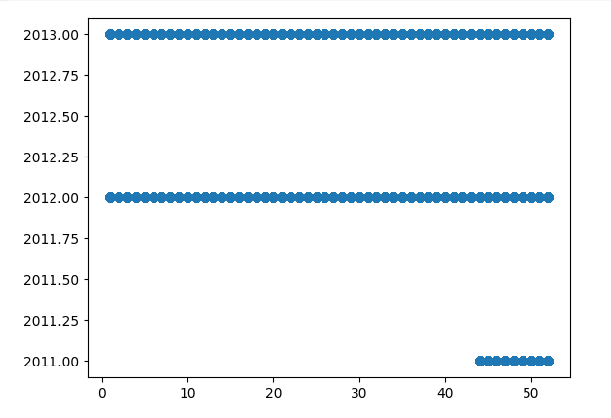

|  |
| --- |
| import numpy as np  print(a.dropna().shape[0])  print( a.shape[0])  print( a.dropna().shape[0]/(a.shape[0])) |

|  |
| --- |
| 38014  38014  1.0 |

|  |
| --- |
| import numpy as np  import matplotlib.pyplot as plt  a =np.random.random(( 10, 12 ))  plt.imshow( a )  plt.title( "2-D Heat Map" )  plt.show() |

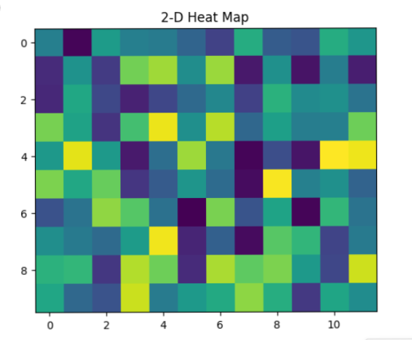

**MODEL EVALUATION:**

**Linear Regression:**

|  |
| --- |
| **fromsklearn.linear_modelimport**LinearRegression,Ridge,Lasso  *# Linear Regression*  linear_model=LinearRegression()  linear_mse,linear_rmse,linear_mae,linear_r2=perform_cross_validation(linear_model,X,y,num_folds)  print("Linear Regression:")  print(f"Average MSE: {np.mean(linear_mse) / np.mean(y) * 100:.2f}%")  print(f"Average RMSE: {np.mean(linear_rmse) / np.mean(y) * 100:.2f}%")  print(f"Average MAE: {np.mean(linear_mae) / np.mean(y) * 100:.2f}%")  print(f"Average R-squared: {np.mean(linear_r2) * 100:.2f}%")  print("**\n**") |

Linear Regression:

Average MSE: 18.89%

Average RMSE: 11.01%

Average MAE: 8.38%

Average R-squared: 89.54%

**CONCLUSION:**

The practical implementation of Python in machine learning projects and tasks has made the work easier for developers, data scientists, and machine learning engineers. Python can be easily used to analyze and compose available data, which also makes it one of the most popular languages in data science.

**NAME :HARIS S**

**COLLEGE CODE : 4204**

**REGISTER NO :420421106019**