1.

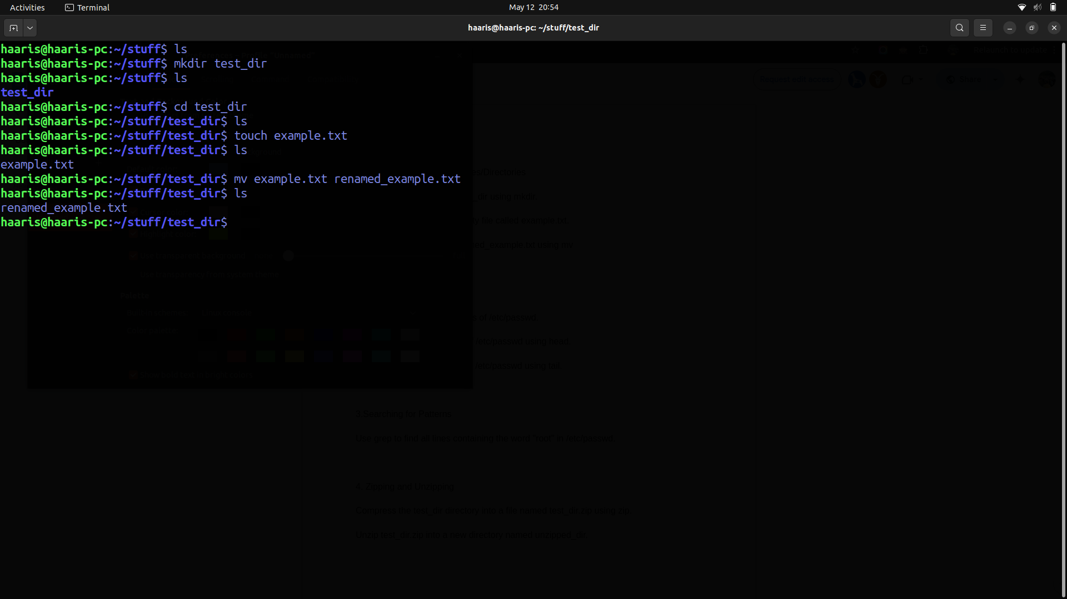

Explanation - First using **ls** we confirmed its an empty directory then by using **mkdir** we made a

directory named **test_dir** then by cd we go inside test_dir then we again check using ls directory is empty then by **touch** we made **example.txt** named file then by **mv** command we renamed it as **renamed_example.txt.**

2.

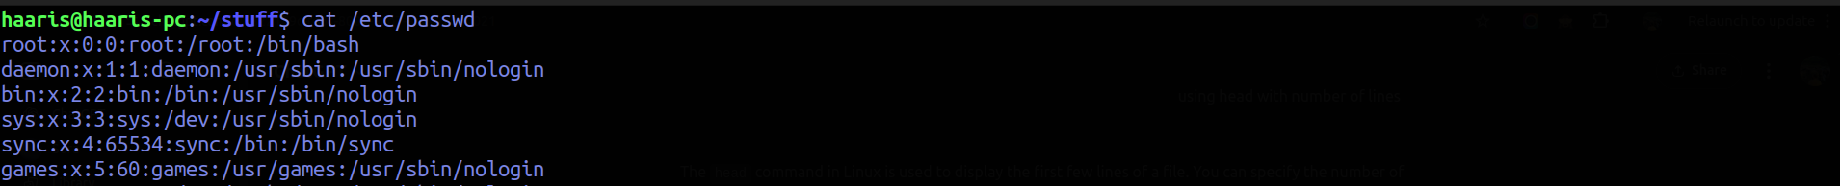

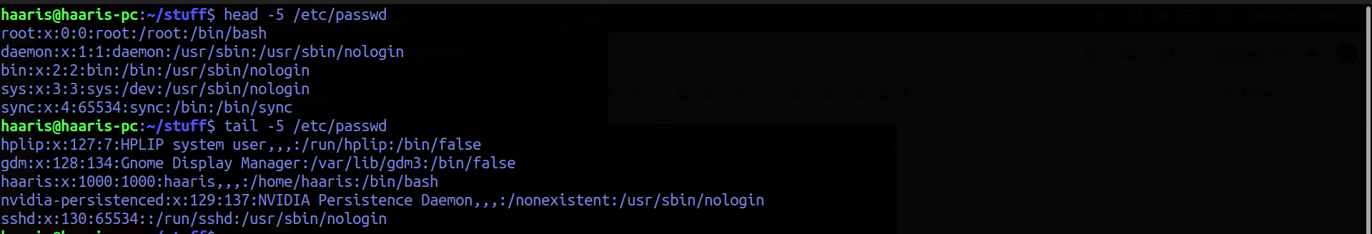

3.

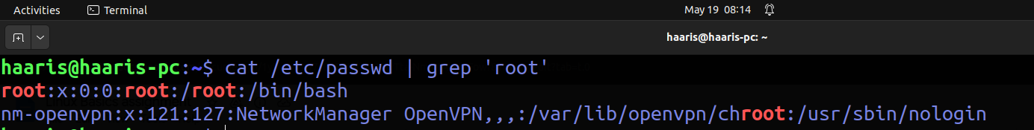

4.

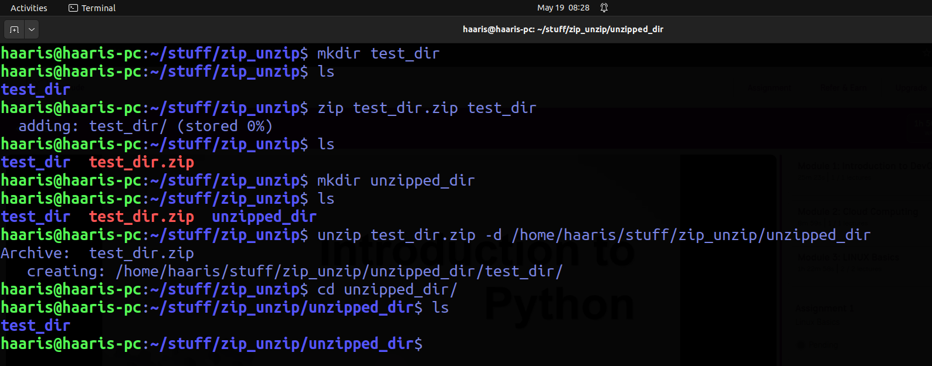

5.

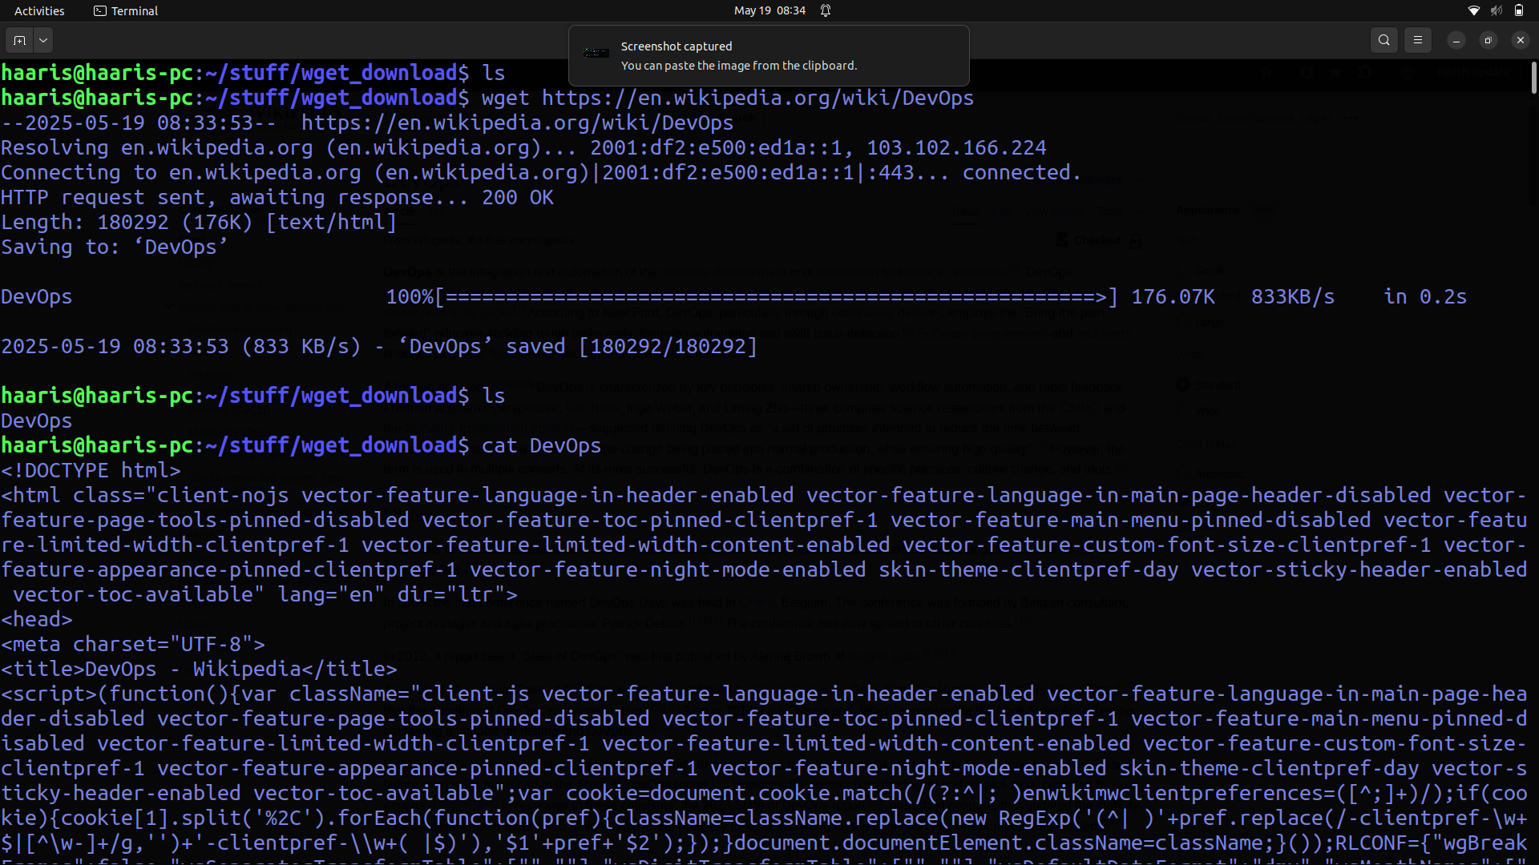

6.

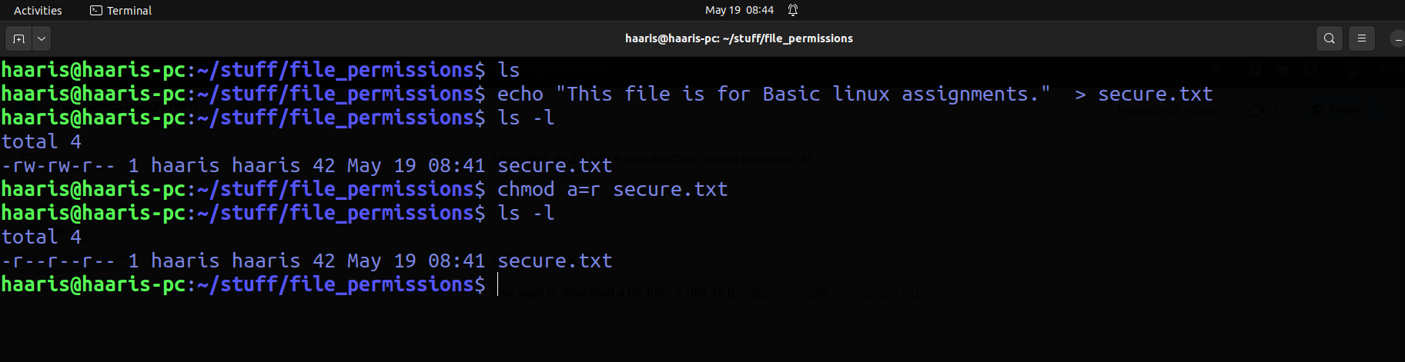

7.

