How to mount NTFS file system in CentOS

Step 1: To check the file system in Centos, use the following command.

# sudo lsblk -f
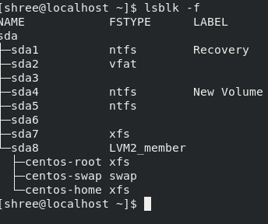

If we try to mount ntfs file system (sda4 for example), it does not work as CentOS does not understand it without installing NTFS driver.

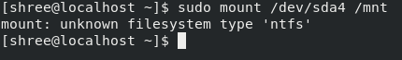

Step 2: Install ntfs-3g and epel-release. NTFS-3G is a stable Open Source NTFS driver. And it is available in EPEL (Extra Package Enterprise Linux).

# sudo yum -y install epel-release
#sudo yum -y install ntfs-3g

Step 3: Create a directory where the ntfs drive is mounted.

# sudo mkdir /mnt/win

Step 4: Mount the ntfs file system.

# sudo mount /dev/sda4 /mnt/win

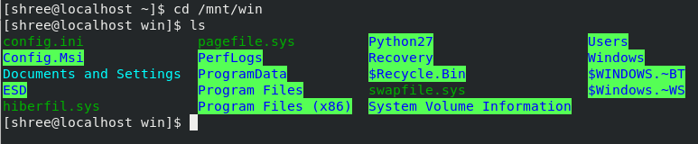
The screenshot below shows that I am able to access the files of Windows machine from CentOS.
In case, you get the following error as shown in the screenshot, use the following command to fix it.

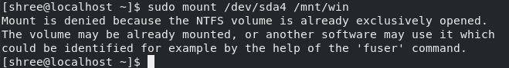
#sudo ntfs-3g -o remove_hiberfile /dev/sda4 /mnt/win
(Note: sda4 is the ntfs file system in my machine. Your machine may have different.)

Reference
https://unix.stackexchange.com/questions/163806/force-mount-windows-hibernated-partition-in-read-write-mode/236145
https://www.youtube.com/watch?v=bSGSSHu6RlU

