SQL PRACTICE EXAMPLES

Student Marks Database

SELECT, WHERE, Aggregate Functions & GROUP BY
Practical Execution & Results

Overview
This document demonstrates practical SQL queries on a student_marks table containing roll numbers, student names, subjects, and marks. The exercises cover basic SELECT operations, aggregate functions (COUNT, SUM, AVG, MAX, MIN), WHERE filtering, ORDER BY sorting, GROUP BY aggregation, and HAVING conditions.
Table Structure: student_marks (roll_no, name, subject, marks)

SECTION 1: Basic SELECT & Aggregate Functions

Execution Screenshot 1: Table Display & Aggregate Functions
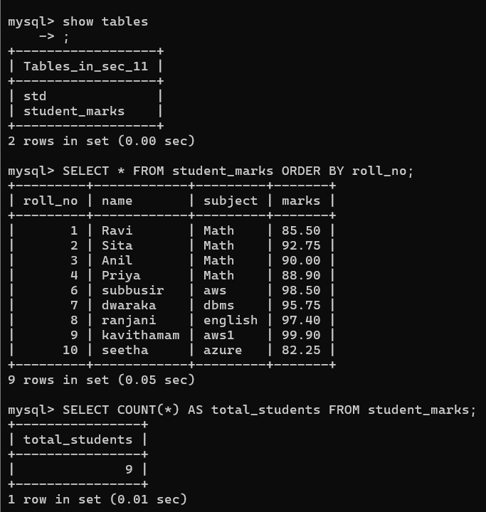
Results: SHOW TABLES displayed available tables. SELECT * FROM student_marks returned 9 rows of student data ordered by roll_no. Aggregate functions:
• COUNT(*) = 9 total students
• SUM(marks) = 830.95
• AVG(marks) = 92.33
• MAX(marks) = 99.90
• MIN(marks) = 82.25

Execution Screenshot 2: Aggregate Function Details
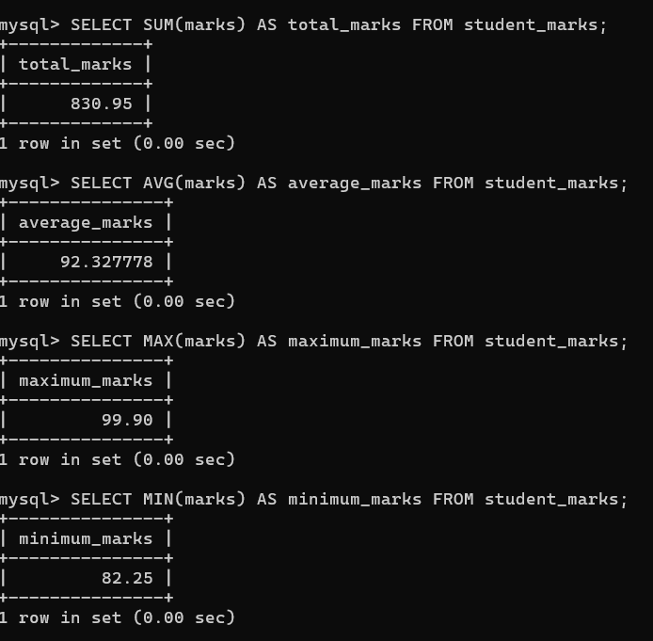
Results: Detailed view of SUM, AVG, MAX, and MIN calculations on the marks column. Each aggregate function executed successfully with precise results.

SECTION 2: WHERE Filtering & Conditions

Execution Screenshot 3: WHERE Clause Variations
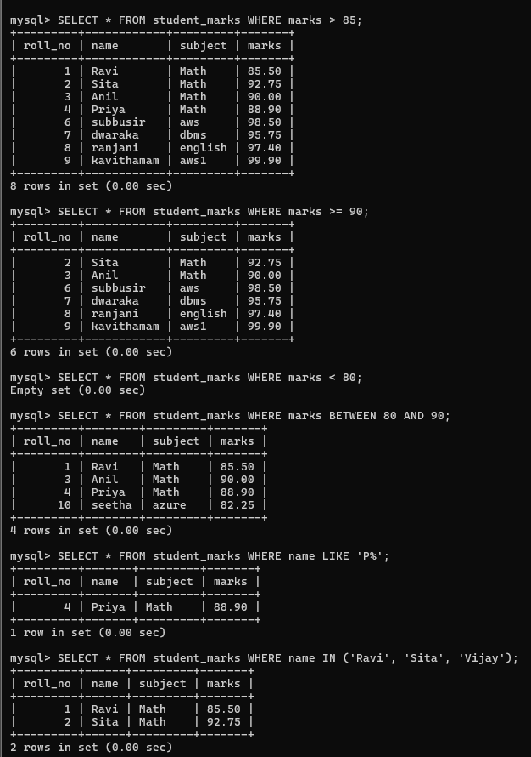
Results: Multiple WHERE queries executed:
• WHERE marks > 85: Returned 8 students with marks above 85
• WHERE marks >= 90: Returned 7 students with marks 90 or above
• WHERE marks < 80: Empty set (no students with marks below 80 after updates)
• WHERE marks BETWEEN 80 AND 90: Returned 4 students in the 80-90 range
• WHERE name LIKE 'P%': Found 1 student (Priya) starting with P
• WHERE name IN (...): Found 2 students in the specified list

SECTION 3: Complex WHERE Conditions & Sorting

Execution Screenshot 4: AND/OR Conditions & ORDER BY
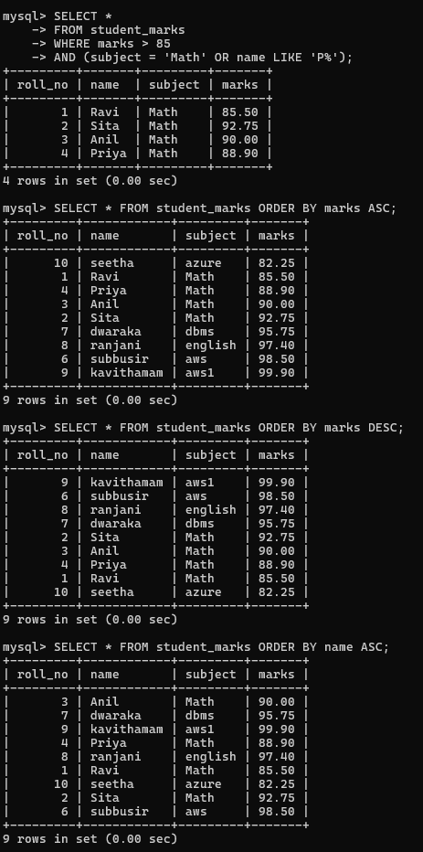
Results: Complex queries demonstrating advanced filtering and sorting:
• WHERE marks > 85 AND (subject = 'Math' OR name LIKE 'P%'): Returned 4 rows matching combined conditions
• ORDER BY marks ASC: Sorted students from lowest to highest marks (82.25 to 99.90)
• ORDER BY marks DESC: Reverse sorted by marks (99.90 to 82.25)
• ORDER BY name ASC: Alphabetical order by student names

SECTION 4: GROUP BY & HAVING Aggregation

Execution Screenshot 5: GROUP BY with Aggregate Functions
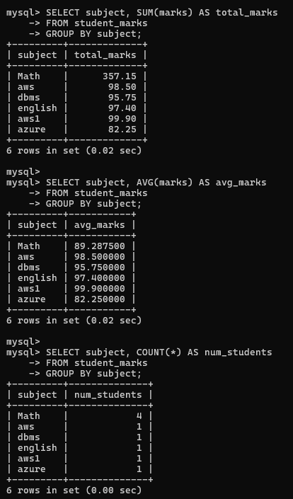
Results: GROUP BY queries aggregating data by subject:
• GROUP BY subject with SUM(marks): Total marks per subject
- Math: 357.15, AWS: 98.50, DBMS: 95.75, English: 97.40, AWS1: 95.90, Azure: 82.25
• GROUP BY subject with AVG(marks): Average marks per subject
• GROUP BY subject with COUNT(*): Number of students per subject

Execution Screenshot 6: HAVING Clause Filtering
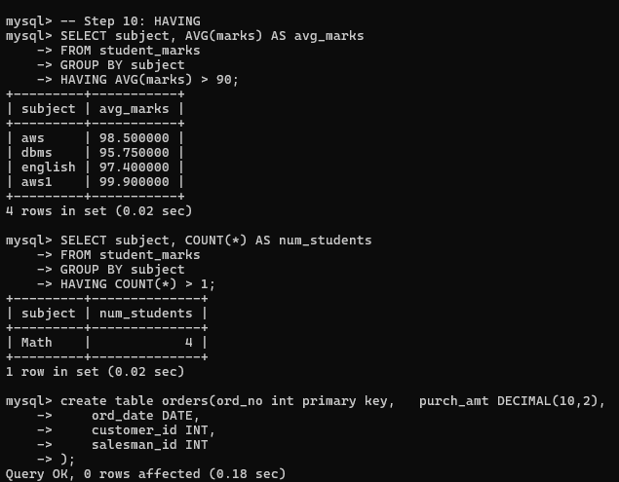
Results: HAVING clause filtering grouped results:
• HAVING AVG(marks) > 90: Returned 4 subjects with average marks above 90 (AWS, DBMS, English, AWS1)
• HAVING COUNT(*) > 1: Returned only Math subject with 4 students
• CREATE TABLE orders: Successfully created new orders table with order_no, purch_amt, ord_date, customer_id, salesman_id

QUERY SUMMARY & KEY CONCEPTS
Query Type | Purpose | Example / Result
SELECT * | Retrieve all columns and rows | Displays complete student_marks table
Aggregates | COUNT, SUM, AVG, MAX, MIN functions | Total: 9 students, Sum: 830.95, Avg: 92.33
WHERE | Filter rows based on conditions | marks > 85, BETWEEN, LIKE, IN operators
ORDER BY | Sort results in ascending or descending order | ASC for lowest to highest, DESC for reverse
GROUP BY | Group rows by column values | Results aggregated by subject with totals
HAVING | Filter groups based on aggregate conditions | AVG(marks) > 90, COUNT(*) > 1

Key Findings
✓ All 9 student records successfully retrieved and filtered
✓ Aggregate functions calculated precise statistics across the dataset
✓ WHERE conditions effectively filtered data using multiple operators (>, <, BETWEEN, LIKE, IN)
✓ Sorting with ORDER BY ASC/DESC produced properly ordered result sets
✓ GROUP BY with aggregates provided subject-wise analysis (6 distinct subjects)
✓ HAVING clause successfully filtered grouped results based on aggregate conditions

