SQL PRACTICE EXAMPLES

Orders Table - Advanced Queries

WHERE, ORDER BY, GROUP BY, HAVING & Aggregates
Business Scenario-Based Practical Execution

SECTION 1: WHERE Clause - Filtering Orders

Screenshot 1: CREATE TABLE & INSERT Data + WHERE Queries
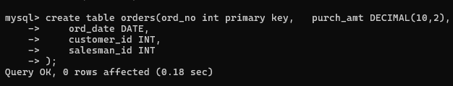
Results Summary:
• WHERE purch_amt > 2000: Found 4 orders (70005, 70008, 70003, 70013)
• WHERE ord_date = '2012-09-10': Found 3 orders placed on this date
• WHERE salesman_id = 5001: Found 4 orders handled by this salesman

Screenshot 2: Additional WHERE Clauses & ORDER BY DESC
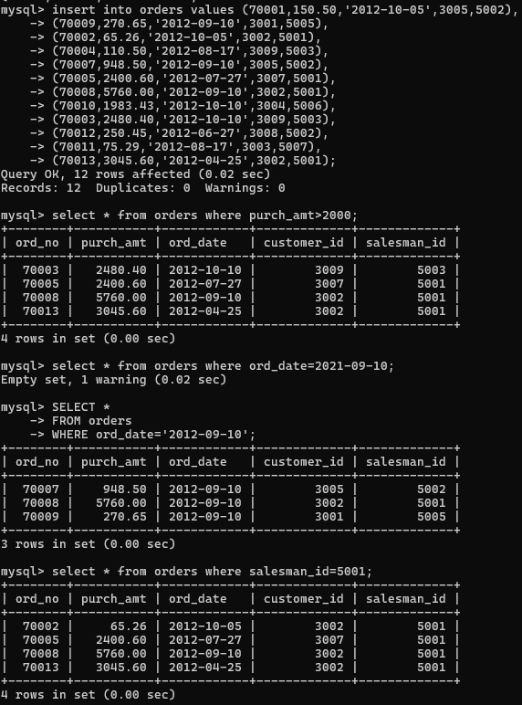
Key Query Results:
• ORDER BY purch_amt DESC: Highest orders first (70008: $5760, 70013: $3045.60, 70003: $2480.40)
• ORDER BY ord_date: Chronological order from oldest to newest orders

SECTION 2: Aggregate Functions - Financial Summary

Screenshot 3: Aggregate Functions (SUM, AVG, MAX, MIN, COUNT)
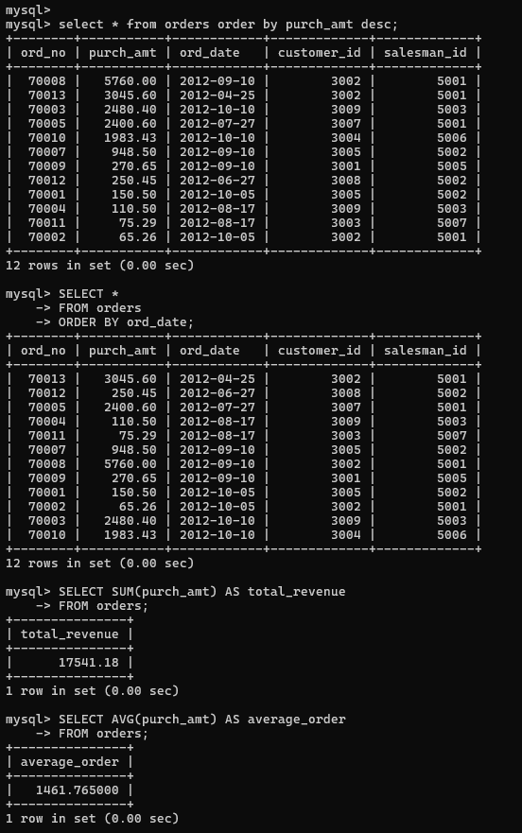
Financial Metrics:
• Total Revenue (SUM): $17,541.18
• Average Order Value (AVG): $1,461.77
• Highest Order (MAX): $5,760.00
• Lowest Order (MIN): $65.26
• Total Orders (COUNT): 12

SECTION 3: GROUP BY - Sales & Customer Analysis

Screenshot 4: GROUP BY Salesman & Customer with Aggregates
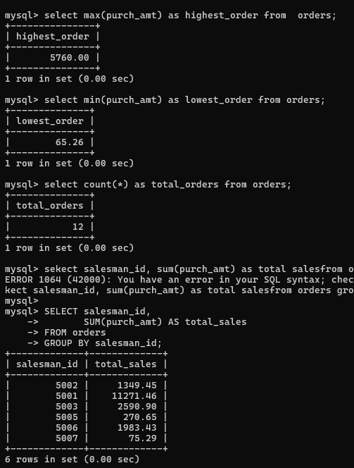
Results Analysis:
• Top Salesman: 5001 with $11,271.46 in total sales
• Salesman Distribution: 5001 (4 orders), 5002 (3 orders), others with fewer orders
• Top Customer: 3002 with total purchases of $8,870.86
• Customer Count: 8 distinct customers with varying purchase volumes

Screenshot 5: MAX Purchase per Customer & GROUP BY Analysis
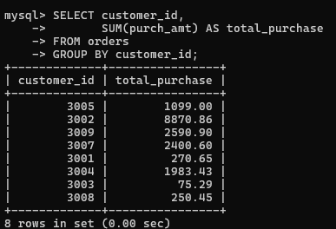
Maximum Order Analysis:
• Customer 3002: Maximum order value $5,760.00
• Customer 3007: Maximum order value $2,400.60
• Customer 3009: Maximum order value $2,480.40

SECTION 4: HAVING Clause - Advanced Filtering

Screenshot 6: HAVING with Conditions & ORDER BY DESC
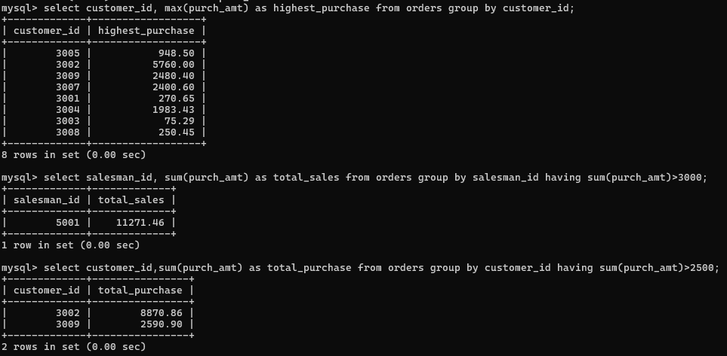
HAVING Query Results:
• Salesmen with sales > $3,000: Only salesman 5001 ($11,271.46)
• Customers with purchases > $2,500: 3002 ($8,870.86) and 3009 ($2,590.90)
• Top customers ranked by spending: 3002 (8870.86), 3009 (2590.90), 3007 (2400.60)

Screenshot 7: HAVING with BETWEEN & COUNT Conditions
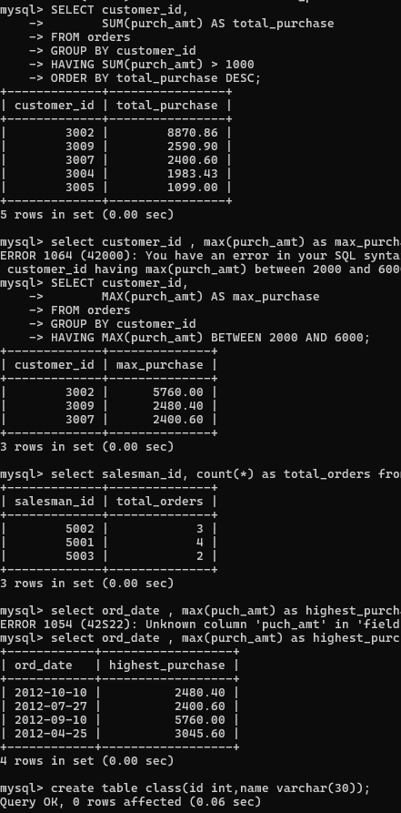
Advanced HAVING Analysis:
• MAX(purch_amt) BETWEEN 2000-6000: 3 customers qualify (3002, 3009, 3007)
• Salesmen with 2+ orders: 5002 (3 orders), 5001 (4 orders), 5003 (2 orders)
• Daily highest purchases > $2,000: 4 dates with significant orders

COMPREHENSIVE QUERY REFERENCE
Query Type | Description | Results / Output
WHERE | Filter by purchase amount, date, salesman | 4 orders > $2000; 3 orders on 2012-09-10
ORDER BY | Sort by amount, date, name ASC/DESC | Highest to lowest: $5760, $3045.60, $2480.40
SUM | Total revenue generated | $17,541.18 total across all orders
AVG | Average order value | $1,461.77 average per order
GROUP BY | Aggregate by salesman, customer, date | 6 salesmen; 8 customers; 6 dates analyzed
HAVING | Filter groups by aggregate conditions | Salesman 5001 > $3000; 2 customers > $2500

Execution Summary
✓ 12 orders inserted into database
✓ WHERE queries successfully filtered orders by multiple criteria
✓ Aggregate functions provided comprehensive financial analysis
✓ GROUP BY queries analyzed data by salesman, customer, and date
✓ HAVING clause effectively filtered grouped results using aggregate conditions
✓ All business scenarios executed with accurate results

