SQL JOINs AND SET OPERATIONS

Comprehensive Guide
Dr. Y Subbarayudu | Department CSE | KL University
Practical Execution with Real-World Examples

SECTION 1: CROSS JOIN
A Cartesian product that pairs every row from the first table with every row from the second table.

Screenshot 1: Table Creation & Data Insertion
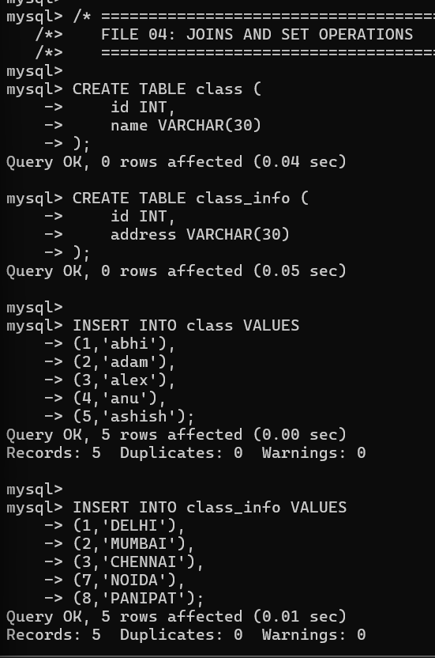
Created two tables: class (5 students) and class_info (5 addresses)

Screenshot 2: CROSS JOIN Result
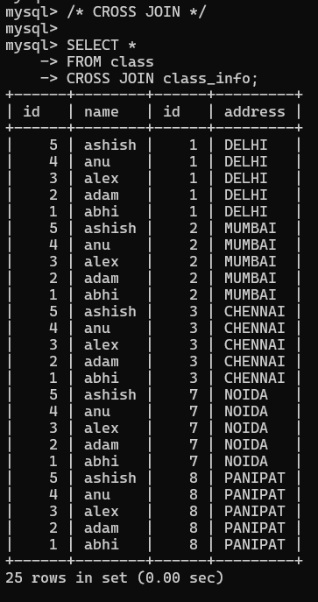
Result: 25 rows (5 students × 5 addresses). Every student paired with every address for survey analysis.

SECTION 2: INNER JOIN & NATURAL JOIN
Retrieves only matching records where the join condition is satisfied.

Screenshot 3: INNER JOIN & NATURAL JOIN
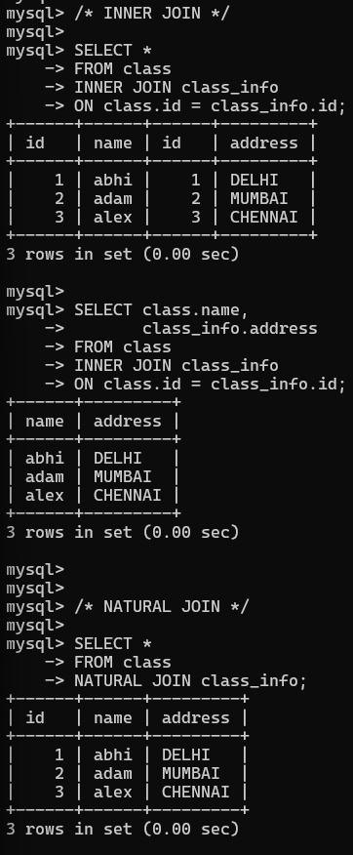
• INNER JOIN: Returns 3 rows with matching IDs (abhi-DELHI, adam-MUMBAI, alex-CHENNAI)
• NATURAL JOIN: Automatically joins on common column (id) with same result
• Selective columns: Shows only name and address for registered students

SECTION 3: LEFT OUTER JOIN & RIGHT OUTER JOIN
LEFT JOIN keeps all left table records, RIGHT JOIN keeps all right table records.

Screenshot 4: LEFT JOIN & RIGHT JOIN
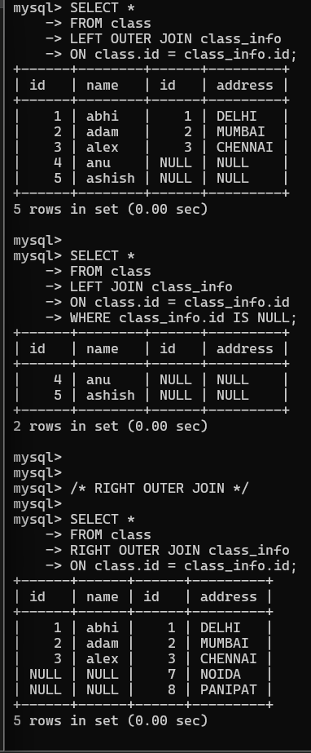
• LEFT JOIN: Returns 5 rows - all students including anu & ashish with NULL addresses
• LEFT JOIN + WHERE: Finds unmatched students (anu, ashish)
• RIGHT JOIN: Returns 5 rows - all addresses including NOIDA & PANIPAT with NULL students

Screenshot 5: RIGHT JOIN Unmatched Records
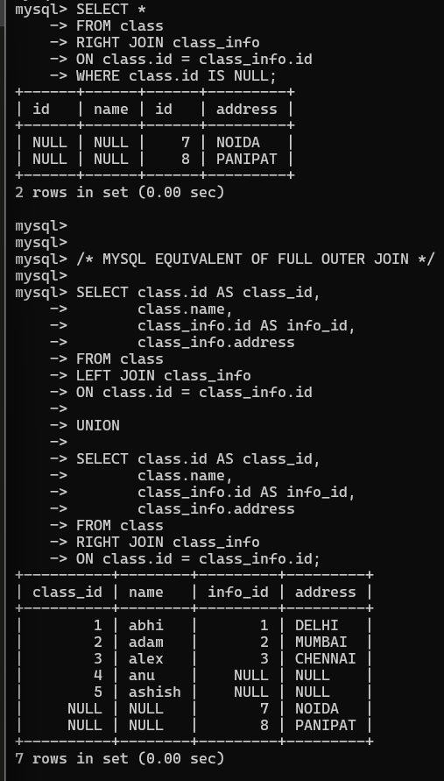
• RIGHT JOIN + WHERE: Finds unmatched addresses (NOIDA, PANIPAT) not linked to any student

SECTION 4: FULL OUTER JOIN
Returns all records from both tables - matched and unmatched.

Screenshot 6: FULL OUTER JOIN (MySQL Equivalent)
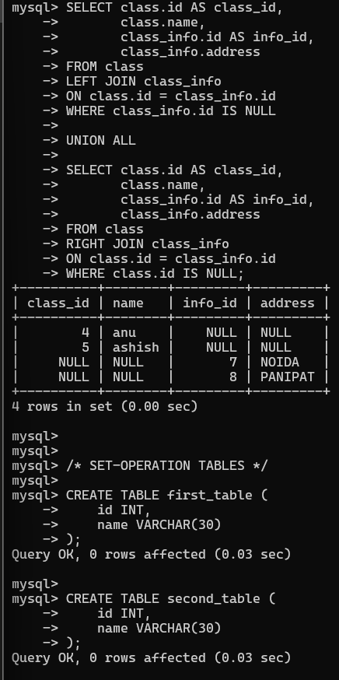
FULL OUTER JOIN achieved through LEFT JOIN UNION RIGHT JOIN:
• Returns 7 rows: All matched records + unmatched students + unmatched addresses
• With WHERE clause: Returns only unmatched records (4 rows)

SECTION 5: SET OPERATIONS (UNION, INTERSECT, MINUS)

Screenshot 7: UNION & UNION ALL
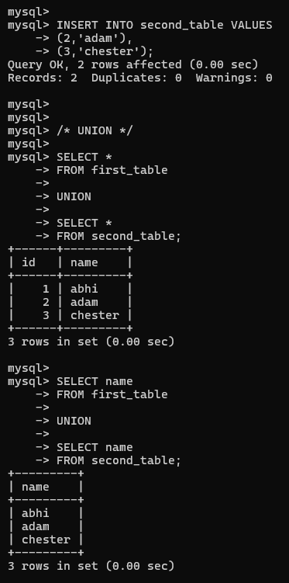
• UNION: Combines records from two tables, removes duplicates → 3 rows (abhi, adam, chester)
• UNION (names only): Produces unique student names across both tables

Screenshot 8: UNION ALL & Record Counting
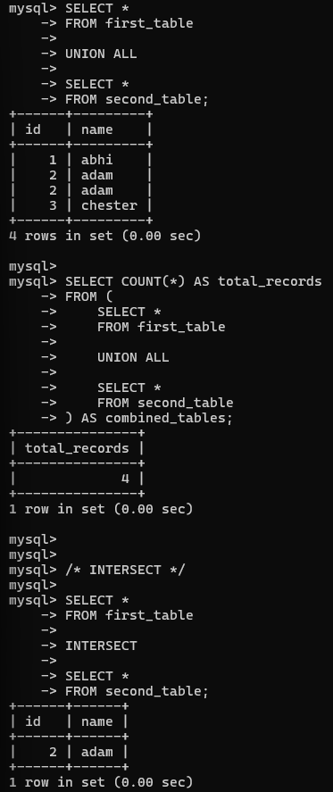
• UNION ALL: Includes duplicates → 4 rows (adam appears twice)
• COUNT with subquery: Counts total records from both tables including duplicates

Screenshot 9: INTERSECT & MINUS Operations
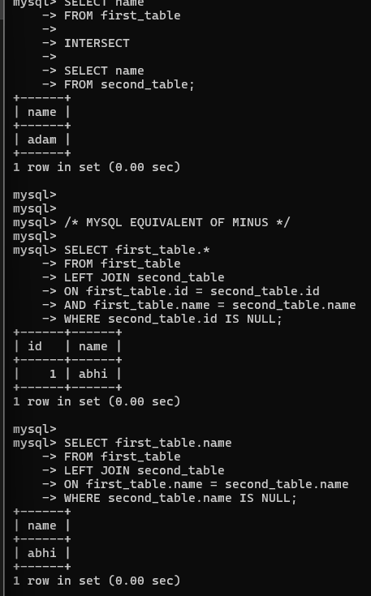
• INTERSECT: Finds common records in both tables → Only adam (present in both)
• MINUS (MySQL equivalent): Uses LEFT JOIN to find records only in first table → abhi

SECTION 6: Advanced JOIN Queries

Screenshot 10: INNER JOIN with Aliases & CASE Statement
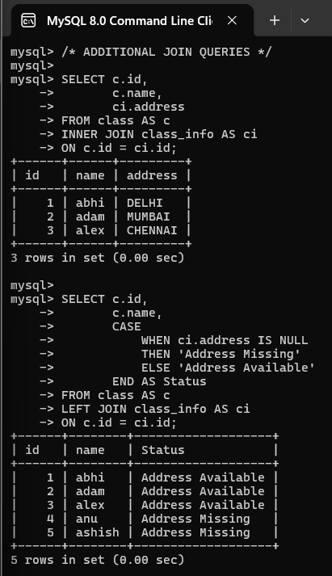
Advanced Query Patterns:
• Table Aliases: Using AS c and AS ci for cleaner syntax
• INNER JOIN: Matches students with their addresses based on ID
• CASE Statement: Conditional logic to show "Address Available" or "Address Missing"
• LEFT JOIN + CASE: Comprehensive report showing status for all students
- Output: 5 students with their address availability status

COMPREHENSIVE JOIN & SET OPERATION REFERENCE
Operation | Description | Result / Use Case
CROSS JOIN | Cartesian product of all rows | 25 rows (5×5 combination for survey analysis)
INNER JOIN | Only matching records | 3 rows with confirmed address records
NATURAL JOIN | Auto-join on common columns | 3 rows with implicit ID matching
LEFT JOIN | All left table + matching right | 5 rows including students without addresses
RIGHT JOIN | All right table + matching left | 5 rows including orphaned addresses
FULL OUTER | All records matched and unmatched | 7 rows with all data combinations
UNION | Combine tables, remove duplicates | 3 unique records (abhi, adam, chester)
UNION ALL | Combine tables, keep duplicates | 4 records (adam counted twice)
INTERSECT | Common records in both tables | 1 record (adam in both branches)
MINUS | Records only in first table | 1 record (abhi only in first_table)

Key Takeaways
✓ CROSS JOIN: Used for combinations (surveys, pairings)
✓ INNER JOIN: Most common - only matched data
✓ LEFT/RIGHT JOIN: Preserve unmatched records from one side
✓ FULL OUTER: Complete data from both tables
✓ UNION: Combines datasets, removes duplicates for clean master lists
✓ INTERSECT: Finds common data across tables
✓ MINUS: Identifies unique records in one table
✓ CASE in JOINs: Adds conditional logic for reporting

