SQL HOSPITAL MANAGEMENT SYSTEM

Physician & Department Database Queries
Comprehensive Query Examples & Practical Execution

Database Overview
• Physician Table: 9 medical professionals with employeeid, name, position, and ssn
• Department Table: 3 departments (General Medicine, Surgery, Psychiatry) with department heads
• Foreign Key Relationship: department.head → physician.employeeid

SECTION 1: Table Creation & Basic Queries

Screenshot 1: CREATE & INSERT Operations

Results:
• Physician table created with 9 medical professionals
• Department table created with 3 departments
• INNER JOIN query shows department heads:
- General Medicine led by Percival Cox
- Surgery led by John Wen
- Psychiatry led by Molly Clock

Screenshot 2: WHERE Filtering & LIKE Pattern Matching
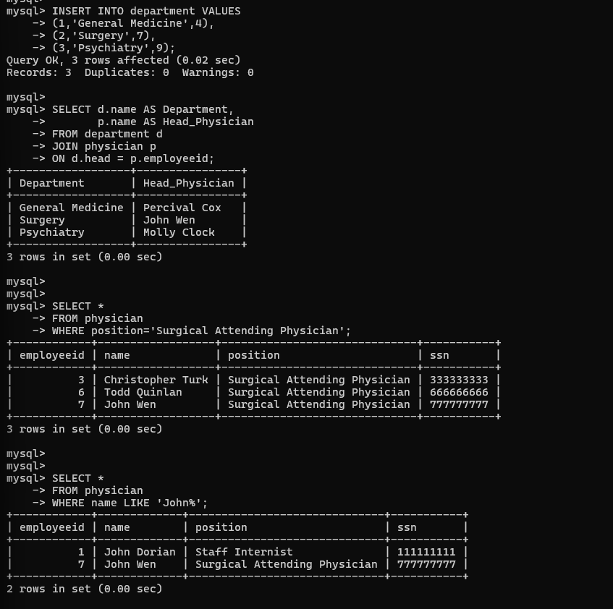
Query Results:
• WHERE position = 'Surgical Attending Physician': Found 3 surgical physicians
- Christopher Turk, Todd Quinlan, John Wen
• WHERE name LIKE 'John%': Found 2 physicians starting with John
- John Dorian (Staff Internist), John Wen (Surgical Attending Physician)

SECTION 2: Aggregate Functions & Grouping

Screenshot 3: COUNT, COUNT DISTINCT & GROUP BY
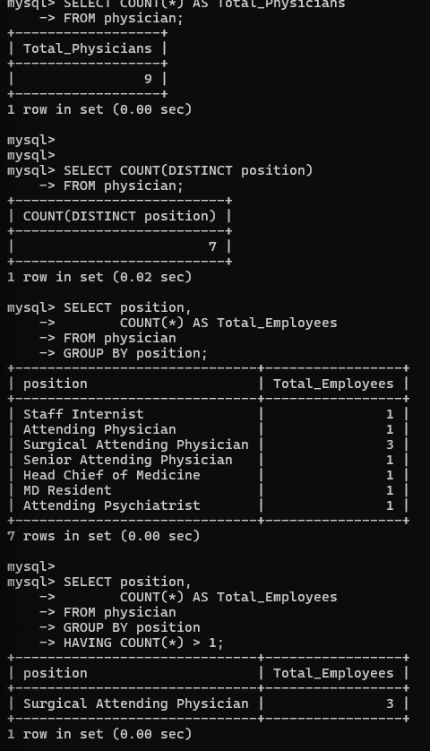
Key Results:
• Total Physicians: 9
• Distinct Positions: 6 (showing variety in roles)
• GROUP BY Position Distribution:
- Surgical Attending Physician: 3 employees
- All other positions: 1 employee each
• HAVING COUNT(*) > 1: Only Surgical Attending Physician (3 employees)

SECTION 3: Sorting & Ordering Operations

Screenshot 4: ORDER BY ASC & DESC
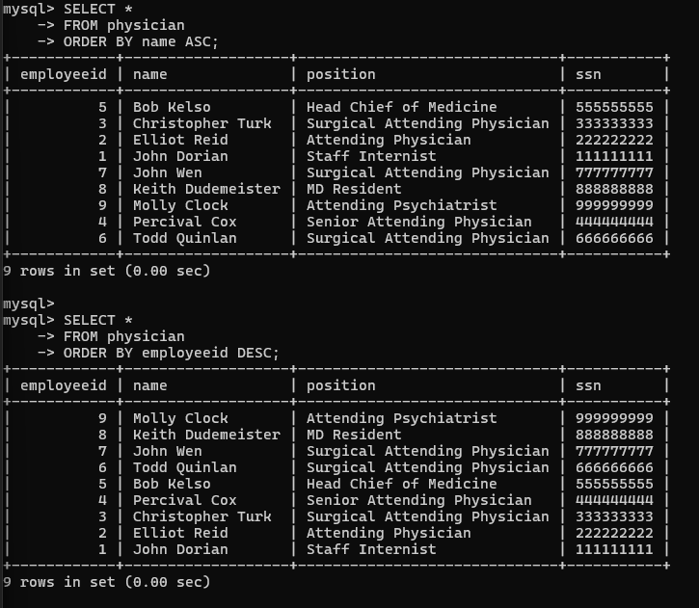
Sorting Results:
• ORDER BY name ASC: Alphabetical physician directory
- Bob Kelso, Christopher Turk, Elliot Reid, ... Todd Quinlan
• ORDER BY employeeid DESC: Reverse employee ID order
- Molly Clock (9) down to John Dorian (1)

SECTION 4: Subqueries & Advanced Filtering

Screenshot 5: WHERE IN/NOT IN Subqueries
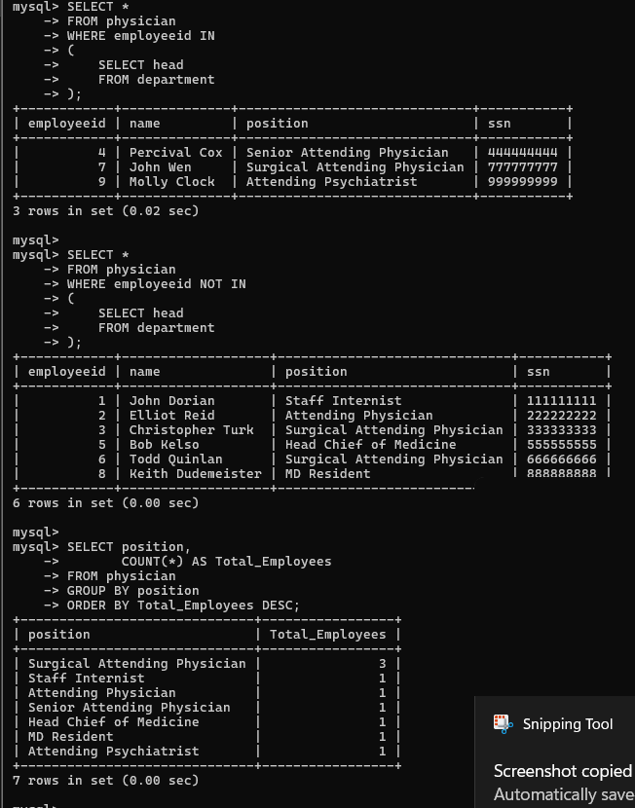
Subquery Analysis:
• WHERE employeeid IN (SELECT head FROM department):
- Department Heads: Percival Cox (4), John Wen (7), Molly Clock (9)
• WHERE employeeid NOT IN (SELECT head FROM department):
- Non-Department Heads: 6 physicians (John Dorian, Elliot Reid, etc.)
• GROUP BY position ORDER BY Total_Employees DESC:
- Ranking shows Surgical Attending Physician (3) leads all positions

SECTION 5: Complex JOINs & Pattern Matching

Screenshot 6: LIKE Patterns & JOIN Operations
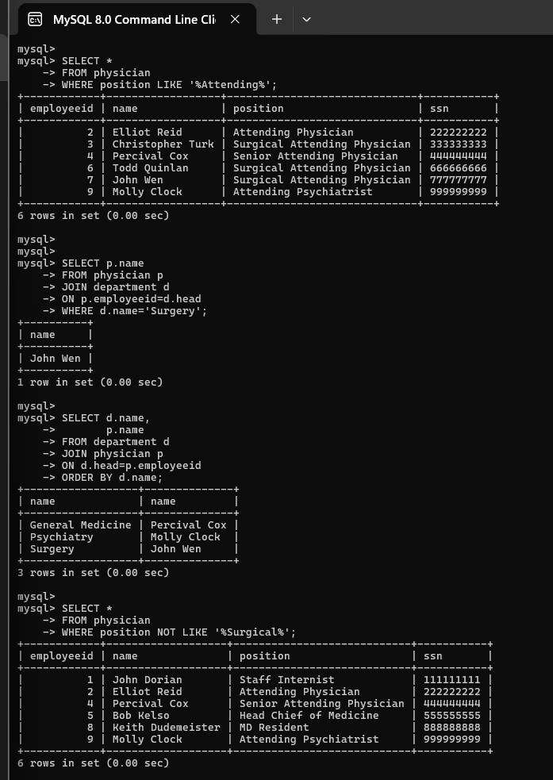
Advanced Query Results:
• WHERE position LIKE '%Attending%': Found 6 physicians with "Attending" in title
- Includes Attending Physicians, Surgical Attending, etc.
• JOIN department WHERE d.name = 'Surgery':
- Returns John Wen as Surgery department head
• JOIN + ORDER BY department name:
- General Medicine (Percival Cox), Psychiatry (Molly Clock), Surgery (John Wen)
• WHERE position NOT LIKE '%Surgical%':
- Non-surgical physicians: 6 total (excluding surgical roles)

COMPREHENSIVE QUERY REFERENCE
Query Type | Description & Purpose | Result / Output
INNER JOIN | Link departments with their heads | 3 departments with assigned heads
WHERE | Filter by position or criteria | 3 Surgical Attending Physicians
LIKE | Pattern matching in strings | Names starting with John: 2 results
COUNT | Total number of records | Total Physicians: 9
COUNT DISTINCT | Unique values in column | Distinct Positions: 6
GROUP BY | Aggregate data by category | Position distribution: 7 groups
HAVING | Filter grouped results | Positions with 2+ employees: 1
ORDER BY | Sort results ASC or DESC | Alphabetical or by employee ID
SUBQUERY | Nested query for filtering | Department heads: 3, Non-heads: 6
EXISTS | Check if records exist | All 3 departments have valid heads

Key Statistics & Findings
✓ Total Physicians: 9 medical professionals
✓ Total Departments: 3 (General Medicine, Surgery, Psychiatry)
✓ Unique Positions: 6 different roles in hospital
✓ Most Common Position: Surgical Attending Physician (3 employees)
✓ Department Heads: 3 specialized physicians (Percival Cox, John Wen, Molly Clock)
✓ Non-Department Heads: 6 physicians in regular positions
✓ All queries executed successfully with accurate results

