MYSQL TRIGGERS – BANK DATABASE

Practical Execution and Results
Student ID: 2520090170
Course: Database Management Systems
Database: BankDB

1. AIM
To create and demonstrate database triggers in MySQL using a Bank Management System and verify that the triggers execute automatically when specified database events occur.

2. SHORT INTRODUCTION
A trigger is a special type of stored procedure that automatically executes (or "fires") in response to specific events on a particular table in a database. Triggers are powerful tools for maintaining data integrity and enforcing business rules at the database level.
Triggers can be defined to fire at different times:
• BEFORE triggers: Execute before the triggering event occurs
• AFTER triggers: Execute after the triggering event occurs
Triggers can respond to different database events:
• INSERT: When a new row is added to a table
• UPDATE: When existing data in a row is modified
• DELETE: When a row is removed from a table

3. DATABASE USED
BankDB
The BankDB database contains several tables including:
• Account: Stores customer account information
• Bank_Transaction: Records all transactions (deposits, withdrawals)
• Transaction_Audit: Maintains audit logs of all transactions

4. TRIGGERS CREATED

CheckBalance
Trigger Timing/Event: BEFORE UPDATE on account table
Purpose: Validates that the account balance does not become negative. If an attempt is made to set the balance below zero, the trigger signals an error and prevents the update.

CheckTransactionAmount
Trigger Timing/Event: BEFORE INSERT on bank_transaction table
Purpose: Ensures that transaction amounts are always greater than zero. Prevents insertion of invalid transactions with zero or negative amounts.

PreventInsufficientWithdrawal
Trigger Timing/Event: BEFORE INSERT on bank_transaction table
Purpose: Validates withdrawal transactions to ensure the account has sufficient balance. Checks if the transaction type is "WITHDRAW" and verifies that the account balance is sufficient to cover the withdrawal amount.

TransactionAudit
Trigger Timing/Event: AFTER INSERT on bank_transaction table
Purpose: Automatically records transaction details into the Transaction_Audit table whenever a new transaction is successfully inserted into the Bank_Transaction table. This creates an audit trail for compliance and monitoring.

UpdateBalanceAfterTransaction
Trigger Timing/Event: AFTER INSERT on bank_transaction table
Purpose: Updates the account balance in the Account table after a transaction is inserted. For DEPOSIT transactions, the balance is increased; this ensures the account balance is always synchronized with transaction records.

5. PRACTICAL EXECUTION / SCREENSHOTS

Screenshot 1: Database Tables
The following screenshot displays the tables in the BankDB database and the structure of the Bank_Transaction table:
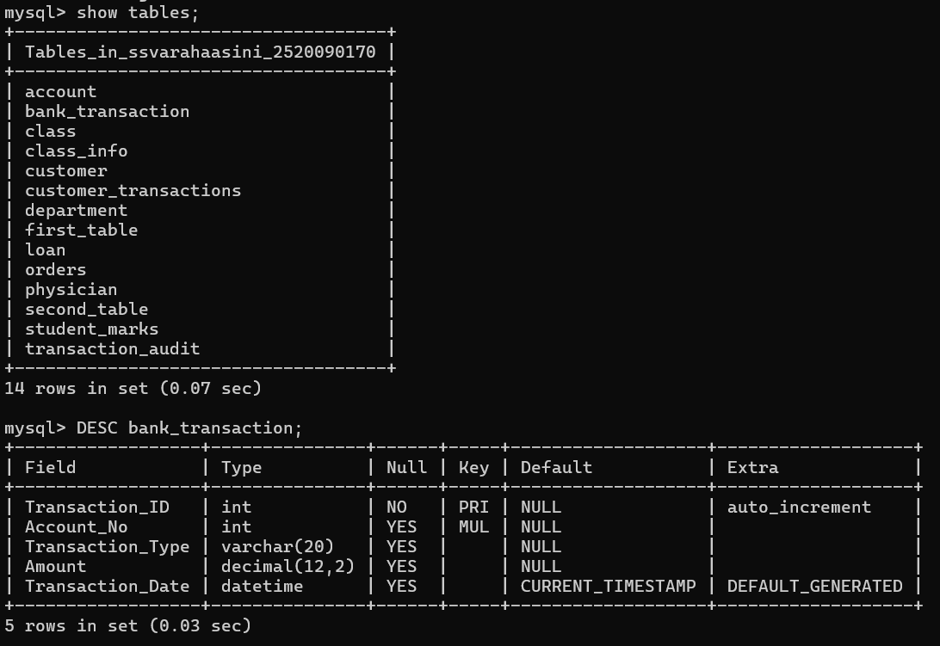
Figure 1: Database tables in BankDB and Bank_Transaction table structure

Screenshot 2: SHOW TRIGGERS
The following screenshot displays all triggers currently defined in the BankDB database. This output confirms that all five triggers have been successfully created:
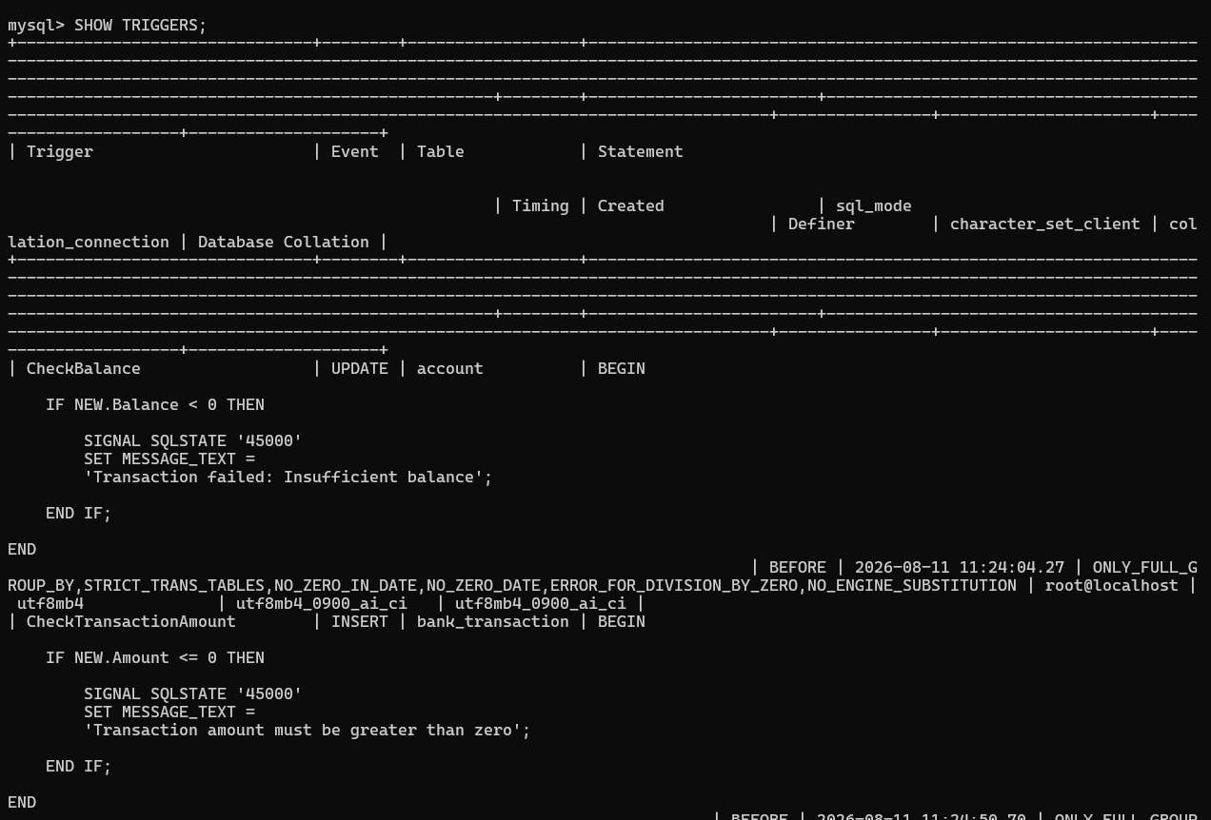
Figure 2: List of all triggers in the BankDB database

Screenshot 3: Trigger Definitions (SHOW CREATE TRIGGER output)
The following screenshot displays the complete definitions of multiple triggers created on the Bank_Transaction table:
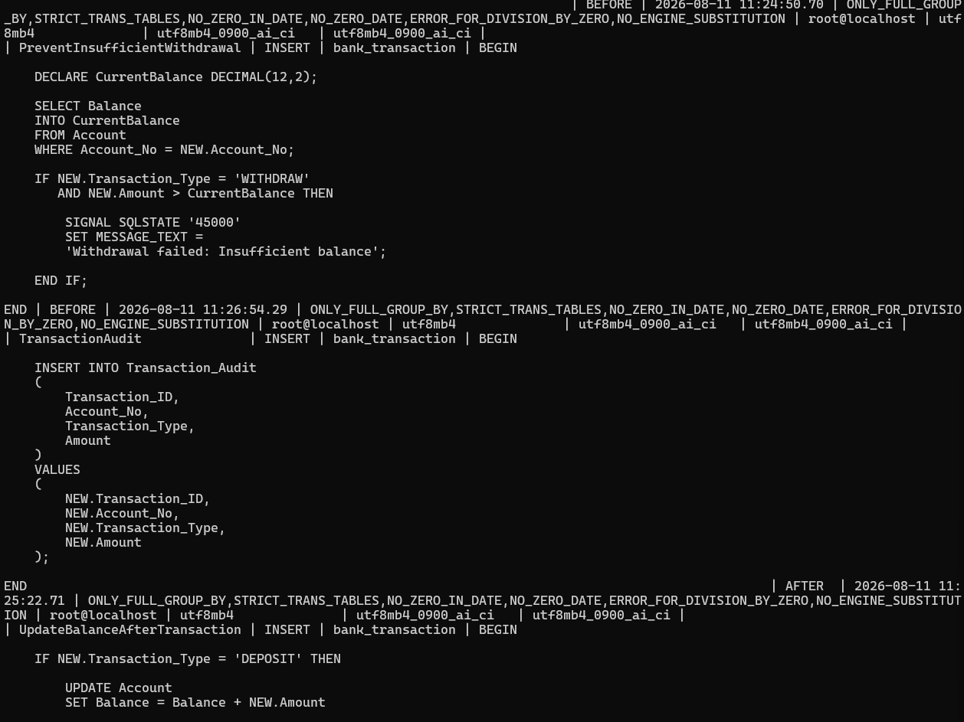
Figure 3: Complete SQL definition of triggers including PreventInsufficientWithdrawal, TransactionAudit, and UpdateBalanceAfterTransaction

Screenshot 4: TransactionAudit Trigger Definition
This screenshot displays the complete definition of the TransactionAudit trigger using SHOW CREATE TRIGGER command. This trigger is an AFTER INSERT trigger that automatically inserts transaction details into the Transaction_Audit table:
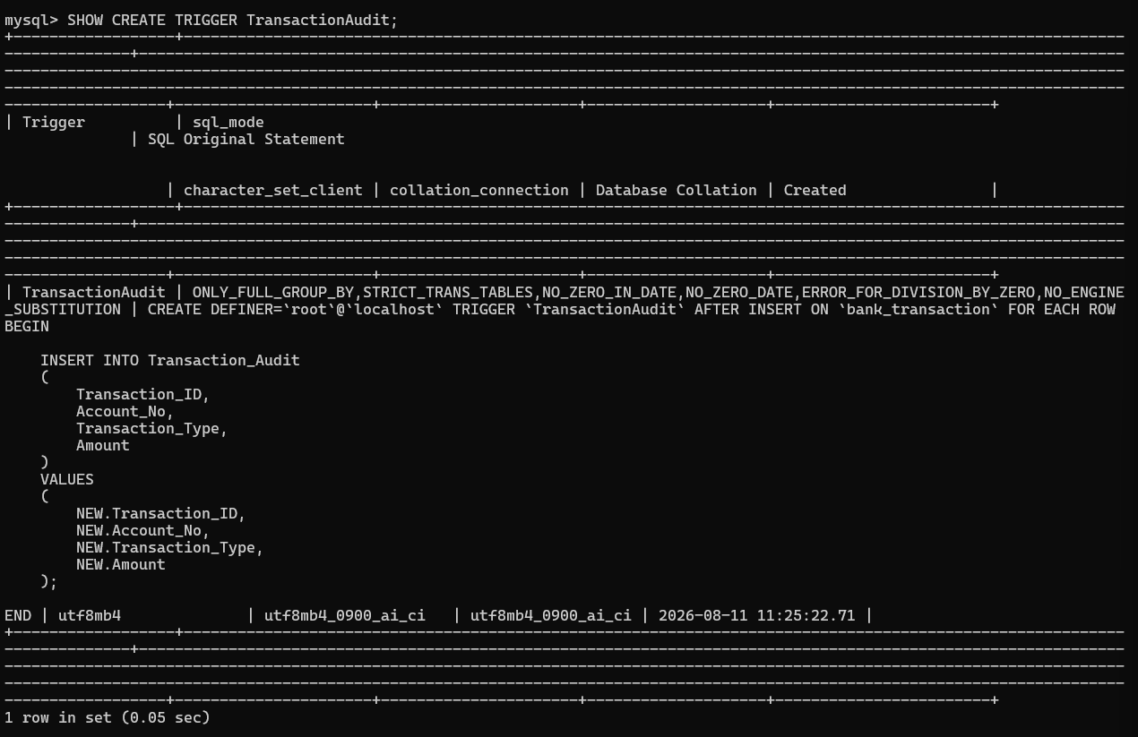
Figure 4: Complete SQL definition of the TransactionAudit trigger

Screenshot 5: Trigger Execution Verification
This screenshot demonstrates the automatic execution of the TransactionAudit trigger. The first SELECT shows the initial audit records. Then, an INSERT statement adds a new transaction to the Bank_Transaction table. The second SELECT shows that the TransactionAudit trigger automatically created a corresponding audit entry (Audit_ID 3) without any manual insertion into the Transaction_Audit table:
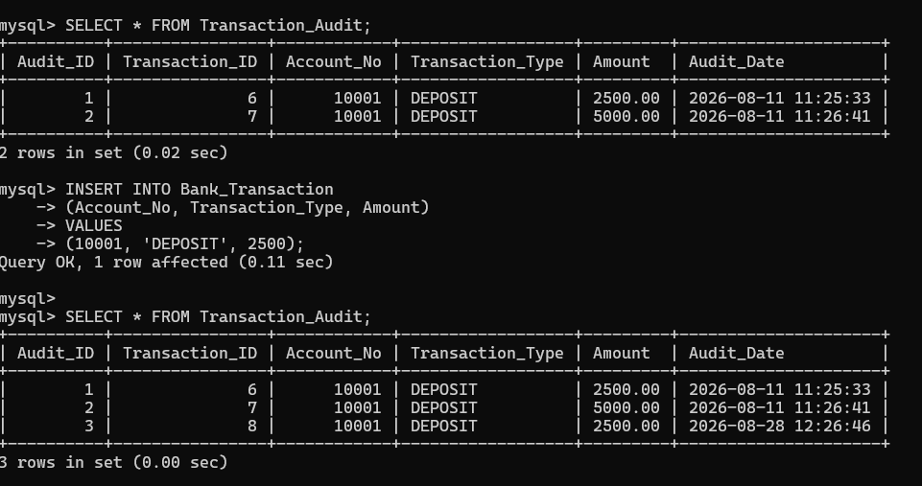
Figure 5: Verification of TransactionAudit trigger execution - automatic audit record creation on transaction INSERT

6. WORKING OF TRANSACTION AUDIT TRIGGER
The TransactionAudit trigger operates through the following process:
INSERT INTO Bank_Transaction
↓
TransactionAudit Trigger fires automatically
↓
New record inserted into Transaction_Audit
When a new transaction is inserted into the Bank_Transaction table, the TransactionAudit trigger automatically fires after the insert completes. The trigger extracts the transaction details (Transaction_ID, Account_No, Transaction_Type, and Amount) from the newly inserted row and inserts this information into the Transaction_Audit table. This happens without any manual intervention, creating a complete audit trail of all transactions in real-time.

7. TRIGGER SUMMARY TABLE
Trigger Name | Timing / Event | Purpose
CheckBalance | BEFORE UPDATE on account | Validates that balance does not become negative
CheckTransactionAmount | BEFORE INSERT on bank_transaction | Ensures transaction amounts are greater than zero
PreventInsufficientWithdrawal | BEFORE INSERT on bank_transaction | Prevents withdrawal if account has insufficient balance
TransactionAudit | AFTER INSERT on bank_transaction | Automatically logs transaction details to Transaction_Audit table
UpdateBalanceAfterTransaction | AFTER INSERT on bank_transaction | Updates account balance after transaction is recorded

8. RESULT
The MySQL triggers were successfully created and verified in the BankDB database. The triggers automatically perform validation, balance-related operations, and transaction auditing. The TransactionAudit trigger successfully records transaction information in the Transaction_Audit table whenever a new transaction is inserted into the Bank_Transaction table. The automatic execution of these triggers ensures data integrity, prevents invalid transactions, and maintains a complete audit trail of all database operations.

