K L (DEEMED TO BE) UNIVERSITY
DEPARTMENT OF COMPUTER SCIENCE AND ENGINEERING

PROJECT REPORT
ON
MULTITHREADED LINUX APPLICATION
USING POSIX THREADS AND MUTEXES
Course: Operating System and System Programming (25CS2104E)

Submitted by
Roll Number | Name
2520090170 | S Svara Haasini
2520090227 | B Sudharshini
2520090190 | Sumanjali

Section: 10 | Team: 8
Under the Esteemed Guidance of
Mr. M. Raghupathi
CSE Department
Academic Year 2026–2027

DECLARATION
We hereby declare that the project report entitled “Multithreaded Linux Application Using POSIX Threads and Mutexes” is a record of the bonafide work carried out by S Svara Haasini (2520090170), B Sudharshini (2520090227), and Sumanjali (2520090190), under the guidance of Mr. M. Raghupathi, Department of Computer Science and Engineering, K L (Deemed to be) University.
The work presented in this report is based on the implementation, testing, and documentation of a Linux-based multithreaded application developed using the C programming language, POSIX threads, and mutex synchronization. The report has been prepared for academic submission as part of the course Operating System and System Programming (25CS2104E).
We further declare that the implementation and results described in this report correspond to the project source code, project documentation, and demonstration material prepared by the team.

Name | Signature
S Svara Haasini | ____________________________
B Sudharshini | ____________________________
Sumanjali | ____________________________

CERTIFICATE
This is to certify that the project report entitled “Multithreaded Linux Application Using POSIX Threads and Mutexes” is a bonafide work carried out and submitted by S Svara Haasini (2520090170), B Sudharshini (2520090227), and Sumanjali (2520090190), in partial fulfillment of the academic requirements of the course Operating System and System Programming (25CS2104E), Department of Computer Science and Engineering, K L (Deemed to be) University.
The project was developed and demonstrated using Linux/Ubuntu-based development tools and implements POSIX multithreading, shared-resource access, race-condition demonstration, and mutex-based synchronization.

Signature of the Guide | Signature of the Course Coordinator | Signature of the HOD

____________________ | ____________________ | ____________________

ACKNOWLEDGEMENT
We express our sincere gratitude to everyone who supported and guided us during the development and completion of this project. The successful completion of this work was possible through the technical guidance, encouragement, and support provided by our faculty and team members.
We would like to express our special thanks to our supervisor, Mr. M. Raghupathi, CSE Department, for his valuable guidance, suggestions, and encouragement throughout the project. His guidance helped us understand and implement the Operating Systems concepts involved in multithreading and synchronization.
We also thank the Department of Computer Science and Engineering and the university for providing the required academic environment and facilities to develop, test, and demonstrate the project.
Finally, we thank our classmates, friends, and family members for their encouragement and support during the development and documentation of this project.
Name | Signature
S Svara Haasini | ____________________________
B Sudharshini | ____________________________
Sumanjali | ____________________________

ABSTRACT
Modern multi-core systems rely on concurrent execution for efficiency and responsiveness. However, when multiple threads within the same process access shared resources at the same time, race conditions and inconsistent results can occur. This is a key challenge in Operating Systems because threads share the same address space and can concurrently read and modify shared data.
This project presents a multithreaded Linux application developed in C using POSIX Threads (Pthreads) and mutex locks. The application creates multiple worker threads that concurrently update a shared counter. Each of the eight worker threads performs 100,000 increments, giving an expected final value of 800,000. The application provides three execution modes: running without a mutex, running with a mutex, and running both modes for comparison.
In the unsynchronized mode, the program intentionally exposes the read-modify-write operation on the shared counter. Because multiple threads can access the shared resource concurrently, updates can be lost and the final result can be less than the expected value. The program also uses sched_yield() during the unsynchronized execution to encourage thread interleaving and make the race condition more observable.
In the synchronized mode, pthread_mutex_lock() and pthread_mutex_unlock() protect the critical section containing the counter update. This provides mutual exclusion and ensures that only one thread modifies the shared resource at a time. The main thread uses pthread_join() to wait for all worker threads before checking the final result. The project also includes a custom Linux shell that can launch the multithreaded application through a dedicated project command, integrating process creation and program execution concepts with the multithreading demonstration.
The project therefore provides a practical demonstration of concurrency, critical sections, race conditions, mutual exclusion, POSIX thread management, and safe resource sharing in a Linux environment.

TABLE OF CONTENTS

Note: In Microsoft Word, right-click the table of contents and select “Update Field” → “Update entire table” after opening the document.

CHAPTER 1 – INTRODUCTION

1.1 Background of the Project
Modern operating systems support concurrent execution to improve responsiveness and make effective use of multi-core processors. Multithreading allows multiple execution flows, called threads, to operate within the same process. Threads of a process share the process address space and can therefore access common variables and other shared resources.
Shared-memory concurrency improves performance for suitable workloads, but it also introduces synchronization problems. When two or more threads access and modify the same data without proper coordination, the order of operations can affect the final result. Such behavior is known as a race condition.
The project demonstrates this issue using a shared counter. Eight worker threads execute concurrently, and each thread performs 100,000 increments. The expected total is therefore 800,000. The application compares the behavior of the shared counter when synchronization is absent and when a POSIX mutex protects the critical section.

1.2 Problem Statement
Applications increasingly use concurrent execution to utilize multi-core processors efficiently. However, multiple threads within the same process can simultaneously access shared resources. Since threads share the process address space, an unsynchronized read-modify-write operation can produce lost updates and inconsistent results.
The problem addressed by this project is to design and implement a Linux-based multithreaded application that clearly demonstrates the effect of synchronization. The application must show the incorrect or inconsistent behavior that can occur without mutual exclusion and then demonstrate how mutex-based synchronization protects the critical section and produces the correct result.

1.3 Scope of the Project
- Develop a C application using POSIX threads in a Linux/Ubuntu environment.
- Create and manage multiple worker threads using pthread_create().
- Use a shared counter as a simple shared resource.
- Demonstrate a race condition by allowing unsynchronized concurrent updates.
- Use pthread_mutex_t to provide mutual exclusion around the critical section.
- Use pthread_join() to ensure all worker threads complete before result verification.
- Provide three execution modes: without mutex, with mutex, and both for comparison.
- Provide a custom Linux shell that can launch the multithreaded application using the project command.
- Compile and execute the project using GCC and Make on Linux/Ubuntu or WSL.

1.4 Objectives of the Project
- Understand and apply multithreading in Linux using the POSIX Threads library.
- Create multiple threads that perform concurrent work.
- Identify the critical section involved in shared-data access.
- Demonstrate race conditions caused by unsynchronized access to shared data.
- Apply mutex locks to prevent race conditions and ensure data consistency.
- Use thread joining to synchronize program completion.
- Compare synchronized and unsynchronized execution results.
- Gain practical experience with Linux process and thread APIs.

1.5 Importance of the Application
The project provides a controlled and measurable demonstration of a fundamental Operating Systems problem. Rather than discussing race conditions only theoretically, the application allows the effect to be observed directly through the difference between the expected and actual counter values.
The synchronized version demonstrates the practical role of mutual exclusion. The project also connects thread-level synchronization with Linux process management through the supporting custom shell, making the implementation useful as an integrated systems-programming exercise.

1.6 Target Users / Audience
- Students studying Operating Systems and System Programming.
- Learners studying POSIX threads and synchronization.
- Students learning race conditions and critical sections.
- Developers who want a simple demonstration of mutex-based synchronization in C.
- Faculty and evaluators assessing practical understanding of Linux concurrency concepts.

CHAPTER 2 – OS CONCEPTS AND BACKGROUND STUDY

2.1 Operating System Concepts Related to the Project

2.1.1 Process and Thread
A process is a program in execution with its own process context and resources. A thread is an execution unit within a process. Threads belonging to the same process share resources such as the address space, while each thread maintains its own execution state. The project uses multiple threads within a single process so that all worker threads can access the same shared counter.

2.1.2 Multithreading
Multithreading is the execution of multiple threads within a process. It can improve responsiveness and allow work to be performed concurrently. In this project, eight worker threads are created, and every worker performs the same counter-update task.

2.1.3 Shared Resource
A shared resource is data or another resource that can be accessed by more than one execution flow. The variable counter in this project is shared by all worker threads. Because every thread modifies the same variable, synchronization is required when the update must be performed safely.

2.1.4 Critical Section
A critical section is a portion of a program in which a shared resource is accessed or modified and therefore requires controlled access. In the synchronized mode, the counter increment is executed while the mutex is locked.

2.1.5 Race Condition
A race condition occurs when the outcome of concurrent execution depends on the timing or interleaving of operations. The unsynchronized counter update can be represented as a read followed by a write. If two threads read the same old value before either writes its new value, one update can overwrite the other. This is called a lost update.

2.1.6 Mutual Exclusion and Mutex
Mutual exclusion ensures that only one thread at a time enters a protected critical section. A POSIX mutex, represented by pthread_mutex_t, provides this behavior. A thread locks the mutex before entering the critical section and unlocks it after the protected operation is complete.

2.1.7 Thread Creation and Joining
pthread_create() starts a new thread that executes a specified function. pthread_join() makes the calling thread wait until a target thread terminates. In this project, the main thread creates eight worker threads and joins all of them before checking the final counter value.

2.2 Existing Methods / Algorithms
A simple unsynchronized shared-variable update can be implemented without a synchronization primitive. Although this approach is straightforward, it is unsafe when multiple threads can update the same variable concurrently. The sequence of operations can overlap and produce lost updates.
A synchronization-based approach uses mutual exclusion. A mutex serializes access to the critical section while still allowing the worker threads to exist and execute concurrently outside the protected region. This project uses this approach for the synchronized execution mode.

2.3 Proposed Approach
The proposed application creates eight POSIX worker threads. Each worker performs 100,000 updates to a shared counter. The application supports two synchronization states: mutex disabled and mutex enabled. When disabled, the program explicitly performs a separate read and write of the counter and periodically calls sched_yield() to encourage thread interleaving. When enabled, the counter increment is enclosed by pthread_mutex_lock() and pthread_mutex_unlock().
After creating all workers, the main thread calls pthread_join() for each thread. It then calculates the expected result as NUM_THREADS × ITERATIONS and compares it with the actual counter value. A mismatch is reported as a race condition, and the difference is reported as lost updates.

2.4 Advantages of the Proposed Approach
- Provides a clear practical demonstration of a race condition.
- Uses a simple shared counter, making the synchronization effect easy to understand.
- Provides both synchronized and unsynchronized execution for direct comparison.
- Uses standard POSIX thread and mutex APIs.
- Verifies the result after all threads finish.
- Can be compiled and executed using standard Linux development tools.
- Integrates with a custom shell for a broader systems-programming demonstration.

CHAPTER 3 – SYSTEM REQUIREMENTS

3.1 Hardware Requirements
Component | Requirement / Purpose
Processor | Modern multi-core processor recommended for observing concurrent thread execution.
RAM | At least 4 GB recommended for Linux/WSL and development tools.
Storage | Sufficient space for source code, compiler, editor, build outputs, and documentation.
Display | Standard monitor/laptop display for terminal and development environment.

3.2 Software Requirements
Software / Library | Purpose
Linux / Ubuntu | Development and execution environment.
C | Programming language used for the application.
GCC | Compiler used to build the C source files.
POSIX Threads | Thread creation, joining, and mutex synchronization APIs.
Make | Automates compilation of my_shell and project executables.
VS Code | Source-code editing and project development.
WSL | Optional Windows-based Linux environment used for development/testing.

3.3 Operating System Environment – Ubuntu / WSL
The application is designed for a Linux environment and can be developed and executed on Ubuntu. The project can also be used in Windows through Windows Subsystem for Linux (WSL), which provides a Linux user space and command-line environment. The source code uses standard Linux/POSIX interfaces such as fork(), execvp(), execl(), waitpid(), and the POSIX thread APIs.

3.4 Development Tools and Compilers
GCC is used to compile the C source files. The project Makefile defines separate build targets for the custom shell and the multithreaded application. Compiler warnings are enabled using -Wall and -Wextra. The project executable is linked with the pthread support option -pthread.
CC = gcc
CFLAGS = -Wall -Wextra

all: my_shell project

my_shell: src/shell.c
$(CC) $(CFLAGS) src/shell.c -o my_shell

project: src/project.c
$(CC) $(CFLAGS) src/project.c -o project -pthread

CHAPTER 4 – TECHNOLOGY AND TOOLS USED

4.1 C Programming
The project is implemented in C. C provides direct access to system-level programming constructs and is suitable for demonstrating Linux processes, threads, synchronization, and command execution.

4.2 GCC Compiler
The GNU Compiler Collection (GCC) is used to compile the project source files. The Makefile uses the compiler with -Wall and -Wextra warning options. The multithreaded executable is built with -pthread so that the POSIX thread library support is correctly enabled.

4.3 Linux System Calls / APIs
API / Function | Module | Purpose
fork() | shell.c | Creates a child process for command execution.
execvp() | shell.c | Replaces the child process image with a requested Linux command.
execl() | shell.c | Launches the project executable from the custom shell.
waitpid() | shell.c | Makes the parent shell wait for the child process.
pthread_create() | project.c | Creates worker threads.
pthread_join() | project.c | Waits for worker threads to finish.

Additional synchronization functions used by project.c include pthread_mutex_init(), pthread_mutex_lock(), pthread_mutex_unlock(), and pthread_mutex_destroy().

4.4 POSIX Threads / Synchronization
The POSIX Threads library provides standardized APIs for creating and managing threads. The project uses pthread_t to store thread identifiers and pthread_mutex_t to represent the mutex used for mutual exclusion.

4.5 Linux Commands and Utilities
The custom shell supports common Linux commands such as ls, pwd, date, whoami, echo, clear, and cd. The shell also provides a help command and a project command that launches the multithreaded application.

4.6 Make and Project Build System
The Makefile provides a simple build interface. Running make compiles both executables. Running make clean removes the generated my_shell and project executables.
make
# Builds:
# my_shell
# project

make clean
# Removes the generated executables

4.7 VS Code / GDB
VS Code can be used as the development environment for editing and managing the project. GDB may be used for debugging when required. The final project demonstration is performed from the Linux terminal.

CHAPTER 5 – SYSTEM ARCHITECTURE AND DESIGN

5.1 Overall System Architecture
The project has a multithreaded execution component and a supporting custom shell. The shell provides a command-oriented interface and can launch the project executable. The multithreaded component then creates worker threads that operate on the shared counter.
Linux / Ubuntu / WSL
|
v
+----------------------+
| Custom Shell |
| my_shell$ |
+----------+-----------+
|
project command
|
v
+------------------------------+
| Multithreaded Application |
| main() |
+--------------+---------------+
|
pthread_create()
|
+-------+-------+
| | |
v v v
Worker Worker Worker ... Worker
\ | /
\ | /
+-----+-----+
|
Shared Counter
|
Mutex-protected
Critical Section
|
pthread_join()
|
v
Result Verification

5.2 System Workflow
- The user starts the custom shell or directly executes the project executable.
- The application initializes the mutex and displays the three execution modes.
- The selected test resets the shared counter and sets the mutex mode.
- The main thread creates eight worker threads using pthread_create().
- Each worker performs 100,000 counter updates.
- In the unsynchronized mode, the worker reads the counter into a temporary variable, may yield the CPU, and writes the incremented value.
- In the synchronized mode, the worker locks the mutex, increments the counter, and unlocks the mutex.
- The main thread calls pthread_join() for all workers.
- The program calculates the expected value and compares it with the actual value.
- The result is reported as correct/thread-safe or race condition detected.

5.3 Flowchart / Data Flow
START
|
v
Initialize mutex
|
v
Display execution menu
|
v
Read user choice
|
+-----------------------------+
| | |
v v v
Choice 1 Choice 2 Choice 3
No Mutex With Mutex Run Both
| | |
+-------------+---------------+
|
v
Reset counter = 0
|
v
Create 8 worker threads
|
v
Each performs 100000
increments
|
+--------+--------+
| |
v v
No Mutex Mutex Enabled
| |
v v
Read/Write Lock -> Increment
shared data -> Unlock
| |
+--------+--------+
|
v
Join all threads
|
v
Expected = 800000
|
v
Compare with actual
|
+-------+-------+
| |
Equal Not Equal
| |
v v
Thread Safe Race Condition
| |
+-------+-------+
|
v
END

5.4 Module Description
Module | Main Responsibility | Key APIs / Components
Custom Shell | Reads commands and launches Linux programs. | fork(), execvp(), execl(), waitpid()
Thread Manager | Creates and joins worker threads. | pthread_create(), pthread_join()
Shared Resource | Stores the common counter accessed by workers. | long long counter
Synchronization | Protects the counter update. | pthread_mutex_t, lock/unlock

5.5 Input and Output Design
The primary user input is the integer menu choice entered when the multithreaded application starts.
Input | Meaning
1 | Run without mutex.
2 | Run with mutex.
3 | Run both modes and compare.

The output contains the expected result, actual result, execution status, and—when a race condition is detected—the number of lost updates.

CHAPTER 6 – IMPLEMENTATION

6.1 Module-wise Implementation

6.1.1 Multithreaded Application
The main multithreaded application is implemented in project.c. It includes stdio.h for input/output, pthread.h for POSIX threads and mutexes, and sched.h for sched_yield(). The constants define eight threads and 100,000 iterations per thread.
#define NUM_THREADS 8
#define ITERATIONS 100000

long long counter = 0;
pthread_mutex_t mutex;
int use_mutex = 0;

6.1.2 Worker Thread Function
The worker function is executed by every created thread. When mutex synchronization is enabled, the counter increment is protected by the mutex. Otherwise, the program explicitly performs a read and write sequence and periodically calls sched_yield() to encourage a context switch.
void *worker(void *arg)
{
for (int i = 0; i < ITERATIONS; i++)
{
if (use_mutex)
{
pthread_mutex_lock(&mutex);
counter++;
pthread_mutex_unlock(&mutex);
}
else
{
long long temp = counter;

if (i % 100 == 0)
sched_yield();

counter = temp + 1;
}
}

return NULL;
}

6.1.3 Test Execution Function
run_test() resets the counter, selects the synchronization mode, creates all worker threads, waits for them, calculates the expected result, and compares the expected and actual values.
counter = 0;
use_mutex = mutex_enabled;

for (int i = 0; i < NUM_THREADS; i++)
pthread_create(&threads[i], NULL, worker, NULL);

for (int i = 0; i < NUM_THREADS; i++)
pthread_join(threads[i], NULL);

long long expected =
(long long) NUM_THREADS * ITERATIONS;

6.1.4 Custom Linux Shell
The custom shell is implemented in shell.c. It displays the my_shell$ prompt, reads user commands, tokenizes the input, handles built-in commands such as cd and exit, and uses fork() and execvp() to execute normal Linux commands. The special project command uses fork(), execl(), and waitpid() to launch the multithreaded application.
if (strcmp(args[0], "project") == 0)
{
pid_t pid = fork();

if (pid == 0)
{
execl("./project", "project", NULL);
exit(1);
}
else
{
waitpid(pid, NULL, 0);
}
}

6.2 Algorithm / Pseudocode

6.2.1 Overall Algorithm
1. Initialize the mutex.
2. Display the execution menu.
3. Read the user's choice.
4. For each selected test:
a. Set counter = 0.
b. Set mutex mode.
c. Create NUM_THREADS worker threads.
d. Each worker repeats ITERATIONS times.
i. If mutex is enabled:
- Lock mutex.
- Increment counter.
- Unlock mutex.
ii. Otherwise:
- Read counter into temp.
- Occasionally call sched_yield().
- Write temp + 1 back to counter.
e. Join all worker threads.
f. Compute expected = NUM_THREADS × ITERATIONS.
g. Compare expected and actual values.
h. Report the result.
5. Destroy the mutex.
6. Terminate the application.

6.2.2 Race Condition Algorithm
READ shared counter
|
v
Store value in temp
|
v
Another thread may access counter
|
v
WRITE temp + 1
|
v
Possible lost update

6.2.3 Mutex Synchronization Algorithm
LOCK mutex
|
v
READ / UPDATE shared counter
|
v
UNLOCK mutex
|
v
Allow another thread to enter

6.3 Core C Implementation
The core implementation uses standard POSIX thread functions. The mutex is initialized before the tests begin and destroyed after all testing is complete. The menu allows the same program to demonstrate both unsafe and synchronized behavior.
pthread_mutex_init(&mutex, NULL);

/* run selected tests */

pthread_mutex_destroy(&mutex);

6.4 Linux System Calls / APIs Used
Function | Category | Use in Project
fork() | Process management | Creates a child process in the custom shell.
execvp() | Program execution | Runs normal Linux commands.
execl() | Program execution | Runs the project executable from the shell.
waitpid() | Process synchronization | Waits for the child process to finish.
pthread_create() | Thread management | Creates worker threads.
pthread_join() | Thread synchronization | Waits for each worker thread.
pthread_mutex_lock() | Synchronization | Enters the protected critical section.
pthread_mutex_unlock() | Synchronization | Leaves the protected critical section.

6.5 Process / Thread Implementation
The custom shell demonstrates process creation by creating a child process for command execution. The child replaces its process image using an exec-family function, while the parent waits for completion. The multithreaded application separately demonstrates thread creation using pthread_create(). This combination provides practical exposure to both processes and threads.

6.6 IPC / Synchronization Implementation
The project does not implement an IPC mechanism such as pipes, message queues, or shared-memory IPC. Its synchronization mechanism is thread-level mutual exclusion using a POSIX mutex. The custom shell uses parent-child process synchronization through waitpid().

6.7 Memory Management Implementation
The project uses automatic/local variables for thread arrays, input buffers, argument arrays, and temporary values. The shared counter is a global variable accessed by all worker threads. The implementation does not use dynamic heap allocation for the core multithreaded counter demonstration.

6.8 User Interface Implementation
The application uses a command-line interface. The multithreaded program presents three menu options, while the custom shell provides a terminal-style prompt. This lightweight interface is sufficient for demonstrating the Operating Systems concepts without adding unrelated GUI complexity.

CHAPTER 7 – EXECUTION AND DEMONSTRATION

7.1 Compilation in Ubuntu / WSL
Open a Linux/Ubuntu/WSL terminal and move to the project directory. Then compile the project using Make.
cd ~/Multithreaded_Project
make
The build creates two executable files: my_shell and project. The project target is compiled with pthread support.
./project
./my_shell

7.2 Execution Commands
Direct execution of the multithreaded application:
./project
Execution through the custom shell:
./my_shell
Inside the shell:
my_shell$ help
my_shell$ pwd
my_shell$ ls
my_shell$ project
my_shell$ exit

7.3 Sample Inputs and Outputs
The application displays three choices:
1. Run WITHOUT Mutex
2. Run WITH Mutex
3. Run BOTH

Enter choice:
Sample input: Choice 1 — without mutex.
Expected Result : 800000
Actual Result : 139942
Status : RACE CONDITION DETECTED
Lost Updates : 660058
The exact unsynchronized result can vary between executions because thread scheduling is nondeterministic. The value shown above is the value captured in the project demonstration screenshot.
Sample input: Choice 2 — with mutex.
Expected Result : 800000
Actual Result : 800000
Status : CORRECT / THREAD SAFE
Sample input: Choice 3 — both modes.
WITHOUT MUTEX
Expected Result : 800000
Actual Result : 628298
Status : RACE CONDITION DETECTED
Lost Updates : 171702

WITH MUTEX
Expected Result : 800000
Actual Result : 800000
Status : CORRECT / THREAD SAFE

7.4 Screenshots of Execution
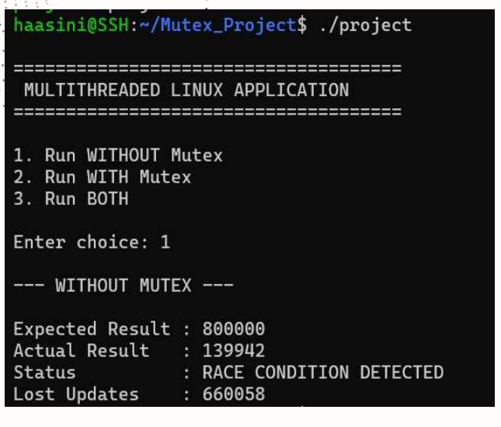
Figure 7.1: Execution without mutex showing a race condition and lost updates.
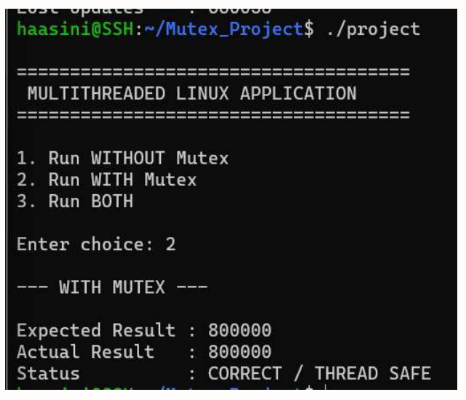
Figure 7.2: Execution with mutex producing the expected thread-safe result.

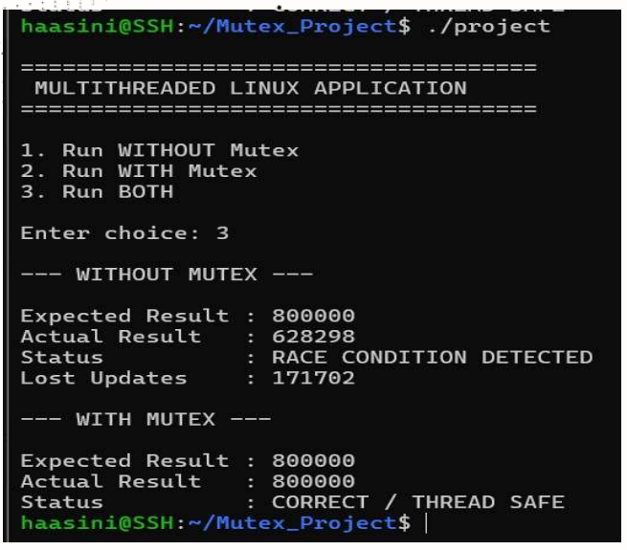
Figure 7.3: Comparison mode showing incorrect unsynchronized output and correct synchronized output.

7.5 Demonstration of OS Concepts
OS Concept | Demonstration | Observed Evidence
Multithreading | Eight worker threads are created. | Concurrent worker execution.
Shared resource | All workers update counter. | One common counter is accessed by all threads.
Race condition | Mutex disabled. | Actual result can be less than 800000.
Critical section | Counter update is protected. | Only one thread enters the protected update at a time.
Mutual exclusion | Mutex enabled. | Concurrent updates are serialized inside the critical section.
Thread joining | Main thread calls pthread_join(). | Final result checked only after workers finish.
Process management | Custom shell uses fork/exec/waitpid. | Commands and project executable are launched through child processes.

7.6 Result Analysis
The demonstration confirms the expected effect of synchronization. With mutex disabled, the actual counter value is lower than 800000 in the captured execution, indicating lost updates. With mutex enabled, the actual value equals 800000. The difference is explained by the fact that the unsynchronized read-modify-write sequence can overlap between threads, while the mutex prevents simultaneous entry into the protected update.

CHAPTER 8 – CONCLUSION

8.1 Summary of the Project
This project developed a Linux-based multithreaded application using C, POSIX Threads, and mutex synchronization. The application creates eight worker threads, with each thread performing 100,000 updates to a shared counter. The expected result is 800,000. The application supports execution without synchronization, with synchronization, and in a comparison mode.
The project also includes a custom Linux shell that supports basic commands and can launch the multithreaded application through a dedicated project command. This adds practical exposure to process creation, program execution, and parent-child process synchronization.

8.2 Objectives Achieved
- POSIX threads were created and managed successfully.
- A shared resource was accessed by multiple worker threads.
- The critical section was identified and protected using a mutex.
- Race-condition behavior was demonstrated without synchronization.
- Thread-safe behavior was demonstrated with mutex synchronization.
- pthread_join() was used to ensure all workers completed before result verification.
- The application was compiled and executed in a Linux-based environment.
- The custom shell demonstrated fork(), exec-family functions, and waitpid().

8.3 Results Achieved
Execution Mode | Captured Actual Result | Observation
Without Mutex | 139942 | Race condition detected; 660058 lost updates.
With Mutex | 800000 | Correct / thread safe.
Both | 628298 / 800000 | Unsynchronized mode is inconsistent; synchronized mode is correct.

The unsynchronized result is not expected to remain constant across executions because thread scheduling and timing can change. The values in the table are the values captured in the project demonstration screenshots.

8.4 Skills and Learning Outcomes
- Understanding of process and thread execution in Linux.
- Practical use of POSIX thread APIs.
- Understanding of shared-memory concurrency.
- Identification and demonstration of race conditions.
- Application of mutual exclusion using POSIX mutexes.
- Use of pthread_join() for thread completion synchronization.
- Understanding of Linux process creation and execution through fork(), execvp(), execl(), and waitpid().
- Use of GCC, Make, Linux terminal commands, and WSL/Ubuntu for systems programming.

INDIVIDUAL CONTRIBUTION
Roll Number | Student Name | Individual Responsibility
2520090170 | S Svara Haasini | Designed the overall program structure, implemented thread creation using pthread_create(), and prepared the project documentation.
2520090227 | B Sudharshini | Implemented the mutex locking mechanism using pthread_mutex_lock()/pthread_mutex_unlock() to protect the critical section and tested for race conditions.
2520090190 | Sumanjali | Implemented thread joining logic using pthread_join(), verified output consistency, and handled debugging/testing on Linux.

The responsibilities above are based on the individual-contribution section of the final project presentation.

CHAPTER 9 – REFERENCES

9.1 Books
- Abraham Silberschatz, Peter B. Galvin, and Greg Gagne, Operating System Concepts, Wiley.
- Robert Love, Linux System Programming: Talking Directly to the Kernel and C Library, O'Reilly Media.
- Michael Kerrisk, The Linux Programming Interface, No Starch Press.

9.2 Research / Technical References
- POSIX.1-2017 thread and synchronization interfaces and specifications.
- GNU C Library documentation for process, thread, and synchronization interfaces.

9.3 Linux / GNU Documentation
- Linux manual pages for fork(2), exec(3), waitpid(2), pthread_create(3), pthread_join(3), pthread_mutex_lock(3), pthread_mutex_unlock(3), and sched_yield(3).
- GCC documentation for C compilation and compiler options.
- GNU Make documentation for build automation.

9.4 Project Source and Supporting Material
- Project source file: src/project.c — POSIX threads and mutex demonstration.
- Project source file: src/shell.c — custom Linux shell and process execution.
- Project Makefile — build rules for my_shell and project.
- Project README — project overview, execution instructions, expected results, and project structure.
- Final project presentation — Multithreaded Linux Application Using POSIX Threads and Mutexes.

APPENDIX A – PROJECT STRUCTURE
Multithreaded_Project/
|
+-- src/
| +-- shell.c
| +-- project.c
|
+-- .github/
| +-- workflows/
| +-- run-project.yml
|
+-- docs/
+-- data/
+-- reports/
+-- results/
|
+-- Makefile
+-- README.md

APPENDIX B – BUILD AND EXECUTION QUICK REFERENCE
# Move to project directory
cd ~/Multithreaded_Project

# Build
make

# Run multithreaded application directly
./project

# Run custom shell
./my_shell

# Inside custom shell
my_shell$ help
my_shell$ ls
my_shell$ pwd
my_shell$ project
my_shell$ exit

# Clean generated executables
make clean

APPENDIX C – CORE RESULT INTERPRETATION
Expected result = 8 threads × 100,000 iterations = 800,000. A synchronized execution should produce 800,000 because the mutex prevents overlapping updates to the shared counter. An unsynchronized execution may produce a smaller value because two or more threads can read the same old counter value and subsequently overwrite each other's updates.
The exact unsynchronized value is nondeterministic and should not be presented as a universal fixed result. The captured values in this report are included as demonstration evidence from the final project presentation.

END OF PROJECT REPORT
Multithreaded Linux Application Using POSIX Threads and Mutexes

