OSSP Skill Week 2
Name: S Svara Haasini | Roll No: 2520090170

Task 1: Linux/GCC/Git Setup, Project Structure and Makefile

Development Tools and Project Structure
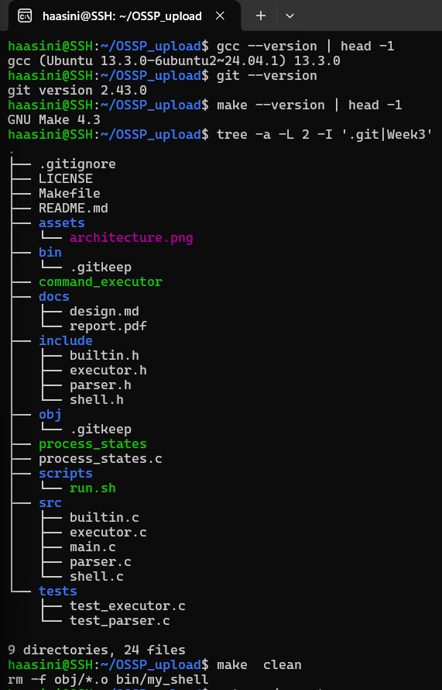

Build Configuration and Compilation
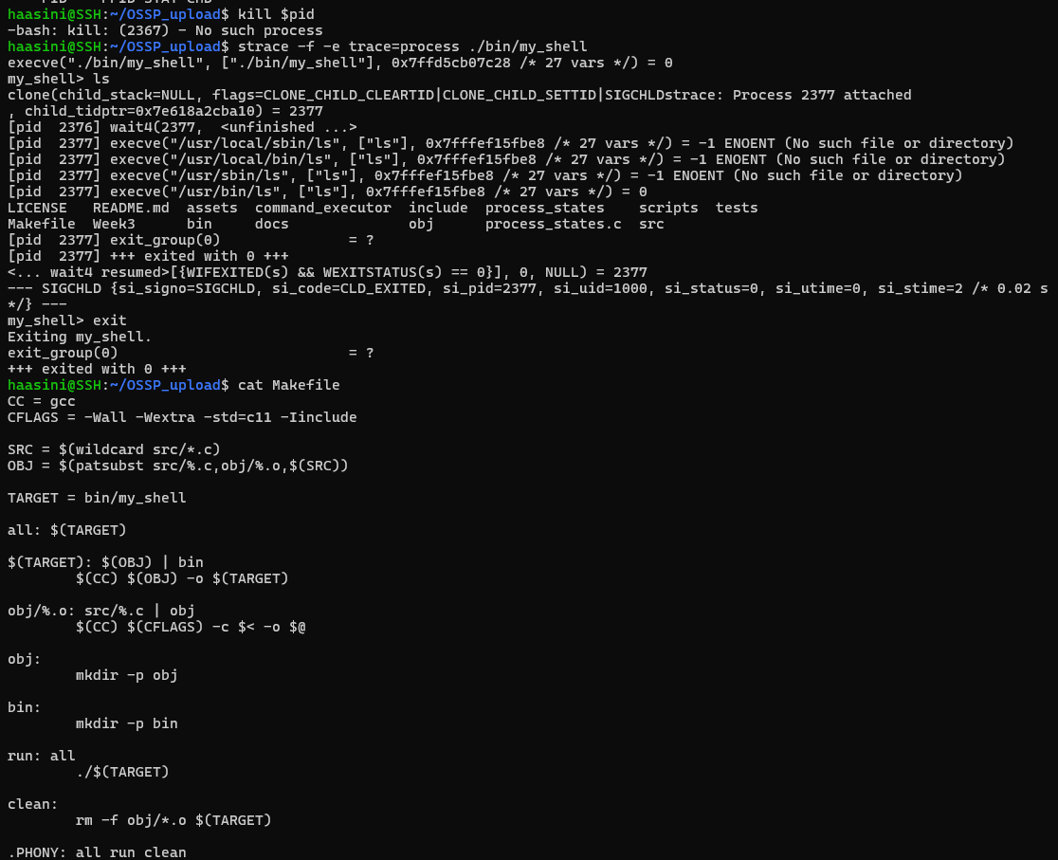

Task 2: fork(), exec() and Process Execution

Process Execution Implementation
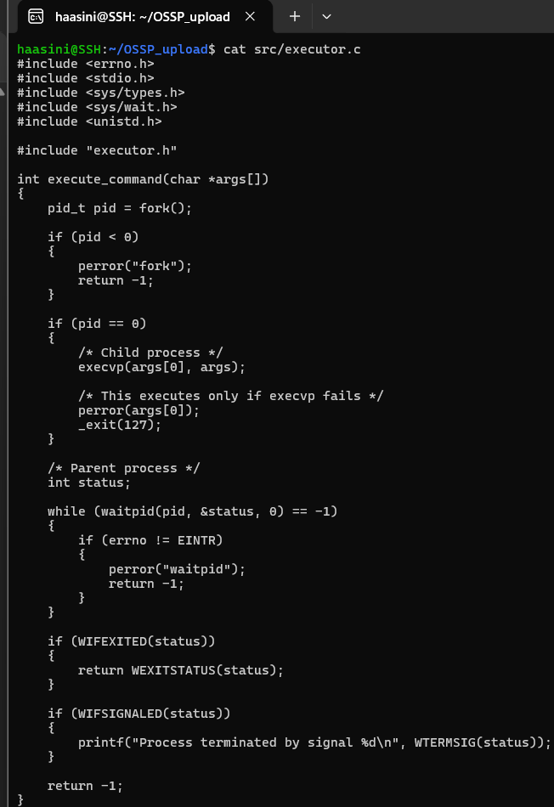

Execution and Process Monitoring
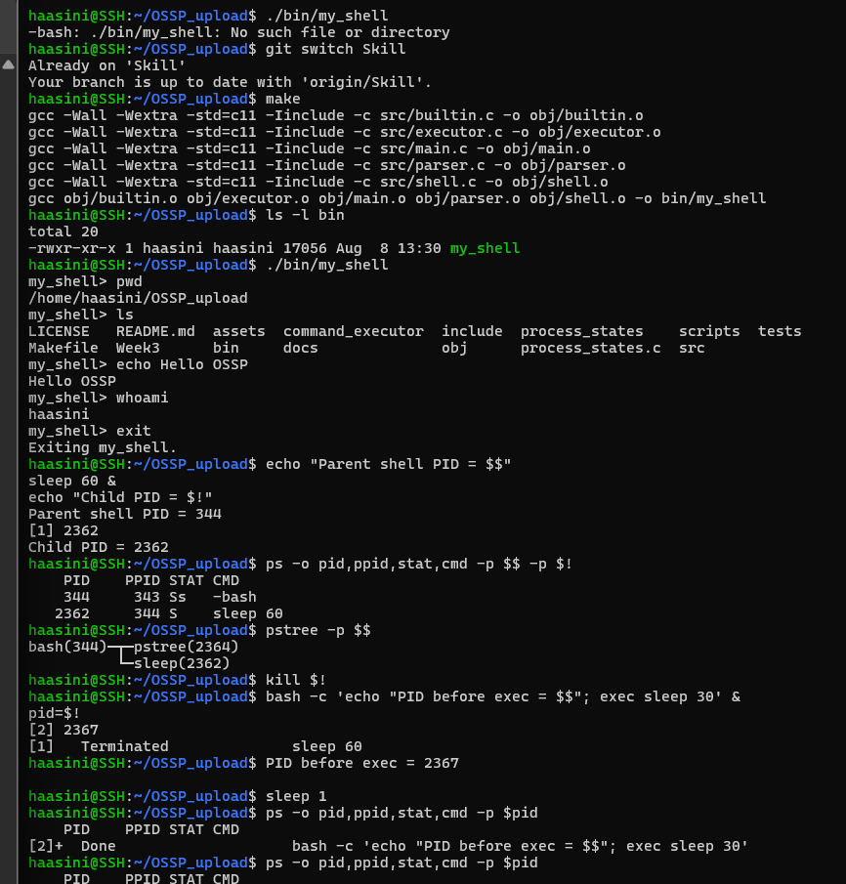
Result: Custom shell (my_shell) successfully created and compiled. fork() creates child processes, execvp() replaces child process with user commands. Parent process waits for child completion using waitpid(). Process states verified via ps, pstree, and system monitoring.

