OSSP Skill Week 3
Name: S Svara Haasini | Roll No: 2520090170

Task 1: Interactive Shell with Main Loop

Shell Main Loop Implementation
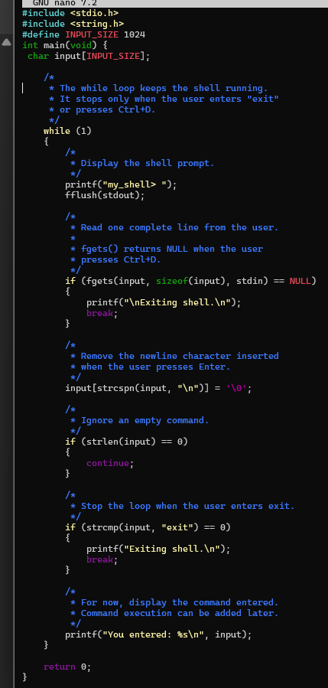

Control Flow Diagram
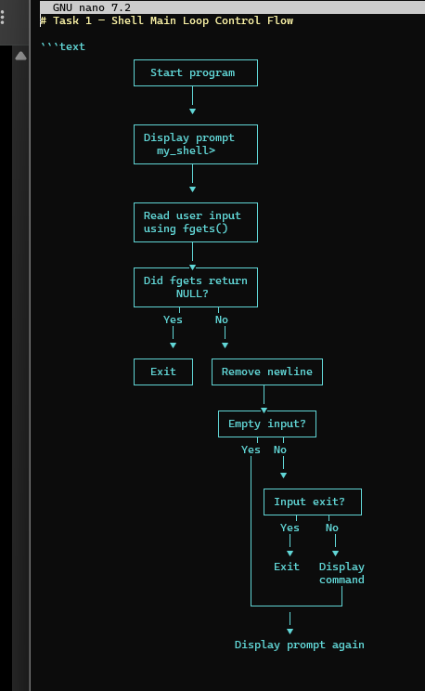
Result: Interactive shell implemented with while(1) loop. Shell displays prompt, reads user input via fgets(), checks for exit condition, and repeats. Empty input ignored, "exit" command terminates shell.

Task 2: File Copy using System Calls

Source Code - File Copy Program
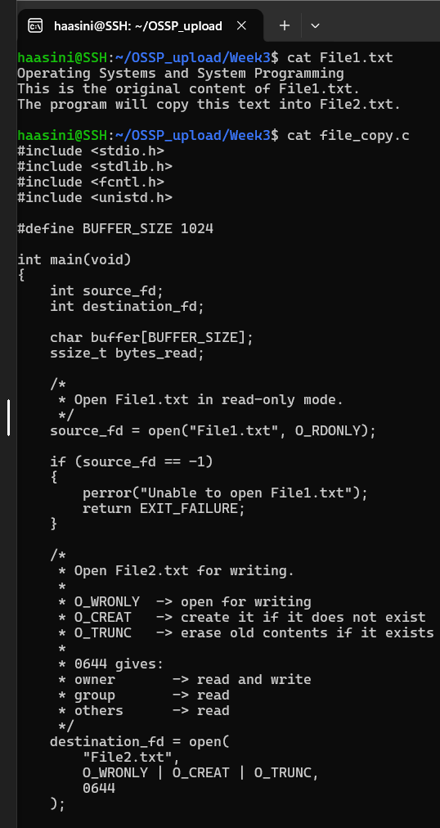

File Copy Implementation (Continued)
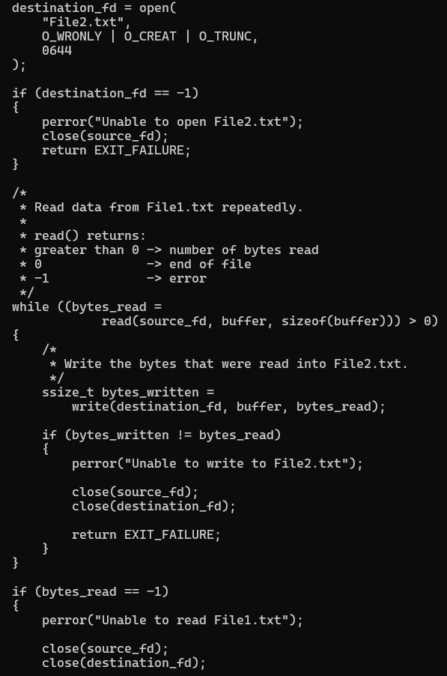

Compilation, Execution, and Verification
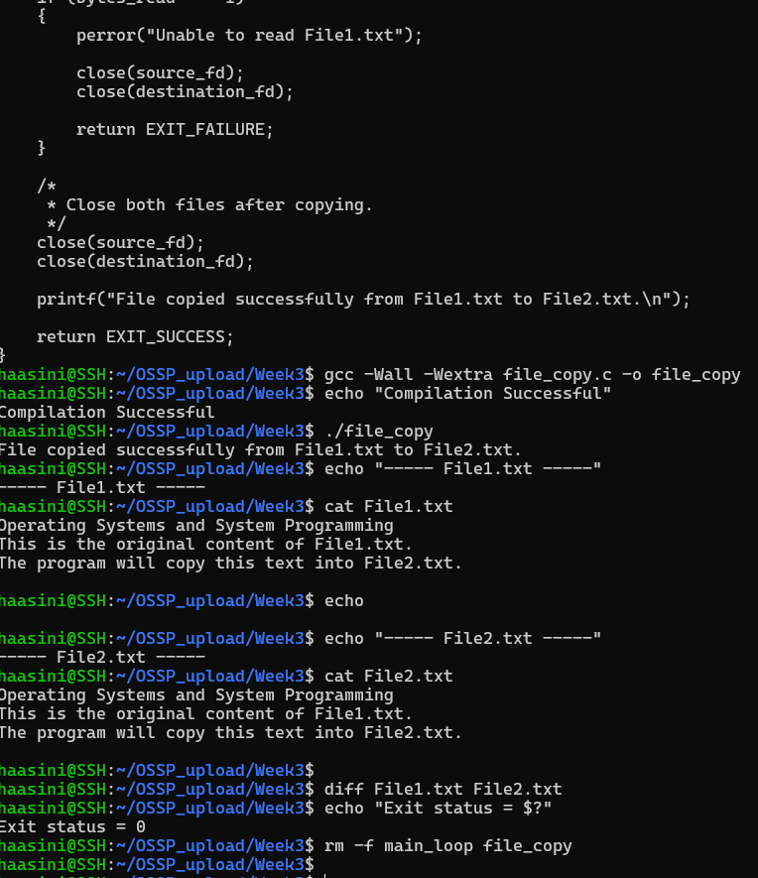
Result: File copy program successfully copies File1.txt to File2.txt using open() with flags O_RDONLY/O_WRONLY/O_CREAT/O_TRUNC, read() and write() in 1024-byte buffer chunks. Compilation successful. Execution successful with matching file contents verified by diff.

