Task 1: Develop a C program that demonstrates how a Linux operating system executes a command entered by a user that 1. Accept a Linux command as input. 2. Create a child process using fork(). 3. Execute the command in the child process using an appropriate exec() system call. 4. Allow the parent process to wait for the child using wait (). 5. Display the Process ID (PID) of both parent and child processes.
- Write a C code to create a process using fork() system call.
- Read the user input as shell command.
- Use a system call exec() to execute the shell command.
- Use a wait() system call for waiting a parent process.
- Display the PIDs of parent and child processes.

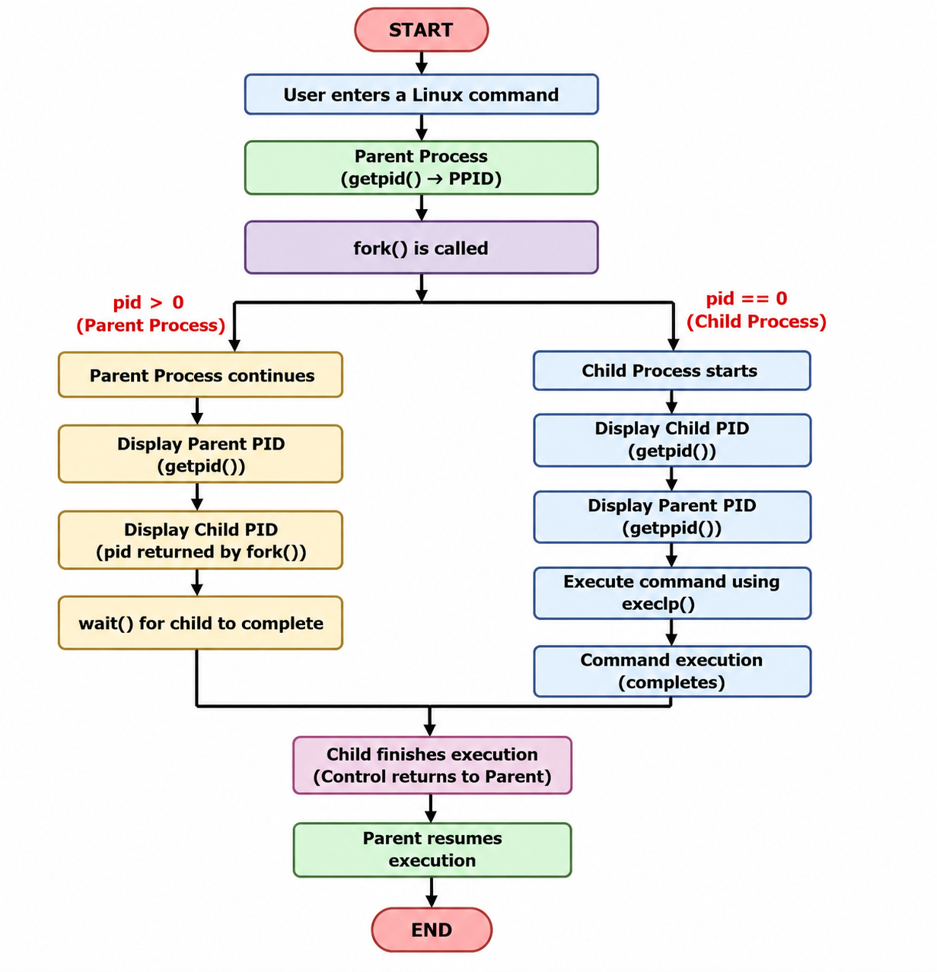

Example Output:
Enter a Linux command: ls
Parent Process
Child Process
Parent PID : 67
Child PID : 68
Child PID : 68
Parent PID : 67

Executing command: ls
CE1 FIRST.c File2.c Proces_States.c command_executor filecopy.c hello.c process_example session_4_a session_4_b.c
CE1.c File1.c First.c Process_States.c command_executor.c fork_example.c.save my_shell process_example.c session_4_a.c
FIRST File1.txt Proces_States R1 filecopy hello os-lab process_example.cyes session_4_b

Child process completed.

Task-2: Using Linux terminal commands (uname, lscpu, ps, top), investigate the relationship between hardware resources and operating system services. Prepare a report explaining how the OS abstracts CPU, memory, storage, and I/O devices.

Task 1: C Program using fork(), exec() and wait()

Source Code (Part 1):
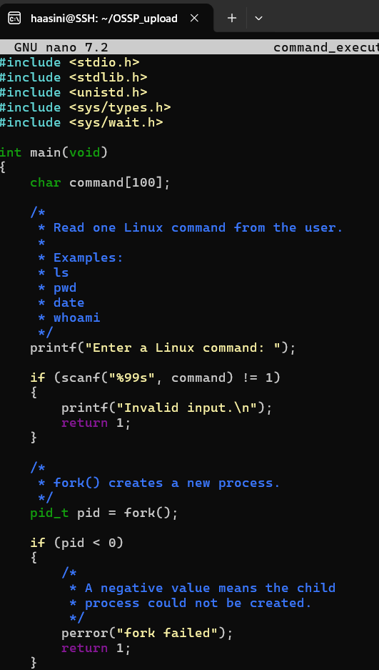

Source Code (Part 2):
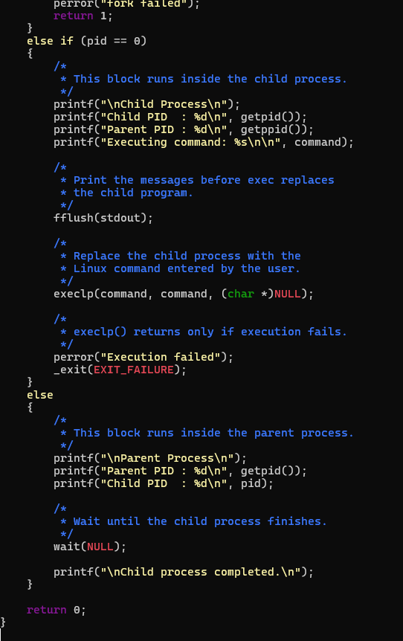

Compilation and Execution:
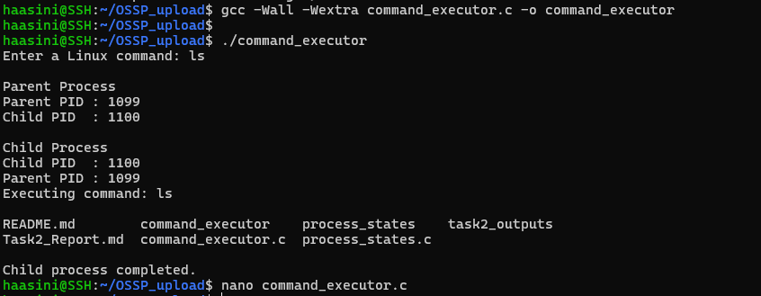

Task 2: Investigation of Hardware Resources and Operating System Services Using Linux Commands

Objective
The objective of this task is to use Linux commands such as uname, lscpu, ps, and top to examine the relationship between computer hardware resources and operating system services.

1. System and Kernel Information — uname
The following command was used: uname -a
The uname command displays information about the operating system kernel, hostname, kernel version, and system architecture. The Linux kernel acts as an intermediary between applications and hardware. Applications request services from the kernel rather than directly accessing the hardware.

2. CPU Information — lscpu
The following command was used: lscpu
The lscpu command displays information about the processor, including its architecture, number of logical CPUs, cores, threads, caches, and virtualization support.

How the OS abstracts the CPU
The physical CPU can execute only a limited number of instructions at one time. However, many programs appear to run simultaneously. The operating system provides a process and thread abstraction. The CPU scheduler gives each runnable process a small amount of CPU time. It rapidly switches between processes using context switching. Therefore, every process appears to have access to the CPU even though the processor is shared among many processes.

3. Process Information — ps
The following commands were used: ps, ps aux
The ps command displays information about currently running processes. Each process is given a unique Process ID called a PID. The operating system maintains information about every process, including its state, CPU usage, memory usage, owner, and parent process. This demonstrates that the OS converts a running program into a managed process abstraction.

4. Live Resource Monitoring — top
The following command was used: top
The top command displays continuously updated information about CPU usage, memory usage, system load, and currently running processes. top demonstrates that the operating system monitors resource usage and distributes CPU and memory among multiple processes.
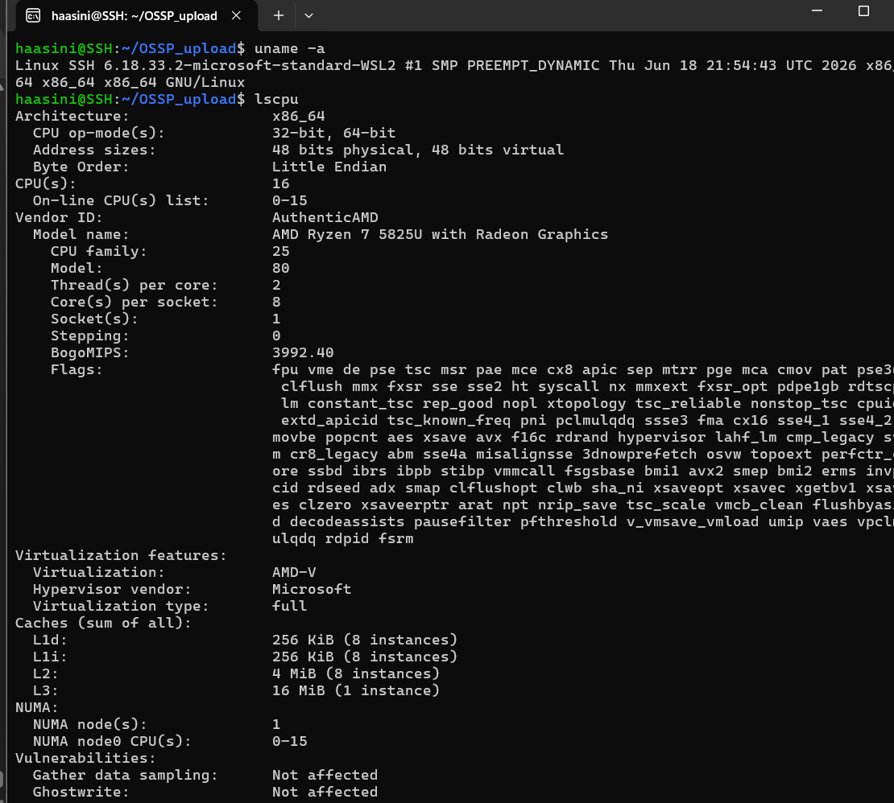
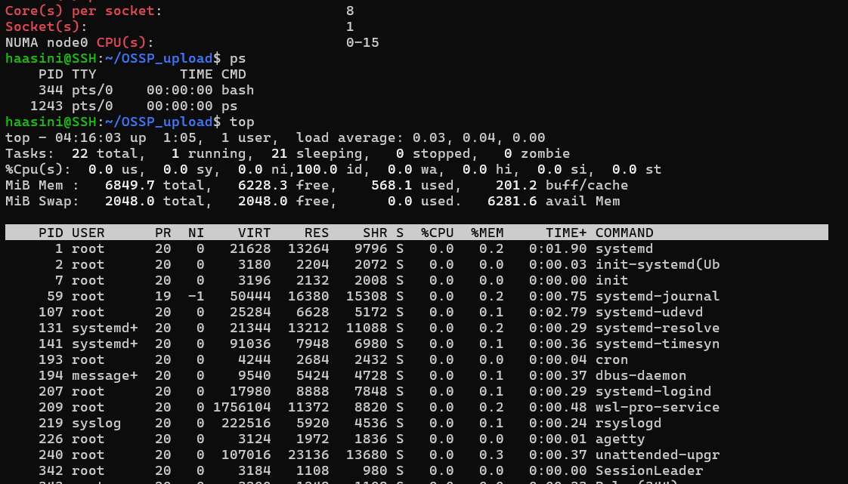

5. OS Abstractions
The operating system provides convenient abstractions such as processes (CPU abstraction with context switching and scheduling), virtual memory (preventing processes from accessing each other's memory), files and directories (storage abstraction), and device interfaces (I/O device abstraction through drivers and system calls). These abstractions allow applications to use hardware safely without needing to understand all of the hardware's internal details.

Conclusion
The commands uname, lscpu, ps, and top demonstrate how Linux manages hardware and running programs, providing convenient abstractions that allow safe hardware access without deep internal knowledge.

