**Virtual Key**

By Habtom Haile

Class: Full Stack Java Developer

Date: 04/09/2023

**Contents**

* **Application GitHub Link**
* **Application Objectives**
* **Core Concept of Application**
* **Sprint Planning of Application**
* **Flow Chart of Application**
* **Algorithm of Application**
* **Conclusion**

## Application GitHub Link

* <https://github.com/hab288/virtual-key>

# Application Objectives

When user run this application by going to VirtualKey folder and AppStart.java class, the application displays first menu which included bellow details.

########################### First Menu ############################

======> 1, To display all files, press 1

======> 2, To go to second menu, press 2

======> 3, To quite this application, press 3

If user press 1, the application will display all files if there are any files in MainFolder directory.

If user press 2, the application will take the user to the second menu.

If user press 3, the application will stop and exit user from using this application.

#### Core Concept of Application

The core concept of this application is to learn bellow concepts.

* How to create java application using IDE.
* How to use java Scanner library and System.in
* How to use java loops, if statements, switch statements, try catch exception handler, functions, searching algorithms, file handler, and GitHub.

### Sprint Planning of Application

Virtual Key application will be completed in two sprints.

**Sprint 1**

* Create GitHub account.
* Create Virtual Key project in Intellij.
* Create Flow Chart
* Create Java AppStarter class.
* Create Java MenuController class.

**Sprint 2**

* Create Specification document.
* Create Java FileController class.
* Test the functional of the application with different inputs.
* Test the application and fix any bugs if exists before delivery.
* Create Specification document.
* Add the Virtual Key project into GitHub repository.
* Add GitHub link into Specification document.

##### Algorithm of Application

In this application I used Merge sort algorithm to sort files alphabetically and to search the files I used linear search algorithm.

###### Flow Chart of Application

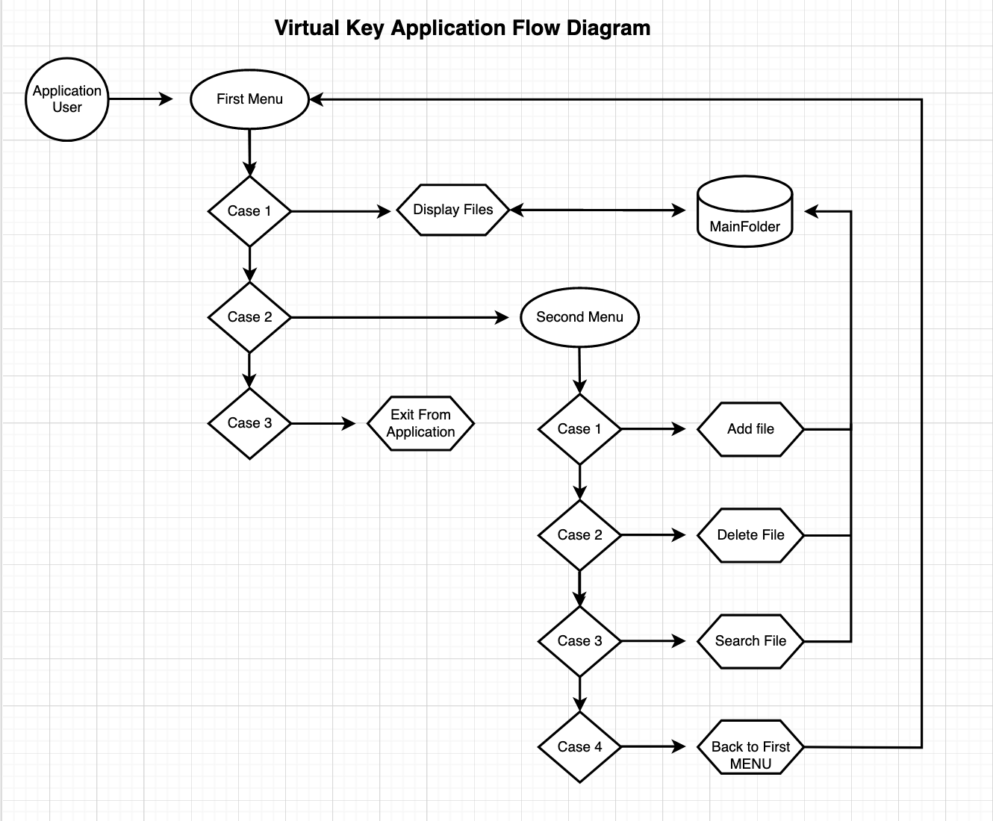

Conclusion

**Enhancing application**

* Application can be improved if we create GUI.
* Application can be improved if we limit user input 3 times only for security.