**Ghada Faisal - CV**

|  |  |
| --- | --- |
| Name | Ghada Faisal Mohammad Abu Ghalieh |
| ID Number | 9872032674 |
| Nationality | Jordanian |
| Religion | Islam |
| Data of Birth | 18/9/1987 |
| Address | Amman-Jordan- Alwahadat |
| Gender | Female |
| Phone Number | 0797987784 |
| E-Mail | content@habaybna.net |

**Personal Information**

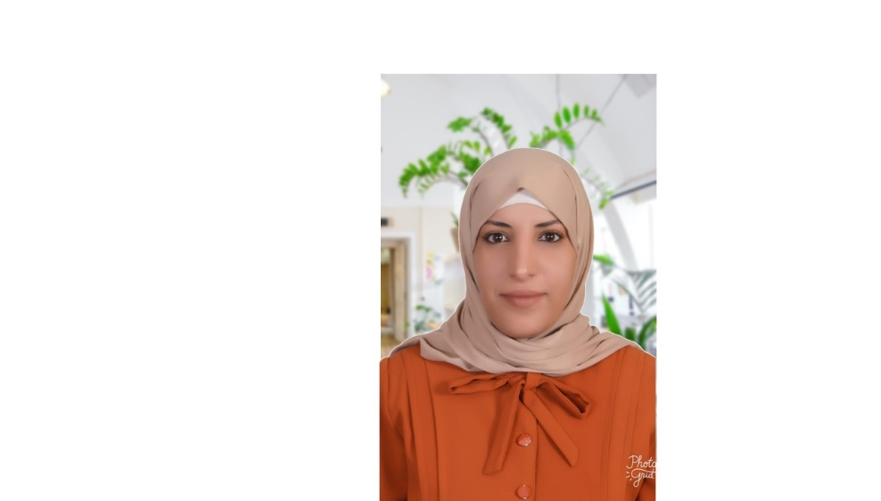

**Education:**

**Bachelor Degree in Special Education**

AlBalqa Applied University – 2005

Amman – Jordan

**Diploma in Autism Training**

Appliced Science University - 2018

**Diploma in the Montessori Methodology**

British Board and the Ministry Of Higher Education And Scientific Research – 2020 till now

**Work Experience:**

|  |  |
| --- | --- |
| Work | Time |
| Content Manager @habaybna.net | March 2020 till now |
| Volunteer Trainer @The world readers of kids application | 2019 |
| Content Editor @habaybna.net | January – October 2019 |
| Volunteer @ Sport Association of The Disabled | 2017 |
| Volunteer @Clothing Bank - Hashemite Charitable Organization | 2017 |
| Volunteer @I-Learn | 2017 |
| Member of The Khirbet souk Women Association | 2017 |
| Shadow Teacher @Montessori Gardens | 2018 |
| Teacher for Austism and Slow learner students @ Lila and Dalal Consulting and Training | 2013 - 2017 |
| Teacher for students with learning difficulties @ Petra Wonder Center | 2012 |
| 1st grade teacher @ Al-Bayt AL-Ateeq Islamic School | 2010 |

**Training Courses**

|  |  |  |  |
| --- | --- | --- | --- |
| Skill | Time | Place | Authority |
| Braille | 2007 | Al-Balqa Applied University | Center for Consultation Studies and Training University. |
| Establishment of Resources Room | 2007 | Al-Balqa Applied University | Center for Consultation Studies and Training University. |
| Beginner Sign Language | 2009 | Deaf Charity Association in Amman | Social Development |
| ICDL | 2012 | Princess Center Eman Technologies | Creator Amman Municipality |
| Pronunciation and Language | 2013 | Sanad center | Sanad center |
| English Conversation | 2013 | Petra Wonder Center | Petra Wonder Center |
| Portig | 2017 | Sanad center | Sanad center |
| TOT for Kids | 2017 | Khirbet Souk Women Association | Initiative I-Learn |
| Autism Children Autism  Workshop | 2017 | Solaf Training and Consulting | Solaf Training and Consulting |
| RBT Course | 2018 | Online | Florida Institute of Technology |
| TOT | 2018 | Clan Technology Education | Clan Technology Education |
| Advance Signal Language | 2019 | Kindom Creators | Kingdom Creators |
| RBT 40 hour training | 2020 | online | Autism partnership foundation |
| Training | 2019-2020 | Autism Mena | Autistic behavior technician |
| Training | 2020 | EDRAK | The entry of autism world |
| Soft skills training | 2020 | online | NRC |
| Employment skills training | 2020 | online | NRC |

**Languages**

|  |  |
| --- | --- |
| Arabic | Excellent Read and Write |
| English | Very Good Reading and Writing |

**Personal Skills**

|  |
| --- |
| Team player and good communicator |
| Ability To Work Under Pressure |
| Quick Learner and always seeking new learning opportunities |
| Multitasking and organized |

**Interests**

|  |
| --- |
| Reading |
| Writing |
| Storytelling |