Lamis Ehsan Al-Shaheen

**Personal Information**

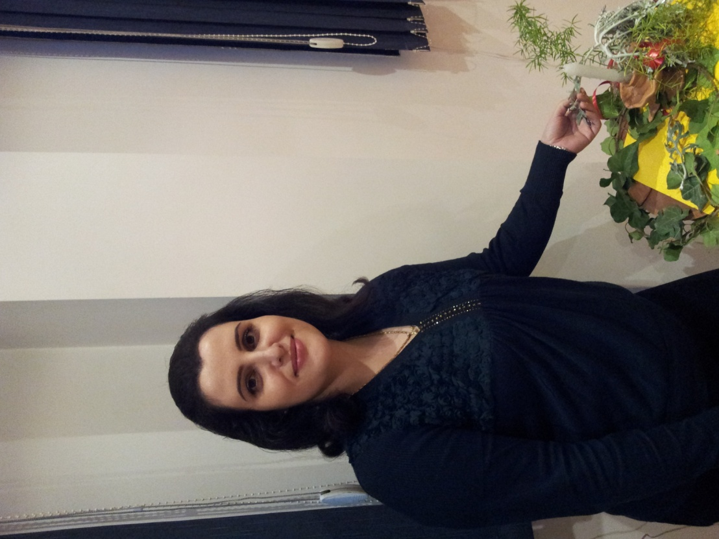

* **Year of Birth:** 1981.
* **Place of Birth:** Al- Swaida’a.
* **Marital Status:** Married.
* **Nationality:** Syrian.
* **Address:** Jaramanah.
* **E-mail:** [lamis981@hotmail.com](mailto:lamis981@hotmail.com)
* **Facebook:** <https://www.facebook.com/lamisalshaheen.lamis>
* **Mobile:** 00963932807347

**Educational Qualifications:**

* **2019:** PHD student – Special Education – Damascus University.
* **2007:** Master’s Degree in Special Education – Damascus University & The University of Jordan.
* **2004:** Bachelor in Psychology – Faculty of Education – Damascus University.

**Practical Experience:**

* Manager of the Educational Center for Hearing Impairment at the Syrian Organization for Persons with Disabilities (Aamal).
* Senior Specialist in Special Education at the Syrian Organization for Persons with Disabilities (Aamal).
* Certified Trainer of Portage Program for Early Education from Debono Center in Jordan.
* Working with Autistic andMentally Retarded Children, as well as Children with Hearing Impairment.
* Member of Preliminary Evaluation Committee at the Syrian Organization for Persons with Disabilities (Aamal).
* Providing Scientific Lectures on Disability, Carrying Out Workshops and Training Courses for University Students, the Institute of Social Service Students, Families of Children with Disabilities, Disability Associations and UNHCR Community Development Centers.
* Participating in Awareness Activities by Providing Awareness Bulletins, and Planning and Implementation of Several Events.
* Preparation of Aamal Curriculum for Children with Hearing Impairment.

**Participations:**

* **2020:** Participating in the Technology Conference for Persons with Disabilities (Ministry of Affairs and ESCWA).
* **2018 - 2021:** Training of UNHCR Community Service Centres (Portage Program, Behavioral Modification, Initial Disability Interventions).
* **2017:** Participating in the Conference of Ear, Nose and Throat Doctors with a Lecture Entitled Autism and Hearing Loss..
* **2017:** Training Regional Early Childhood Center Staff on the Portage Home Rehabilitation Program for 40 Hours.
* **2016:** Training UNHCR Community Service Centers in Damascus, Homs and Latakia (18 Hours for Pics Program + 40 Hours for Portage Program).
* **2015:** Training Autism Teachers in Aamal on Pep-3 Evaluation Program – the Pedagogical Psychological File for 20 Hours.
* **2014:** 10-Hours Training in Hand-To-Hand Association.
* **2014 – 2021:** Participating in TV and Radio Interviews.
* **2012:** TV Seminar on Dealing with Children with Hearing Impairment.
* **2011:** Participation in a Seminar within the Deaf Week, Aamal.

**Courses and Trainig:**

* A course for Accreditation in the 2020 Portage Training Program.
* Sexual Education Course 2020.
* Family Counselling Course 2019.
* TED 2019 Nonverbal Communication Course.
* Several Courses in Psychomotor therapy at the Jesuit University 2015-2020.
* Several Training Courses on Psychomotor Tests at the Jesuit University 2015-2020.
* The use of Drama in the Rehabilitation of Autistic Children- Adnan Azroni - Aamal - August 2014 - 15 Training Hours.
* ToT - Levant Institute - Mustafa Abbasi - Aamal - June 2014 - 100 Training Hours of Training.
* Workshop in Evidenced Based Practice in Communication Disorders - David McPherson - Aamal - June 2012 - 14 Training Hours.
* First aid – Mu’ayad Qusaybati - Aamal - December 2012 - 16 Training Hours.
* Early Intervention, Portage - Dr. Suha Tabal - Aamal - November 2011 - 55 Training Hours.
* Arabic Advisory Dictionary for the Deaf - Haitham Dado - Aamal - July 2011 - 30 Training Hours.
* Learning Difficulties: Theory and Application (Level 2) - Child Education and Evaluation Center - Kuwait - December 2010 – 30 Training Hours.
* Interactive Workshop on Lego and learning in Interactive Ways - Massar in Cooperation with Syria Trust for Development - Aamal - June 2010 - 1 day.
* Visual Strategies - Dr. David McPherson - Aamal - May 2010 - 9 Training Hours.
* Workshop Entitled “Education Children Who are or Hearing” - Dr. Patricia Spencer - Aamal - May 2010 - 8 Training Hours.
* Workshop Entitled “Methods for Teaching Children With Hearing Loss & Identification and Program Modification for individual Children with Special Needs” - Dr. Patricia Spencer - Aamal - May 2010 – 16 Training Hours.
* Training and Education for Children with Hearing Impairment - Dr. Yasser Al-Fares - Aamal - January 2009 - 18 Training Hours.
* International Computer Driving License - ICDL SBS - February 2009.
* British Council Pre-Intermediate Level at General English - January 2008 - 24 Training Hours.
* How Teachers and Families Deal with Issues of Sexual Development in Persons with Disabilities - Dr. Ma'ad Barakat - Aamal - August - 2008 – 12 Training Hours.
* The Concept of Learning Difficulties, Characteristics and Appropriate Educational - Children's Assessment and Education Center in Kuwait - Aamal - April - 2008 - 3 days.
* Specialist Training Course to Learn the Concept and Characteristics of Learning Difficulties, and Methods of Psychological and Educational Diagnosis - Children's Assessment and Education Center in Kuwait - Aamal - April - 2008 - 3 days.
* Language and Communication - Caritas Egypt City Center in Corporation with the Association of Fathers and Sons - Damascus University / Faculty of Education - August 2007 - 55 Training Hours.
* Behavior Modification - Dr. Jamal Al-Khateeb - Aamal - June 2007 - 30 Training Hours.
* Team Building Skills - Coach Rami Saba - Aamal - May 2007 - 2 days.
* Verbal and Nonverbal Communication Skills - Caritas Egypt City Center in Corporation with Al-Hayat Organization - Aamal - May 2007 - 30 Training Hours.

**Researches:**

* **2022:** The Level of Awareness of Kindergarten Teachers About the Primary Indicators of Autism Spectrum Disorder.
* **2021:** The Knowledge Level of Teachers of Children with Autism Spectrum Disorder with the Social Skills Needed to Integrate them into Schools, Damascus University Journal of Educational and Psychological Sciences.
* **2020:** The level of Behavior Modification Strategies Use by Mothers of Children with Autism Spectrum Disorder, Al-Baath University Journal.
* **2020:** The Level of Knowledge of Specialists Working with Autism Spectrum Disorder Children with the Applied Behavior Analysis Strategies, Journal of the Arab Universities Union for Education and Psychology.
* **2016:** The Availability of Professional Standards among Teachers of children with Autism Spectrum Disorder, Field Study in Damascus City and its Countryside, Damascus University Journal of Educational and Psychological Sciences.
* **2007:** The Impact of a Training Program on Improving Reading Skills in Children with Hearing Impairment, Master’s Degree Research, University of Jordan - Damascus University.

**Language and Computer Skills:**

* **Arabic:** Native Speaker.
* **English:** Very Good.
* **Computer Skills:** Very Good.

**References Available Upon Request**