**Step 1: Prepare Webserver**

Launch an EC2 instance that will serve as “Web Server”. Create 3 volumes in the same AZ as your Web Server EC2, each of 10 GiB.

Webserver:

Volumes created and attached to Webserver

Check whether volumes are properly attached, create partition, Create File System and Make it all changes to be persistent.

Content of /etc/fstab

Total Configuration Set for WebServer:

**Step 2: Prepare DbServer**

DbServer

Check whether volumes are properly attached, create partition, Create File System and Make it all changes to be persistent.

Total Configuration Set for DbServer

**Step 3: Creating necessary folders in Webserver to store the web and back up**

**Step 4: Install Php and MySQL on Webserver:**

**Step 5: Install WordPress on Webserver and configure SELinux policies**

**SELinux policies**

**Step 6: Install MySQL on DbServer and make it secure**

**Step 7: Configure MySQL on DbServer**

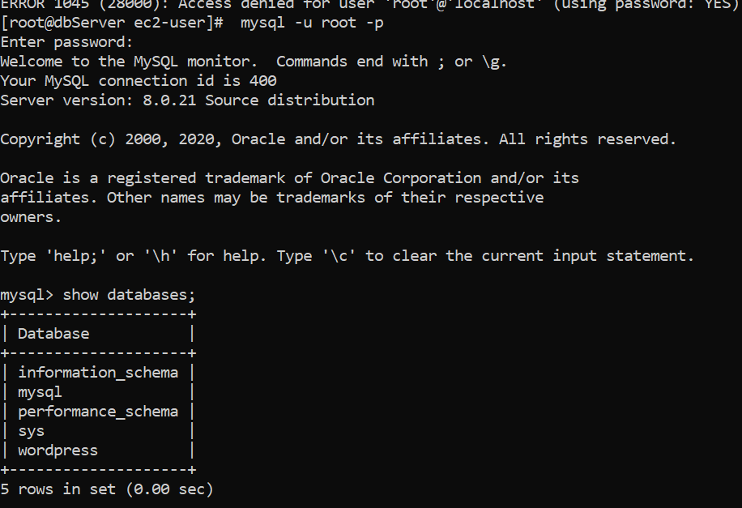

**Step 8: Set bind address and restart MySQL:**

**Step 9: Configure wp-config.php directory**

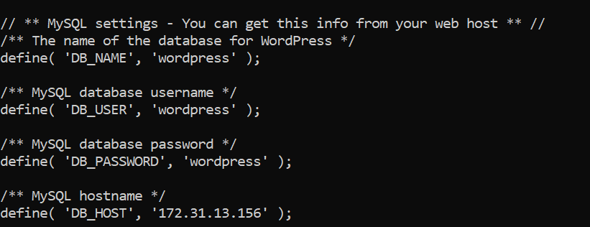

**Step 10: Ensure that Dbserver can talk to Webserver by open appropriate port and test**

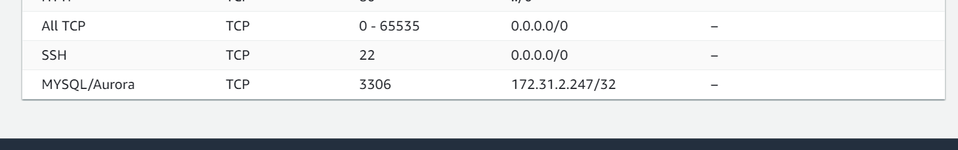

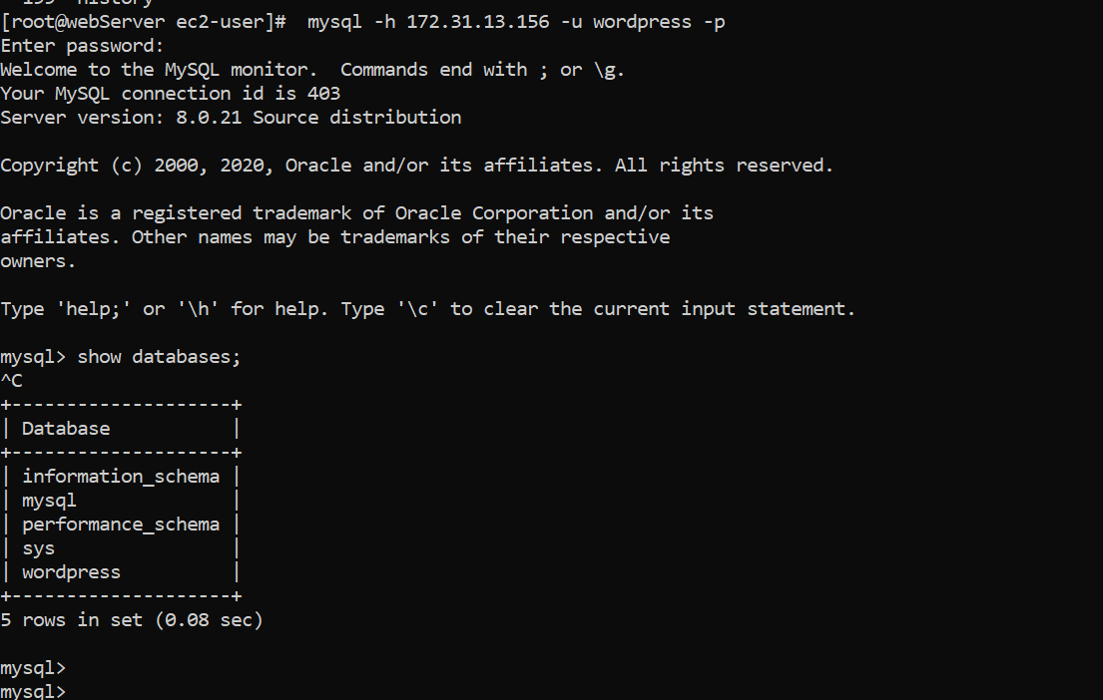

**Step 10: Grab the public ip address of Webserver to install WordPress**

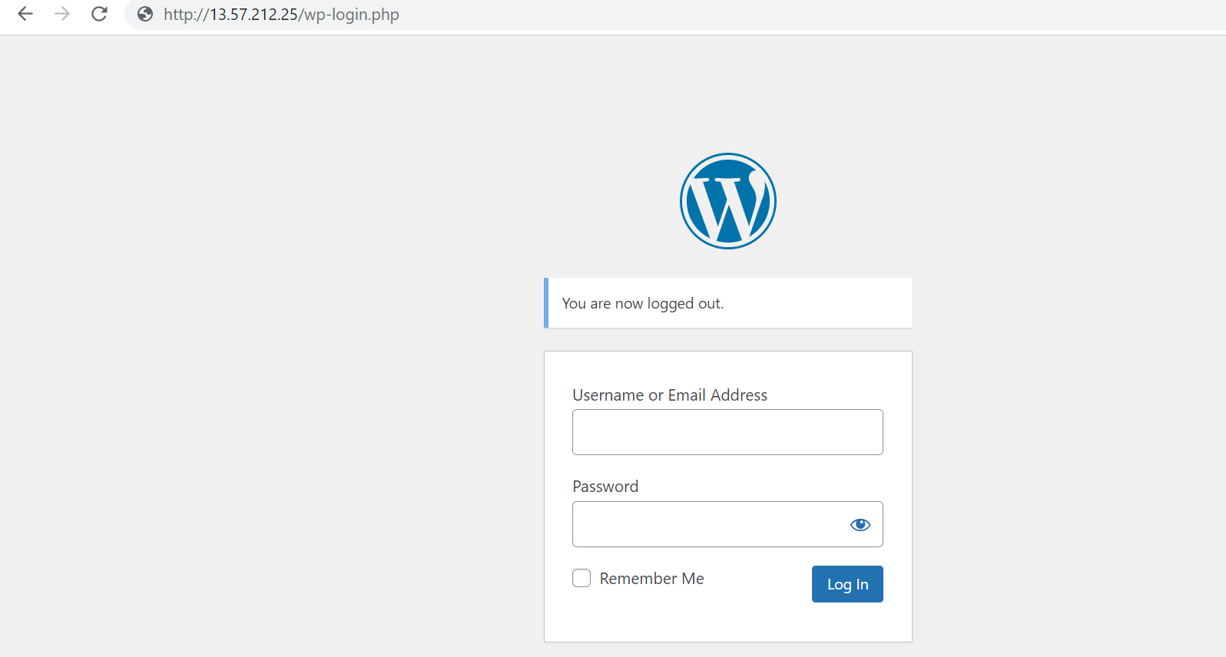

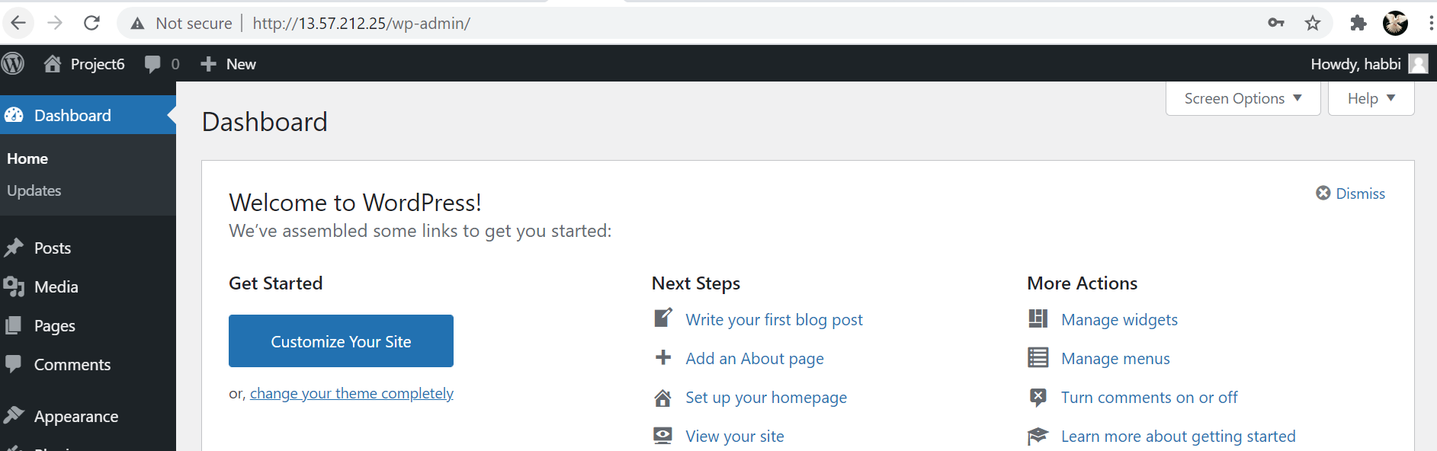

**The End!**