1. Store articles into database.

<http://localhost:8080/wiki/searcharticle?title=jordan>

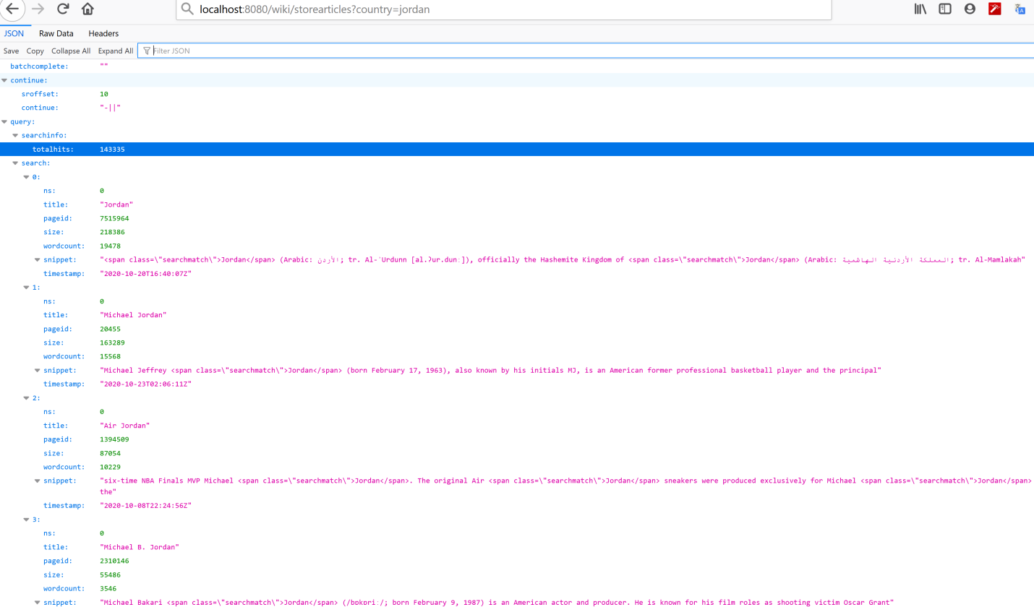

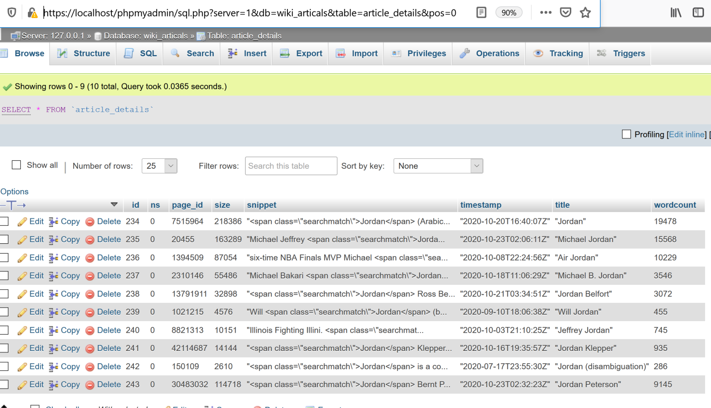

1. Display stored records as per title or snippet

<http://localhost:8080/wiki/searcharticle?title=jordan>

<http://localhost:8080/wiki/searcharticle?snippet=officially%20the%20Hashemite%20Kingdom%20of>

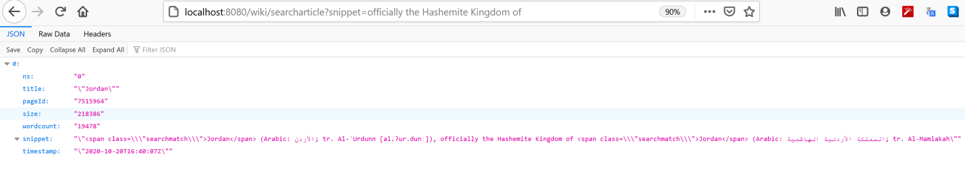

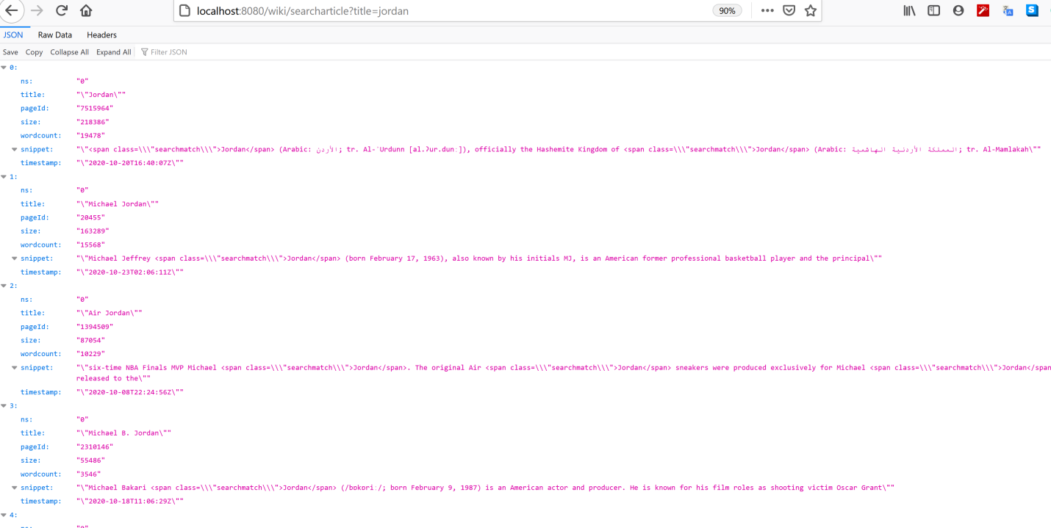

1. Search largest article.

<http://localhost:8080/wiki/largestarticle?country=Jordan>

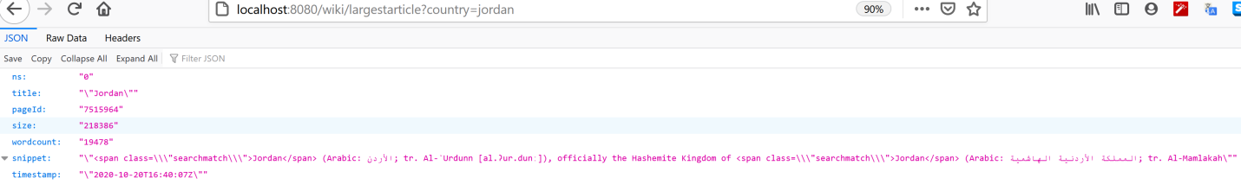

1. Search smallest article

<http://localhost:8080/wiki/smallestarticle?country=jordan>

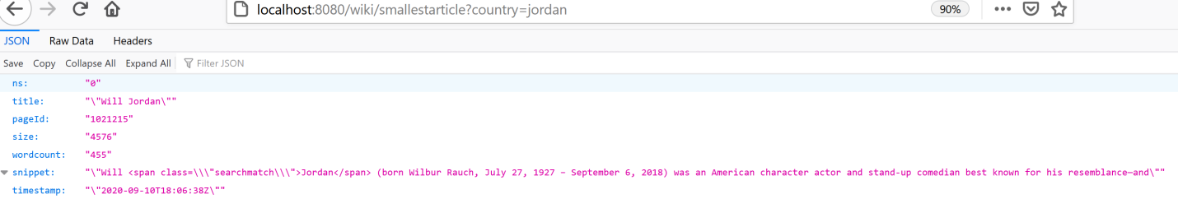

1. Statics of articles on the basis of size and wordcount.

<http://localhost:8080/wiki/articlestatics?country=jordan>

