./



Version Number:

Team Members :

Team No:

Module: Model Based System Engineering

|  |  |  |  |  |  |
| --- | --- | --- | --- | --- | --- |
| **Ver.Rel. No.** | **Release Date** | **Prepared. By** | **Reviewed By** | **Approved By** | **Remarks/Revision Details** |
|  |  |  |  |  |  |
|  |  |  |  |  |  |
|  |  |  |  |  |  |
|  |  |  |  |  |  |
|  |  |  |  |  |  |

**Document History**

# 

Case Study – Washing Machine

Introduction: -

A washing machine is a machine that washes dirty clothes, the fallowing case study is used to analyze the working of washing machine, its architecture and which are the different units, which work together to perform all the operations stated by the user.

Block Diagram: -

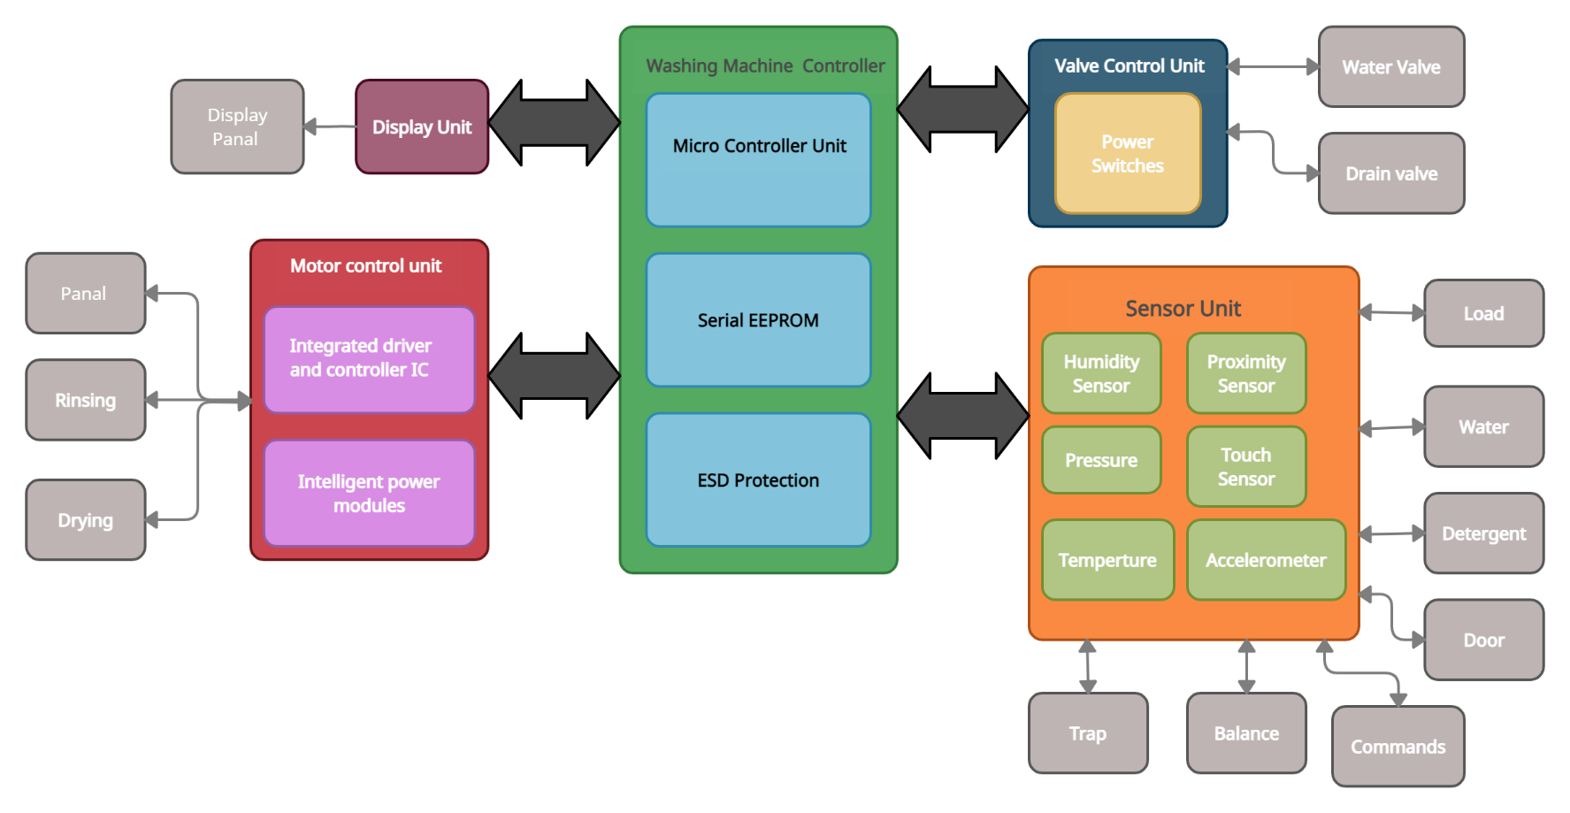

Figure 1 Block diagram of washing machine

**Design of Washing machine: -**

1. **Washing machine Controller:**

It is the main controller which controllers all the units and according the various inputs given by the user it gives the command to all section in order to complete the washing cycle.

1. **Valve Control Unit:**

This unit control the water inlet valve and drain valve. It contains all the information about the water valve, such as when it open and close. Similarly, it contains all the information about the opening and closing of drain valve. All the operations are done by the power switches like Triac’s, Logic-Level gate etc.

1. **Sensor unit:**

Sensor unit contains all the information of the sensors which are used in washing machine, such as, sensor for load check (clothes weight) gives the information that how much load is present inside the tub accordingly water fills into the tub. Similarly, it contains information for all other sensors required in washing machine, such as, water availability check, detergent availability, door open/close, balance check and trap check.

1. **Motor control unit:**

This unit controls the functioning of motor. It contains all the information about the rotation of motor, such as when motor rotates in clockwise direction and when in counter clockwise. It also contains the information when motor will on and off in all three cases i.e., washing, rinsing and drying.

1. **Display unit:**

The display unit consist of LEDs to indicate the completion of process, occurrence of some problem while washing, set or reset of buttons, etc. Seven segment display for the numeric value display and also for the message display of errors.

Requirements:

**High level: -**

1. The user can be able to wash his/her cloth in washing machine based on cloth material.
2. The washing machine automatically dry’s the cloth.
3. The machine has different user-friendly options.
4. The machine displays the time require to wash.
5. It has multi-functional buttons for user.
6. It has Built in surge protector.
7. It has child protection.
8. It has door sensor for the protection.
9. The machine comes with different range of price according to the user demand.
10. The user can also add conditioners for pleasant smell.

**Low Level: -**

1. It has a different options like Delicate, Sports, Wool, Cotton Synthetic etc.
2. It has option like mixed cloth, Quick 15 mins wash.
3. User can also increase the temperature of water to 20 °C, 40 °C, 60 °C.
4. It has built-in display to show different option like motor speed, temperature and different mode.
5. The different buttons are on/Off, Speed, Temperature, Start/Pause.
6. It has ESD (Electrostatic Discharge) protection to protect machine from surge.
7. Child protection can be activated by long press of Speed button.
8. Magnet sensor or Reed sensors are used for door protection.
9. The different range of machine is based on drum capacity i.e., 6kg to 18kg.
10. It has a special cabinet for the detergent and conditioners.