* **STM32 Naming Convention:**

**STM32F446RET6**

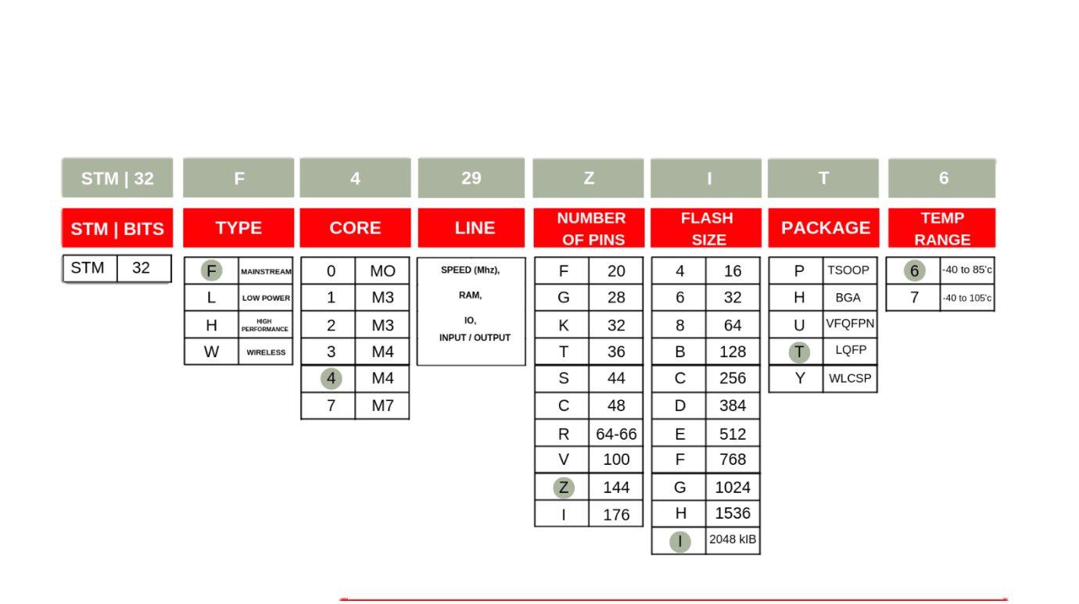

* **STM32 ECO System:**

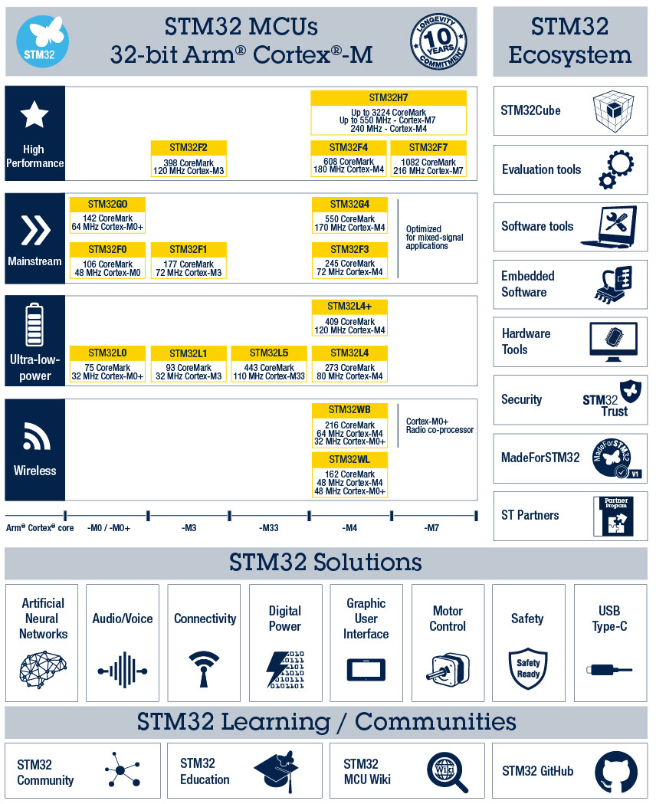

* **STM32 ECO System Development Boards:**

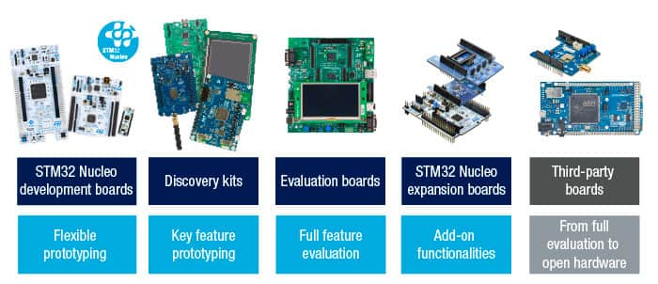

* **STM32 For Signal Processing:**

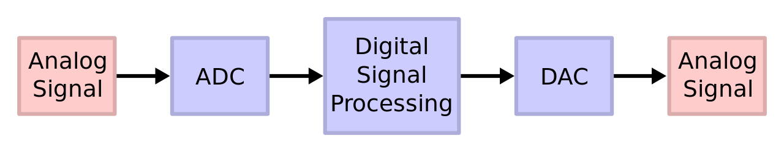

* **STM32 For Signal Processing:**

STM32F446RE is a High-performance foundation line, Arm Cortex-M4 **core with DSP and FPU**, 512 Kbytes of Flash memory, 180 MHz CPU, ART Accelerator, Dual QSPI

