**Clock Configurations:**

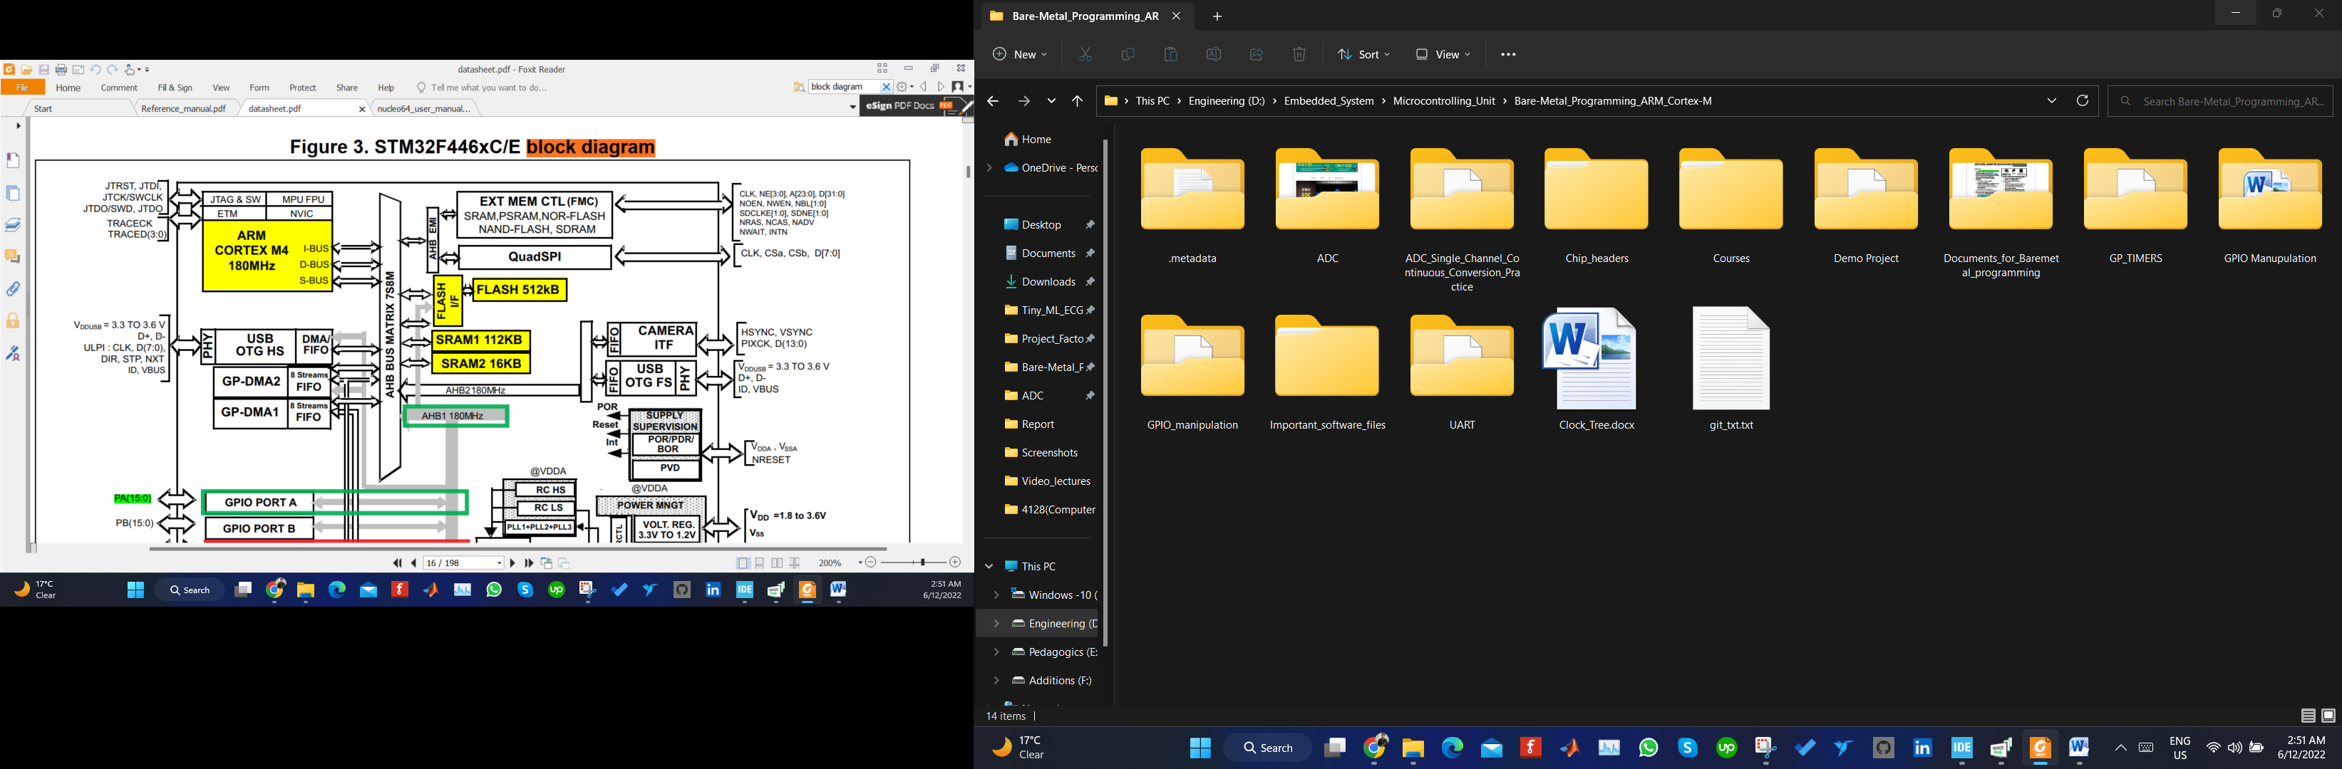

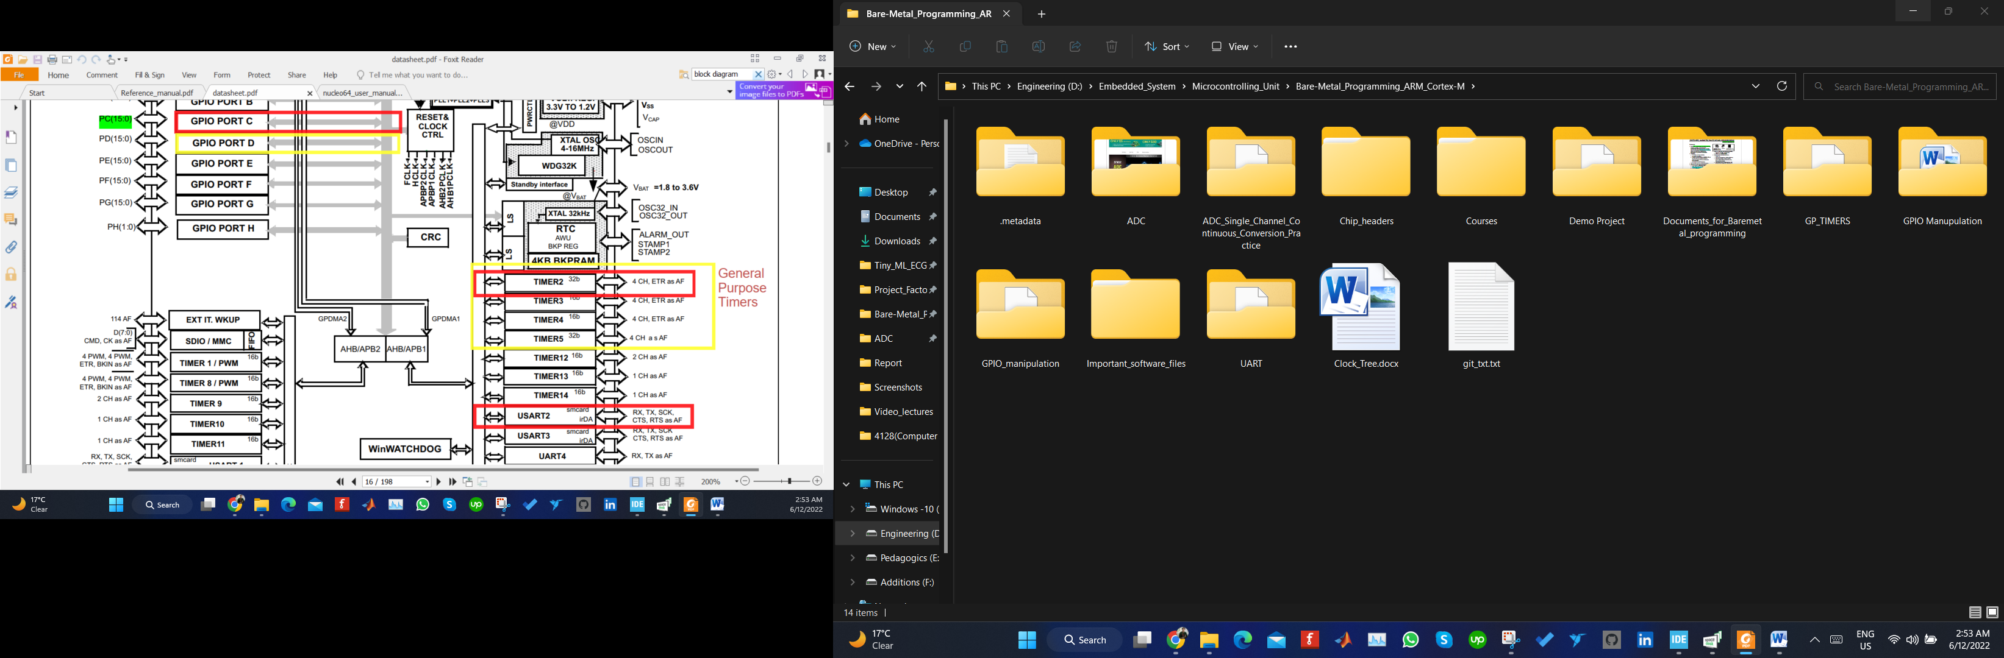

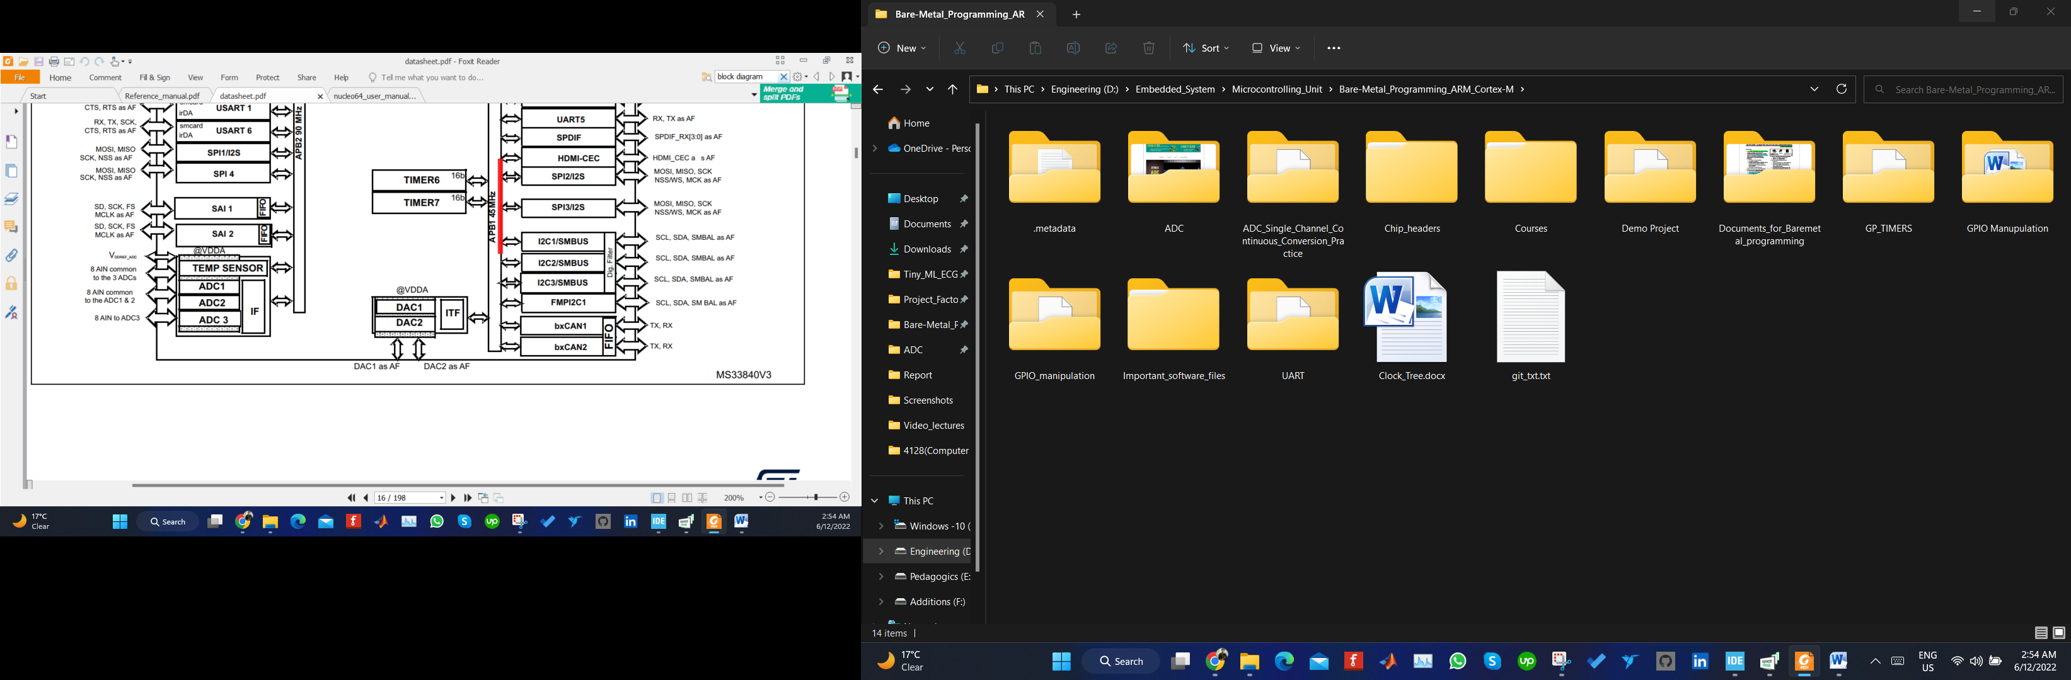

**Cube Mx Clock Tree:**

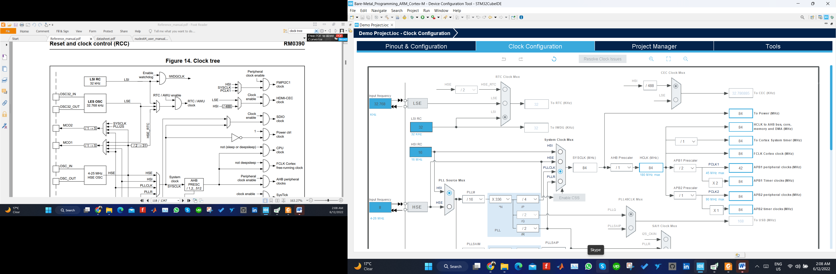

**Simplified Clock Tree:**

