**QA Automation**

**Prerequisite for Test Engineer**

1. Scripting Language (Like C#, Python, JavaScript).
2. Selenium (for web).
3. Appium (for mobile app).
4. Postman (API).
5. JMeter (Performance).

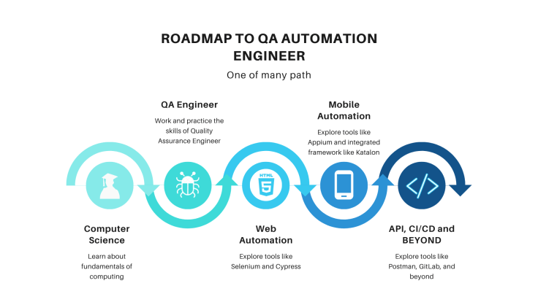

**Type of Testing**

* Acceptance testing
* Unit testing
* Software performance testing
* Function Testing
* Regression testing
* Stress testing
* Security testing
* Smoke testing
* Accessibility testing
* API testing
* Compatibility testing
* Usability testing
* Black box testing
* End-to-end testing
* Alpha testing
* Beta testing
* Component testing
* Exploratory testing
* Volume testing
* Globalization testing
* Recovery testing
* Assertion testing
* Equivalence tests
* Basis path testing,
* Branch testing