**Course: COMP1645**

**Information Requirements Analysis**

**=========================================================================**

**Submitted By**

**User name : hb9565m**

**ID : 001073871**

**Submission Date 24-04-2019**

Table of Contents

Introduction 3

Part A- Requirements Analysis Using Rich Pictures 4

A1. Rich picture of the New Skill Set Gateway (NSSG) Head Office 4

A2. Rich picture of the Easy Learning Organisation (ELO) 5

A3. Understanding of the New Skill Set Gateway (NSSG) environment 7

Identifying the key actors in the environment 7

Key issues and areas of conflict affecting the environment 8

Identifying cultures and subcultures within the environment 10

Discussing about the main focus of the system that the organisation requires 11

Part B- Requirements Analysis using Use Case Modelling 12

B1. Use Case Diagram for the Current ELO Course Management System 12

B2. Documentation of Use Case 13

B2.1 Primary Use Case (or Normal Use Case) Scenario 13

B2.2. Identifying secondary scenario 18

B3. Understanding of Use Case Modelling 21

B3.1 Identify the actors and processes in the current system of ELO 21

B3.2 Clarify understanding of the current system 21

B3.3 Further investigation 22

B3.4 Identify whether use cases where sensible and workable 22

B3.5 Clarifying step by step action of use cases 23

B3.6 Questionnaires 23

Part C- Critique of Use Cases and Rich Pictures 24

The way of those techniques that I get helped for requirements analysis 24

Common approaches of rich picture and use case 25

Strengths and Weaknesses of the Rich Picture and Use Case 25

Conclusion 27

# Introduction

New Skill Set Gateway (NSSG) is a literacy skills training provider across the country. It has a learning gateway that aids their employers to book courses, pay, register and study through online. There happened a lot of changes, contradiction among staffs when the managing director Felicia LaBelle has announced to participate in government contract ‘Looking forward’ which was to deliver the numeracy and literacy skills courses to the adults. There are also identified that the low IT system in the partners organisation whom the Felicia wants to work with to deliver the government project. All that initiatives that are taken by the Felicia is to only expanding the NSSG.

# Part A- Requirements Analysis Using Rich Pictures

## A1. Rich picture of the New Skill Set Gateway (NSSG) Head Office

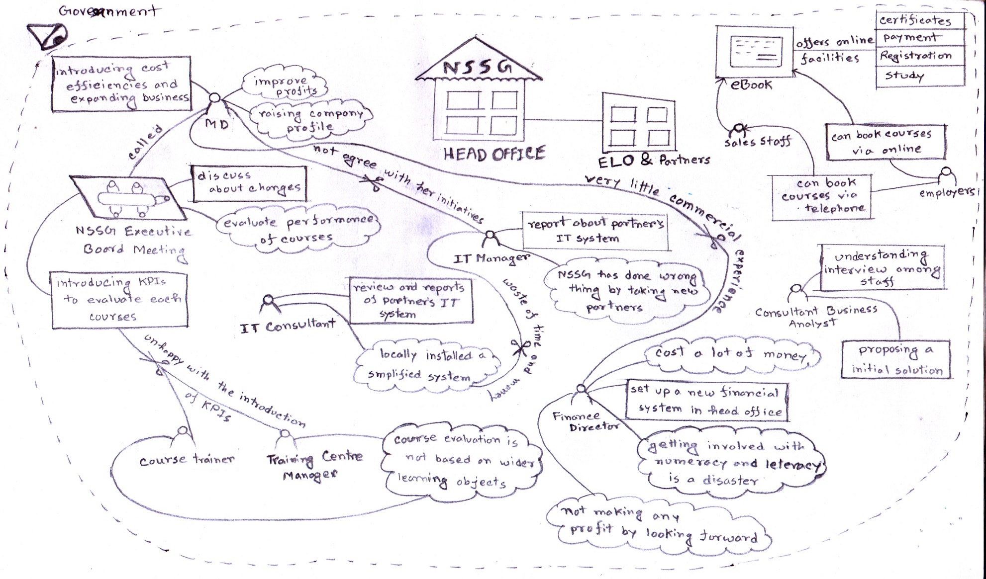

## A2. Rich picture of the Easy Learning Organisation (ELO)

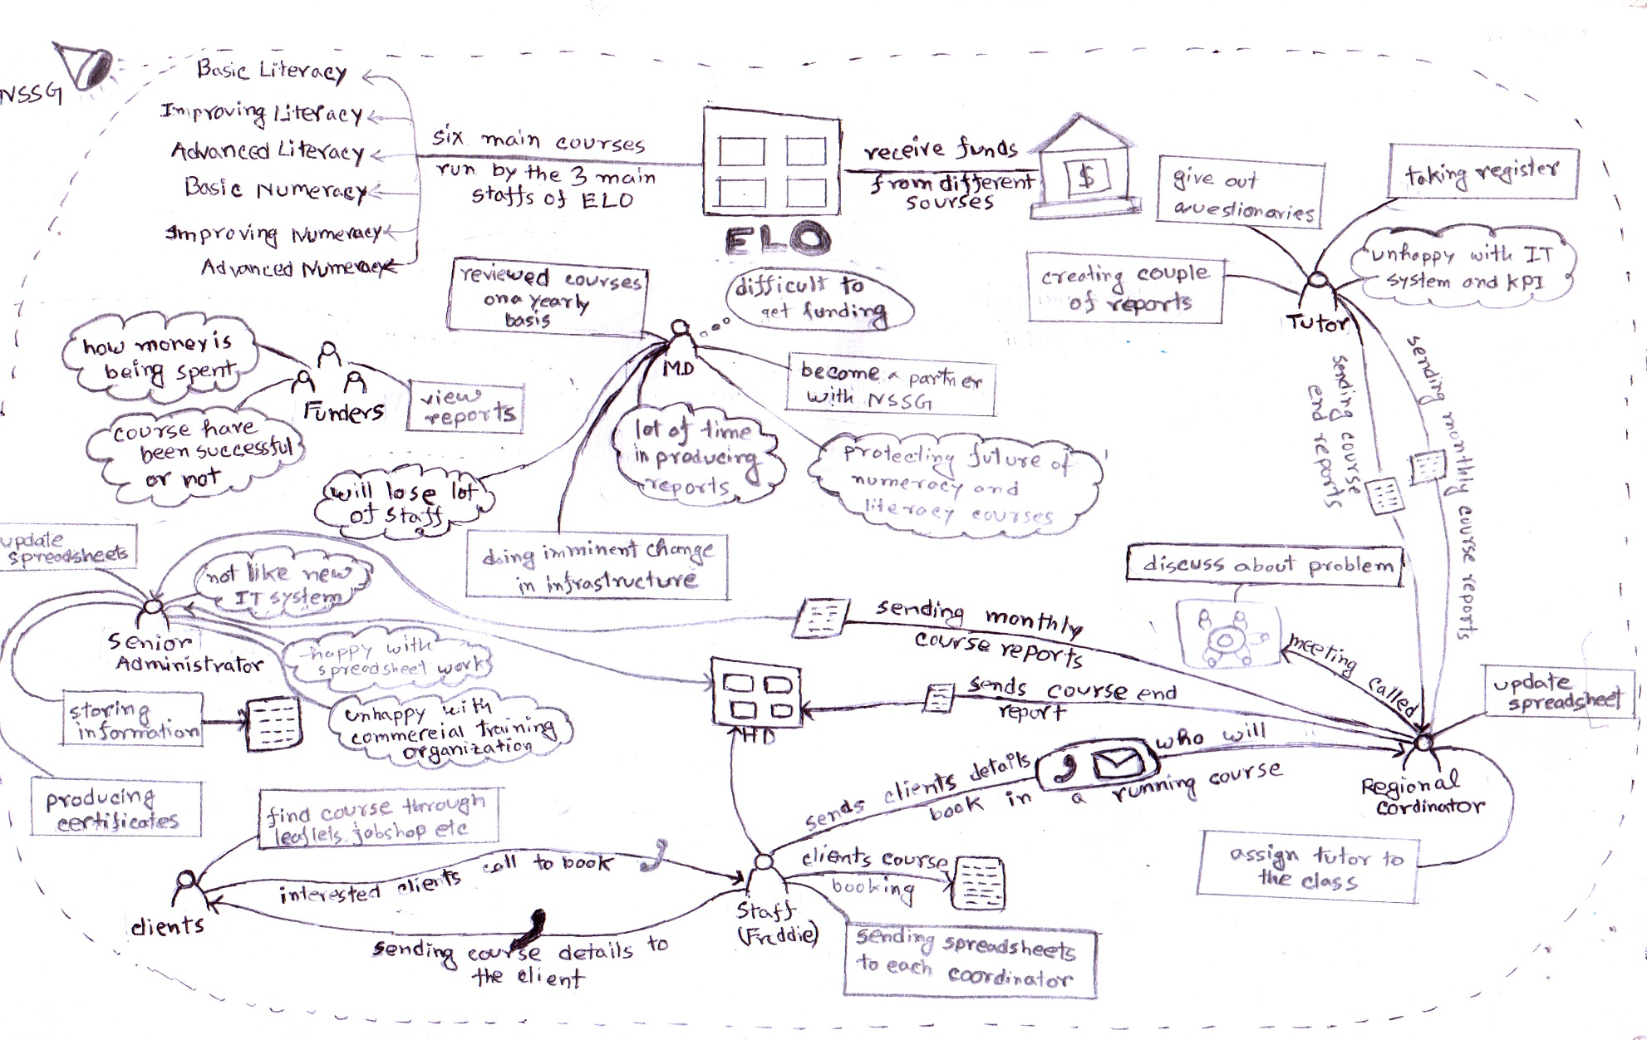

Legends for rich pictures-

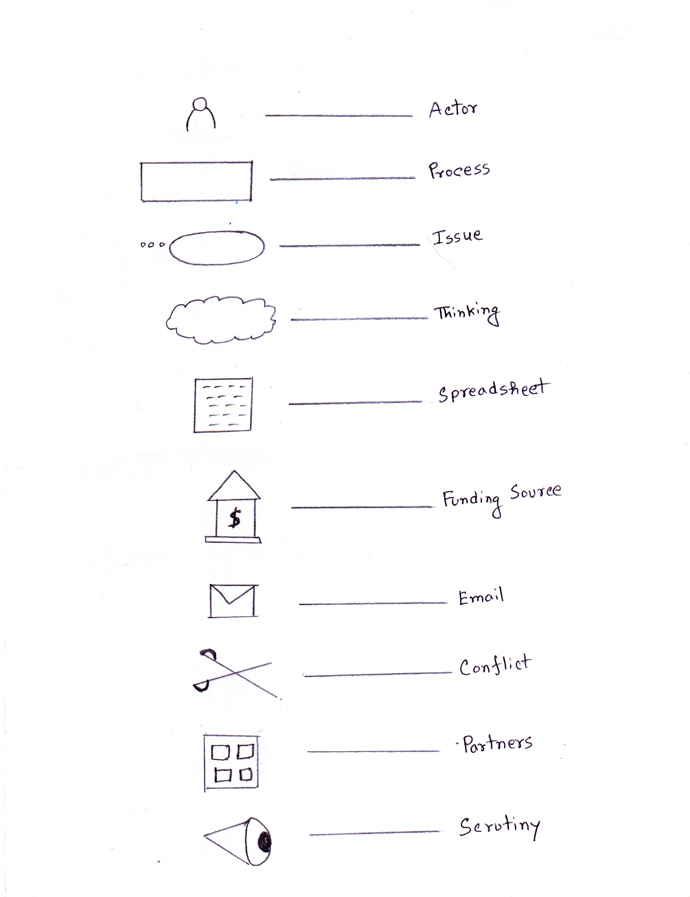

## A3. Understanding of the New Skill Set Gateway (NSSG) environment

### Identifying the key actors in the environment

**Felicia LaBelle** (Managing Director)

She takes several initiatives through the whole organisation to raise the company. Subsequently, she enrolled a government project “Looking forward” to improve profits and expanding the company.

**Johnny Golding** (IT Manager)

He has developed the eBook system where employers get facilitated through online. He is also responsible for monitoring all IT management system and make report of them.

**Hao Pun** (External IT Consultant)

His job is to do review and analysis through partners IT infrastructure for assuming the state of IT management system and make solution for them.

**Ken Wong** (Finance Director)

To receive all government fund, he sets up a new financial system in the head office. Besides, he monitors all finance reports of Partners Company.

**Carrie Johnson** (Consultant Business Analyst)

He was commissioned to take interviews among the NSSGs head office staff and ELO staff for proposing any changes and initiatives.

**Employers**

They can find courses through the NSSGs learning gateway which enables employers to book any courses through online or by telephone.

**Sales staff**

The sales staffs are responsible for responding customer queries and takes course booking through telephone.

### Key issues and areas of conflict affecting the environment

**Key issues**

* According to the course trainers and training centre managers, they were **unhappy with the KPIs.** They think that the KPI evaluates individual’s success or failure by course results but not based on their wider learnings.
* **Getting involved in a government contract** ‘Looking forward’ seems like unprofitable for NSSG organisation according to the finance director.
* According to the Johnny Golding’s report, the partners IT infrastructure is **too limited to integrate them with NSSG.** Furthermore, it will be a big mistake to roll out the NSSGs eBook system to them.
* To receive government funds, a new financial system at the head office is need to be set up which **costs a lot** according to the financial director. Besides, it will be a trouble, **if the finance report and KPIs are not documented** by the partners company.
* Working by **integrating all culture and sub-culture is too difficult** as because each partners company works in their own way of culture. If something went wrong, the whole process will be a complete disaster.

**Conflicts**

**Conflict 1**

**Being a complete disaster**

Between IT manager and Managing Director of NSSG

IT manager don’t agree with the strategies and initiatives that is taken by the MD. He thinks that the MD is trying to prove herself that she is worth for the salary whether being a complete disaster.

**Conflict 2**

**Little commercial experience**

Between Finance Director and Managing Director

According to the finance director, the managing director has a little commercial experience to work by maintaining culture and subculture.

**Conflict 3**

**Waste of time and money**

Between IT manager and External IT Consultant

The IT manager thinks that IT consultant has deliberately take the opposite view of using eBook. As well as he also things that engaging an IT consultant is a waste of money.

**Conflict 4**

**Unhappy with KPIs performance**

Between training centre managers, course trainers and NSSGs board

They think that the NSSG management don’t understand the bad practice of using the strategy of using KPI.

### Identifying cultures and subcultures within the environment

NSSG has heavily invested in IT sector and developed an **eBook** management system which enables employers to book any courses **through online**. The Managing Director Felicia LaBelle has taken a few initiatives to expand the business and improve profits. To increase performance, the NSSG board has **enabled key performance indicators (KPIs)** which allows evaluating each course and students details on three monthly basis. Moreover, the NSSG has **enrolled a government training contract** “Looking forward” and Felicia has decided to deliver the work integrating other partners including ELO.

The training centres are therefore delivering the skill training program such as adult literacy and numeracy skill courses across the country. For better performance an evaluation process is held in monthly basis through questionnaires or based on KPIs. The course trainers and training centre managers have shown the opposite view of KPIs and thinks that the management don’t understand the issues associated with the result of KPIs.

The main focus of the ELO is to help the adults by providing literacy and numeracy skills. The courses which they are currently running are need to be funded for the continuation of the organisational work. The courses are available in different sources where their clients can book the courses through telephone. All their clients’ information and course details are maintained by spreadsheets.

### Discussing about the main focus of the system that the organisation requires

The main focus of the organisation **should be increasing the IT literacy skills among the collaborating partner**s as they are currently integrated and work with the NSSG.

NSSG has their learning gateway to provide the online service to their employers. And recently they have bid for a government contract and the managing director of NSSG wants to deliver the project with other collaborating partners. But according to the overall review of the IT manager and IT consultant of NSSG, the scope of the partners IT system is limited and a few of them are done their organisational work by spreadsheets. The current IT infrastructure of the ELO is very poor from other partners. For expanding the IT system, a simplified course booking and management system could be installed of the partner’s organisation as an initial solution. A well **staff training approach** need to be organised in a regular basis to expand the staffs as well as tutors IT literacy skills and manage that system properly. Furthermore, it’s highly emphasized to **introduce KPIs** in each partner’s organisation to keep track of their course details and students performance. The crucial thing is realizing them about the less time consuming and appropriate usages of IT who were disagreed with the changes of new IT requirements.

Number of word- 1024

# Part B- Requirements Analysis using Use Case Modelling

## B1. Use Case Diagram for the Current ELO Course Management System

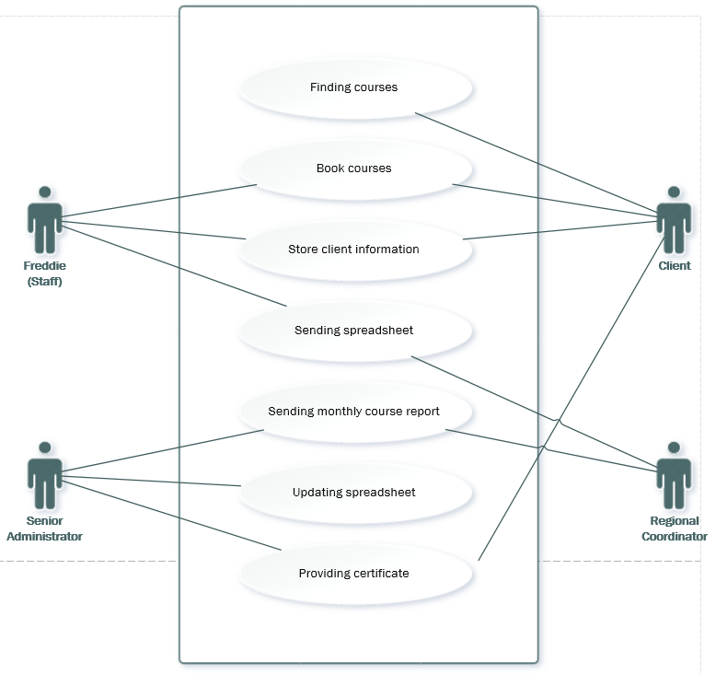

Figure 1Course management system of ELO

## B2. Documentation of Use Case

### B2.1 Primary Use Case (or Normal Use Case) Scenario

**Use case 1**

**Use case name:** Find courses from different sources

**Actor:** Client (Initiator).

**Precondition:** Client finds courses through various sources

**Flow of events:**

1. Clients go and find courses from leaflets, libraries, community centers and at job shops.
2. They are also told about the courses via word of mouth.

**Post Condition:** Interested clients will phone or contact with head office and Freddie.

**Use Case 2**

**Use case name:** Book courses

**Actor:** Client (Initiator), Freddie (Staff)

**Precondition:** Client book courses through telephone.

**Flow of events:**

1. Client make a call to the head office and Freddie for booking.
2. Freddie take the call.
3. Client book the specific course.
4. Client confirm the booking.

**Post condition:** When client confirm booking, Freddie provide details and also sends out a letter to them.

**Use case 3**

**Use case name:** Store client information.

**Actor:** Freddie (Staff)(Initiator), Clients.

**Precondition:** Freddie will store client’s information who have booked course.

**Flow of events:**

1. Freddie receives phone calls.
2. Client confirm for course booking.
3. Freddie store their information to a spreadsheet.
4. If the course has just started, Freddie will try to book the client on the course.
5. Freddie confirms the clients booking.

**Post condition:** Freddie will phone or email the Regional Coordinator and sends details of that client.

**Use case 4**

**Use case name:** Sending spreadsheet

**Actor:** Freddie (Staff) (Initiator), Regional Coordinator

**Precondition:** Sending spreadsheet to each Regional Coordinator.

**Flow of events:**

1. Freddie stores client’s information in a spreadsheet.
2. Freddie organises all those information with course details.
3. Freddie send it to each regional coordinator.

**Post condition:** Each regional coordinator will receive that spreadsheet from Freddie.

**Use case 5**

**Use case name:** Sending monthly course report

**Actor:** Regional Coordinator (Initiator), Senior Administrator

**Precondition:** Sending a monthly course report to the Senior Administrator.

**Flow of events:**

1. Setting up a few questionnaires.
2. Provide it to the client to fill up at the end of each course.
3. Call for a meeting once a month.
4. Tutor sends a monthly course report.
5. Sends the report to the head office.

**Post condition:** The report will be received by the Senior Administrator.

**Use case 6**

**Use case name:** Updating spreadsheet.

**Actor:** Senior Administrator (Initiator)

**Precondition:** Updating spreadsheet with the client details.

**Flow of events:**

1. Get the report from regional coordinator.
2. Go through the spreadsheet.
3. Update each spreadsheets with client’s attendance and their progress.

**Post condition:** Client will be notified of the changes.

**Use case 7**

**Use case name:** Providing certificates

**Actor:** Senior Administrator (Initiator), Clients

**Precondition:** Clients will be provided certificate at the end of the course

**Flow of events:**

1. Check the client’s attendance.
2. Check the clients overall progress
3. Check if the client has completed the course
4. Create a certificate template.
5. Post the certificate to the client

**Post condition:** Client will receive the certificate and can register for new course.

### B2.2. Identifying secondary scenario

**Use case 1**

**If the courses are not available?**

**Flow of events:**

1. Client contact with head office.
2. Check the course availability.
3. If not, then tell them ‘not available now’.

**Use case 2**

**If client want to book any course that has been running for 3/4 weeks**

**Flow of events:**

1. Freddie check the current course duration.
2. If longer than 2 weeks then tell the client to book after 3 months.

**Use case 3**

**If the client need to update their existing information**

**Flow of events:**

1. Contact with the head office staff.
2. Freddie check the client information exist.
3. Update client information.

**Use case 4**

**If a spreadsheet doesn’t send to the regional coordinator**

**Flow of events:**

1. Contact with head office.
2. Freddie check the spreadsheet.
3. Send it through phone or email

**Use case 5**

**If the monthly course report isn’t ready by the tutor**

**Flow of events:**

1. Contact with the tutor.
2. Asking for the report.
3. Send to the head office

**Use case 6**

**If clients report aren’t accurate.**

**Flow of events:**

1. Contact with regional coordinator
2. Ask for the updated report.
3. Check the updated report.

**Use case 7**

**If certificate isn’t provided by mistakenly to any client**

**Flow of events:**

1. Client contact with head office.
2. Ask for their certificate.

## B3. Understanding of Use Case Modelling

### B3.1 Identify the actors and processes in the current system of ELO

Initially, use case diagram **helps to identify that the process where to begin** and as well as it also helps to **identify the set of actors and the processes** that they have to perform. For example**-** The students of their organisation are known as clients who are able to find courses from different sources such as leaflets, commercial libraries or any job shops and can book three months of courses. Use case modelling also helps identifying the relationship between actor’s and their processes. And **this relations are the most crucial part to clarifying the whole system in a few narrative words**. For example- Freddie sends spreadsheets to each regional coordinator that contains course and clients details. In this example, the Freddie is the initiator or primary actor of the process and the regional coordinator is the secondary actor who is responsible for receiving the spreadsheet. It also **helps understanding the position and the level of access of the organisation.** For example-“The senior administrator has to only check the monthly course reports and provide certificates whether the regional coordinator has to manage monthly course report, end course report by calling monthly meetings with tutors”.

### B3.2 Clarify understanding of the current system

The use case modelling **helps understanding the ELOs current course management system** and how the actors of the organisation manage the system. It also helps to identify the relations among the actors of the organisation. For example- “The students of their organisation are known as clients who can book three months of courses and the head office staff Freddie is responsible for managing the course booking process of the clients. Freddie stores all the clients’ information in a spreadsheet who confirm course booking. Subsequently, he sends the spreadsheet to each regional coordinator”. If any clients want to book a course during the course runtime. Freddie tries to book them on to that course and provide those clients information to the regional coordinator. According to the use case relationship between process and actors, regional coordinator keep track of client’s progress during the runtime of the course. Clients are provided certificates by their progress at the end of the course.

### B3.3 Further investigation

There are some aspects which area are need to be further investigated while booking on a specific course. Firstly, its need to be checked that if a client have booked any courses before or the client is new to the organization. Secondly, it’s not mentioned that how many courses can be booked by a client at the same time.

### B3.4 Identify whether use cases where sensible and workable

The secondary scenario helps to explore the possibilities of vulnerabilities of the ELOs course management system. Though the whole course management system is workable but in some use cases it sensible too such as properly keep tracking of client information.

### B3.5 Clarifying step by step action of use cases

According to the secondary scenario, initially the actors of the management are identified. The relationship are identified among the actors and processes. Their process are identified associated with alternative approach. If a process will work in the same way all the time then how it may take action when another action can be happened. For example- Clients can book a course at a time but it isn’t mentioned that they can book multiple courses at the same time. Secondly, the flow of work associated with the actors are identified. And eventually, the alternative thinking of each use cases are identified related with possibility of issues. And in this way the problematic issues can be solved at the very early stage.

### B3.6 Questionnaires

I would like to ask a few questions to Freddie (Staff) that-

* How do you manage bookings if clients booked before?
* What if a client book a course that has been running for 1 month?
* What will be the action if clients want to book multiple courses?

I would like to ask a few questions to Regional Coordinator that-

* Are you keep the backup files of the monthly course reports?
* Do you check all the clients’ information at the end of the course?
* Do you prefer work in a technology based environment?

Number of word- 711

# Part C- Critique of Use Cases and Rich Pictures

Using both rich pictures and use case diagram are useful for the requirements analysis. Moreover there are also a few aspects that differs from each other. Both techniques have their qualitative approach for requirement analysis. For example- rich pictures represent the problematic situation of a scenario where use case depict the relation among the actor. Rich pictures show the conflicts among the actors whether use case stands for identifying the probable issues at the earlier stage. Both techniques have some advantages and disadvantages that are found during the analysis of this task.

## The way of those techniques that I get helped for requirements analysis

In order to do the requirements analysis for NSSG and ELO, initially a rich picture or any use case diagram is used to do the analysis. These techniques are used in any organisation according to their needs. Rich pictures are used to identify the key actor and their processes. It represents the way of thinking and the key issues of each actors. As well as it aids to point out the conflicts between their processes and with other actors in the organisation. But as an analyst, my opinion is to select using use case model instead of using rich pictures. Rich pictures are not good at all for requirement analysis as it’s sometimes difficult to understand in some aspects.

On the other hand, using use case modelling helps doing requirement analysis. By using this approach the relation between actors are easily identified and driving the system to achieve the goal. It helps to identify the possible problems at the early stage of the system. Use case techniques has its primary and secondary scenario which provides the entire relationships between actors and overall process of the organisation. As well as it also provides the alternative solution for the system.

## Common approaches of rich picture and use case

Between these two techniques there are a few common approaches that are assumed during requirement analysis. These common approaches are briefly discussed below-

* Both of the techniques are time consuming approach for analysis.
* These techniques can be used by any organisation according to their needs.
* Both of these techniques are complicated to develop.
* In both approaches, we can find the key actors and factors of any organisation.
* Both techniques are used to do problematic solution.
* These techniques are used to understand and clarify the whole system.

## Strengths and Weaknesses of the Rich Picture and Use Case

These two techniques are used for requirements analysis in organisation according to their need. However the both approaches have some strength and weaknesses in some aspects of requirements analysis. The strengths and weaknesses for each of those techniques are briefly discussed below-

**Strengths of the Rich pictures**

* It can be used to identify the changes and progress easily from primary situation.
* The key actors and processes can be easily identified.
* Rich pictures are not required so much material to develop.
* For individuals, any special skills are not required to develop.
* Anyone can depict the whole organisation by using it.
* It enables user to understand the problematic situations by visual representation.

**Weaknesses of Rich Pictures**

* It’s challenging to represent all integrated information visually.
* It is complicated and time consuming approach.
* It requires multiple revisions to develop.
* Representing the relationship between stakeholder and actors are difficult.

**Strengths of the Use Case Modelling**

* Use case simplifies any extensive overview of a system in a single illustration.
* It is a time saving approach. For example- If it finds any problematic issue or any wrong, it solves that at the earlier stage.
* The actors and their relations are easily identified.
* The approaches of use cases are easily understandable as it uses the descriptive words.
* This use case modelling can be used in various aspects. I.e. project planning, any organisation system analysis, user documentation and so many aspects.

**Weaknesses of the Use Case Modelling**

* It is difficult to represent the non-functional requirements of any system.
* It is a time consuming approach.
* Difficult to implement logic in each use case scenario.
* It is difficult to represent any geometric issues.
* Use case requires special set of skills of both developer and user.

Rich picture and use case modelling both are most useful for an organisation to achieve their goal. But choosing these techniques are depend on each organisation’s needs. In order to do a complete requirements analysis, use case modelling is much preferable between those techniques. Rich pictures shows the problematic situation while use case manages the relationship between actors. Rich pictures show contradictions and conflicts where happens while use cases resolve the probable issues at the earlier sage that saves plenty of times. Conflicts, contradictions are now common in every organisation but finding a solution and resolve the problem at the early stage is most important for that organisation.

Number of word- 807

# Conclusion

The organisational environments of NSSG and ELO are properly reviewed an analyzed. Rich pictures of those organisation’s are depicted showing the relationships, issues, processes and contradictions between the actors. All those case studies help find out the possibility of issues and resolve that at the early stage. This analysis has also provided the alternative solutions by assuming the scenario where it is vulnerable. By following some techniques and doing some case studies, the analysis has been properly accomplished for those organisation.