***Lab3***

* **Create users called itiuser1,itiuser2**

To create Them we write command :

Sudo adduser itiuser1

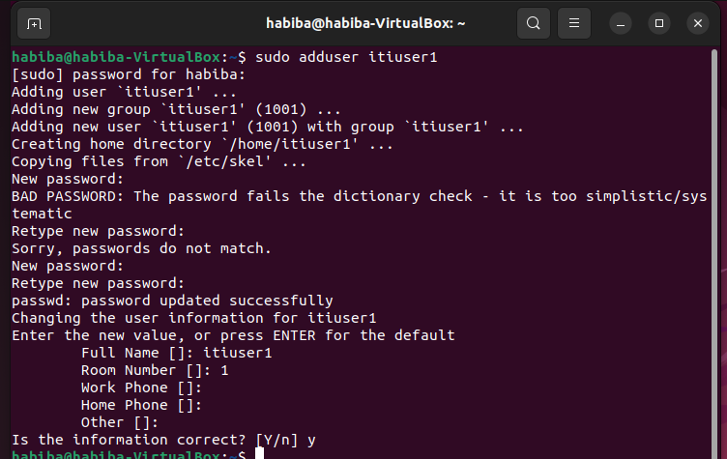

Sudo adduser itiuser2

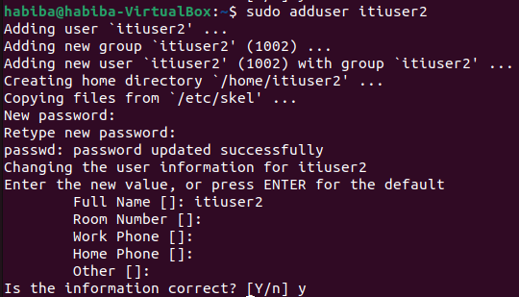

* **Create group called os_team:**



* **Create directory called os_team_workspace:**



* **Assign os_team group to the directory os_team_workspace and change mode to setgid:**

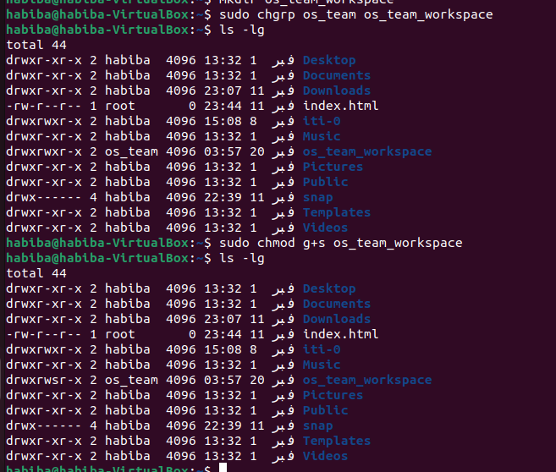

* **Add users itiyser1 and itiuser2 to os_teamgroup:**

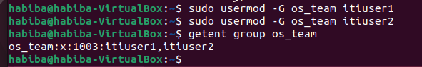

* **Create directory mydir1 using itiuser1 and mydir2 using itiuser2, List directory permissions and send screenshot:**

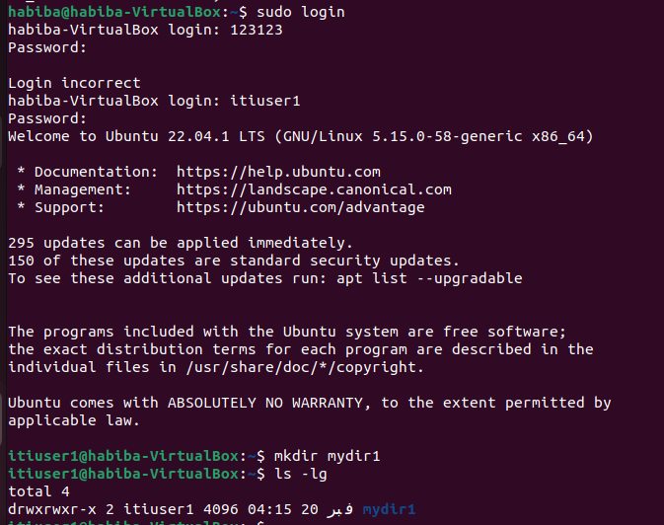

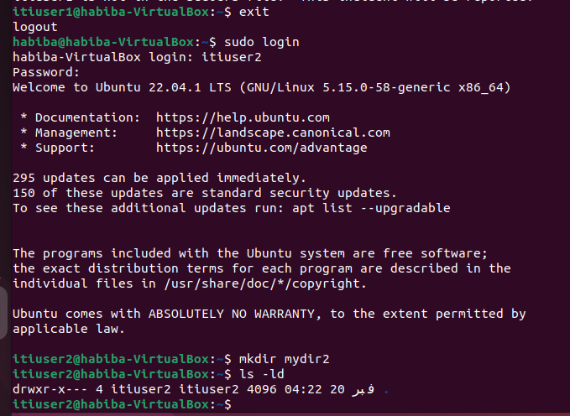

* **Send screenshot of all processes in tree mod:**

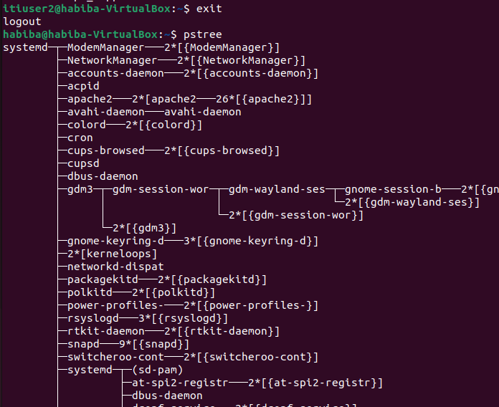

* **Execute command tail-f/var/log/syslog:**

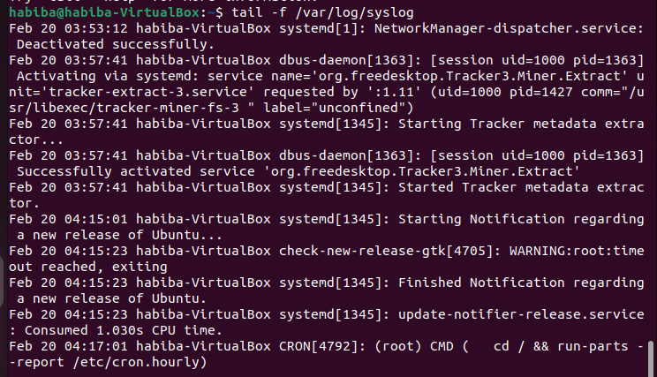

* **Find the process id PID of tail process then kill it using kill command:**

