**Lab 5**

• using dd command create empty file with size of 20MB (hint: count 40000, bs=512)

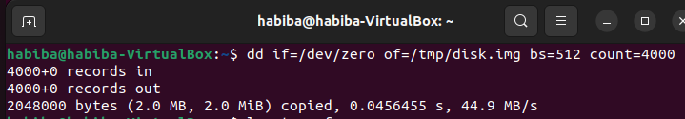

• attach the file as loop device using losetup command (hint: use losetup -f to allocate free device)

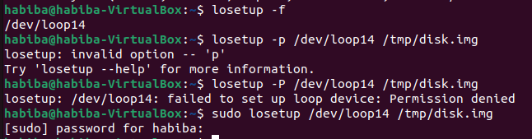

• using fdisk command, create new partition into the loop device (`fdisk /dev/loop<??>` where <??> is the device number)

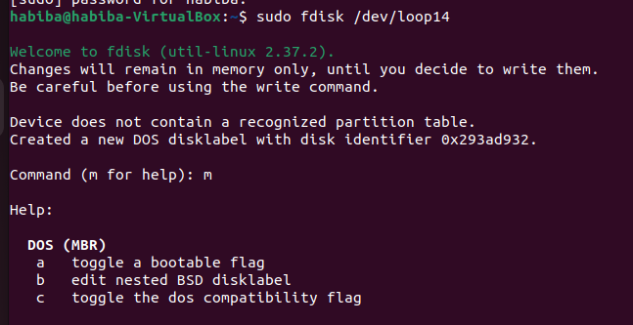

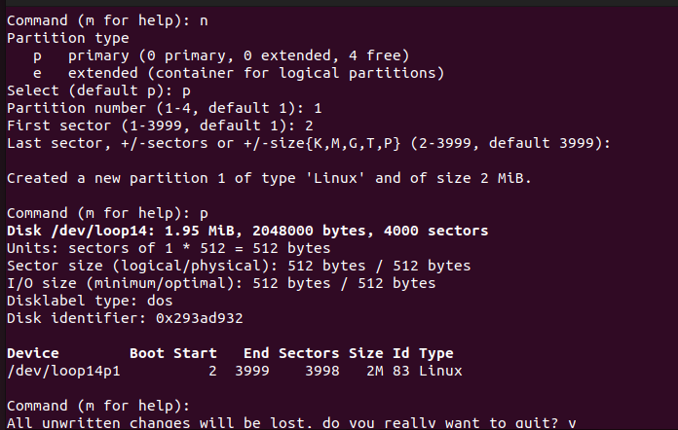

• format the new partition using mkfs.ext4 command

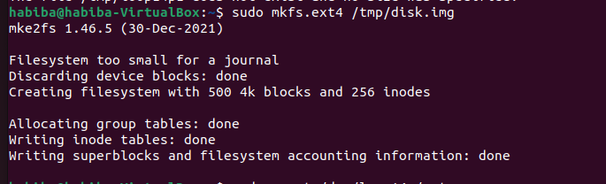

• mount the formatted partition into /mnt directory

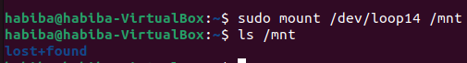

• create some files inside the mounted /mnt directory

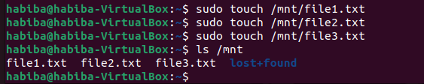

• unmount /mnt directory using umount command



• using `apt` command, search and install `gparted` program

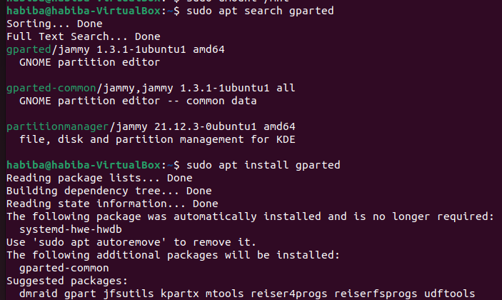

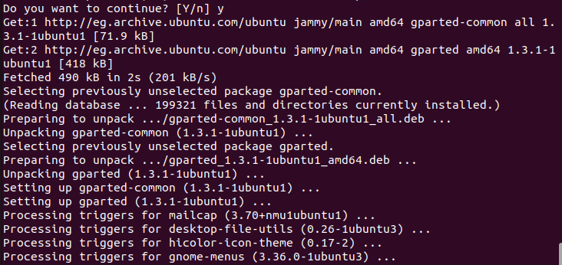

navigate and use gparted to detect the the new partition.

