- What are the peak hours for ride demand overall?
- Do these peak hours differ between weekdays and weekends?
- How do ride patterns vary across different days of the week and seasons?
- Which months have the highest number of rides?
- What is the month-to-month growth or variation in ride volume?
- How do casual and member users differ in:
  - Average ride duration
  - Preferred riding hours
- Which stations have the highest average departure ride duration, and why?
- Which station–time combinations generate the highest ride demand?
- Are these patterns stable over time? **
- Which day of the week has the lowest ride volume compared to the weekly average?

Conceptual model
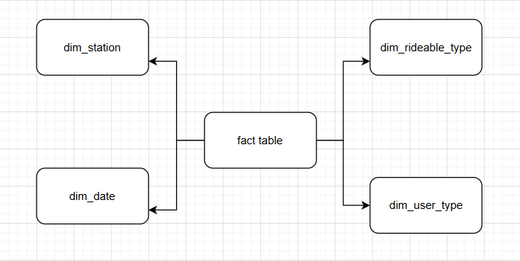
Logical
