Covid 19

Documentation Template
Prepared by Habiba Ibrahim
Date 1/7/2026

Table of Contents
Contents
1. Data Overview …………………………………………………………………………………..3-5
2. Analytics Questions ……………………………………………………………………………6
3. Conceptual & Logical & Physical Models ……………………………………………… 7-9
4. SSIS Overview ………………………………………………………………………………10-13
5. SSAS Overview ……………………………………………………………………………..14-18
6. Power BI Overview ………………………………………………………………………….19-22

1. Data Overview
Data Overview

Dataset Description
This project uses the Our World in Data (OWID) COVID-19 Dataset, one of the most comprehensive and reliable global datasets for COVID-19 statistics. The dataset contains daily records for countries and territories around the world, covering confirmed cases, deaths, testing activities, demographic characteristics, healthcare indicators, and economic information.
Each record represents the COVID-19 statistics for one country on one specific date, allowing both temporal and geographical analysis of the pandemic.

Dataset Features

- Source: Our World in Data
- Data Type: Time-Series Dataset
- Granularity: One record per country per day
- Coverage: More than 200 countries and territories
- Attributes: 40 columns
- Main Categories:
  - Country Information
  - Date Information
  - COVID-19 Cases
  - COVID-19 Deaths
  - COVID-19 Testing
  - Government Response
  - Population Statistics
  - Health Indicators
  - Economic Indicators

Column Description
1. Country Information
Column | Description
iso_code | A unique ISO 3166-1 alpha-3 country code used to identify each country (e.g., EGY, USA, FRA).
continent | The continent where the country is located.
location | The country or territory name.

2. Date Information
Column | Description
date | The reporting date for the recorded statistics. Each row represents one day's data for a specific country.

3. COVID-19 Cases
Column | Description
total_cases | Total cumulative confirmed COVID-19 cases reported up to the specified date.
new_cases | Newly confirmed COVID-19 cases reported on that day.
new_cases_smoothed | Seven-day moving average of new confirmed cases, used to reduce daily fluctuations.

4. COVID-19 Deaths
Column | Description
total_deaths | Total cumulative COVID-19 deaths reported up to the specified date.
new_deaths | Number of newly reported deaths on that day.
new_deaths_smoothed | Seven-day moving average of daily deaths.

5. Cases and Deaths per Million Population
Column | Description
total_cases_per_million | Total confirmed cases per one million people.
new_cases_per_million | New confirmed cases per one million people.
new_cases_smoothed_per_million | Smoothed new cases per one million people.
total_deaths_per_million | Total deaths per one million people.
new_deaths_per_million | New deaths per one million people.
new_deaths_smoothed_per_million | Smoothed new deaths per one million people.

6. COVID-19 Testing
Column | Description
new_tests | Number of COVID-19 tests performed on the reporting day.
total_tests | Total cumulative COVID-19 tests conducted.
total_tests_per_thousand | Total tests performed per one thousand people.
new_tests_per_thousand | Daily tests performed per one thousand people.
new_tests_smoothed | Seven-day moving average of daily tests.
new_tests_smoothed_per_thousand | Smoothed daily tests per one thousand people.
tests_per_case | Average number of tests required to identify one confirmed case.
positive_rate | Percentage of COVID-19 tests that returned positive results.
tests_units | Unit used to report testing data (e.g., people tested or tests performed).

6. Government Response
Column | Description
stringency_index | Composite index (0–100) measuring the strictness of government COVID-19 policies such as lockdowns, school closures, workplace restrictions, and travel bans. Higher values indicate stricter measures.

7. Demographic Information
Column | Description
population | Total population of the country.
population_density | Number of people living per square kilometer.
median_age | Median age of the country's population.
aged_65_older | Percentage of the population aged 65 years or older.
aged_70_older | Percentage of the population aged 70 years or older.

8. Economic Indicators
Column | Description
gdp_per_capita | Gross Domestic Product (GDP) per person, representing the country's economic output per individual.
extreme_poverty | Percentage of the population living in extreme poverty.
human_development_index | Human Development Index (HDI), measuring education, life expectancy, and income. Values range from 0 to 1, with higher values indicating higher human development.

9. Healthcare Indicators
Column | Description
cardiovasc_death_rate | Annual death rate caused by cardiovascular diseases per 100,000 population.
diabetes_prevalence | Percentage of adults diagnosed with diabetes.
female_smokers | Percentage of adult females who smoke.
male_smokers | Percentage of adult males who smoke.
handwashing_facilities | Percentage of the population with access to basic handwashing facilities.
hospital_beds_per_thousand | Number of hospital beds available per one thousand people.
life_expectancy | Average life expectancy at birth in years.

Importance of the Dataset
This dataset enables comprehensive analysis of the COVID-19 pandemic from multiple perspectives, including infection trends, mortality rates, testing performance, government interventions, demographic characteristics, healthcare capacity, and economic conditions. Its rich collection of daily and country-level information makes it well suited for data engineering, data warehousing, and business intelligence projects

2. Analytical Questions

- Question: What is the current global footprint of the pandemic, and how are cases, deaths, and tests distributed worldwide?
- Question: How has the pandemic progressed chronologically, and what are the identifiable peak periods or waves across different timelines?
- Question: Which countries or regions have experienced the highest burden of the pandemic in terms of total volume and scale?
- Question: What is the efficiency of testing strategies across countries, and is there a strong correlation between testing volumes and detected cases?
- Question: What is the case fatality rate (CFR) across different territories, and how does the virus's severity vary globally?
- Question: To what extent do population size and density accelerate or influence the spread and per capita infection rates of the virus?
- Question: Does a country's economic strength (measured by GDP per capita) correlate with its capacity to conduct extensive monitoring or manage infection rates?
- Question: Did the pre-existing infrastructure of healthcare systems (such as hospital beds availability) effectively mitigate mortality rates during the crisis?
- Question: What is the measurable impact of strict government lockdowns and containment policies (Stringency Index) on flattening the curve of new infections?
- Question: What is the comprehensive, granular epidemiological profile and historical trajectory for a specific selected nation?

3. Conceptual, Logical & Physical Model
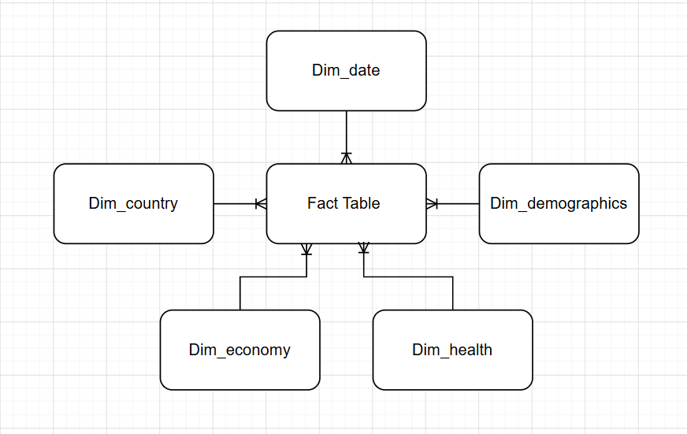

Logical Model

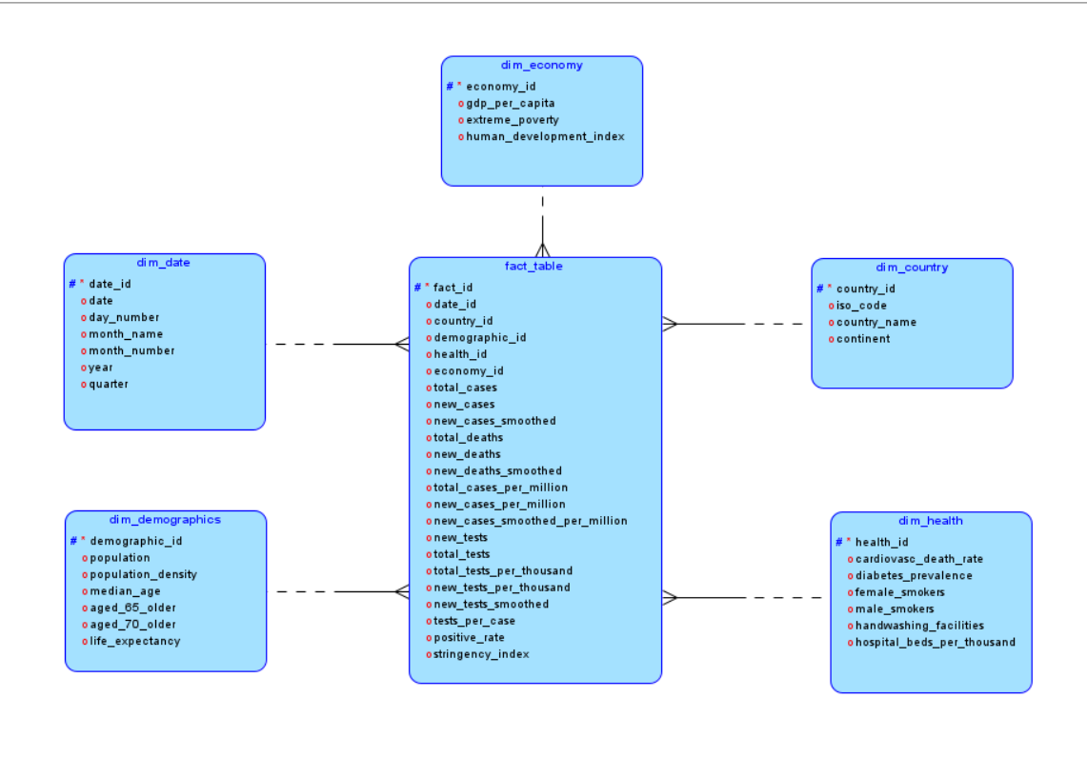

Physical Model
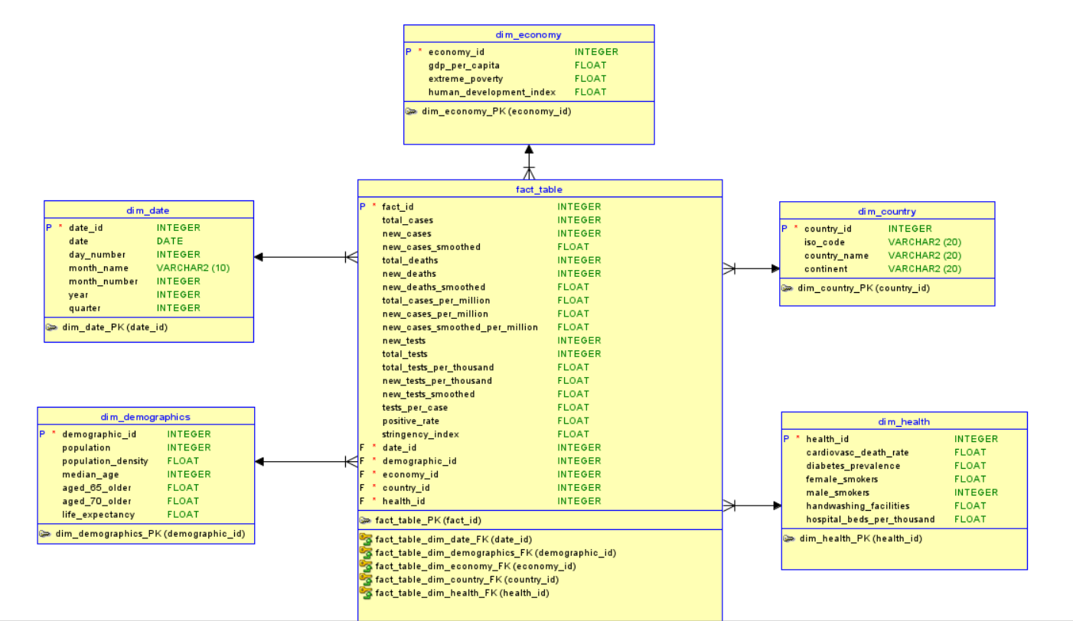

4. SSIS Overview
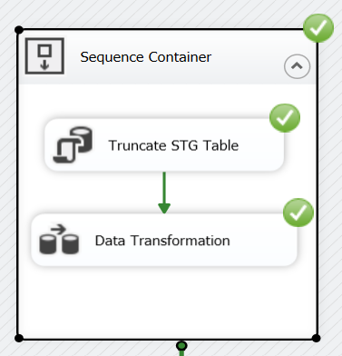

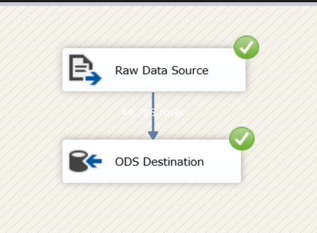

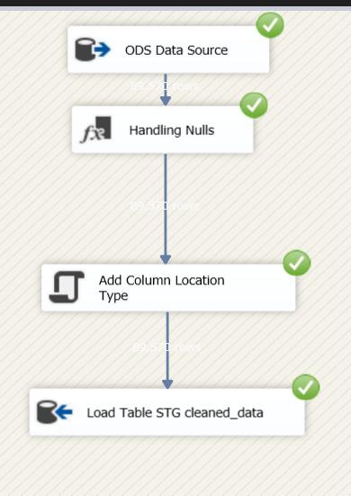
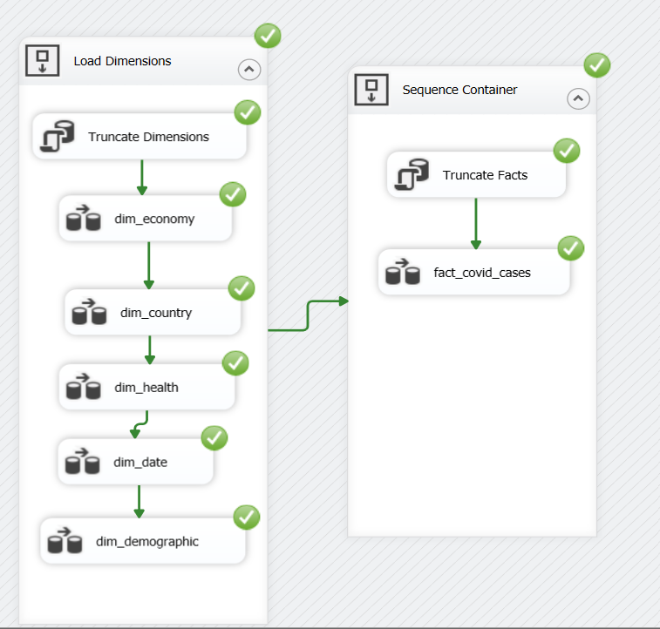

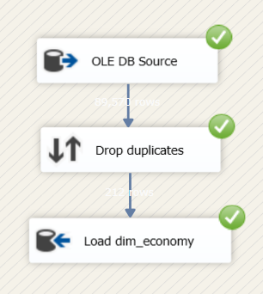

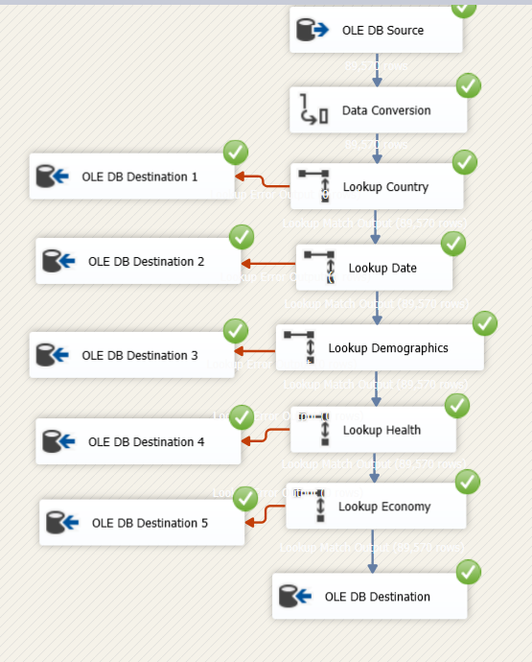

5. SSAS Overview
Measures
Measure Name | DAX Formula | Description
Total Cases | Total Cases:= SUM('fact_corona'[new_cases]) | Calculates the cumulative sum of daily new cases
Total Deaths | Total Deaths:= SUM('fact_corona'[new_deaths]) | Calculates the cumulative sum of daily new deaths
Total Tests | Total Tests:= SUM('fact_corona'[new_tests]) | Calculates the absolute total number of diagnostic tests performed.
Avg New Cases Smoothed | Avg New Cases Smoothed:= AVERAGE('fact_corona'[new_cases_smoothed]) | Computes the average of smoothed daily cases, reducing volatility from erratic daily or weekend reporting.
Avg New Deaths Smoothed | Avg New Deaths Smoothed:= AVERAGE('fact_corona'[new_deaths_smoothed]) | Provides a cleaner historical trend line for mortality by averaging smoothed daily deaths.
Mortality Rate % | Mortality Rate %:= DIVIDE([Total Deaths], [Total Cases], 0) | Measures the percentage of deaths relative to confirmed cases (Case Fatality Rate). Safely handles division by zero.
Avg Positive Rate % | Avg Positive Rate %:= AVERAGE('fact_corona'[positive_rate]) | Computes the average positivity rate of conducted tests across the selected filter context to monitor virus transmission strength.
Avg Cases per Million | Avg Cases per Million:= AVERAGE('fact_corona'[new_cases_per_million]) | Standardizes infection metrics per million residents to facilitate an unbiased geographical comparison regardless of country size.
Avg Deaths per Million | Avg Deaths per Million:= AVERAGE('fact_corona'[new_deaths_per_million]) | Standardizes mortality metrics per million residents for fair cross-border benchmarking.
new cases peak month | new cases peak month:= CALCULATE(FIRSTNONBLANK('dim_date'[month_name], 1) & " " & FIRSTNONBLANK('dim_date'[year], 1), TOPN(1, SUMMARIZE('dim_date', 'dim_date'[month_name], 'dim_date'[year]), [Total Cases], DESC)) | Identifies the specific month and year that experienced the highest spike of new cases within the active filter context.
Population Tested % | Population Tested %:= DIVIDE([Total Tests], SUMX(VALUES('fact_corona'[contry_id]), CALCULATE(MAX('dim_demographics'[population]))), 0)
Avg Hospital Beds | Avg Hospital Beds:= AVERAGEX(VALUES('fact_corona'[contry_id]), CALCULATE(MAX('dim_health'[hospital_beds_per_thousand]))) | Computes the average hospital beds available per thousand individuals across selected regions to evaluate healthcare capacity.

Calculated Columns
Column Name | DAX Formula | Description
Age Segment | =SWITCH(TRUE(), 'dim_demographics'[aged_65_older] >= 15, "High Risk", 'dim_demographics'[aged_65_older] >= 7 && 'dim_demographics'[aged_65_older] < 15, "Medium Risk", "Low Risk") | Segments countries into risk tiers based on the percentage of elderly citizens (65+) to capture demographic vulnerability levels.
Diabetes Risk Segment | =SWITCH(TRUE(), 'dim_demographics'[diabetes_prevalence] >= 12, "Critical Health Risk", 'dim_demographics'[diabetes_prevalence] >= 6 && 'dim_demographics'[diabetes_prevalence] < 12, "Moderate Health Risk", "Low Health Risk") | Categorizes countries dynamically by their diabetes prevalence rates to benchmark chronic healthcare exposure factor

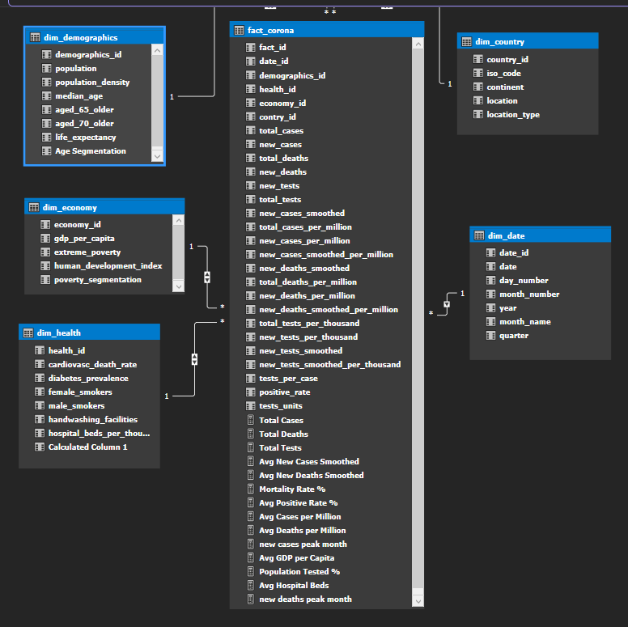
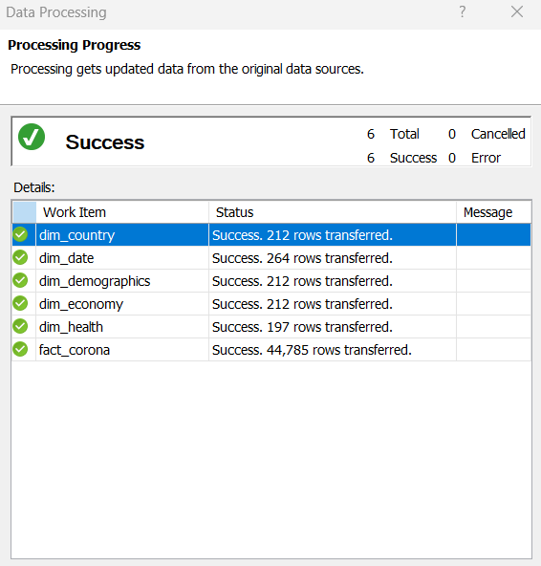

6. Power BI Overview

