Con:lab1
q8
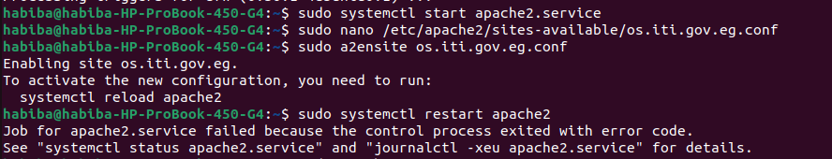
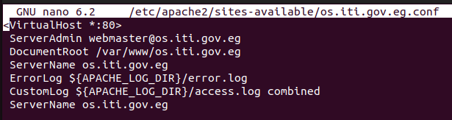

Q9

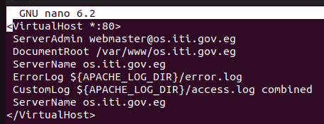

10
1-User-Friendly Links:
Short, readable URLs are easier for users to remember and trust.
2-Security:
You can hide server file structures or real query strings, which makes it harder for attackers to guess internal workings.

3-edirects and URL Changes:
If you redesign a site or move content, you can use rewrites to send visitors (and search engines) to the new URLs without breaking links.

Lab2
q1
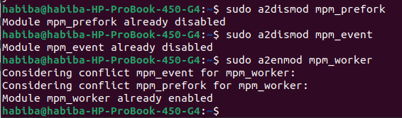

q2

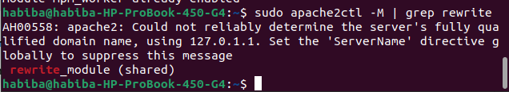
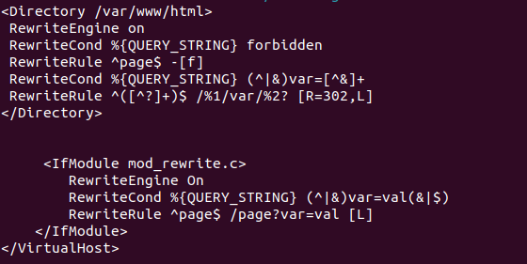
q3 a,b,c

q3d

q3e

q4

