Create Dataabse

q1
Track table

student
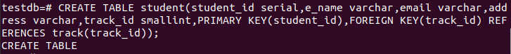

sub
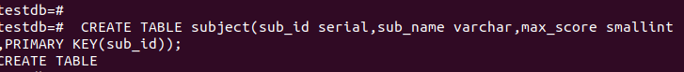
exam
grades
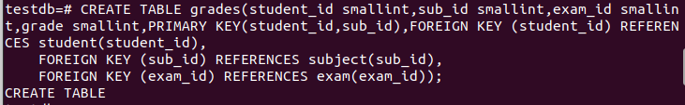
stu_sub

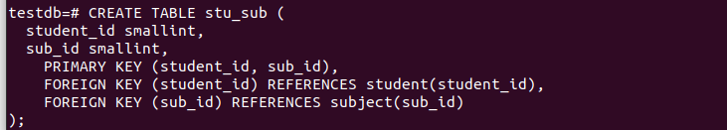
track_sub
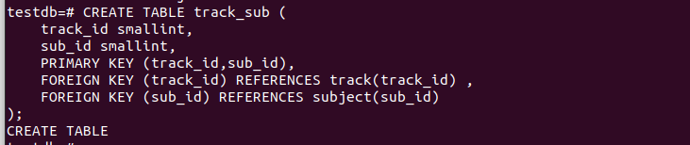

INSERTS
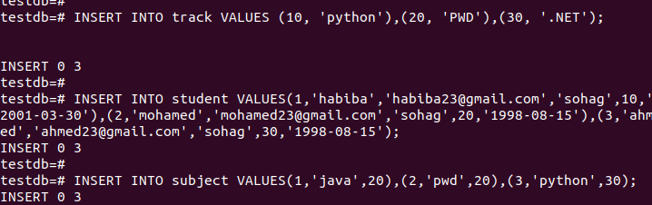
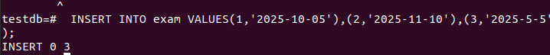
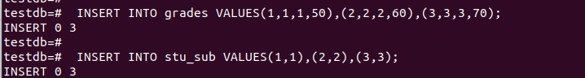

add birthdate
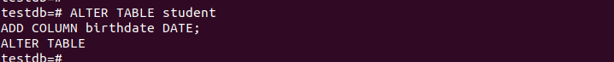

add gender
6
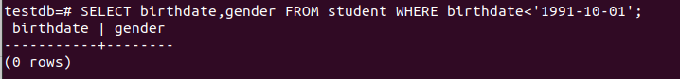
7
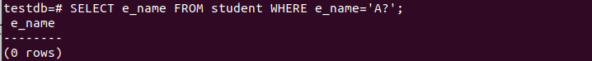
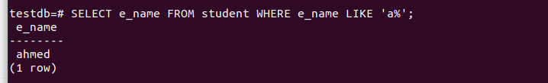
8
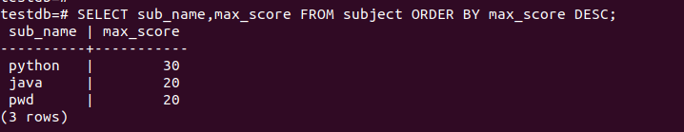
9
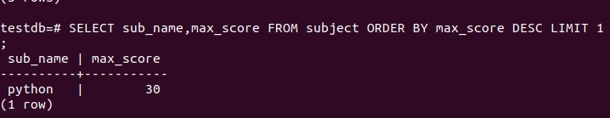

lab2
1
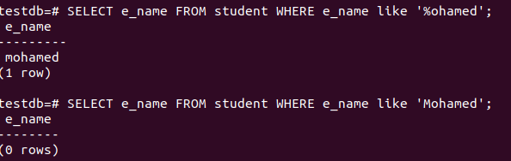
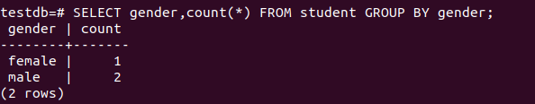
2

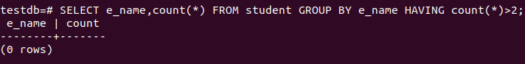
3

4

