e-4Pt App
Software Documentation
G. Brooksby – GE Research
29Jul2020

Introduction:
The e-4Pt app is designed to work with an optical sensor to provide measurements of compressor blade tip clearances for a variety of GE gas turbines. The app runs on an iOS device and communicates with a Micro-Epsilon IFC242x chromatic confocal sensor through either a serial cable (wired) or ethernet (wired or wireless). This document describes the application software.

Overview:
The e-4Pt app is written using the Cordova framework which uses HTML and JavaScript to produce a user interface (UI) rendered in a web view on the iOS device. Cordova provides a mechanism for communicating with iOS native code and hardware through plugins which may be added to a project. Plugins may come from open source locations or they may be custom built. Because the e-4Pt app uses one or more custom lightning cables to communicate with the optical sensor controller, a custom plugin was written to implement the sensor communication, as well as data processing functions. The provider of the cables (Redpark) also provides an iOS library (in iOS terms, a Framework) for communicating via their cables. This framework is accessed through the plugin code. Data processing is also handled in the plugin since the native programming environment gives access to specialized functions, such as the device digital signal processor (DSP).
The overall design of the UI borrows from the TRACC scan app for two reasons. First, it gives a framework from which to begin without having to start from scratch. This reduces development time. Second, users of the TRACC scan app will have a similar user experience when using the e-4Pt app.

Design Methodology:
The app is designed to try as much as possible to keep UI elements in the HTML and JavaScript code, and the data acquisition and processing in the plugin code (native Objective-C). These two domains communicate by means of messages passed between them using standard Cordova calls. The JavaScript code will pass messages, with arrays of arguments to the plugin code. The plugin code will perform operations and pass messages back to the JavaScript code. The messages returned are JSON objects that can be parsed by the JavaScript code to extract the content.
The plugin is designed with two parts. There is a portion that communicates with Cordova and receives the messages passed from JavaScript. There is another portion that communicates with the sensor controller. The portion that communicates with the controller is implemented as a ‘singleton’. That is, this piece of code can have only one instantiation. This causes all communication with the controller to be handled by a single instance of code.

User Interface:
The UI has a main menu that opens when the [MENU] button is pressed. When the app first starts it is in a state where it is not yet connected with the sensor. When the [MENU] button is first pressed, a message is sent to the plugin with two results.
The first consequence of opening the side menu for the first time is that a single instantiation of the sensor controller software object is created, allowing communication with the plugin to begin.
The other result is that the version number of the app is retrieved using native methods. This version number is then displayed in the left side menu. This ensures that when the version number is changed, it will automatically be displayed correctly in this menu.

Tool Setup Menu:
This menu has four collapsible sections.
Gas Turbine Preparation: This section provides instructions on how to use the app. It is intended to hold the tool FRD (still pending as of 29Jul2020).
Sensor Connection: This section contains a button that allows the user to select the type of connection that exists between the iOS device and the sensor controller. When the app starts, the default connection method is via a Redpark Lightning-to-RS232 serial cable. In this section of the app, the user can select an ethernet connection. If an ethernet connection is selected, then the sensor controller must be connected to the iOS device via a hard-wired network connection (i.e. a Redpark Lightning-to-ethernet cable), or via a wireless connection. In this last case, the sensor controller can be connected via wire to a wireless router and the iOS device can connect to the wireless access point.
Switch Mode: The third section of the Tool Setup menu allows the user to switch to a “Demo” mode. In this mode, the sensor and controller are not needed and data is provided from a built-in CSV file.
Sensor Parameters: This section of the Tool Setup menu allows a method to enter specific parameters related to the sensor being used. The start of the measurement range, the sensor length and the master offset can be entered. These parameters should not be changed regularly by users. These are calibration parameters that should only be changed by someone calibrating the tool, therefore they are password protected.

Sensor Setup Menu:
The sensor setup menu has four collapsible sections. These sections provide fields and buttons for performing certain common sensor operations. The operations are sensor dark referencing, probe mastering, setting the measurement rate and setting the measurement intensity threshold.

Measure Turbine:
When this button is pressed the user is presented with a screen where they enter data related to the specific turbine they will be measuring. The frame size is selected from a drop-down on this page. The supported frame sizes are defined in a JavaScript file (e4pt_config.js). The app loads the configuration file and parses it to determine which frames are supported. This information is used to populate the drop-down options.
Pressing the “Next” button on this page will take the user to a setup page where pre-measurement actions can take place; namely mastering. Pressing the “Collect Data” button on this page will take the user to a page which is formatted for the collection of data specific to this frame. The number of stages as well as the positions for each stage appear in tabular form. This data is also parsed from the e4pt_config.js file.

Open Local:
This menu option presents the user with a table of entries for which data has already been collected. Selecting any row from the table will cause any information collected for the selected frame to be loaded.

Get Data:
Pressing this button will present the user with a prompt to enter the number of seconds of data that should be collected. Data collections should be kept as short as possible to avoid overwhelming the iOS device with data. After the data is collected, it is plotted on the screen. The plot is interactive.

Export Data:
Pressing this button will present the user with a screen containing a table listing CSV data files. These files represent all data that has been collected using the “Get Data” button above. These files do not include data collected when going through the “Measure Turbine” or “Open Local” path. A user can select one or more files and press the “Export” button. This will present the user with a prompt to selected either email or a Box folder for file export.
Note: In order to export files to GE Box folders, the Box for EMM app must be installed on the iOS device. The app must be installed from the GE App store. A user must be logged into Box app to have access to Box. The files and folders accessible from the e-4Pt app will be those of the user logged into the Box app.

Data Collection Page:
This page is formatted for the collection of data specific to the selected frame. There are five buttons at the bottom of this page.
Go!: This button provides a prompt for the user to enter the RPM of the rotor. When the RPM are entered, the software will perform calculations to compute the proper sampling rate and intensity threshold to use for data collection. The code will target 4 points per blade tip when making these calculations.
Reset: This button will clear all values on the page.
Report: This button will create a customer report in PDF format. A prompt will appear for the user to indicate if the report should be emailed or copied to a box folder.
Export: This button will present the user with a table showing data files that have been collected for this turbine entry. The user may select one or more files to email or copy to a Box folder. Files include CSV files containing raw data, details files containing statistics on data collected for each stage and position, and customer reports (PDF files).
Details: This button will present the user with a table containing statistics for each stage and position measured. Each entry will contain the clearance computed for each stage and position as well as the maximum clearance, minimum clearance, median clearance and standard deviation of the clearance over all blades. On this page is an “Export” button that will allow the table to be exported as a CSV file and either emailed or copied to a Box folder.

Software Documentation:
The software is comprised primarily of the following files:
File | Function
www/e4Pt.html | Contains HTML layout of the app.
www/js/e4Pt_app.js | Main JavaScript functions of the app.
www/js/e4Ptc_config.js | Contains data defining the characteristics of the turbines supported by the app.
www/js/report.js | Code for creating customer reports.
www/css/app_styles.css | Style information for the main app.
www/css/report.css | Style information for customer reports.
plugins/IFC242xPlugin/src/ios/CDVIFC242x.h | Header file for the plugin code.
plugins/IFC242xPlugin/src/ios/CDVIFC242x.m | Contains data acquisition and processing code for interface with the IFC242x controller.
plugins/IFC242xPlugin/www/ifc242x.js | Plugin interface JavaScript file. Defines the JavaScript API for the plugin.

Conceptually, the JavaScript (e4Pt_app.js) and the objective-C plugin (CDVIFC242x.m) are where most of the work of the app takes place. The JavaScript creates messages based on user input (button clicks, text entry, etc.) and passes those messages through Cordova mechanisms to the objective-C code. The objective-C code performs operations and passes messages back to the JavaScript. The returned messages are JSON objects that may contain simple status messages, or collected and processed data.
On the JavaScript side messages are constructed and sent as follows:
var message = {"args":["get_version"]};
window.plugins.IFC242x.messageToDevice(message, function(msg) {
pluginMessage(msg);
}, null);

In this case a message object is constructed where the ‘args’ key contains an array of arguments. The first argument is a command, and subsequent arguments provide additional data for the command.

On the objective-C plugin side, when a message is received it is parsed and handled by a function called messageHandler. Note that there are two functions in CDVIFC242x.m named messageHandler. One belongs to the cordova plugin and the other belongs to the singleton object IFCObjectiveCManager. The singleton object ensures that only one interface object to the sensor controller exists at a time. The Cordova plugin messageHandler function calls the IFCObjectiveCManager messageHandler function. The message from JavaScript is parsed by the IFCObjectiveCManager messageHandler function.

The messageHandler parses the command and acts on it accordingly. In the example of the “get_version” command, the application version is retrieved using Objective-C code and a return message is constructed as a dictionary:

NSDictionary* jsonDict = @{@"type":@"version",@"version":appVersion};

This dictionary contains a message “type”, along with other data in keys specific to the message type. It is then passed back via Cordova methods by constructing a result and returning it:

CDVPluginResult* result = [CDVPluginResult resultWithStatus:CDVCommandStatus_OK messageAsDictionary:jsonDict];
result.keepCallback = [NSNumber numberWithBool:YES];
[self.plugin.commandDelegate sendPluginResult:result callbackId:self.plugin.cmd.callbackId];

When the result arrives back on the JavaScript side, the object that was constructed as a dictionary is received as a JSON object. The message type is used to determine how to process the rest of the object. The function that processes the returned messages is “pluginMessage()”. This function is provided as the success callback function when the plugin is initially called. In the example described above a message with type == version always contains another key named version. Accessing the version key of this object will give the version of the app.

This pattern of sending and receiving message between the JavaScript and Objective-C is repeated throughout the code.

The message types defined in the code that are passed from the Objective-C to JavaScript are:

alert: May cause a pop-up to be shown to the user.
filename (not presently used)
status: Indicates the current state of execution. May cause the UI indicator to turn different colors.
version: Used to display the app version in the UI.
sensor_params: Returns sensor parameters that are stored persistently in the App Settings.
data: Returns data collected and/or generated by the app.
progress: Provides a progress indication on data collection.

The message types passed from the JavaScript to the Objective-C are:

get_version: Gets the app version
set_demo_mode: Put the app in Demo mode.
set_connection_mode: Set the app to communicate via serial cable or ethernet.
scan_meta_data: Sends data relating to the scan. Includes frame size, serial number, customer, site, operator, units, etc.
set_measuring_rate: Sets the measuring rate of the controller.
set_threshold: Sets the intensity threshold of the controller.
do_dark_reference: Initiates the dark reference sequence on the controller.
do_mastering: Initiates the mastering sequence on the controller.
shutdown: Exits the app.
get_data_file (not presently used)
get_sensor_parameters: Gets the sensor parameters stored persistently in the App Settings.
set_sensor_parameters: Sets the sensor parameters stored persistently in the App Settings.
send_data: Requests a data collection from the Objective-C side.

“Telnet” Commands:
Commands may be sent to the sensor controller via ethernet or serial. They can also be entered manually by logging into the controller using a telnet terminal and manually typing the commands. For this reason, the commands sent to the controller are referred to in this app as “telnet” commands, regardless of the pathway by which they are sent (serial or ethernet).

Sometimes it is desirable to send multiple command to accomplish a task. To facilitate this, an array is held in the Obj-C code to hold telnet commands. They are then sent one at a time to the controller using a timer. This array constitutes a command stack. When the timer fires, a command is sent to the controller and then removed from the stack. When the timer fires again, the next command is sent. When it is determined that the stack is empty, the timer is disabled.

After a command is sent, the telnet channel state is set to “not ready”. The output of the controller is then monitored for data containing the string “->”, which is the telnet prompt. This indicates that the command executed (successfully or not). When this prompt is received the telnet channel state is set to “ready”. When the timer fires to send a telnet command, if the channel is not ready, it will not attempt to send a command. The timer will keep firing until the channel is ready and the command can be sent.

An example of this process is the mastering process. This process requires several commands to be sent sequentially. The telnet command stack is constructed as follows:

if ([self.connectionMode containsString:@"serial"]) {
[self.telnetCmds addObject:[NSString stringWithFormat:@"OUTPUT ETHERNET\n"]];
}
if ([self.connectionMode containsString:@"ethernet"]) {
[self.telnetCmds addObject:[NSString stringWithFormat:@"OUTPUT RS422\n"]];
}

[self.telnetCmds addObject:[NSString stringWithFormat:@"MASTERSIGNAL 01DIST1 NONE\n"]];
[self.telnetCmds addObject:[NSString stringWithFormat:@"MASTERSIGNAL 01DIST1 5.0\n"]];
[self.telnetCmds addObject:[NSString stringWithFormat:@"MASTER 01DIST1 SET\n"]];
[self.telnetCmds addObject:[NSString stringWithFormat:@"OUTPUT NONE\n"]];
[self sendTelnetCommand];

This code adds 5 command to the stack. The sendTelnetCommand function starts the timer that sends the commands sequentially.

Collecting Data:
There are two ways within the app to collect data: Collecting data with or without known turbine parameters.

Basic Data Collection: To collect data without defining a turbine, stage or position, the “Get Data” button on the main menu is used. When this button is pressed, the user is prompted for the number of seconds for which data is to be collected. When this value is entered the system begins collecting data. The sampling rate and intensity threshold used are those to which the unit was last set.

This process is implemented by the JavaScript sending a message to the Obj-C code such as:

{"args":["send_data",acquisitionTime,"0.0"]};

The Obj-C code parses the acquisition time from this message, then calls:

[self doDataCollection:acqTime];

The doDataCollection function converts the acquisition time to a number of data sets that must be acquired from the controller based on whether the connection is a serial or ethernet connection. It then sets up a timer function to regularly report progress back to the UI. Finally it starts the collection by calling:

[self collectData:num_sets casingThickness:[self.metaData.casing_thickness floatValue]];

The collectData function sends back a status message to the UI indicating that data collection is under way. This causes the UI indicator light to turn red. The function then sets a few variables and enables data output to either the ethernet or serial port by sending the telnet command “OUTPUT ETHERNET” or “OUTPUT RS422”.

Receiving Serial Data: Receiving serial data is a complex operation. Serial data arrived via the Redpark serial cable and is passed to the program via the Redpark framework provided for use with the cable. When bytes arrive on the serial cable the function “readBytesAvailable:(UInt32)length” is automatically called. In the e4Pt tool code this function simply extracts the received bytes and passes them to a parser using the following:

NSData* rxBytes = [self.rscMgr getDataFromBytesAvailable];
…
[self parseSerialData:rxBytes];

Appropriate error checking is included in readBytesAvailable. To understand the parsing, one must first understand how data is transmitted serially.

In the e-4Pt tool, measurement values are enabled for output. Video data is not enabled. Accordingly, measurements are transmitted as shown in Figure 1. The Redpark cable supports a maximum transmission rate of 460,800 bits/second. As can be seen in the figure, each measurement value requires 24 bits. Each byte transmitted also requires a start-bit and a stop-bit, making 10 bits required for each byte of data. If the controller is set to transmit only Distance and Intensity, this would require 60 bits to be transmitted for each data pair. At 460,800 b/s at total of 7,680 samples/second can be supported.

Figure 1 shows the format used to send the data, however, the UART in the Redpark serial cable will transmits data in a way that is not synchronized with bytes from the controller. What is received is just a sequence of bytes. The software must look for the preamble for “Measurement value 1” in order to synchronize data decoding.

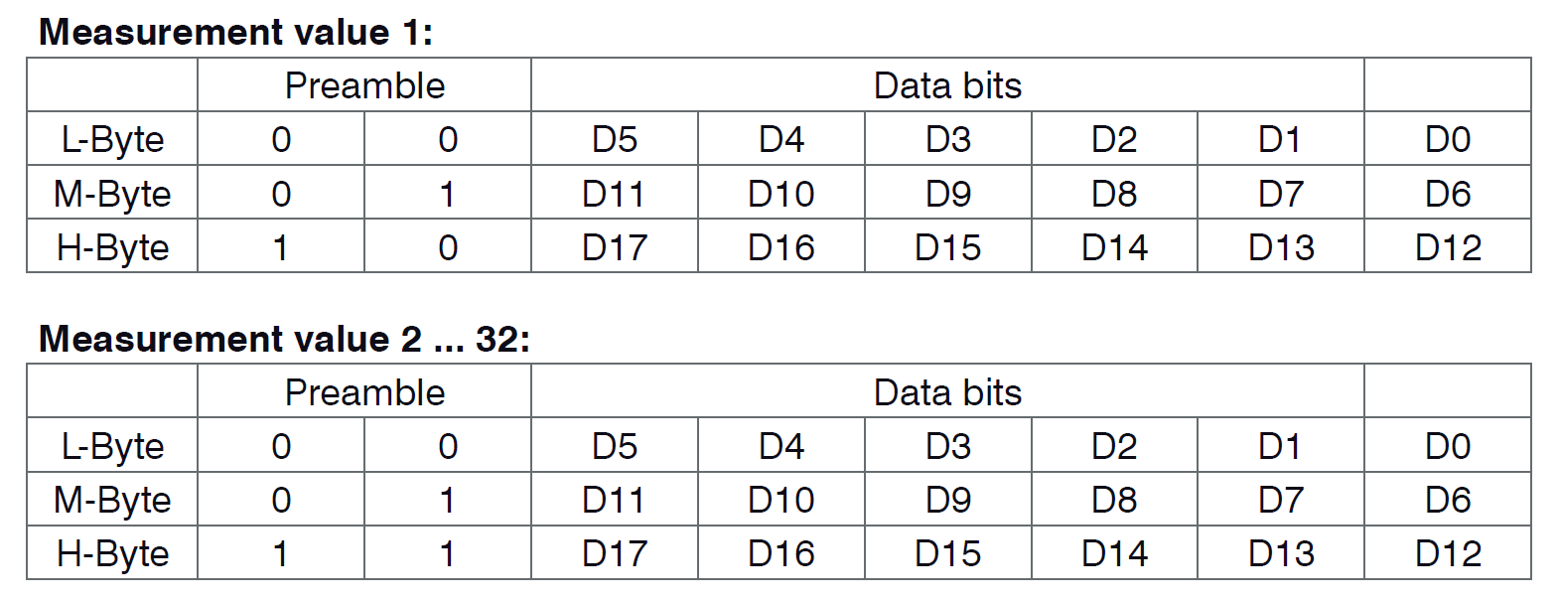
Figure 1: Serial data transmission format.
The process of receiving and decoding serial data is performed in the function parseSerialData as follows. Data is received and a check is performed to see if the code is in a state where telnet command responses are expected. If so, the data is processed by the processResponse function to look for the telnet prompt (see lines ~2694-2703 of CDVIFC242x.m).

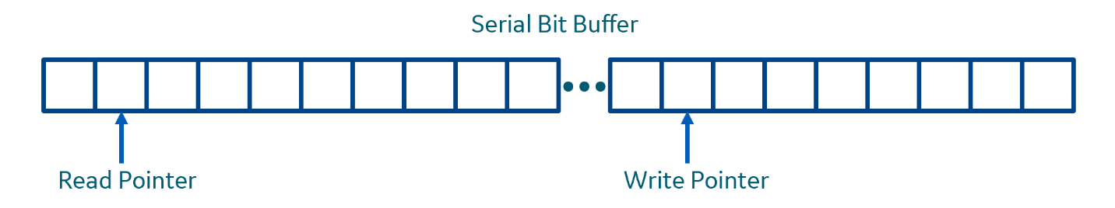
If measurement data is expected, then the received bytes are written into a circular buffer as depicted in Figure 2. Two pointers into this buffer are maintained. One is the position to which new data will be written. The other is the point from which data will be read. Each is updated when a respective read or write operation is performed. When either pointer reaches the end of the buffer, it is repositioned to point to the beginning of the buffer. The size of the buffer is 192 bytes; sufficient to hold 64 measurement values.
Figure 2: Circular Serial Buffer

It should be noted that there are some “ifdef” statements in the code that allow the code to be quickly switched to transmit Distance, Intensity and a Timestamp for each measurement. However, it was determined that the timestamp could be removed to allow more bandwidth, hence, higher sampling rates. Timestamps can be generated by the Obj-C code.

It is also noteworthy to mention that the data is transmitted in the order specified. When the controller is initialized the following command is sent:
OUT_RS422 01INTENSITY 01DIST1

This ensures that the data order will always be Intensity, followed by Distance. Experience has shown that sometimes bits or bytes will get dropped, so each time data is read from the circular buffer it must be verified that synchronization is maintained.

The bits expected for an intensity measurement (x), followed by a distance measurement (y) will be:

00xxxxxx01xxxxxx10xxxxxx00yyyyyy01yyyyyy11yyyyyy

To maintain synchronization the software keeps track of the next expected value from the controller. It takes the next 32 bits from the buffer as an unsigned integer and performs a logical AND with a mask to determine if the expected bits are present. If so, the data is synchronized. If not, synchronization is lost and must be re-obtained (see lines ~2765-2795 of CDVIFC242x.m). To regain synch, the read pointer is advanced through the circular buffer one byte at a time, checking the data with a mask until a match is found (see lines ~2796-2818).

With the data synchronized, if the next expected value is Intensity, it is parsed out giving an 18-bit unsigned integer value. If the next expected value is distance (a.k.a. displacement) it is parsed first as an 18-bit unsigned integer. This is converted to a floating-point value using the formula:

$$x= \frac{\left(d_{out}-98232\right)*MR}{65536}$$

where MR is the measurement range of the sensor. It is possible that the unsigned integer value may read as a value of 262073 or greater. This indicates an error condition which is detected in the code (lines ~2866-2890 of CDVIFC242x.m).

The measured intensity and displacement are pushed onto arrays to maintain the data for subsequent processing. Timestamps, point counts and dataset IDs are also recorded as well. When the data for a given receive event has been processed, the progress is updated.

Progress is reported by a timer which fires once per second and reports the progress by sending a “progress” message back to the UI with a floating-point number between 0 and 1 representing the progress. This value is used by the UI to update the progress indicator.

Data collection proceeds in this manner with data continuing to be recorded until the predetermined number of data sets has been received. When all data for this collection has been received a command is sent to stop data transmission and the serial cable is reset (see lines ~2957-2972 of CDVIFC242x.m). At this point there is no guarantee that the exact same number of Intensities and Distances have been received, so all data arrays are trimmed to match the size of the smallest (see lines ~2978-2987).

A status message is next sent to the UI to indicate that data collection has stopped and computation of the clearance value has begun (lines ~2989-2995).

Clearance Calculation: Calculation of the clearance values involves first, processing the data to identify blade tips, then measuring the tips to produce the clearance value. Clearance values are produced on a per-blade-tip basis then averaged to produce a single value for each stage.

A sample collection of data is shown in Figure 3.

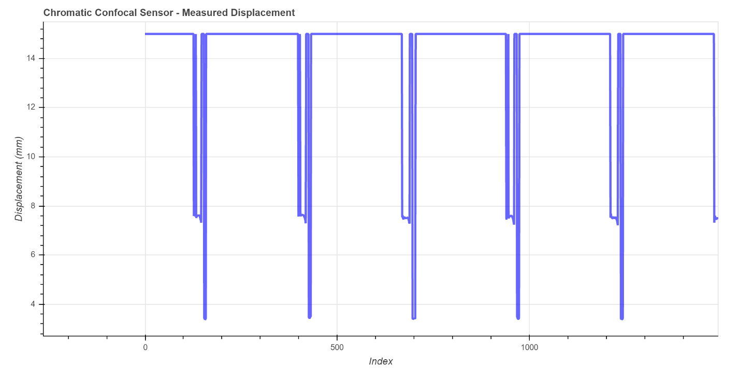
Figure 3: Sample sensor data from R6, top on a 7HA.02 turbine.
The blades for the data in Figure 3 have squealer tips, which are clearly manifest in the data. The calculation of the clearance should only measure the distance between the tip of the blades and the casing and should not consider the entire width of the blade. To accomplish the separation of the tips from the unwanted portion of the blade a threshold is used. Various methods exist to calculate the threshold. In one case, histograms can be constructed to bin the data into ranges. This data appears to have 3 distinct ranges (tip, ‘shelf’, and out-of-range). If histograms are used they must be separated from each other. This has proved problematic. A new approach using Cumulative Distribution Functions (CDF) is being considered. Until a new approach is in place, a single hard threshold of 4.5mm is used (see line ~1996) with data above this threshold not being considered.

Next, the data is filtered using a Laplacian of Gaussian (LoG) filter to find the begin and end points of the individual blade tips. The LoG filter is implemented beginning at ~line 2342 and uses a convolution algorithm pulled from the web. This implementation is preferred because it uses the iOS devices DSP chip to accelerate the processing. The result of the FIR filter is demonstrated in Figure 4. In this example the entire blade is processed rather than just the tip. The filter output has X-axis crossings at the beginning and end of the blade. These zero-crossing locations are identified and recorded in the code to identify where the blade tips start and stop (see lines ~2008-2048 of CDVIFC242x.m). The code then iterates across all the displacement values and performs an average of the points between the start and stops points. These averages are the uncalibrated clearance values for the individual blade tips (see lines ~2068-2176). When averaging data, only data points with intensity values greater than zero are considered.
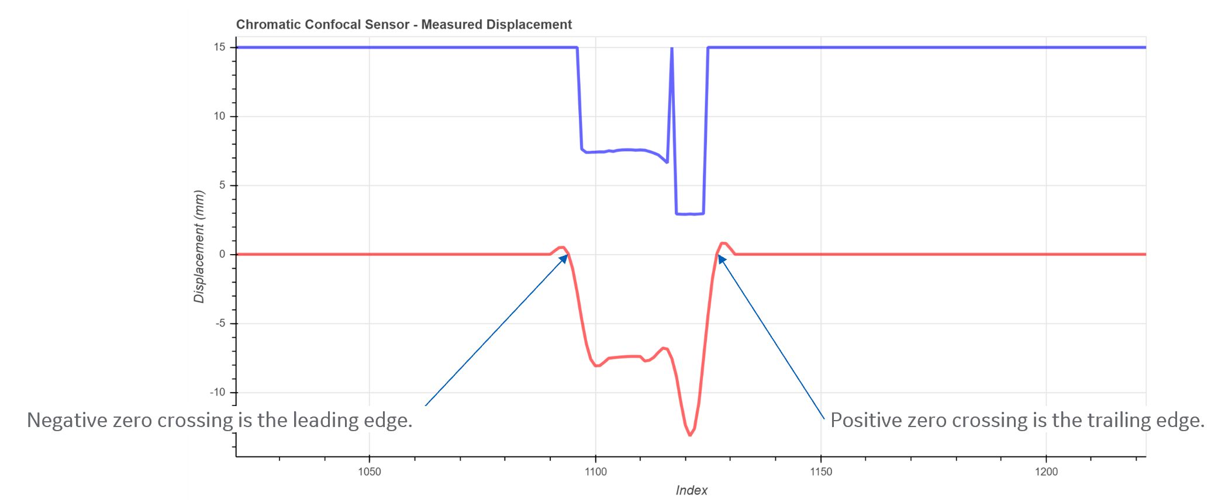
Figure 4: FIR Filtering example.
Based on DDR input, an additional check is performed on the data. A check is performed for data points that deviate from the mean of a blade by >0.001”. If such points exist, they are counted. They are also used to compute a data quality metric. The existence of such points is included when the data is passed back to the UI and the user is informed (see lines ~2141-2153).
To yield a final overall stage clearance value, the average of all blade clearances is computed. Additional calculations are performed to collect statistics on the blade clearances. The maximum, minimum, and median of the clearances, as well as the standard deviation over all clearances, are all calculated and returned to the UI. Because the data collection is conducted over a time that should be approximately 1.1x the time of a full rotations, these final calculations are only performed over the number of blades in the specified stage. This way a single blade should not contribute twice to the statistics.
To calibrate the clearances and give distances from the blade tips to the casing, information about the sensor, casing and spacers used is required. In the case where the app’s “Get Data” button was pressed this data is not available and so uncalibrated data is returned.
Calibrated Data Collection: If data is being collected for a known frame size, stage and position, a slightly different acquisition process occurs. In this case the user is not prompted for a number of seconds of data collection. Rather, the user is prompted to enter the turning RPM of the rotor. In this case the messageHandler routine will recognize that the acquisition time argument of the command contains the string “RPM”. Also in this case, several other arguments are passed to this command containing other important meta-data, such as frame size, serial number, stage, position, casing thickness, spacer thickness, number of blade, tip diameter, blade width and a master offset.
The algorithm will use this data in a function called acquisitionTimeAndRate to calculate the duration of data acquisition, the intensity threshold and the sampling rate to use. The sampling rate is computed to target acquiring 4 samples across the tip of the blade (see lines ~56 and ~1321-1326 of CDVIFC242x.m). The acquisition time is calculated to allow for 1.1 rotations of the turbine at the specified RPM. The intensity threshold is computed from an empirical curve defined by Carlos Diaz-Alfonso in testing. The acquisition time, intensity threshold and measurement rate, as well as any errors encountered in the process, are combined in an array and returned from the acquisitionTimeAndRate function.
Once the acquisition time, rate and intensity are computed, any errors are returned to the UI. If there are errors the acquisition process does not continue. If there are no errors then a process begins to set the measurement rate and intensity threshold before beginning data acquisition (see line ~1084). A special timer is set which, after expiration, will execute the command to acquire data. Data acquisition will proceed as outlined above. However, upon completion of the acquisition a calibration process will occur. The values involved in the calibration of the clearance are shown in Figure 5.
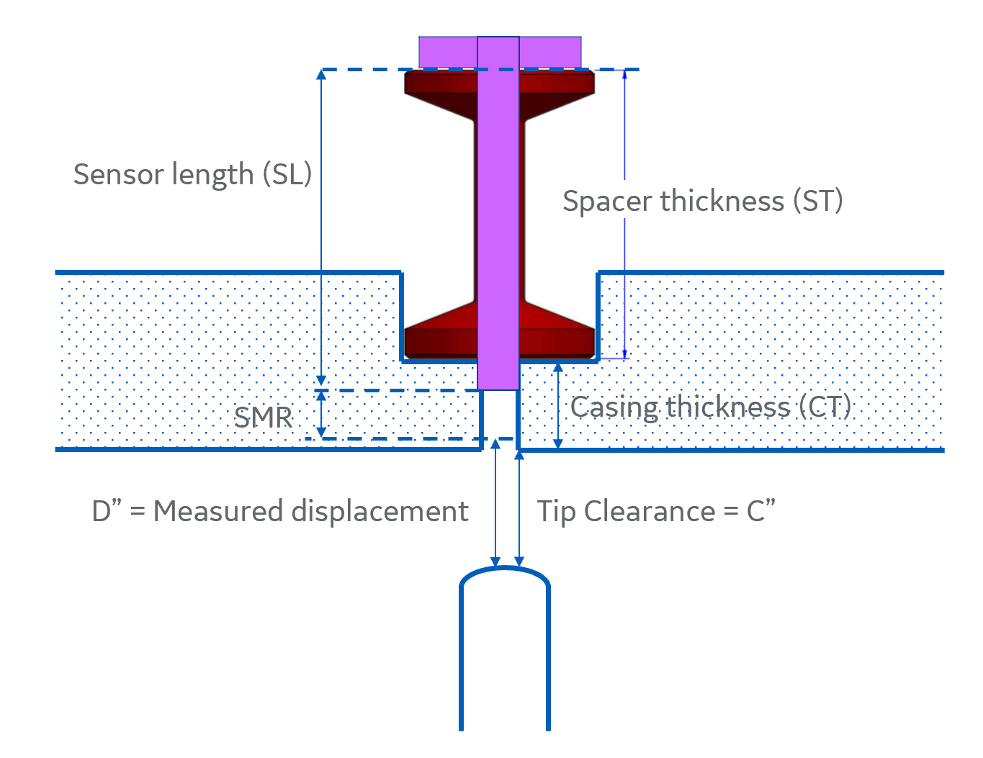
Figure 5: Parameters involved in calibration of clearance.
The computation of the final clearance value is computed as:
$$Clearance=D+SMR+SL-ST-CT+ δ$$
Where SMR is the start of the measuring range for the sensor and δ is a value can may be added to compensate for other systematic errors. In the user interface the value of δ comes from the “Master offset”. Calibration of the filtered values takes place at lines ~2177-2201.
Once the results have been calibrated, data is returned to the UI by calling the function returnData. This function combines the filtered data (or in the case of an uncalibrated data collection, the raw data) and several other results into a JSON dictionary and returns the dictionary in a message to the JavaScript pluginMessage function, which is given as the callback when the collection process is started.
TCP/IP (Ethernet) Data Collection: As an alternative, data can also be collected from the controller via TCP/IP connection over a wired or wireless connection. A wired connection between an iPad/iPhone and the sensor controller may be made using a Redpark lightning-to-ethernet cable. For a wireless connection, the controller can be wired to a WiFi router using a standard network cable. The iPad can then connect to the WiFi router and have a pathway to the controller.
It should be noted that the sensor controller in our testing has been programmed to a static IP address of 192.168.168.150. All future controller should be configured in this same way for consistency. WiFi routers should be configured to give access to this address range.
With TCP/IP data collection, the transmission of data from the controller to the iPad is much cleaner. Data is transmitted in complete packets as shown in Figure 6.
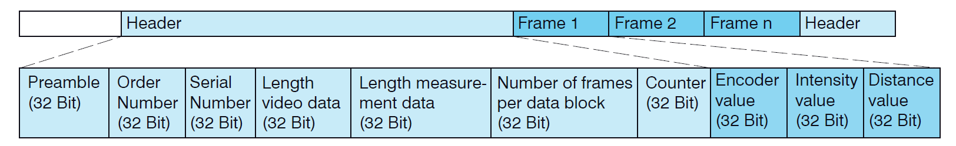
Figure 6: TCP/IP data transmission packet.
Telnet commands are sent, and responses received over a different port than the measurement data. This keeps the two data streams separated. Telnet data uses port 23. Measurement data uses port 1024. When data arrives via TCP/IP, the Obj-C function
- (void)stream:(NSStream *)inStream handleEvent:(NSStreamEvent)streamEvent { … }
is called (see line ~1499). When the function is called the code first identifies what port the data is arriving from. This tells the code whether to handle the data as a response to a telnet command or as incoming data. If the data is a response to a telnet command, the data is sent directly to processResponse the same as with the serial data (see line ~1736).
If the received data is measurement data (i.e. on port 1024) then the prescribed number of data sets is acquired sequentially. The lengths of the various fields is extracted per Figure 6, and then the individual data values are parsed from the data packet. With TCP/IP data packets, the data always arrives in well defined frames, so no circular buffering and synchronization are required. The values can be simply extracted from their place in the packet. Because TCP/IP data transmission is also faster than serial transmission, the intensity, displacement and a timestamp are all transmitted. Extraction of the data elements is seen in lines ~1604-1680 of CDVIFC242x.m. The conversion of data bits to a floating point displacement value is slightly different than the serial case, as is the error message encoding.
When data collection is complete, the same process is followed as it is with the serial data to return the data to the UI.
CSV Files: The app writes out a CSV file for each data collection. Saving of the file is performed in the function saveCSVFile (see line ~2495). CSV files are saved in folders named after the serial number of the turbine for which data is being collected. Additionally, the stage, position and a timestamp are incorporated into the file name. This allows multiple files to be saved for each frame, stage and position. CSV files may be emailed out of the app or copied to a Box folder. They may also be accessed through the File Sharing feature of iOS devices on Windows or Mac. When data is acquired using the “Get Data” button, CSV files are saved in a folder named “data”.
App Database: The app has the ability to store data from data collections in a database. This only happens when data is collected for a specific frame (i.e. not through the “Get Data” button). This function stores the data in a “pouchDB” database. PouchDB was selected because is can be used on mobile devices, it runs well in a browser (the basis of Cordova apps) and it has the ability to sync with another pouchDB. The ability to sync may be useful if, in the future, a database is made available at GE Power where it would be desirable to save this data. If that remote database is also a pouchDB, then synchronization could be greatly simplified.
Data is saved to the pouchDB in the e4pt_app.js file (see lines ~2469-2526). Each database entry is assigned a unique identifier to keep data separate. The identifier is a UUID which should be globally unique for the purposes of this application.
A button is provided in the app which allows a user to completely delete all data in this database. There is currently not a method to delete a single entry from the database. This is due to the way pouchDB stores data and the fact that when an entry is “removed” from the database, no storage is actually reclaimed. Rather the entry is just saved with a “_deleted” attribute so that it does not show up in queries. There are technical reasons for this that are discussed at this link.

Tables from the Micro-Epsilon users guide for the IFC242x controller.
Line numbers may change as the code evolves. These line numbers are taken from the last commit of July 29, 2020. SHA = 7126c65.
Formula from IFC242x users manual.
Figure from IFC242x users manual.

