Digital Signal Processing

Assignment 2

Report

Made by: Habiba Gamal

900151007

Problem 1:

The source code along with the input wav file (named “try3.wav”) and the output wav file (named “output.wav”) are in the submission folder.

The input wav file was read and fed into the dft function, after that, the output of the dft function was fed to the idft function and the output was captured in a wav file.

The magnitude of the dft output was plotted and its figure is attached below.

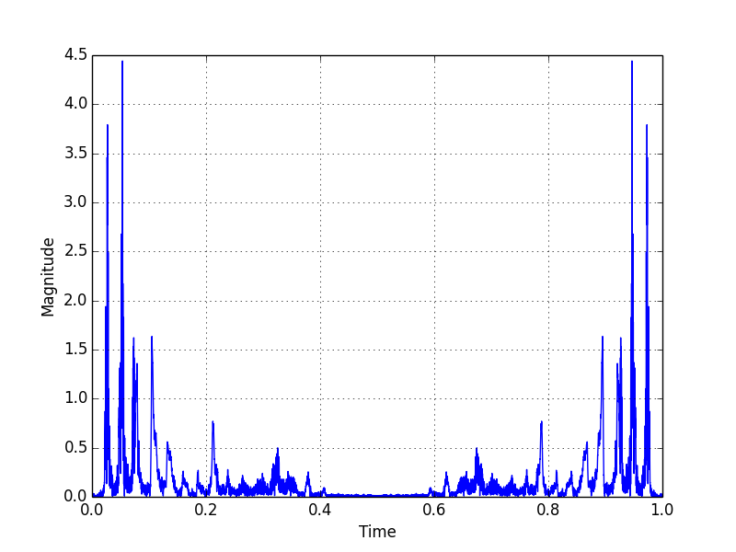

Figure 1.1: Plot of the DFT magnitude of the input wav file against time

Problem 2:

1. Calculating the frequency spectrum of the analog signal:

$\int_{0}^{∞}{e^{-t}.e^{-2πft}dt}$ = $\int_{0}^{∞}{e^{-2πft-t}dt}$

u = 🡪 dt = $\frac{1}{-2πft-t }$ du

$\frac{-1}{2πf+1 } \int_{0}^{∞}{e^{u}du}$ = $\frac{-1}{2πf+1 }e^{u}+c$ = $\frac{-1}{2πf+1 }e^{-2πft-t}$ + c

Substituting with the limits:

- =

Plotting $\frac{1}{2πf+1 }$. f was substituted with values between 0 and 20 and the interval is 1/100000.0 so it is so close to the analog signal. The plot is attached below.

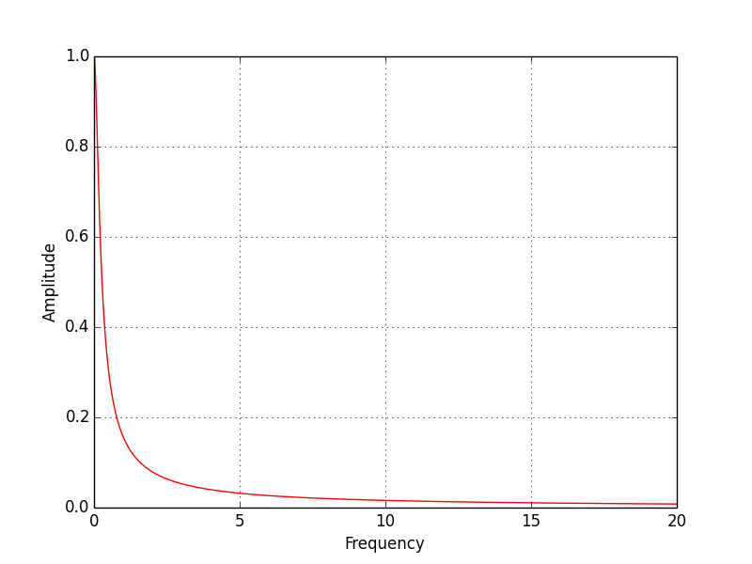

Figure 2.1: Plotting of the frequency spectrum of the analog signal calculated using continuous Fourier transform

1. Below is attached a plot containing the 100 point DFT of the digital signal sampled 100 times at a rate of 20 samples per second.

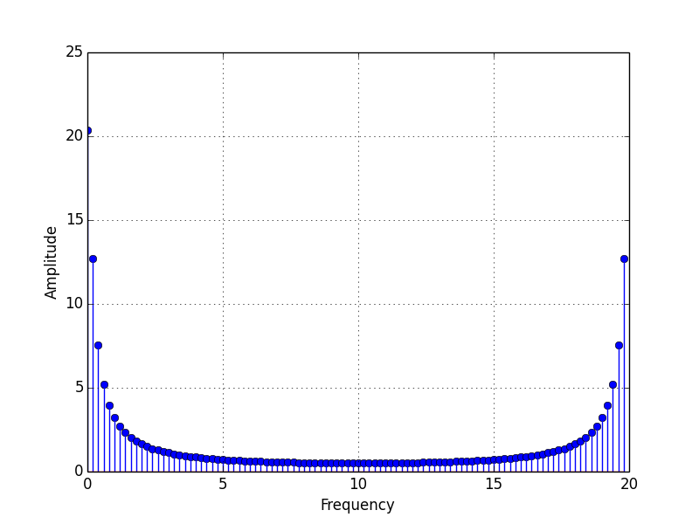

Figure 2.2: a plot of the frequency spectrum of the dft of 100 samples

As shown in the figure, the frequency spectrums looks like the frequency spectrum in figure 2.1 with small differences, although the amplitude is different.

The amplitude is different because a 100-point DFT is not as accurate as the continuous Fourier transform from 0 to infinity. However, if the number of points used in the DFT, as well as, the sampling frequency with which we sampled the digital signal increased, the output will be closer to the frequency spectrum of the analog signal generated with continuous Fourier transform.

1. Below is attached a plot the 200-point DFT of the digital signal sampled 100 times at a rate of 20 samples per second padded with 100 zeros to the right.

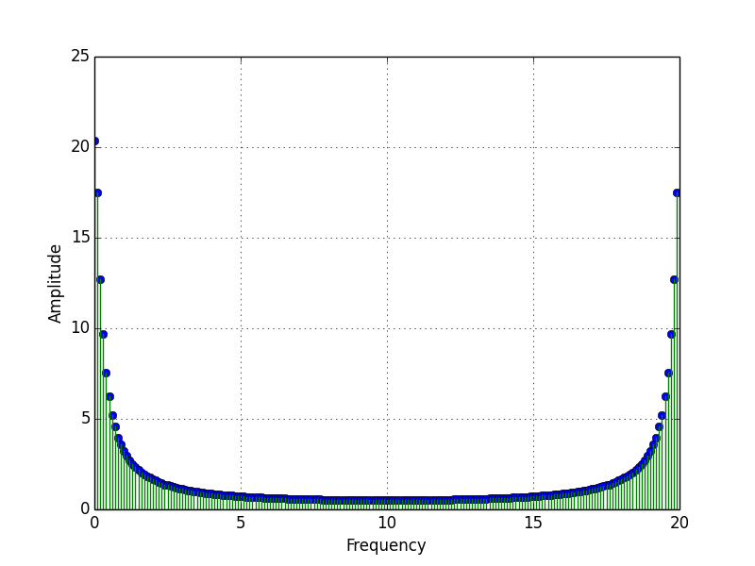

Figure 2.3: a plot of the frequency spectrum of the 200-point dft of 100 samples padded with 100 zeros

As shown in the figure, there is very little to no difference between the plot in green and the plot in blue in figure 2.2. This is because the 100th sample in the digital signal is 0.00708340892905, so when we pad 100 zeros to the right of the 100 samples, we are not decreasing the quality of the output of the DFT in a considerable way.

Again, as shown in the figure, the frequency spectrum looks like the frequency spectrum of the analog signal with small differences, although the amplitude is different. Again, this is because a 200-point DFT is not as accurate as the continuous Fourier transform from 0 to infinity. However, if the number of points used in the DFT, as well as, the sampling frequency with which we sampled the digital signal increased, the output will be closer to the frequency spectrum of the analog one generated with continuous Fourier transform.

Attached below is a figure containing both the plots of the 100-point DFT with 100 samples (in blue) and the 200-point DFT with 100 samples padded with zeros from the right (in green).



Figure 2.4: a plot of the 100-point DFT with 100 samples and the 200-point DFT with 100 samples

As shown in the above figure, both DFT outputs are almost or exactly the same. Again, this is because 100th sample of the digital signal is 0.00708340892905, so padding zeros to the right of it is an acceptable approximation.

1. Below is attached a plot containing both the frequency spectrum of the analog signal calculated with continuous Fourier transform, as well as, the 200-point DFT of the digital signal sampled 20 times at a rate of 20 samples per second padded with 180 zeros to the right.

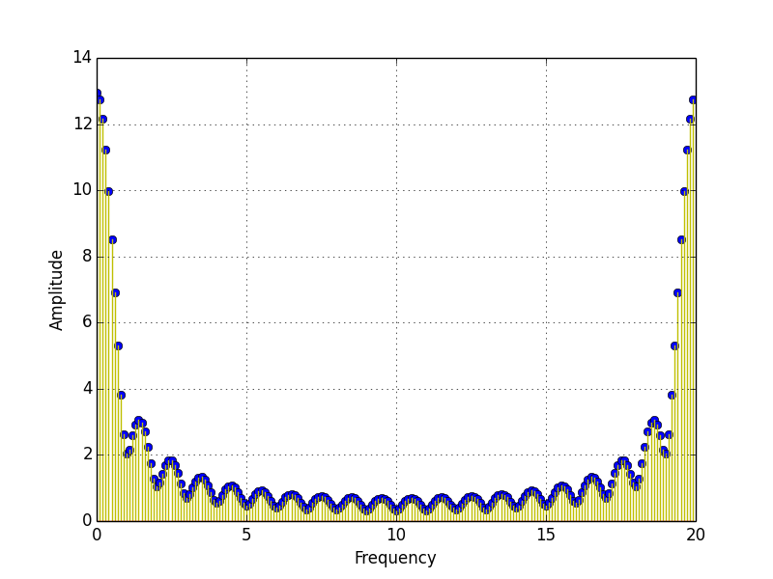

Figure 2.5: a plot of the DFT of the 20 samples padded with 180 zeros to the right

As shown in the figure, the DFT output does not like the frequency spectrum of the analog signal.

The reason why the frequency spectrum in figure 2.5 does not like the frequency spectrum of the analog signal is DFT leakage.

“Leakage is caused by the truncation of a signal to a finite length when the length selected for DFT is not an integer product of each signal component.” This must have been the case here.

Therefore, our case might have happened because of the sharp junction points when we took only the first 20 samples and then padded 180 zeros to the right. This is because the magnitude of the 20th sample is 0.386741023455, so it is not as close to zero as the case with the 100 samples as the 100th sample was 0.00708340892905 which is closer to 0 (Therefore a smoother change).

In order to make it closer, without changing the number of samples or the sampling rate, I will pass it through a window. The window I chose to implement is the Hanning Window.

“Windowing reduces the amplitude of the discontinuities at the boundaries of each finite sequence acquired by the digitizer.” This is done through multiplying the signal by a window whose values decrease smoothly and gradually towards zero at the edges. This results in a continuous waveform without sharp transitions.

Attached below is a plot of the enhanced frequency spectrum.

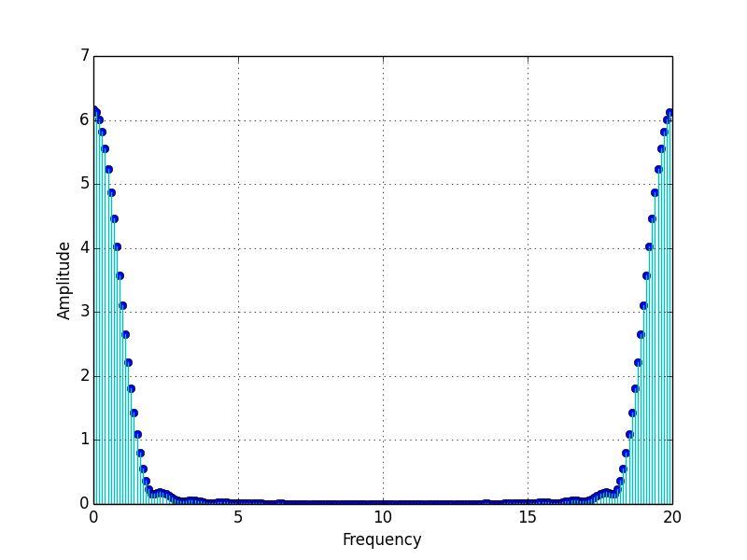

Figure 2.6: Plotted in cyan is the frequency spectrum of the 200-point DFT with 20 samples after windowing.

It is noticeable that the amplitude is not the same as the previous DFT in figure 2.5 without the windowing. This is because windowing reduces the gain of the original signal. To correct for the gain of the hanning window, the signal should be multiplied by 2 (reciprocal of ½)

A close up of a map


Figure 2.7: This is a plot of the 200-point DFT with 20 samples after multiplying by 2 to correct for the gain of the hanning window

As noticed by the above figure, the amplitude is now almost the same as the one in figure 2.5. This is because I have done correction for the hanning window to not only decrease the leakage, but also to preserve the amplitude.